4Foundations Academy Facilitator Agenda: Day #1
General Materials Needed: |  |  |  |  | Room Set-up:
1 Set of Handouts per Person  Name Tags  Table Tents  Sign-in Sheet  Agendas for table (1 per)  Room signs |  | Chart Paper – Large Post-it Style  Post its – Regular size and large size (4’’x5”)  Index Cards – 3”x5”  Highlighters – 5 Colors – Pink, Orange, Yellow, green and blue  Chart Markers – non-permanent chisel tip  Pens and Pencils |  |  | Round Tables  Projector, Screen and Speakers  Carousel stations and reporting stations around the perimeter  40 people MAX  Material Boxes with Participant “toys” on each table  CHARTS NEEDED:  - Parking lot  - Core Values (2)  - Leadership styles (Direct, Systematic, spirited, considerate)
Overall Outcomes: Participants will learn core, foundational practices that can support a successful UniServ career. They participate in a Worksite Organizing Practice in a local affiliate to know what it is like to implement a local organizing plan. They will learn a variety of methods for making member contacts, will hone their one-on-one skills, and will develop a plan for translating the work of the Academy into their everyday work life.
Pre-attendance Resources and Information:
Participants have completed a pre-attendance survey, will be contacted by phone from one facilitator, and will read three short articles.
Key Outcomes for the Day:
Participants will understand who they are as individuals and as a community of learners – Communicators, Leaders, Organizers
Participants will learn how a racial justice framework can shape their work and organizing decisions
Participants will develop and share a Story of Self
Time | Essential Questions |  | Resources | Instructions, Activity and Debrief (Facilitators) |  | Outcomes
 | What question(s) should this learning section answer? |  | Charts, handouts, articles, materials, slide | What are you saying, what are they doing, what questions will you use to guide learning and make clear the important points.  Include an estimate for how long each section of the learning will take |  | As a result of this section of learning, what will participants know or be able to do?
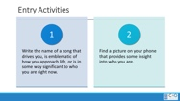    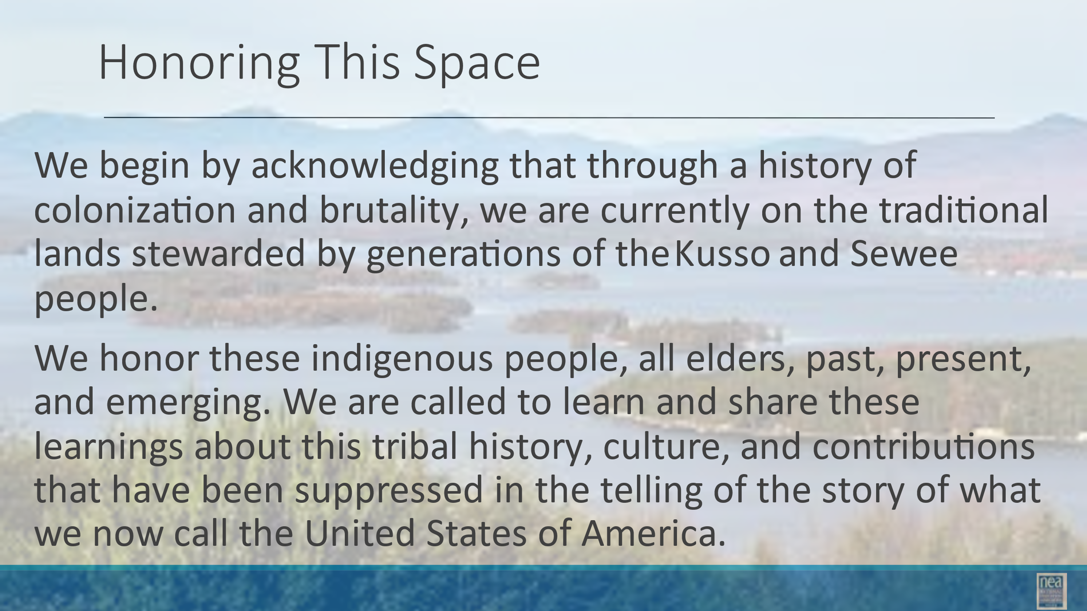 |  |  |  | Entry Activity:  - Select a picture on your phone that says something important about who you are. We will be using this later in the morning.  - Encourage participants to add their song to the chart  We begin by acknowledging that through a history of colonization and brutality, we are currently on the traditional lands stewarded by generations of the Indigenous people in the area4.  We honor these indigenous people, all elders, past, present, and emerging. We are called to learn and share these learnings about this tribal history, culture, and contributions that have been suppressed in the telling of the story of what we now call the United States of America.
8:30 – 9:30    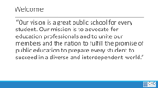  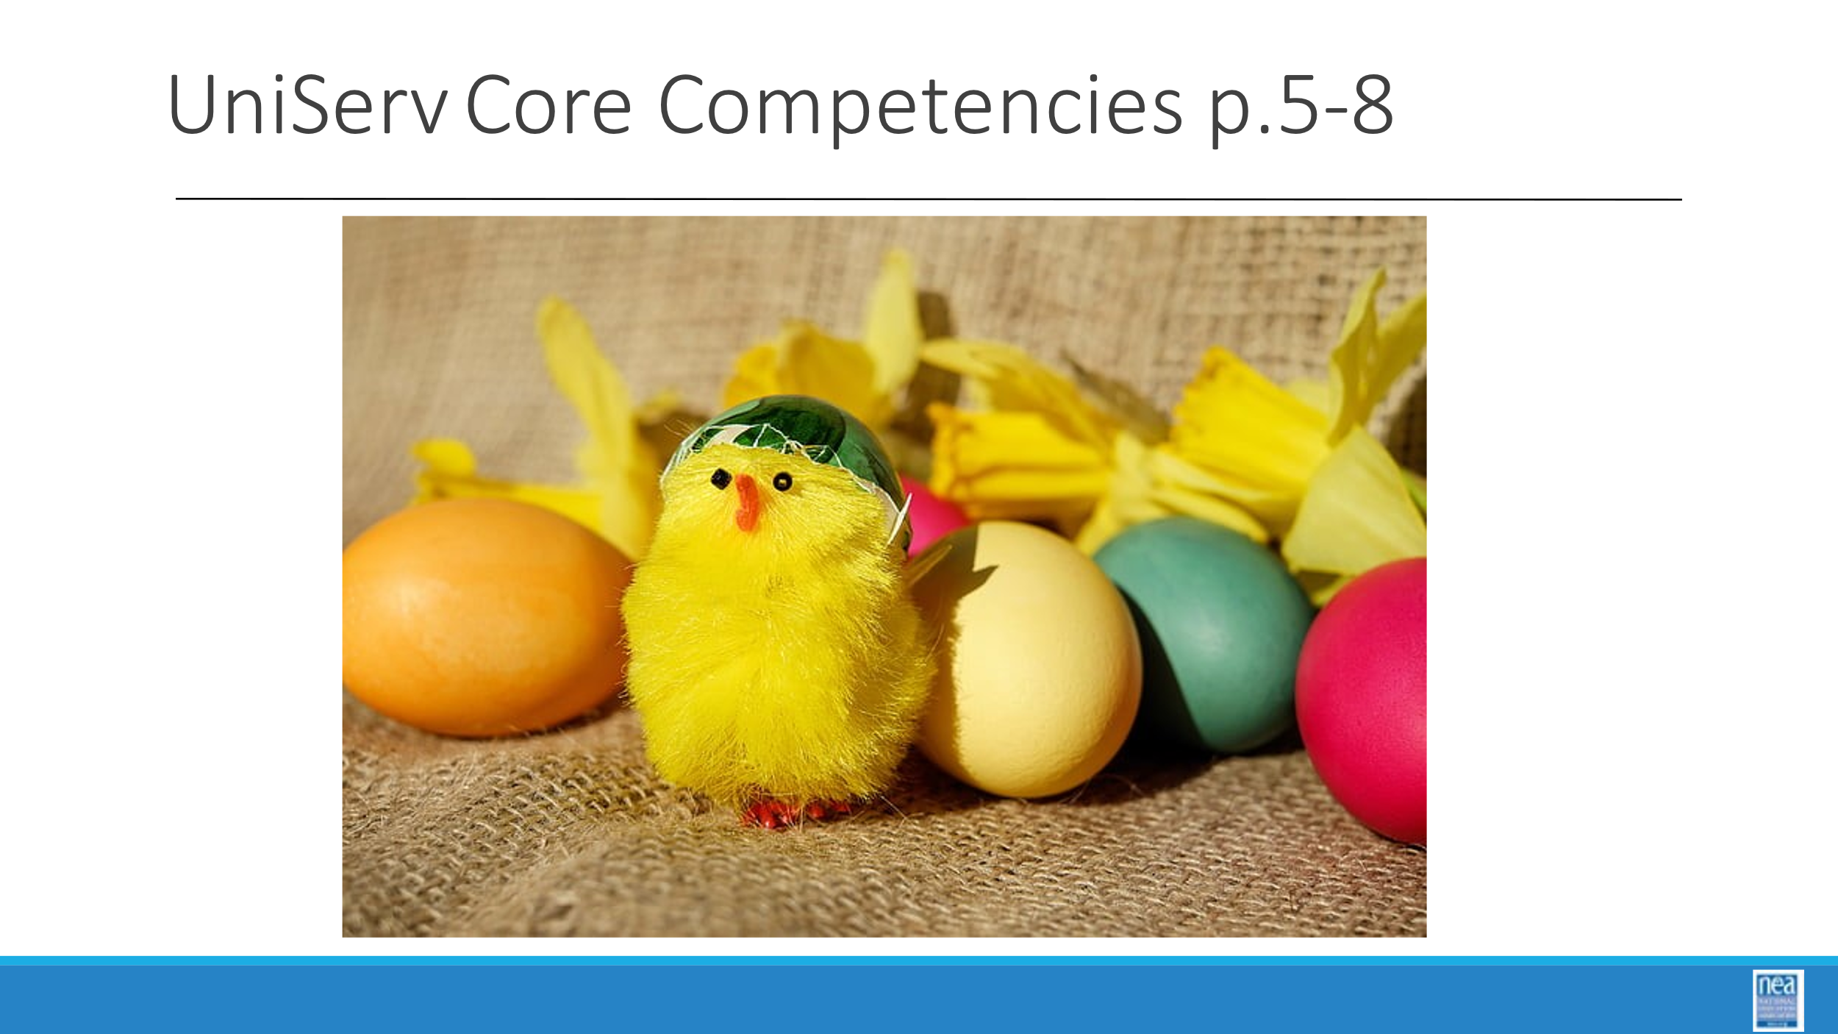  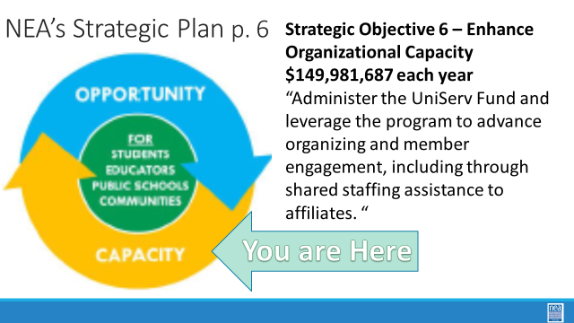  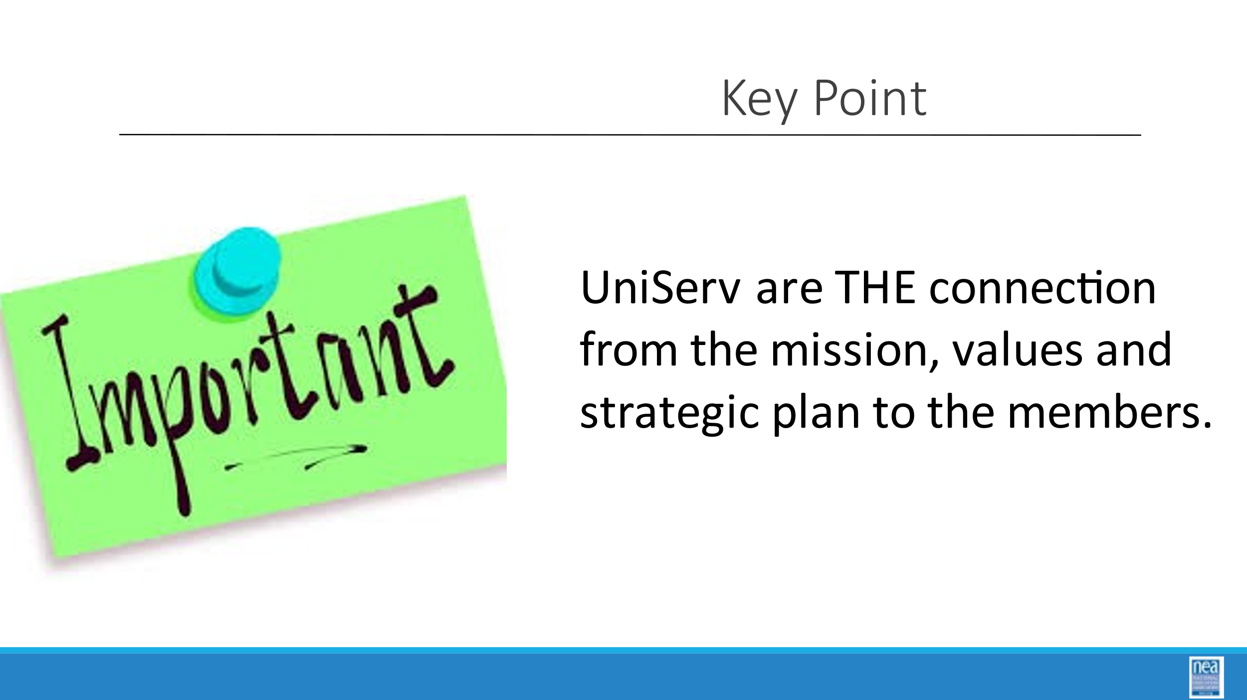  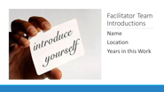  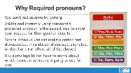    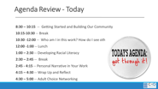  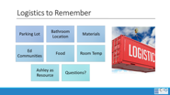  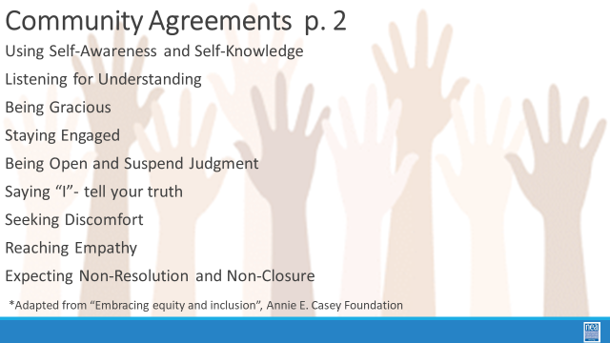 | How are we going to work together this week?  CHANGE TO WORKSITE FROM FILED |  | Parking Lot  Agenda  Agreements  Spirals  Mission Vision Values  NEA Strategic Framework  Member Retention Research Brief  Community Agreements | 60 Mins - Welcome, Introduction and Group Agreements  10 Mins  Welcome  NEA welcome and align the UniServ Academy with the NEA purpose – growth and strength triangle. Key message – UDs are the key connection between members and leaders and the organization. Introduce the  UA Spirals –  Adult Learning techniques, Unionism/Labor, Race/Social Justice, UniServ Competencies, Organizing, real world applicability, and work/life balance.  Refer to Mission Vision Values handout (p. _4_ handbook)  Refer to the NEA Strategic Framework (p. _6__ )  Refer to Member Retention Research Brief (p. _11__)  Core Competencies Page 7-10  10 Mins  Team Introductions and Logistics  - Team lead does a brief introduction of the team  - Name  - Location  - Their title (not everyone is called “UniServ”  - Years in the work.  - Review agenda, parking lot and logistics (materials, food, schedule, bathroom, room temp, etc.)  Key Points of this Section:  - The UniServ Program IS the connection of the organization to the membership  - Introduction to what will be covered this week  30 Mins Community Agreements (p. 2-3)  15 Mins  Group Review  Begin with a proposed list of community agreements, each table needs to describe what they think each agreement means and propose any additional norms not covered by the proposed agreements:  - Using Self-Awareness and Self-Knowledge  - Listening for Understanding  - Being Gracious  - Staying Engaged  - Being Open and Suspend Judgment  - Saying “I”- tell your truth  - Seeking Discomfort  - Reaching Empathy  - Expecting Non-Resolution and Non-Closure  Refer them to the Community Agreements in their handouts and that they received as part of their Pre Attendance documents  10 Mins  - Prompt table groups to review the agreements  - They will have 10 minutes to scan the agreements looking for items that they don’t understand.  - They should also be tracking what they think is missing.  15 Mins  Debrief  - Share what you mean by the agreements  - Check to see if tables were on track or need clarity for EACH of the Agreements. Before moving to the next one- ask the group to show thumbs  - Thumbs up is I totally agree  - Thumbs sideways is I can live with it and I am fine to move on  - Thumbs down – I simply cannot move on AND I have questions or something different to propose.  - A thumbs down comes with the responsibility of working until your thumb can at least be sideways. (what follows are facilitator notes to help you debrief the ways of thinking that shaped each of the proposed agreements 1-4)  - Learning is two-way experience you need to communicate well with the facilitators and your group mates in order to insure your own learning and that of the group. You are invited to share in the development and maintenance of a productive adult learning space.  - Speak up and make room for others to do the same. Sometimes that means stepping back. Expect to be called on even if your hand is not up – it is a way for facilitators to ensure a balance of voices in the room – we expect that you might pass as well.  - Be free to discuss ideas that you heard hear, but not identifying the person or people involved.  - Adult learning is a cooperative and collaborative experience. We need to share in the management of the learning space, because it is a shared space. This is particularly true for an extended experience like this. These sub-agreements are intended to help us commit to the routine expectations we might have of each other – curb side talking, watch your tech use, arrive on time, respect and listen to one another, speak your own truth when addressing differences.  - Share what you think each of the agreements 1-4 means as a facilitator  - Take questions and look for ways that the tables understood the agreements.  - Before ending ask: Do we want to make any additions to these agreements?  - Chart and discuss if any are added.  Key Points –  - Agreement on how we will work together for five days that allows us the space to manage “airtime” and teaching - AND allows adult learners a safe space to learn |  | Participants will establish and understand the agreements and routines that will guide their learning this week.
9:30- 10:15  Jeny  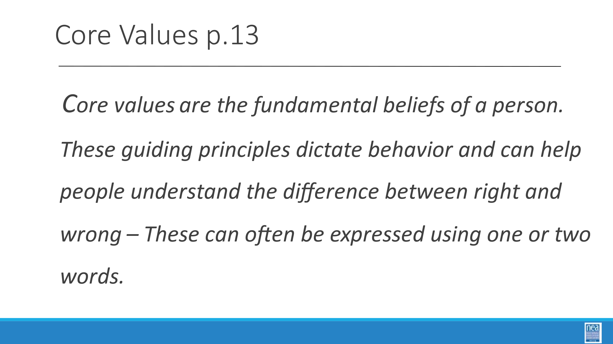  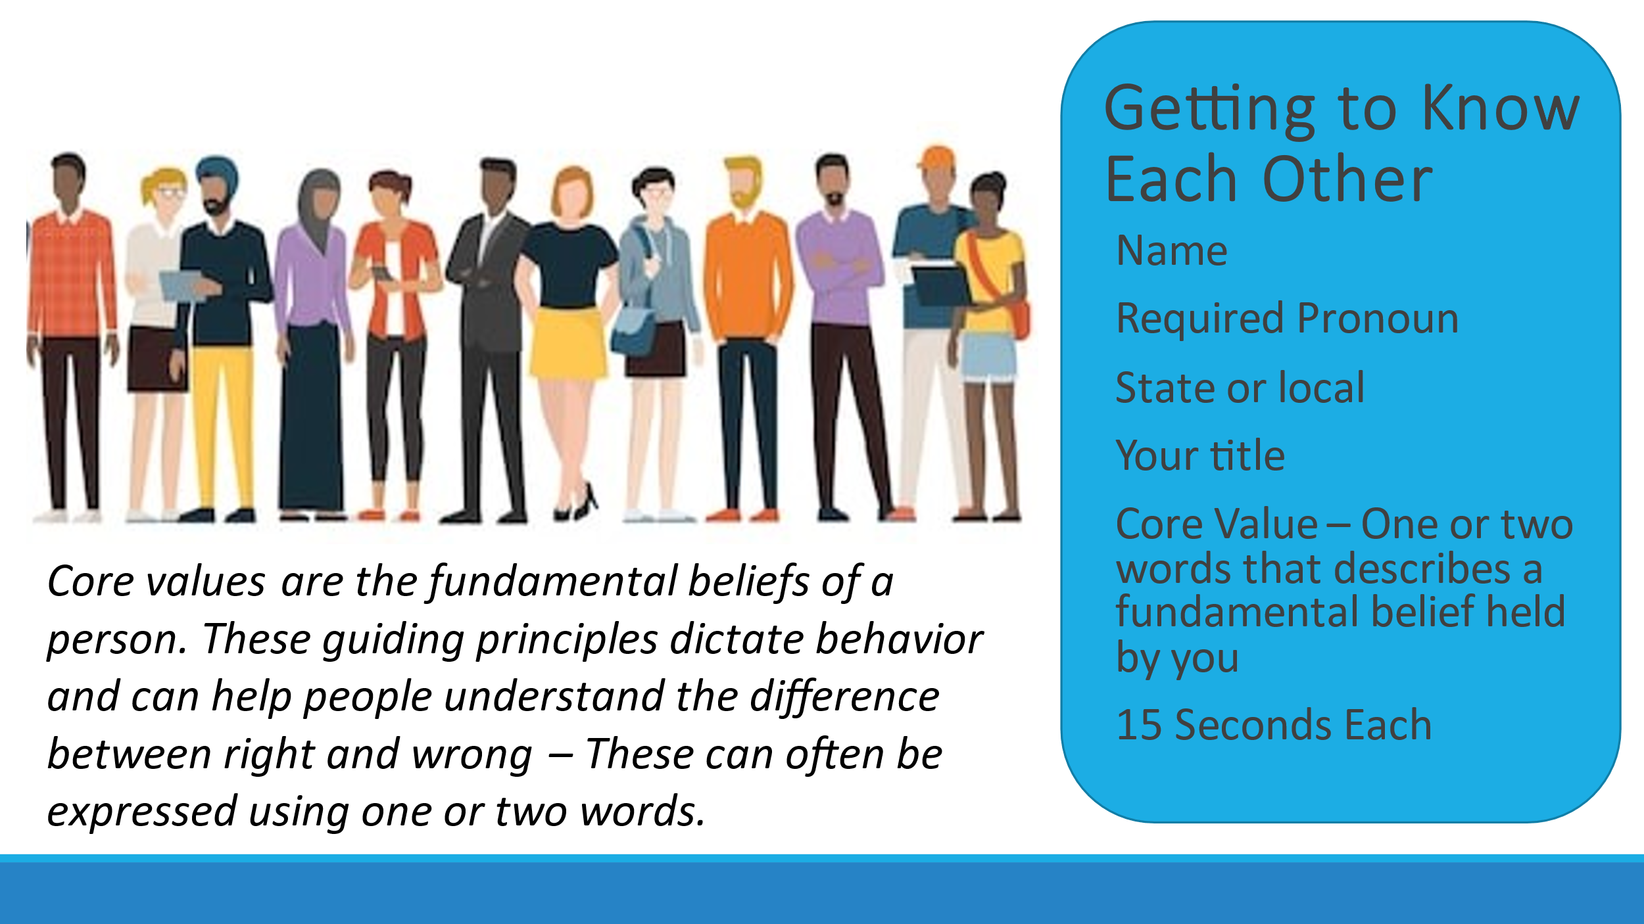  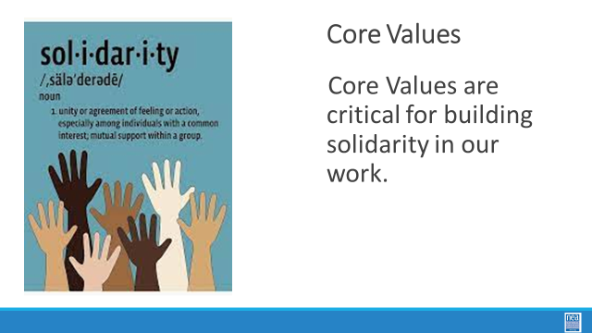      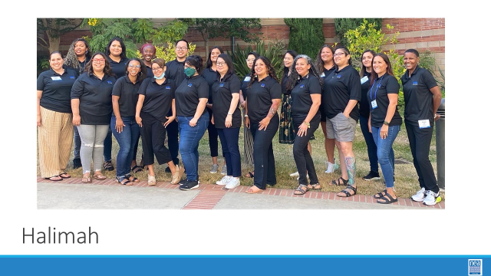  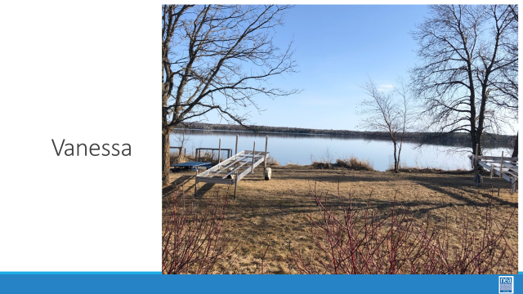  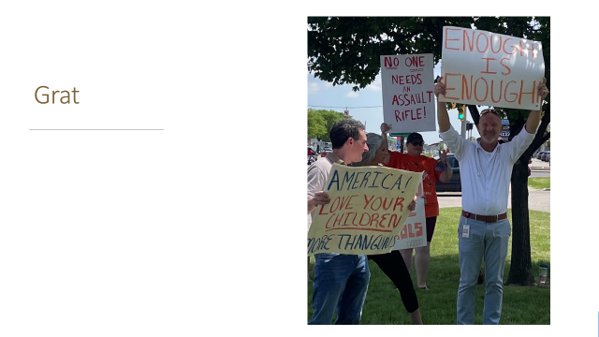    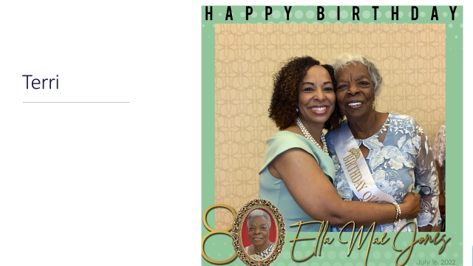  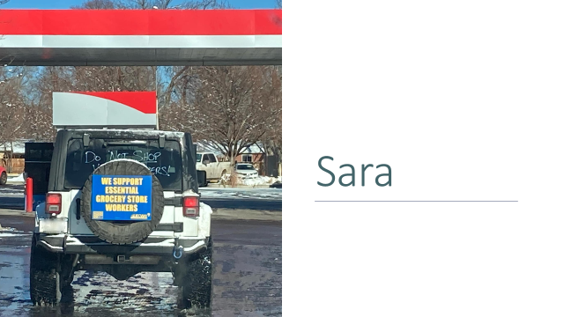         | Who are we as a group? |  | Core Values That Drive Work / Life | 45 Mins Building the Community  10 Minutes -  Core Value Quick whip intro  - Ask participants to introduce themselves:  - By saying their name and state  - A core value –  - Review what a core value is (Core values are the fundamental beliefs of a person. These guiding principles dictate behavior and can help people understand the difference between right and wrong – one or two words)  - One word or two that describes a fundamental belief held by you – start the chart with yours (ex. Solidarity) - you and your partners will chart the core values only as they are shared – Use two charts and two recorders so that it can move quickly. (15 seconds per person INCLUDE THE PRESENTERS)  5 Min Debrief -  - Share that these Core Values can act like an anchor for us in our own work and are a solidarity builder across people in our unions.  - When we are unsure and feeling overwhelmed by what we are supposed to be doing, a good reflect and check is to ask “does it align with my core values.”  - Three good reflective questions to ask when your work life seems out of balance are:  - What are the core values that drive my work and life?  - How am I living and working with integrity towards these values?  - What can I do to improve that integrity?  A copy of this can be found on your handouts. (p. 14)  Key Idea  - Our work can be balanced by reflecting on our values  - Values are at the core of relationships, community and solidarity  Presenter leads into Picture activity and has each team member model this.  6 Mins Presenter Picture Time -  Each member of the team has 60 seconds to share their picture along with why it is important to them.  10 Mins Cell Phone Artifact Mixer -  - Participants will need to be able to access the photo on their phone that has something to say about who they are.  - Open your phone and open the picture that has something to say about who you are.  - You will be repeating this at least 3 times with one other person in the room.  - For each round you and your partner will have three minutes TOTAL – 90 seconds each- to share  - Your name  - Where you are from  - WHY you selected this picture as a representation of something important to know about you.  - Find a partner and begin – make sure it is someone new to you  - Share and repeat  10 Mins Final Debrief -  - How did you feel when you were presenting or listening?  - What are some common themes that you see across the introductions?  Key Point  - Sharing our stories and listening to others is the key way that we recruit and retain members AND engage them in values-based union activity  5 Mins Introduce Who you are in this work -  - The next part of our time together will be focused on getting to know you, how it presents in the work you do, and how you see other people. (The emphasis will be on how we see other people)  - This video from Denmark is a good bridge from what we are doing to get to know each other, and a reminder for how we approach “getting to know our people” in our work. What can happen when we unbox each other?  - [Trainer: Share that while there is no assigned work during breaks, if they haven’t completed the pre work- Leadership Style Survey they will need to do that during break] |  | The group will share their own and develop a collective set of core values.  The group will begin to explore and share their identity.  The group will build a sense of community with each other.
10:15  10:30   | BREAK  [Trainer: Share that while there is no assigned work during breaks, if they haven’t completed the pre work Leadership Style Survey they will need to do that during break]
10:30-Noon  Barb  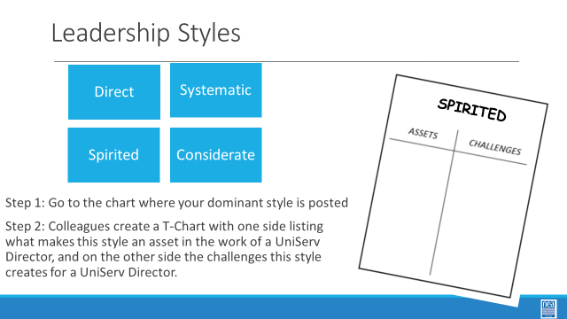  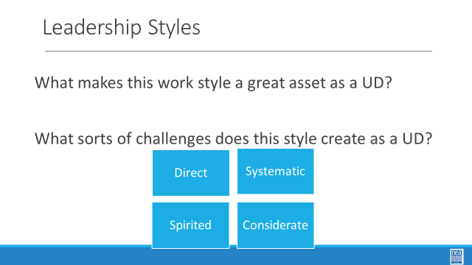  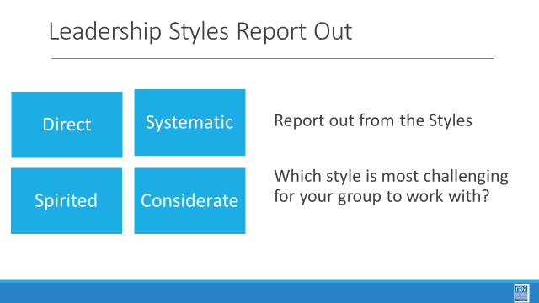  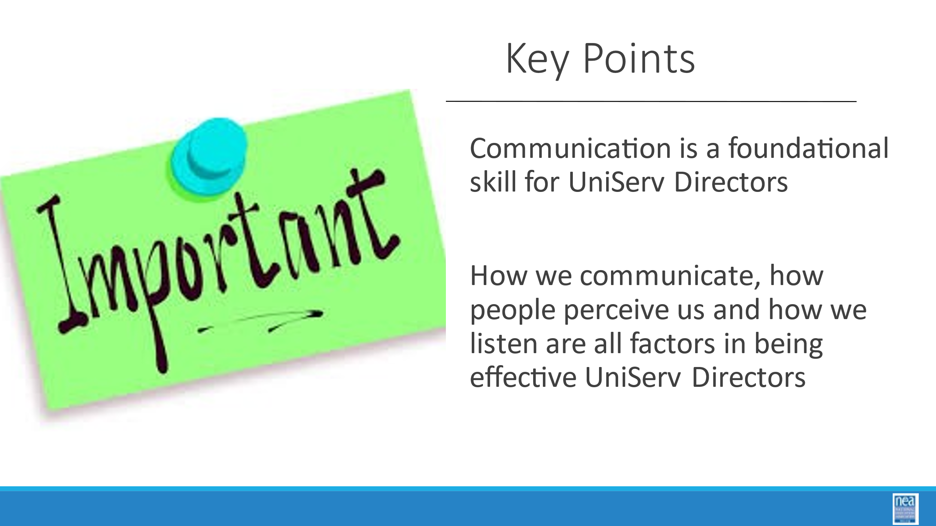  Halimah  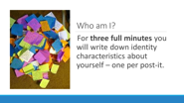  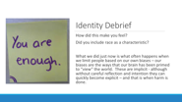  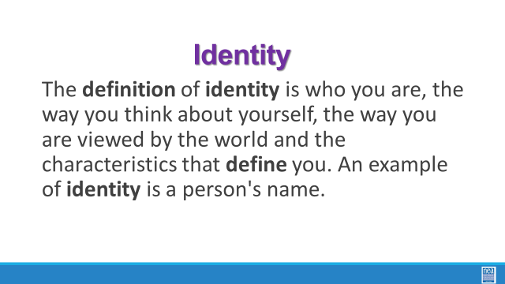  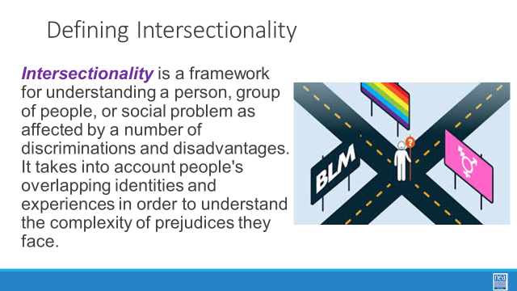  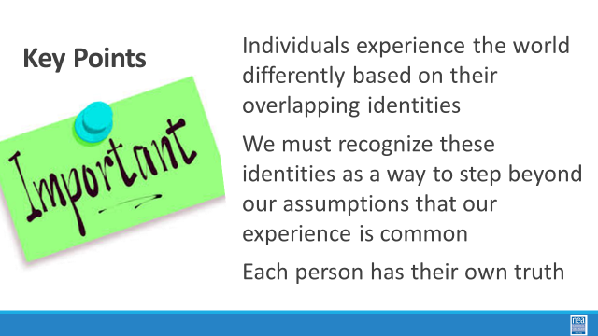  Barb  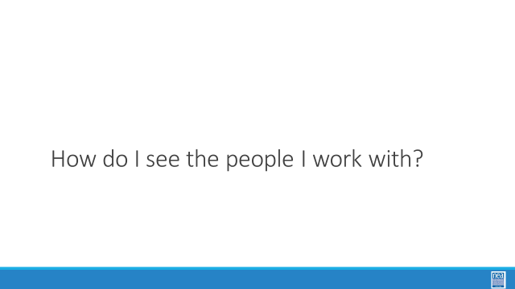  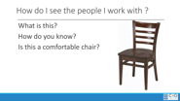  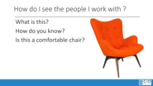  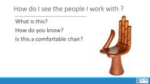  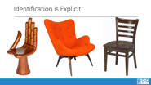  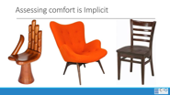  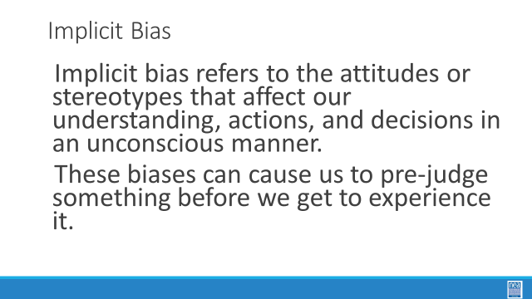  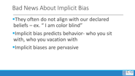  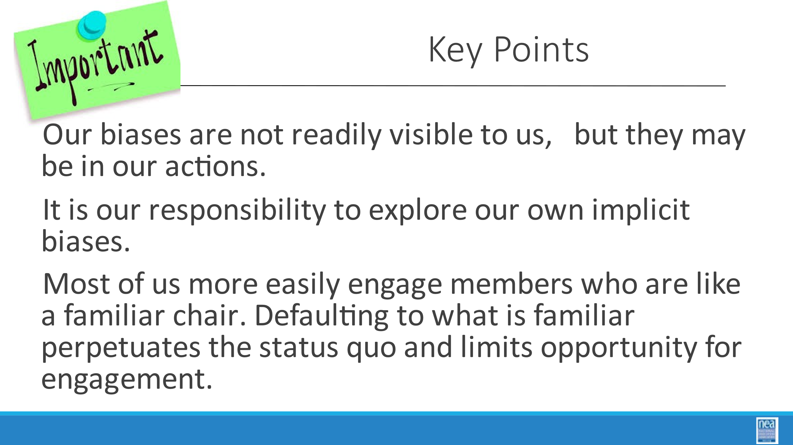  Halimah  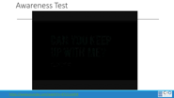  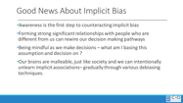  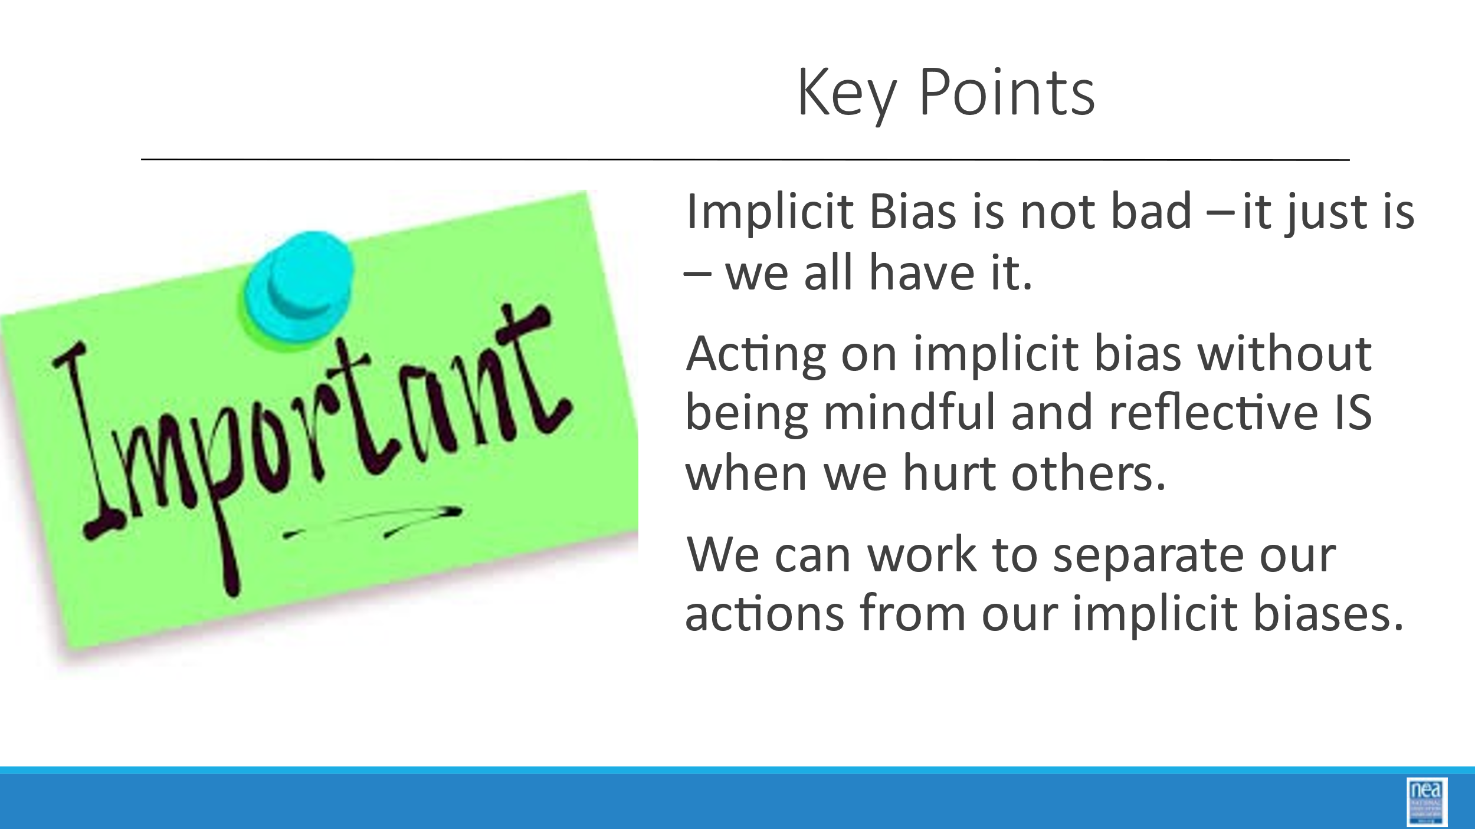    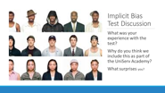  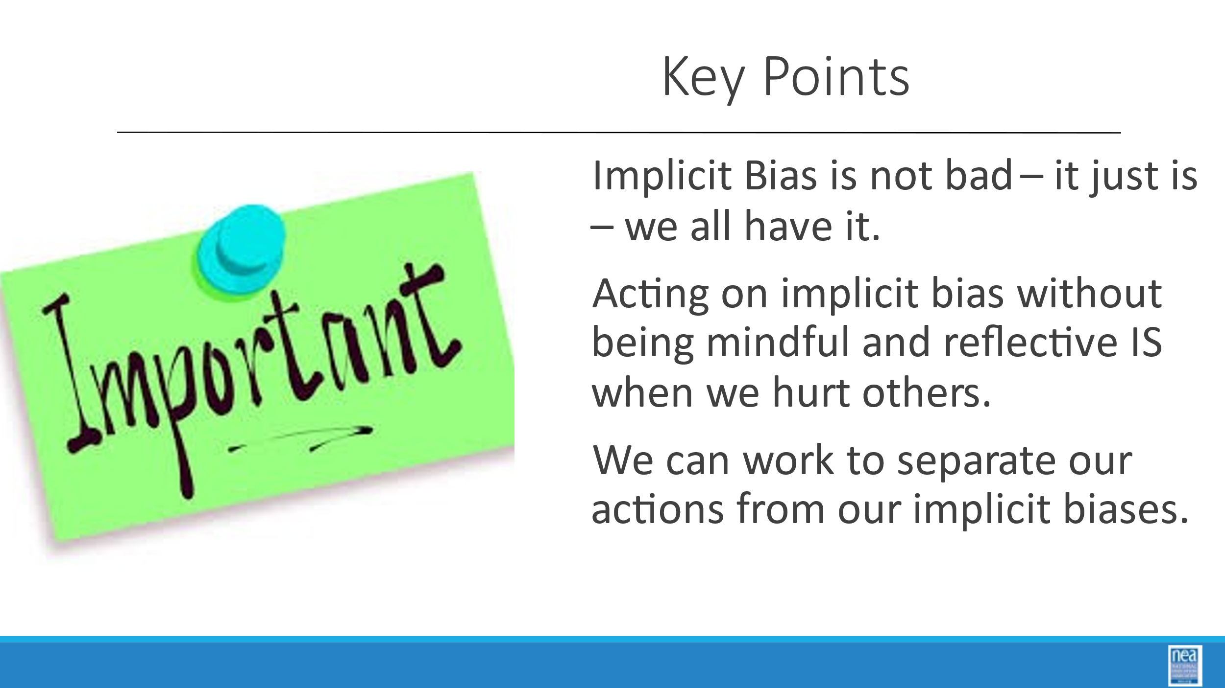 | What do I bring to the work?  TIE BACK TO CORE VLAUES |  | Leadership Style Survey Done in Advance  4 Charts Direct ,Systematic, Spirited, Considerate)  Small Post it notes – 20 per person  Harvard Implicit Bias Test to be completed prior to attending  Harvard Implicit Association Test Video  Facilitator Resource on Implicit Bias | 90 Mins Total for Section - (Split b/t C Style and Who Am I?)  What do I bring to the work?  30 Mins - BOLD OVER ALL TIMES  Leadership Style Survey  - Participants will have completed this PRIOR to attending and will have it ready for this experience.  - Tell Participants that everyone has recognizable, consistent communication styles.  - We are exploring these today because each style can have positive and negative aspects to it.  - We are going to work in style-alike groups to identify these.  10 Mins  - Go to the chart with the heading of your style as defined by this profile.  - With your colleagues, create a T-Chart  - Side 1 – What makes this work style a great asset as a UD?  - Side 2 - What sorts of challenges does this style create as a UD?  12 Mins  Report Out  - Each Corner will have 3 Minutes to Share an overview of their Assets and Challenges.  8 mins  Final Debrief  - Ask each group to point to the style that they find most challenging to work with.  - How do those differences impact our work?  Key concept to draw out – we are in a line of work that requires us to communicate effectively – 80% of that is in our ability to attend to others. Reflect especially on which of the other styles we find most challenging to work with.  Key Point  - Communication is a foundational skill for UniServ Directors  - How we communicate, how people perceive us and how we listen are all factors in being effective UniServ Directors  25 Mins - Who am I? P. 47  5 Mins –  Step 1  - Ask each person to get a nice pile of small post-it notes. About 20.  - For three full minutes you are going to write down identity characteristics about yourself – one per post-it.  - For example, my pile might include woman, mother, white, daughter, short, union supporter, quilter, survivor etc.  - This is a non-talking, no sharing, portion of the activity. Go…  5 Mins  Step 2  - Once each person has created their pile and the three minutes are up, ask them to spread them out in front of them and count how many there are. Have a number in your head.  - For the next 5 minutes share a bit of what you wrote with someone beside you – do you see any similarities, surprises or special characteristics?  2 Mins  Step 3  - Without talking, turn your attention to your own pile and remove ½ of the least important ones. No talking.  2 Mins  Step 4  - Turn to the person you first shared with and Share HOW THIS MADE YOU FEEL.  1 Min  Step 5  - Without talking, turn your attention to your own pile and remove ½ of the least important ones. No talking.  2 Mins  Step 6  - Turn to the person you first shared with and Share HOW THIS MADE YOU FEEL.  1 Min  Step 7  - Select the one most important identity characteristic  2 Mins  Step 8  - Turn to the person you first shared with and Share HOW THIS MADE YOU FEEL.  5 Mins  Debrief  - What did this make you feel like?  - How many of you included race as a part of your identifying characteristic?  - When we limited the number of your identities, for some of you it caused some emotions of loss and confusion, and this is what often happens when we limit people to singular identities.  So let’s look at what identity is –  The definition of identity is who you are, the way you think about yourself, the way you are viewed by the world and the characteristics that define you. An example of identity is a person's gender.  But – we just did an activity where we said that no one is just simply one identity – well that is called intersectionality.  Intersectionality is a framework first defined by Kimberle Crenshaw for understanding a person, group of people, or social problem as affected by a number of discriminations and disadvantages. Intersectionality takes into account people's overlapping identities and how those identities inform their relationship to power and oppression.  Key Point  - Individuals experience the world differently based on their overlapping identities  - We must recognize these identities as a way to step beyond our assumptions that our experience is common  - Each person has their own truth  20 Mins - How do I “see” the people I work with?  10 Mins Implicit Bias –  I need Four Volunteers who will play a game with me. I am going to show you three pictures and ask you three questions about each picture.  Show the first chair picture and ask  - What is this?  - How do you know?  - How do you feel about this chair?  Repeat for all chair pictures.  Identifying all of these as chairs is explicit. We actively access prior knowledge and assign a label. How we feel about the chairs and why is implicit – and why we feel that way may even be unknow to us. This is the starting point for understanding Implicit Bias.  Implicit bias refers to the attitudes or stereotypes that affect our understanding, actions, and decisions in an unconscious manner.  These biases can cause us to pre-judge something before we get to experience it.  The bad news about implicit bias –  - They often do not align with our declared beliefs “I am color blind”  - Implicit bias predicts behavior- who you sit with, who you vacation with  - Implicit biases are pervasive  Key Point  - Our biases are not readily visible to us, but they may be in our actions  - It is our responsibility to explore our own implicit biases  - Most of us more easily engage members who are like a familiar chair. Defaulting to what is familiar perpetuates the status quo and limits opportunity for engagement.  10 mins  How do we make sense of what we see?  - We are going to do a little assessment of your observation skills – these are very important as an organizer.  - When you watch this video, I want you to watch closely the people in white shirts and count the number of passes they make – there will be people in black shirts – but what matters is counting the number of passes that the team in white shirts make. Let’s watch –  - You were primed to look for a particular thing – white shirt team and the passes they make –  - This is not at all unlike how media, our upbringing, our schooling and other factors in our environment have primed our brains to think about race.  - We all have ideas and biases based on race.  - And sometimes, unaware, we can act in ways that create a poor outcome for someone else.  - The good news is our brains can be re-primed – as it was in the video – did you see the dancing bear?  The Good News about Implicit Bias  - Our brains are wired to notice patterns and make associations in an automatic way.  - Our automatic response to things like pictures of loved ones can be a good thing as it evokes good feelings such as love and a sense of safety.  - But this also means that our automatic response and associations can contribute to hurtful stereotypes that we act upon – such as  - Crossing the street when you meet a group of black boys wearing hoodies  - these overt actions and decision on stereotypes that are related to someone’s race, identity or affiliation and are symptoms of a system of racism.  The good news is that we can do something about this -  - Awareness is the first step to counteracting implicit bias  - Forming strong significant relationships with people who are different from us can rewire our decision-making pathways  - Being mindful as we make decisions – what am I basing this assumption and decision on?  - Our brains are malleable, just like society and we can intentionally unlearn implicit associations– gradually through various debiasing techniques.  Key Points  - Implicit Bias is not bad – it just is – we all have it  - Acting on implicit bias without being mindful and reflective IS when we hurt others  - We can work to delink our actions from our implicit biases  2 mins.  Harvard Implicit Association Test Video  Begin our conversation by watching a video. [Note for participants] There’s lots of research around this tool, there’s also some controversy. This tool is no way to be intended as a prescription, it’s intended to reflect. But it’s important to note, especially with this race test, because of the number of participants the validity and reliability of this test is quite high.  - What was your experience with the test?  - Why do you think we include this as part of the UniServ Academy?  - What surprises you?  2 Mins  Review Key Points  - Implicit Bias is not bad – it just is – we all have it  - Acting on implicit bias without being mindful and reflective IS when we hurt others  - We can work to delink our actions from our implicit biases |  | Participants identify 4 basic communication styles  Participants will identify their own communication styles in normal  circumstances and under stress  Participants will appreciate the communication styles of others  Participants will begin to reflect on their own identity and how this can shape their perceptions and understandings.  Participants will learn about implicit bias.  Participants will learn about the construct of race and how it has been used to limit power.
12:00 to 1:00   | LUNCH
1:00 -1:20  Linda    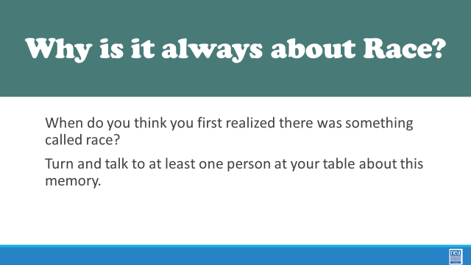  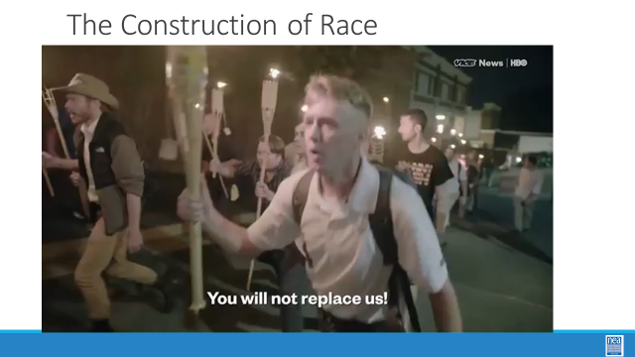  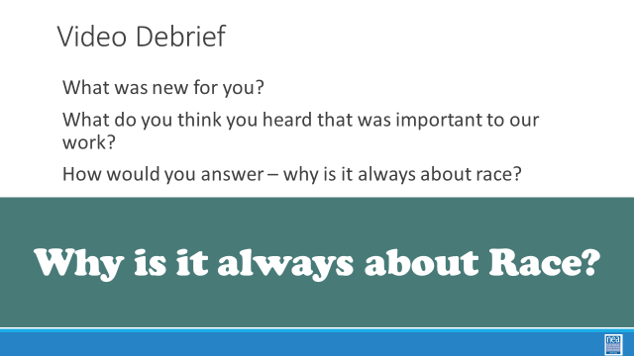  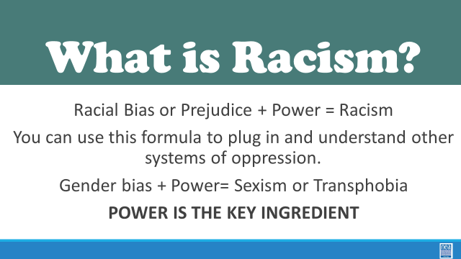  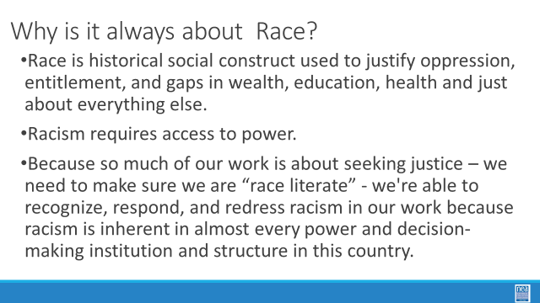  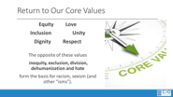  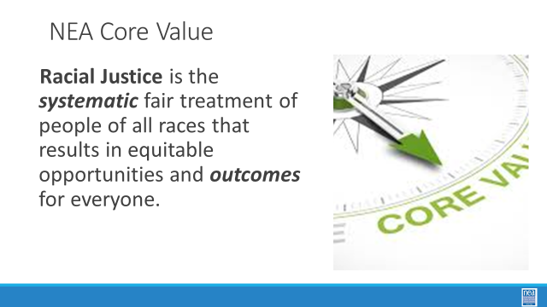 |  |  | Facilitator Resource What is Race  \ | 20 Mins – Why is it important to understand race and identity in our work?  1 Mins  Just before lunch we were beginning to get into implicit bias and suggested that we can begin to reprogram our thinking. By the time we are done with this next section you will be able to answer the question, Why is it always about race?  2 Minute Quick table talk – When do you think you first realized there was something called race?  5 Minutes Video – The Construct of Race  We are going to begin our next section by watching a video about what race is  5 Minutes Discussion – If they are a quieter group, have them talk at their tables first then ask for some whole group discussion.  What was new for you?  What did you hear that was important to our work?  How would you answer why is it always about race?  FACILITATOR COULD BRING OUT THE FOLLOWING POINTS IF NOT SAID  - Race is a social construct  - Race is not a biological difference between humans  - Race has a history of being used to justify oppression, entitlement, and gaps in wealth, education, health and just about everything else.  - Because so much of our work is about seeking justice – we need to make sure we are “race literate”  - We are able to recognize, respond, and redress racism in our work because racism is inherent in almost every power and decision-making institution and structure in this country.  2 Mins What is racism  Racial prejudice or bias, plus power, equals racism  You can use this formula to plug in and understand other systems of oppression. Such as, gender bias plus power equals sexism or transphobia. So, the power piece is really important.  3 Minutes So why is it always about race?  - Race is historical social construct used to justify oppression, entitlement, and gaps in wealth, education, health and just about everything else.  - Racism requires access to power.  - Because so much of our work is about seeking justice – we need to make sure we are “race literate” - we're able to recognize, respond, and redress racism in our work because racism is inherent in almost every power and decision-making institution and structure in this country.  2 Minutes Review Core Values  - As we look at the core values that you identified this morning during our check-in almost each of those is also a way to act to ensure justice in our world.  - These values are aspirational and operational.  - There were a number of equity, inclusion, unity, love and dignity type values there  - These are the core values of a group that wants justice – which means that we are ultimately about shifting power.  - NEA’s Core Value regarding Racial Justice says Racial Justice is the systematic fair treatment of people of all races that results in equitable opportunities and outcomes for everyone.
1:20 – 2:00  Hedy  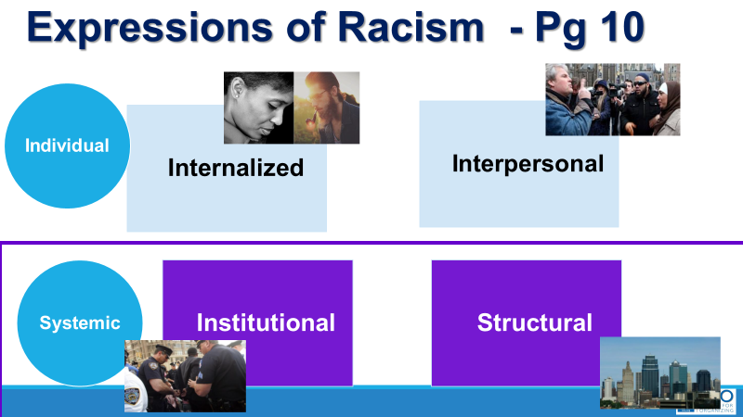  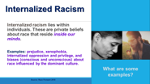  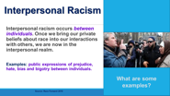  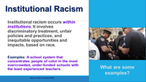  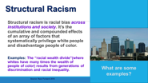  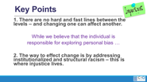  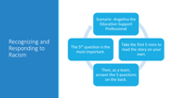  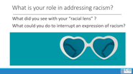  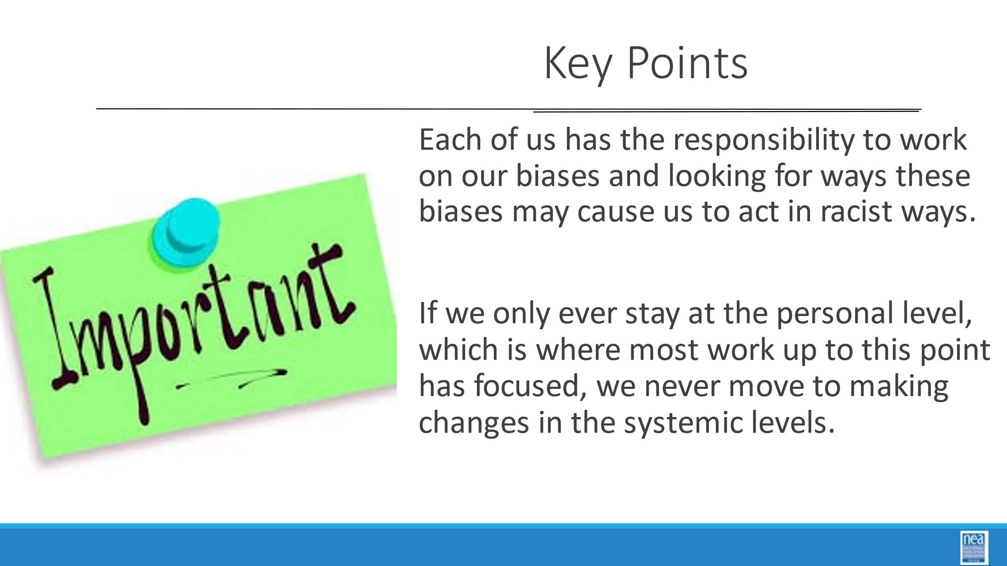 | What are the Expressions of racism? |  | Everyday Racism in Union Work Handout  Levels of Racism Facilitator Resource | 40 Mins Everyday Racism Scenario in UniServ Work  10 Mins  Introduce the 4 Expressions of racism (this is an introduction of the terms only – not a deep dive, ask for and share examples for each): (p.21)  Internalized—The set of private beliefs, prejudices, and ideas that individuals have about the superiority of whites and the inferiority of people of color. Among people of color, it manifests as internalized oppression. Among whites, it manifests as internalized racial superiority.  Interpersonal—The expression of racism between individuals. It occurs when individuals interact and their private beliefs affect their interactions.  Institutional—Discriminatory treatment, unfair policies and practices, inequitable opportunities and impacts within organizations and institutions, based on race, that routinely produce racially inequitable outcomes for people of color and advantages for white people. Individuals within institutions take on the power of the institution when they reinforce racial inequities.  Structural—A system in which public policies, institutional practices, cultural representations, and other norms work in various, often reinforcing ways to perpetuate racial group inequality. It is racial bias among institutions and across society. It involves the cumulative and compounding effects of an array of societal factors including the history, culture, ideology and interactions of institutions and policies that systematically privilege white people and disadvantage people of color.  Understanding that racism operates on multiple levels is what help us move our work toward taking a systems-thinking approach to addressing its impact.  Key point –  - Each of us has the responsibility to work on our biases and looking for ways these biases may cause us to act in racist ways.  - If we only ever stay at the personal level – which is where most work up to this point has focused, we never move to making changes in the systemic levels.  Resources Slide  20 Mins  Everyday Racism in Union Work – (p. 23-24)  - You will work at your table with a story about Angel the Education Support Professional.  - Angel is the first of many employees you are going to meet this week from Enchanted School District.  - Take the first 5 mins to read the story on your own.  - Then, working with your table mates, answer the 5 questions on the back.  - The 5th question is the most important, and likely the one you’ll struggle with most. Lean in to it.  - Might use Handout Resources on p. 21-22 in addition to the scenario & questions  10 Mins  Debrief  As you take responses from various groups, keep coming back to our key idea  - Racism operates on multiple levels and this drives us toward taking a systems thinking approach to addressing its impact.  - What are the “isms” you might see – such race, age, gender, job class, etc.  Key Ideas –  - There are no hard-dividing lines between the levels of racism.  - To advance racial justice, we must focus our work on the systemic levels of racism
2:00-2:15   | BREAK
2:15 – 4:15  Matt  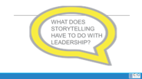  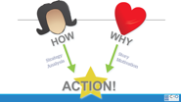  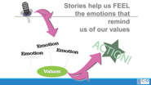  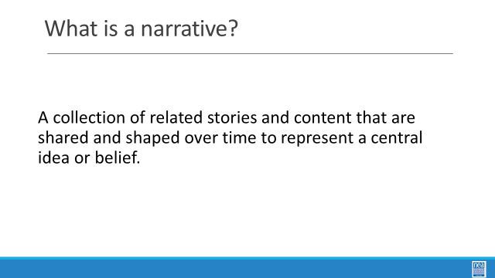  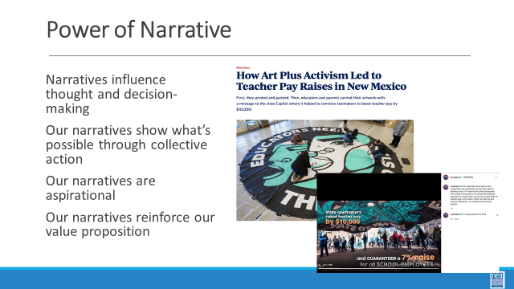  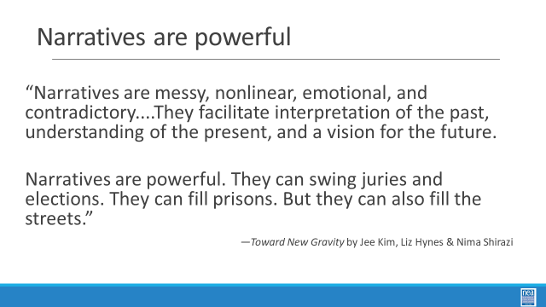  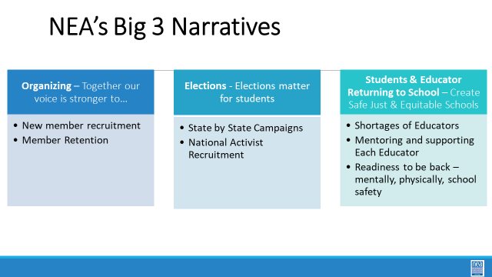  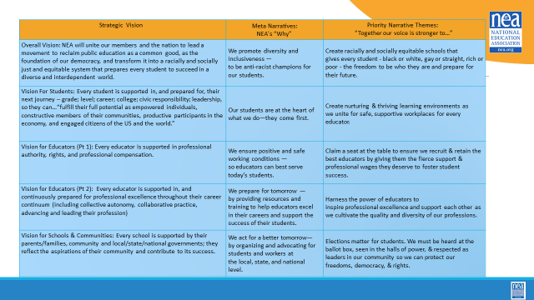  Grat  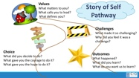  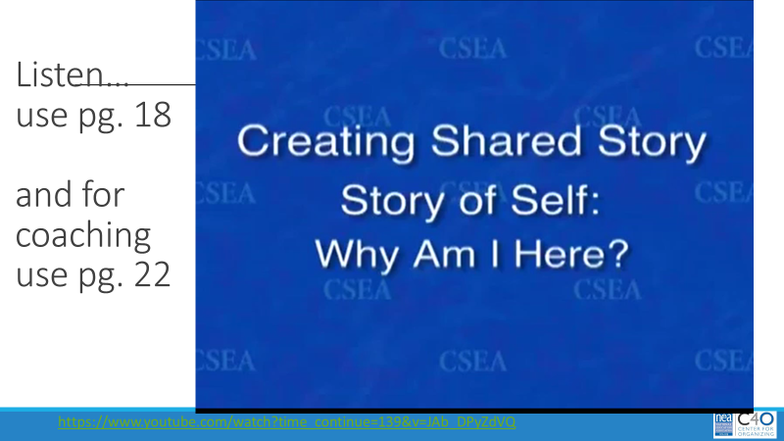  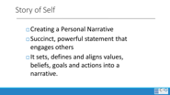 | What do stories have to do with organizing?  What is your leadership story? |  | Public Narrative Handouts  Marshall Ganz video – leadership story of self with coaching  This Chart was used by facilitators  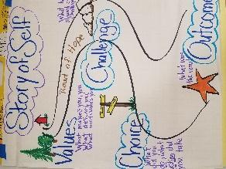  Other resources:  Bill Moyers “how to” and lots of video examples | 105 Mins Storytelling in Organizing – Focus on Story of Self  20 Minute Intro  Content and set up: (pgs.25-38)  Why do we use storytelling as organizers?  Organizers often encounter individuals or groups where mindful action is inhibited by inertia, fear, self-doubt, isolation, and apathy. The job of a leader is not to tell people to stop feeling this way but rather use storytelling to move people from feelings of stagnation to feelings of motivation - urgency, hope, YCMAD (you can make a difference), solidarity, and anger. The language of emotion is the language of movement—they actually share the same root word. Stories mobilize emotions of action to overcome emotions that inhibit us from mindful action.  Organizers use stories to teach values, morals, and lessons, and to connect with each other. In organizing, well-constructed stories also help to engage others in our work. They inspire others to join us. They motivate others to ACT with us to create positive change and move us toward the world that should be. By telling a “story of self” you can communicate the values that move you to lead. Public leaders face the challenge of enabling others to “get” the values that move them to lead. [Key info: As a leader you need to cultivate a compelling “why” for asking people to join you.]  Effective communication of motivating values can establish grounds for trust, empathy, and understanding. In its absence, people will infer our motivations, often in ways that can be very counterproductive. Telling our story of self can help establish firm ground for leadership, collaboration and discovering common purpose. Every one of us has a compelling story of self to tell. We all have people in our lives (parents, grandparents, teachers, friends, colleagues) or characters we love, whose stories influence our own values. And we all have made choices in response to our own challenges that shape our life’s path— confrontations with pain, moments of hope, calls to action.  Narratives are a collection of related stories and events. Narratives are adaptable to respond to events. New characters can be added over time. They are overarching themes (e.g. “We must support educators who are demoralized, leaving the profession, and need solutions.”) that encompass our core beliefs. Narratives influence thought and decision-making. Our narratives show what’s possible through collective action. Our narratives are aspirational. Our narratives reinforce our value proposition.  NEA’s Three big narratives for 2022-23 are Organizing, Elections Matter, Students and Educators Returning to School (p. 37).  These narratives are linked to NEA’s Strategic Vision and Value Statements – Our Why.  We are going to be working on Personal Narrative – the foundation for any group that is working to create a public narrative. IN the Personal Narrative, the key focus is on our choices, those moments in our lives when our values moved us to act in the face of challenge. When did you first care about being heard? When did you feel you had to act? Why did you feel you could act? What were the circumstances, the place, the colors, sounds? What did it look like? The power in your story of self is to reveal something of those moments that were deeply meaningful to you in shaping your life—not your deepest private secrets, but the events that shaped your public life. Learning to tell a good story of self demands the courage of introspection, and of sharing some of what you find.  Review the Anatomy of your organizer’s story --  Character - (that’s you), moral – (where do we connect with you, what did you learn), plot – (you had a challenge, you made a choice and there was a hopeful outcome). Keep in mind, everyone has a story to tell. Your challenge is to use your story to connect with those you are trying to organize - move them to action, join you in the cause, or inspire them to have hope in their own ability to make change.  A key guideline – your story is brief – no more than 3 minutes.  This is not a speech. We all have multiple stories to tell. Knowing when to share our or not to share our public stories becomes crucial.  7 Mins –  Marshall Ganz video – leadership story of self with coaching as a group (only the first 5 mins) to demonstrate how this works. (p 30 and pg 34 for coaching tips)  Quick Debrief  - Whose story does the women tell the first time?  - Whose story does she tell after the coaching?  - What are the kinds of coaching questions that she is asked?  - Notice the length?  - What else do you notice about the coaching that Marshall Provided?  75 Mins – Story of Self  5 Min -Now that we have seen a model of a story of self and some good coaching we are going to write and share a story of self.  Review page 31-32  10 Mins - Writing a Story of Self - You will draft your story of self. Keep in mind the structure and purpose – your audience will be us. You will be expected to share your story in a small group and receive some coaching.  40 Mins  Sharing and coaching (p. 34 for coaching and p. 35 tracking stories__)  In groups of three, you will each share your story – no more than 3 minutes, and then will receive up to 6 minutes of coaching and critical feedback. For each round, one person will be the STORYTELLER, one the COACH and one the OBSERVER. Just as when we watched the video, we had the STORYTELLER, Marshall the Coach, and then we discussed what he did well in the coaching. To help support you in your coaching refer to the coaching questions found in your handouts on PAGE 35. We are also looking for up to 5 people who are good, willing models to share their story with the whole group. So at the end of your group’s sharing time, please incorporate the feedback that your colleagues provided you. Let’s review, take 3 to 5 minutes to locate and review the coaching questions, Then Each person shares a three-minute story, in which they receive 3 mins of coaching and then the coach receives up to 3 minutes of feedback on their coaching. and receives up to 6 minutes of feedback. Once your group has finished, then make adjustments to your story based on the feedback.  20 Mins  Large Group Sharing – (pg. 35 for tracking stories)  Up to 5 People will share their stories to the whole group. As you listen, please use the listening guide found in the handouts.  I will be giving the following signals to the speaker – 2 fingers, 2 mins left, 1 finger is the 1-minute warning, circular wave means to wrap it up your time is up.  (Facilitator note - As you look for people to share a story of self – be mindful of differences in age, race, gender etc. – pay attention for examples of power and privilege and “overcoming” and the organizing that happened to gain justice- to make connections on day 2 to power-privilege- oppression  Debrief  - What are the common values that you hear in the stories?  - What coaching would you provide?  Key Points  - Our story is how we present a “relatable” self that allows someone else to want to join in a public relationship with you.  - It is how you and the people who have a shared purpose and shared values communicate about the work you want to do and encourage others to join with you.  - This takes practice  - COACHING is a required skill to be successful. Coaching is not giving advice; it is asking good guiding questions.  - COACHING AND LISTENTING TAKE PRACTICE |  | Participants will understand the importance and power of storytelling in organizing.  Participants will share their individual stories of leadership to connect with their colleagues.  Participants will understand how to coach each other and provide critical feedback on their stories of self.
4:15-4:30    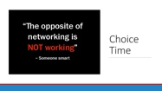 |  |  |  | Describe DAY 2  15 Mins  Questions, Wrap-up and logistics  10 Mins  Reflection of Learning - How would this apply to your work? –  Access and complete Evaluation on email
4:30 – 5:00   |  |  | Choice Networking Suggestion Board | Adult choice networking and learning – any location, any topic
5:00 | ADJOURN

