NEA Foundations Academy Facilitator Agenda: Day #2
General Materials Needed: |  |  |  |  | Room Set-up:
1 Set of Handouts per Person  Name Tags  Table Tents  Sign-in Sheet  Agendas on the table (1 per)  Room signs |  |  | Chart Paper – Large Post-it Style  Post its – Regular size and large size (4’’x5”)  Index Cards – 3”x5”  Highlighters – 5 Colors – Pink, Orange, Yellow, green and blue  Chart Markers – non-permanent chisel tip  Pens and Pencils |  | Round Tables  Projector, Screen and Speakers  Carousel stations and reporting stations around the perimeter  40 people MAX  Material Boxes with Participant “toys” on each table  CHARTS NEEDED:  - Power Shield- actually make one  - Identity Stations  - Race  - gender/presentation  - Age  - Class  - Sexual Orientation  - Nation or language of origins  - Work category  - Ethnic group  - Religion  - Physical/ mental ability  - Role of UD:  - Social Justice Advocate  - Contract Manager  - Problem Solver  - Campaign/Organizer Director  - Racial equity & Institutional choice  - Planning  - Partnership Work  - Budgeting  - Personnel  - Governance  - Policy Dev  - Practices  - Magnetic Ideas  - Raising Expectations  - Terrified of the Public  - Institutional Pessimism  - Insurgency in the labor movement  - Power is the ability to disrupt  - Politics within our Organizations
Key Outcomes for the Day
Participants will explore power and oppression
Participants will understand types of organizing and explore kinds of unions
Time | Essential Questions | Resources |  | Instructions, Activity and Debrief (Facilitators) |  | Outcomes
8:30 a.m. | What question(s) should this learning section answer? | Charts, handouts, articles, materials, slide |  | What are you saying, what are they doing, what questions will you use to guide learning and make clear the important points  Include an estimate for how long each section of the learning will take |  | As a result of this section of learning, what will participants know or be able to do?
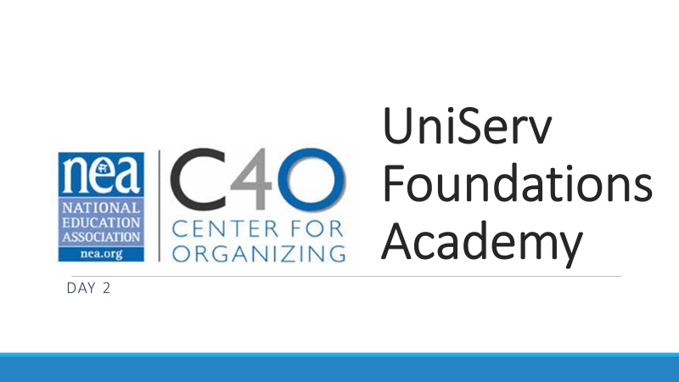  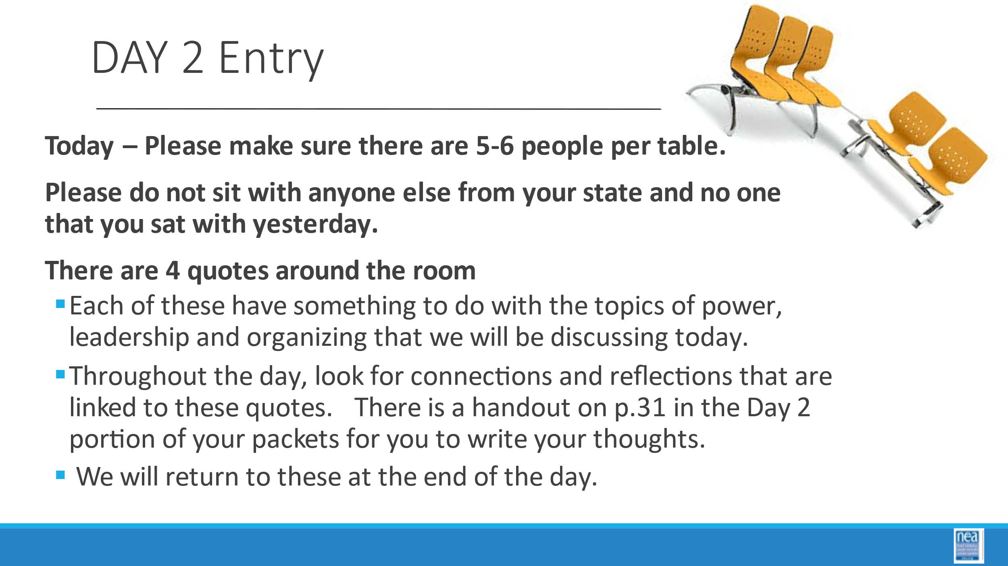 | DELETE 4 POSTERS | 4 Quote Posters |  | Entry Activity Pg. 40 – There are 4 quotes around the room on posters and they are in the participants handouts. Each of these have something to do with the topics of power, leadership and organizing that we will be discussing today. Throughout the day, look for connections and reflections that are linked to these quotes. We will return to these at the end of the day.  Power can be taken, but not given. The process of the taking is empowerment in itself. Gloria Steinem  I believe to be a leader is to enable others to embrace a vision, initiative or assignment in a way that they feel a sense of purpose, ownership, personal engagement, and common cause. Melanne Verveer  Organizing is first of all an attitude. It’s the attitude that you and others together can DO SOMETHING to make things better. It’s the attitude that action is better than complaining. It’s the attitude that problems are just waiting for a solution, and that strength in numbers is part of that solution. It’s the refusal to be discouraged – at least not for long. It’s the willingness to listen to others with respect, so that the plan you come up with reflects the good ideas of many people. – Labor Notes, Secrets of a Successful Organizer  This is the basic difference between the leader and the organizer. The leader goes on to build power to fulfill his desires, to hold and wield the power for purposes both social and personal. He wants power himself. The organizer finds his goal in creation of power for others to use. – Saul Alinsky
8:35 – 9:10  Ellen  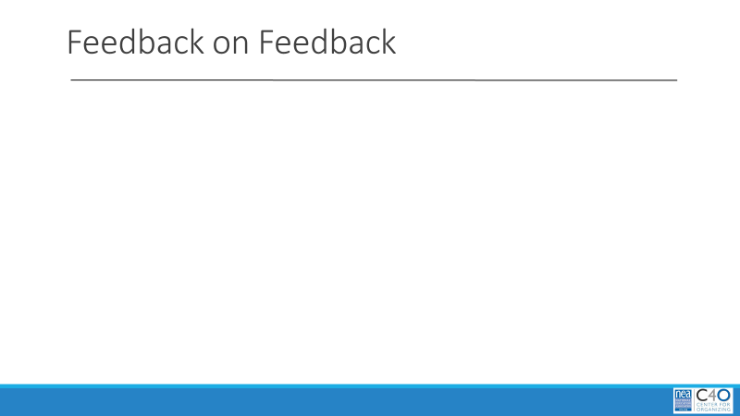  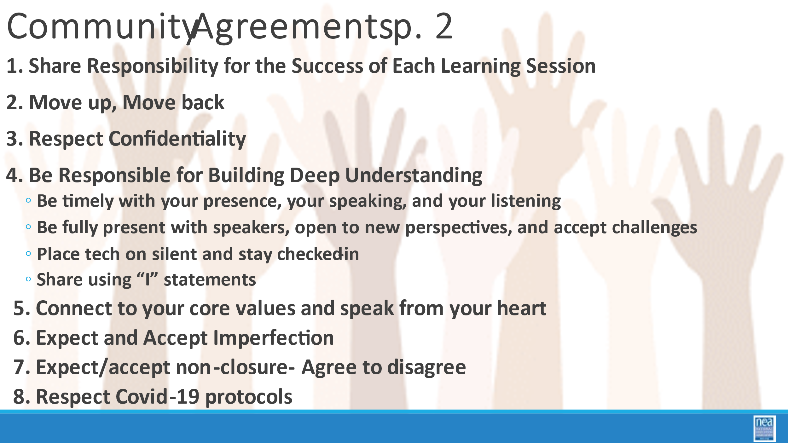  Jeny | What have you learned so far? | - 1 Chart paper per Table  - Markers |  | 10 Mins Welcomes and Reviews  5 Mins – Welcome participants back into the space, review the norms, the spirals and today’s agenda.  5 mins- Review feedback on feedback from the previous day’s evaluations.  25 Mins - Graphic Summary  15 Mins  - Ask participants to reflect on yesterday’s learning.  - Each table will have 15 minutes to create a poster that summarizes the key points learned the previous day.  - There are 3 rules: 1) only one sheet of chart paper can be used, 2) Only pictures can be used, no words, letters or numbers, 3) must be a joint effort, all table members should contribute  8 Minutes  Quick report out  2 Minutes  Facilitators to connect to today’s learning  Key Points  - Connecting the learning and experiences in the room |  | This opening activity will allow for participants to reflect on the previous days learning and give the trainers the opportunity to tie the previous days learning to what will be covered today.
9:10 – 9:55  Hedy  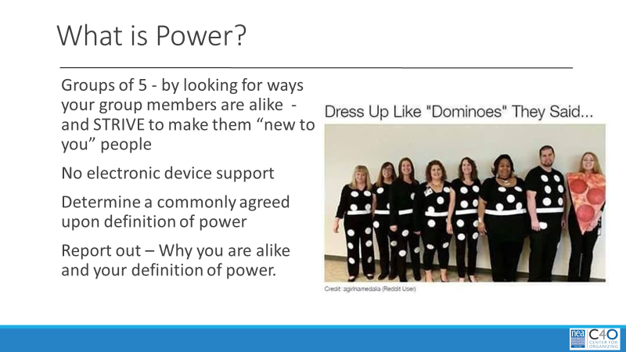  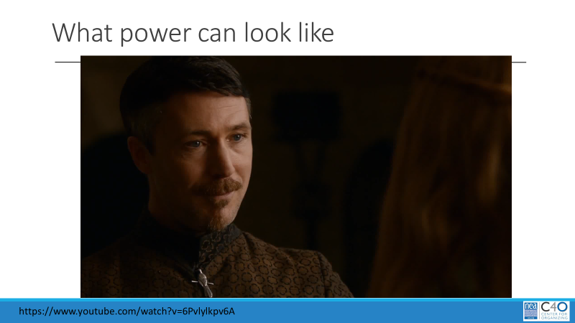  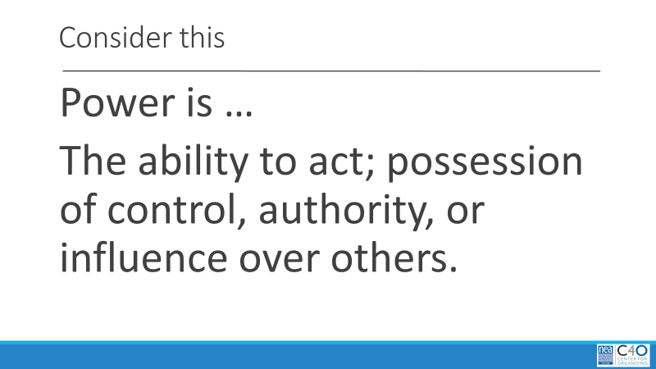  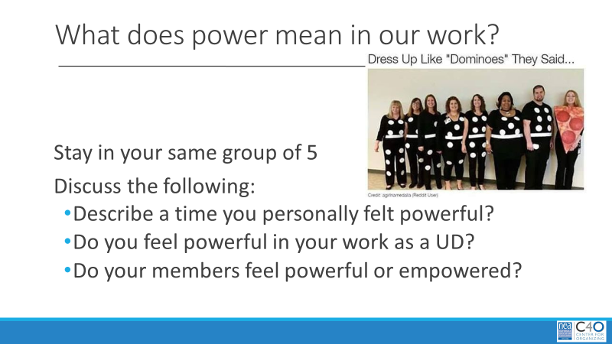  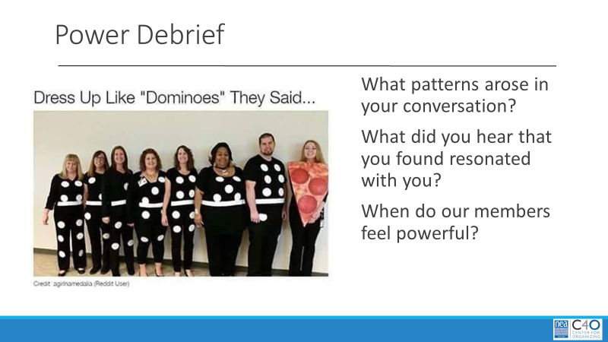  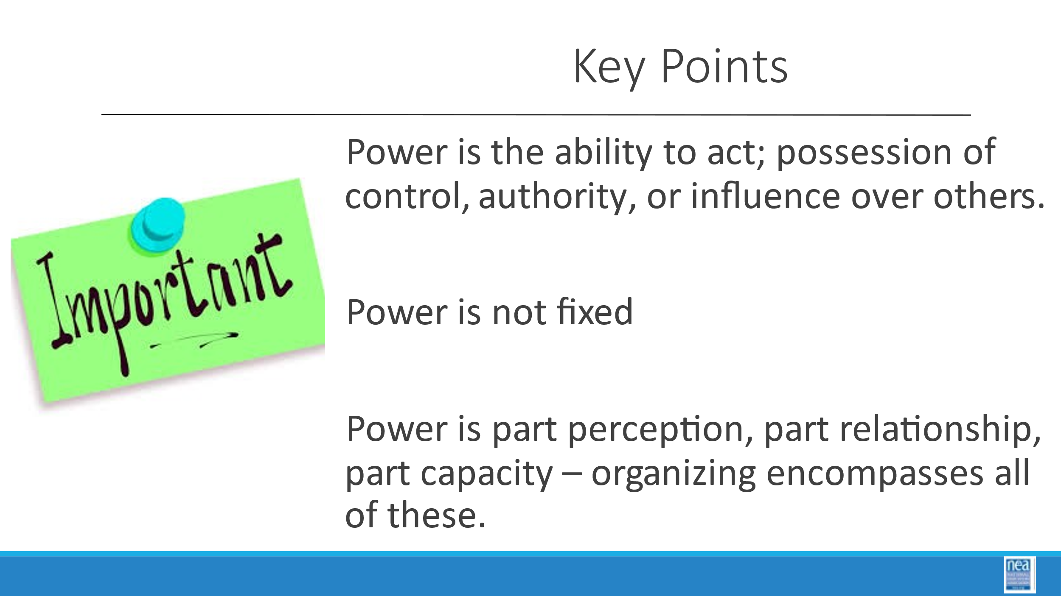 | What is power? | Table discussion  Reading  Power  Looking at Power  Chart of  Power Definition that is on the Slide  The ability to act; possession of control, authority, or influence over others. |  | 45 Mins Power and Oppression in Our Work  15 Minutes Total  Power Definition- Similarity grouping- define a definition of power  10 Minutes –  - We are going to do a little moving.  - Let’s create some new grouping’s  - Get into groups of five by looking for ways that you are alike – [don’t share; just for presenter knowledge]  - example, we are all wearing plaid, or we all have black shoes) –  - BUT – you need to be in a strive to make them “new to you”.  - Once you are assembled, introduce yourself and where you are from.  - Then without using your devices and looking on Wikipedia – come up with a commonly agreed upon definition of power.  5 mins-  Share out your pattern for why you are team AND your definition of power. As these are shared, chart them.  3 Minute Total:  Let’s see what this clip has to tell us about power  Knowledge is power - Cersei Lannister vs Littlefinger scene (Game Of Thrones)  In this – Littlefinger proposes that knowledge is power – as do a good number of members – but what Cersei actually shows him is that power is the ability to act, or possession of control, authority, or influence over others. Cersei gets this through position and uses fear to maintain it. Money can also help with this.  Show the slide as you transition to the next activity -  Power: The ability to act; possession of control, authority, or influence over others.  30 Mins Total What does that mean in our work?  20 Minutes  In your “ways we are alike” groups of five have the following discussion:  1) Begin by each sharing a time when you personally felt powerful, powerless and/or empowered.  2) Do you feel powerful in your work as a UD?  3) Do your members feel powerful or empowered?  10 Mins – Whole group debrief. What patterns arose in your conversation? What did you hear that you found resonated with you? When do our members feel powerful?  p.41-45 resources  Key points:  - Power is the ability to act; possession of control, authority or influence over others  - Power is not fixed  - Power is part perception, part relationship, part capacity...organizing encompasses all of these. |  | Participants will gain a deeper understanding on how we (as UD's) and our members experience power.
9:55-10:15  Halimah  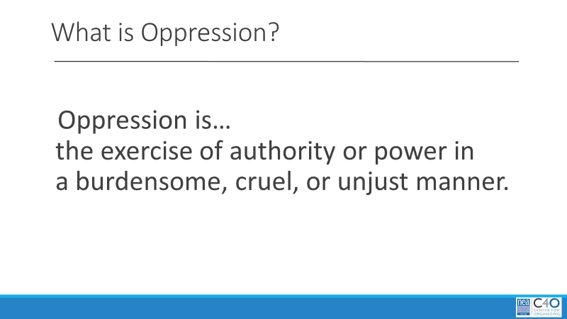  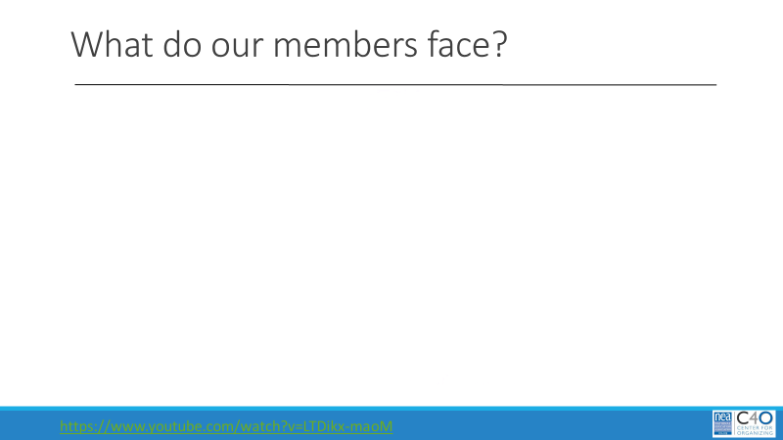    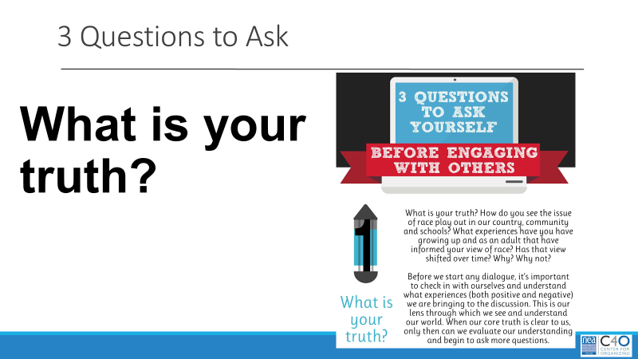  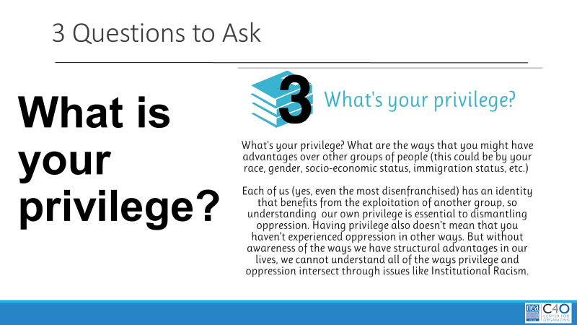  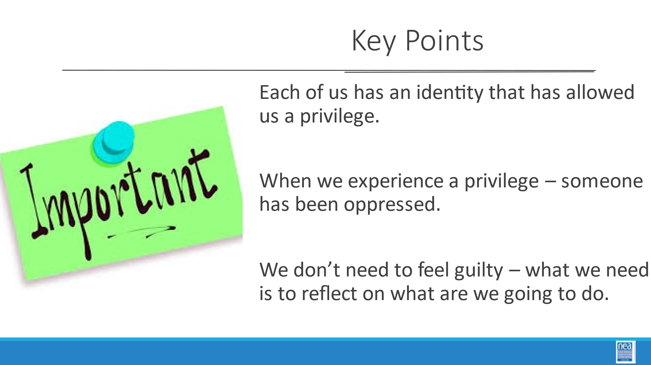 | ADD 10 MINS | 3 Questions to Ask |  | 20 Mins So what is Oppression and Privilege? – they are part of the equation of power  2 mins -show the slide “Oppression: the exercise of authority or power in a burdensome, cruel, or unjust manner.”  15 Mins - As you watch the following video, consider the types of oppression that our members may face on a daily basis.  Power, Privilege and Oppression (6 minutes)  Facilitator Note –  - Make an explicit connection back to bias –  - Bias exists therefore some people will be lifted by systems and others will be limited –  - Make connections by asking people to think about stories we heard yesterday –  - can you think of examples of power? – privilege? and oppression?  3 Mins As union staff, it is important to consider the power dynamics that are present within and around the people we are working with that. You cannot fully understand those without also looking at oppression and privilege.  We would like you to keep in mind the following 3 Questions found on this handout (p.46)  1. What is your truth?  2. What do you value?  3. What is your privilege?  - Everyone experiences privilege, everyone experiences oppression.  - That is not to say that they are all to the same extreme.  - We have explored the first two a bit and are now moving into the third question.  Key Points  - Each of us has an identity that has allowed us a privilege  - When we experience a privilege – someone has been oppressed  - We don’t need to feel guilty – what we need to reflect on is what are we going to do |  | Participants will develop an understanding of power by also learning about oppression and privilege.
10:15-10:30  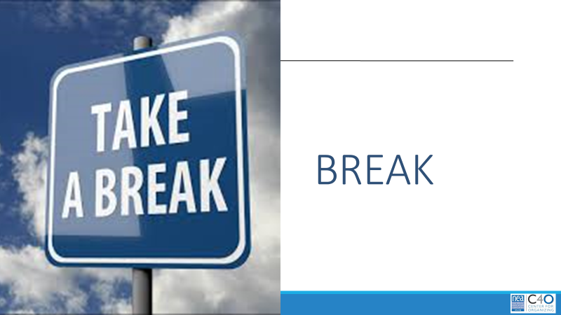 | Break
10:30 -11:00  Barb  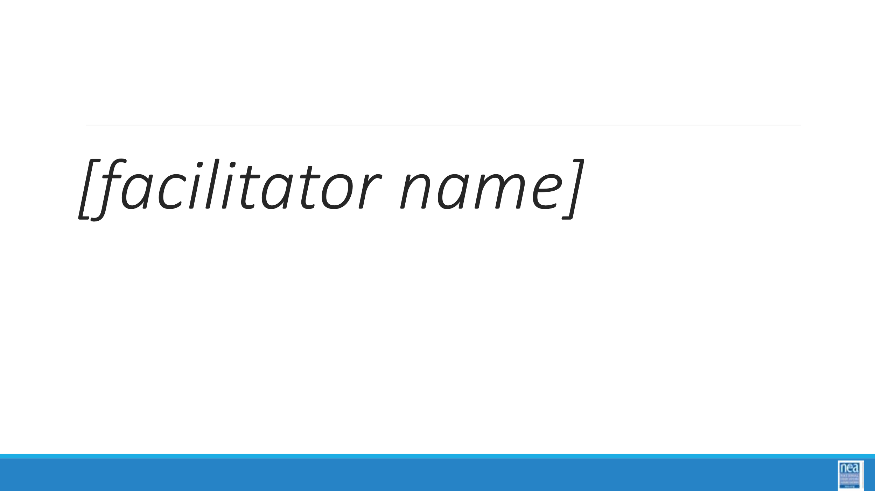  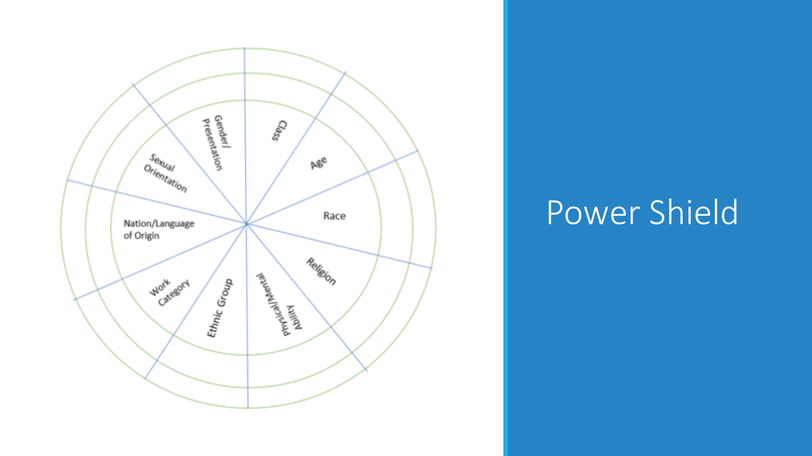  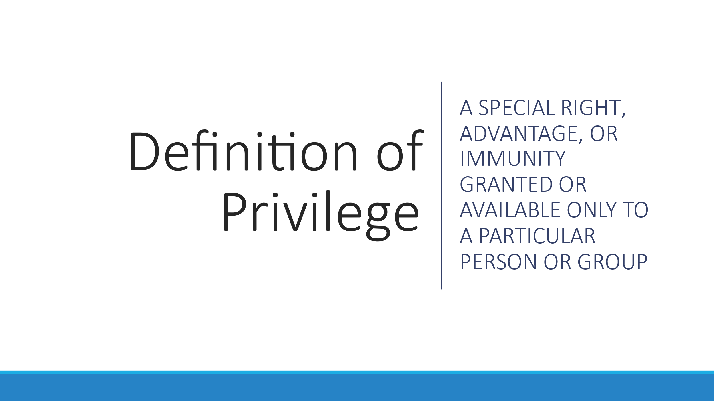    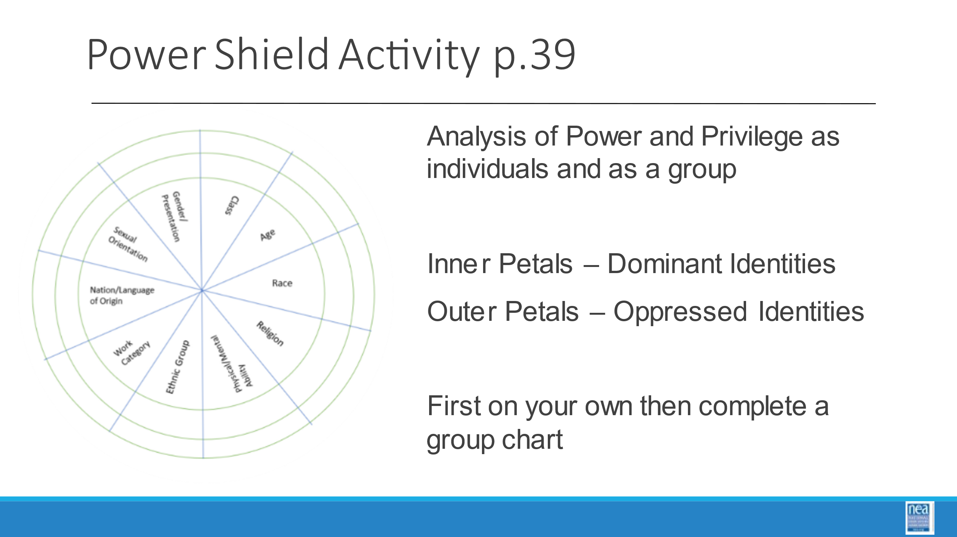  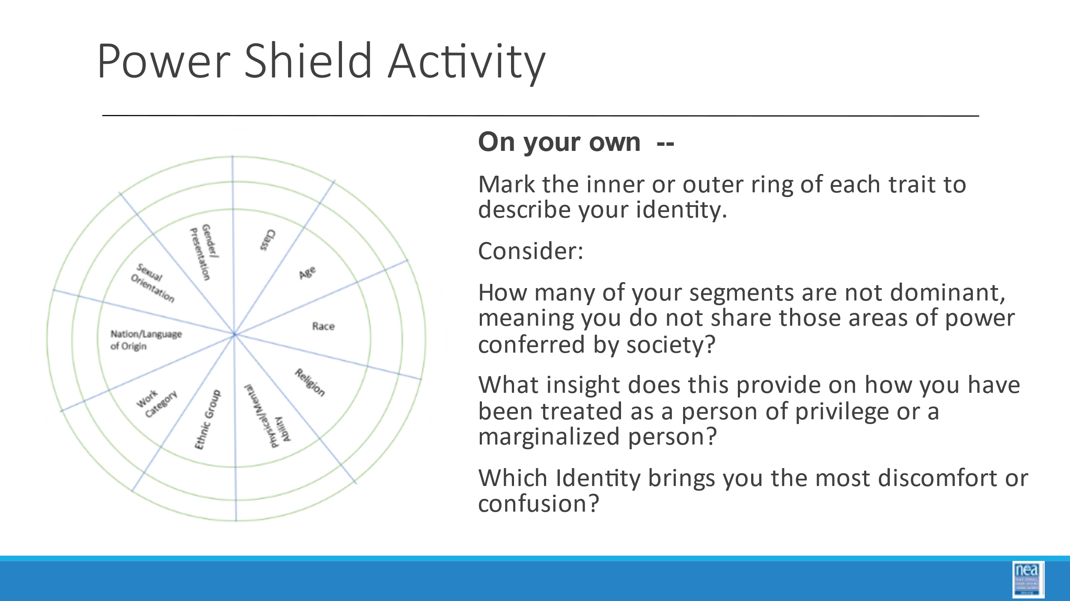  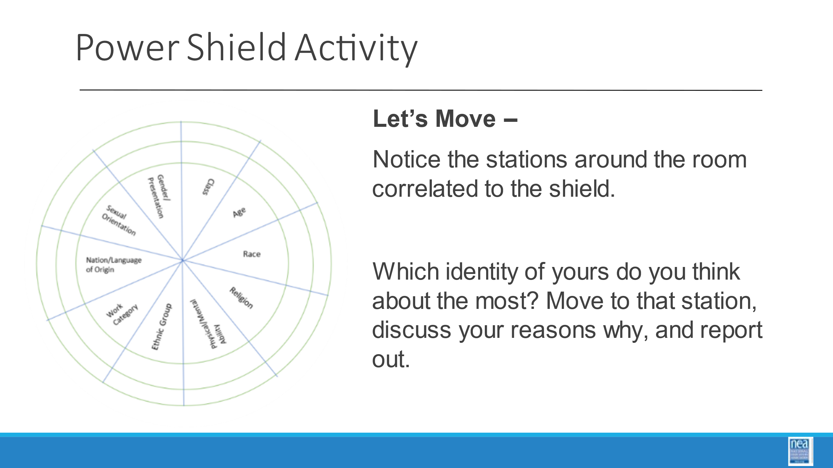  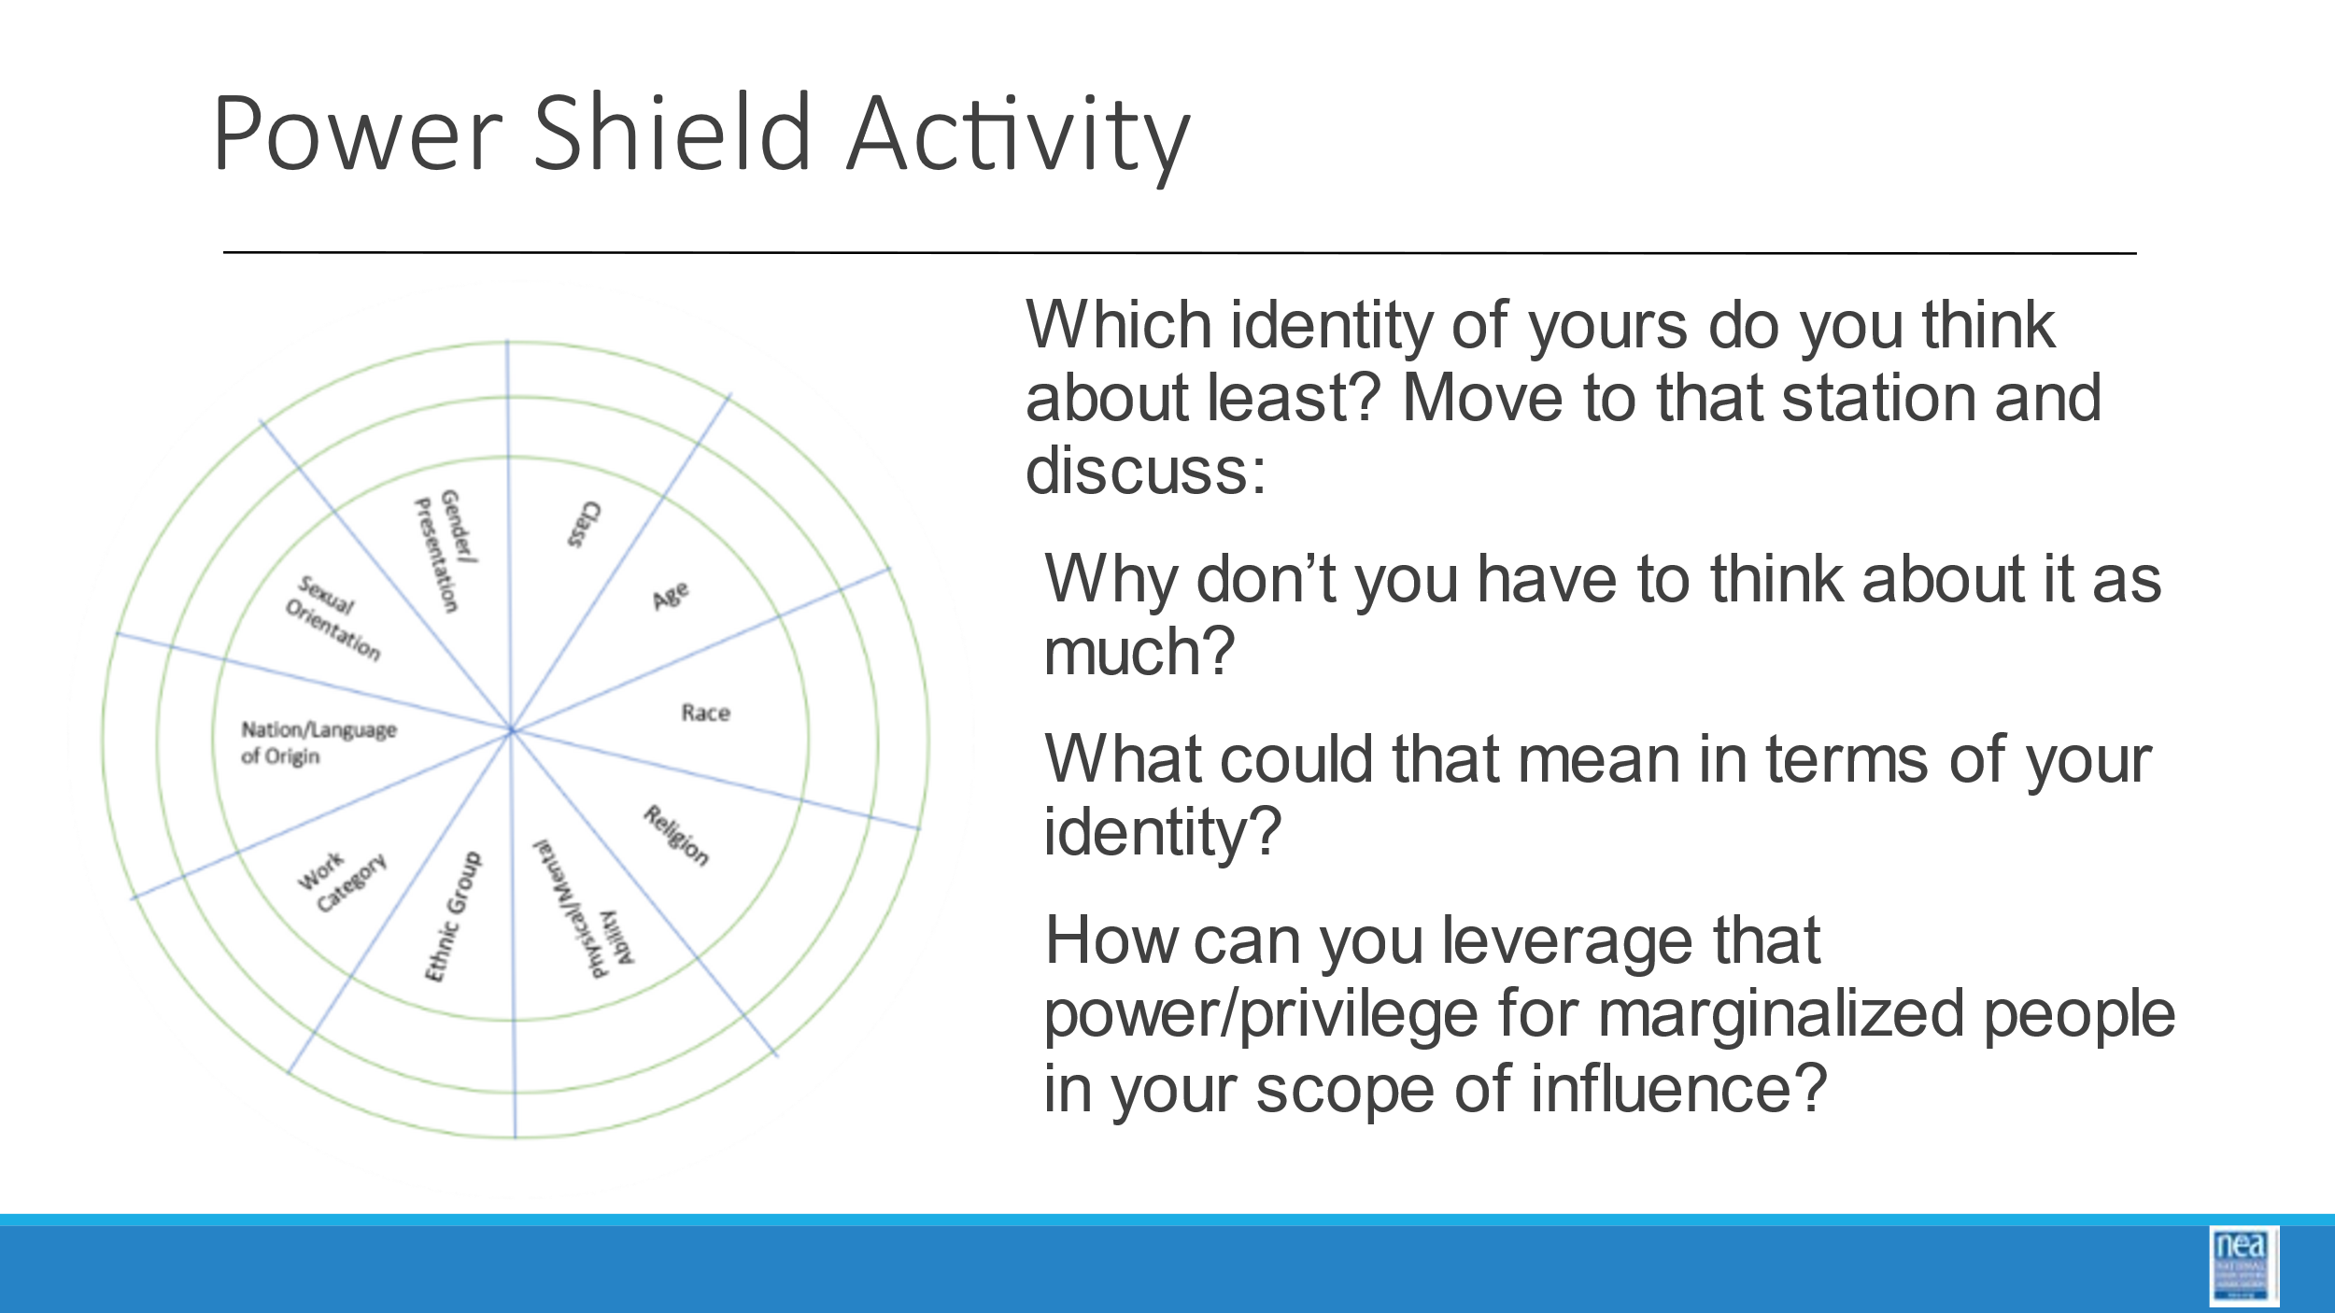  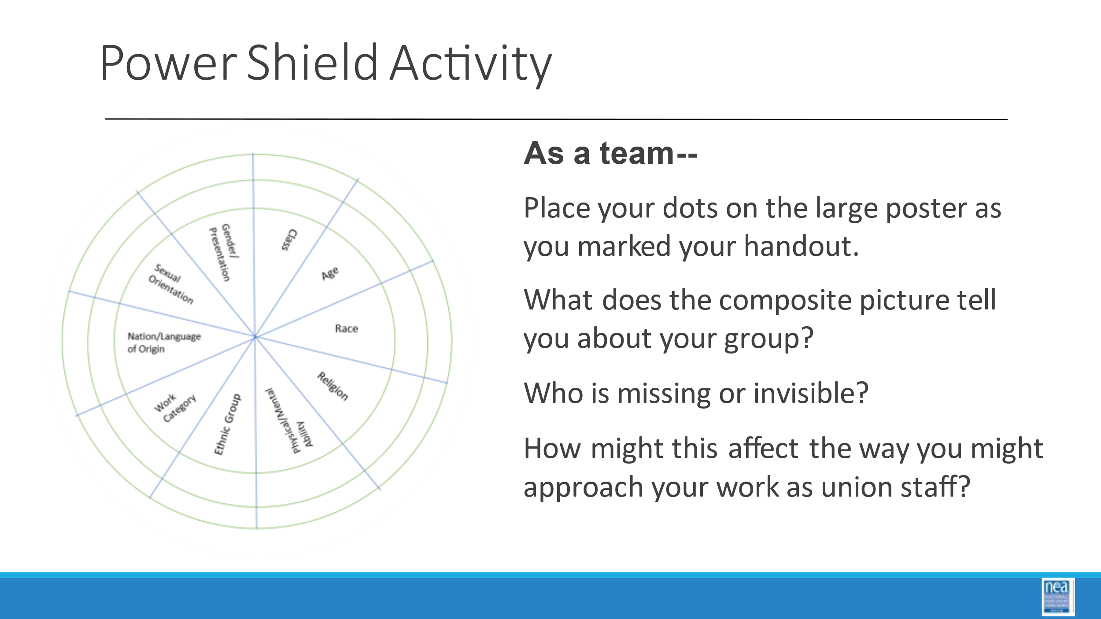  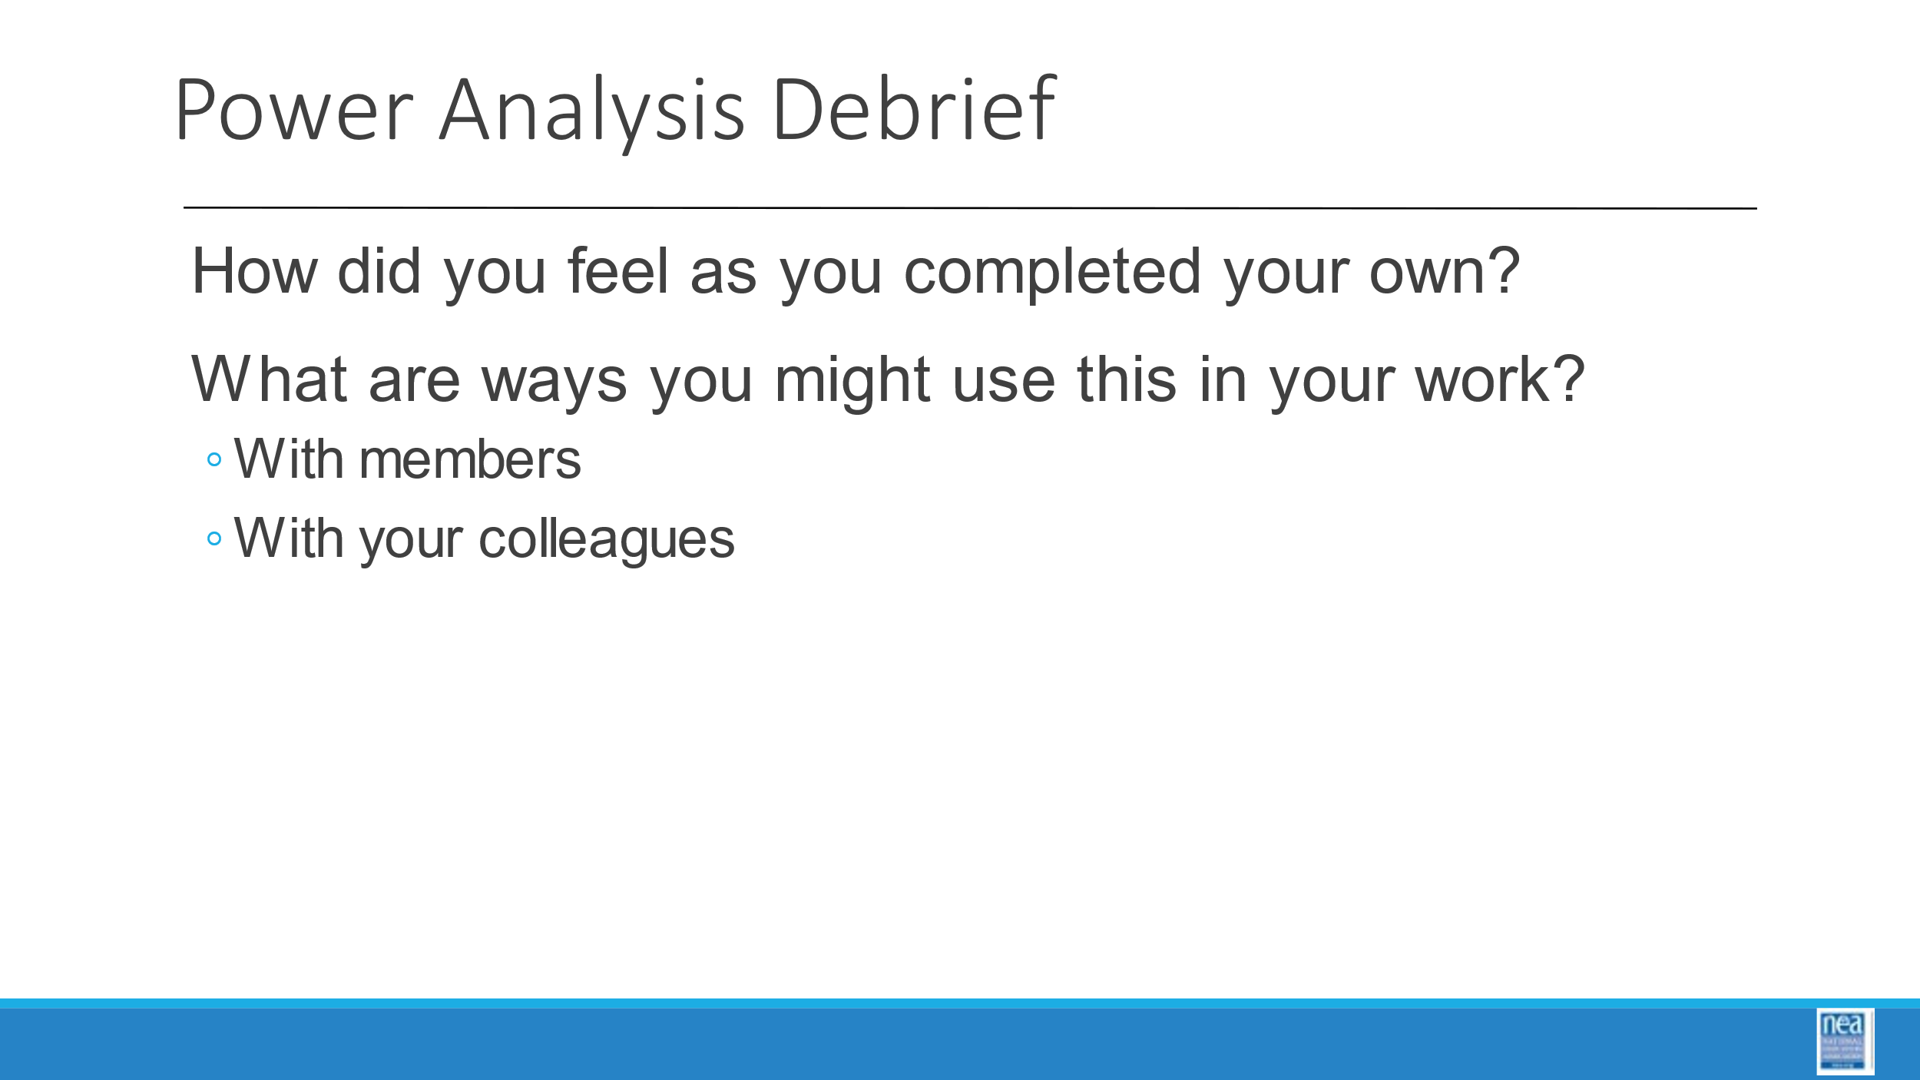  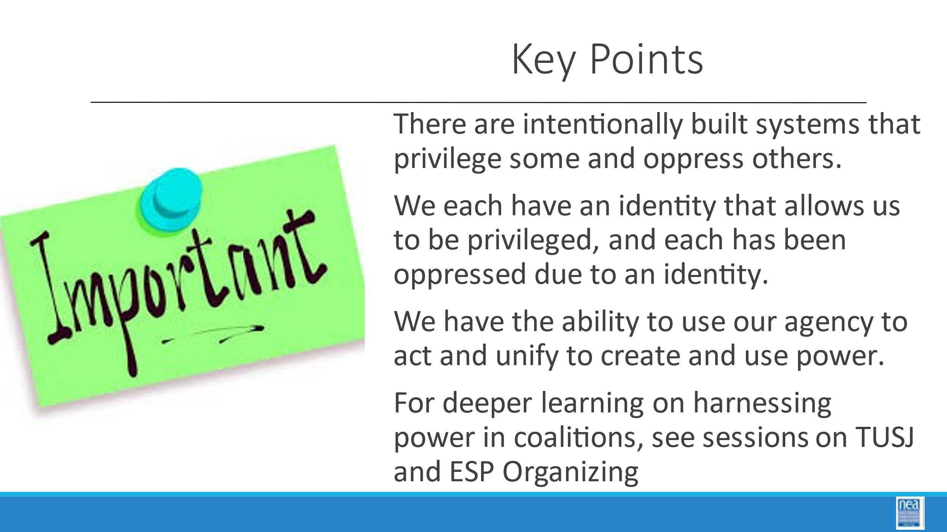 | FIX TIMES THIS TAKES ABOUT AN HOUR WTH DISCUSSION  ARE WE DOING THE DOT CHART AFTER LUNCH? | Stations posted around room include:  - Race  - Gender/Presentation  - Age  - Class  - Sexual Orientation  - Nation or Language of Origin  - Work Category  - Ethnic group  - Religion  - Physical/Mental ability  Power Shield Handout  Possible Reading on Building Power  (note for facilitators when using this article- This reading is good to intro BCG, an explicit link to expanding the petals of the flower ought to be emphasized. This article is not a DIRECT link with the activity, however, so it would have to be threaded.) |  | 30 Min Power Shield –How can you do an analysis of an individual or group’s power dynamic?  2 Mins – We are going to take a minute to look intentionally at our identities.  Facilitator define the term -Privilege: A special right, advantage, or immunity granted or available only to a particular person or group.  - Introduce activity by saying (p.47) –  - This activity is based on “Power Flower,” a tool developed by social change educators when working with groups to “identify who we are (and who we aren’t) as individuals and as a group in relation to those who wield power in our society.” The object of the exercise is to discover how close, or how distant, each person is to the dominant identity of their current society.  - The center of a shield is divided into 10 segments, each representing one facet or category of our social identity. Facilitator note: Explain any confusing identities- gender is referring to gender identity, ie Man, woman, non-binary with Man/Masculinity being the place of privilege), ethnicity, etc.  - Each identity is surrounded by an inner and outer ring segment. The inner ring segments represent the dominant or powerful identities within that category in society. The outer ring segments represent oppressed or marginalized identities within that category. You will select inner or outer segments to describe your social identity. Facilitator note: Participants decide for themselves which ring segment to choose in ambiguous situations such as: non-dominant religious beliefs with no external visual cues, passing or presenting features, or disabilities that may not be obvious to others. Some coaching questions may include,  -Can you choose whether to express this part of your identity?  -If so, how does that choice affect your access to privilege?  -How does that choice feel?  - The more inner segments an individual marks, the more social power that person possesses.  5 mins- Participants complete shield activity and individual reflection questions at their seat.  Questions for individual reflection at your seats:  - How many of your petals are different from the dominant petals, which means you do not share those areas of power conferred by society?  - What light does this throw on the way you have been treated as a person of privilege or as a marginalized person?  - Which identity of yours brings you the most discomfort or confusion?  8 min- small group reflection and movement  - Notice the stations around the room correlated to the identities in the shield. Which identity of yours do you think about the most? Move to that station, discuss your reasons why, and report out on common themes. (Everyone chooses. It is a sign of privilege to sit out.)  - Which identity of yours do you think about the least? Move to that station, and discuss why you don’t have to think about it as much, and what that could mean in terms of your identity? How can you leverage that privilege/power for marginalized people in your scope of influence?  15min- large group reflection (select from debrief questions according to time and group needs)  - Each person comes to the large poster and places dots corresponding to their own shield. This makes up the composite, communal social identity of your group.  - What does the composite picture tell you about who we are as a group?  - Who is missing or invisible?  - How might this affect, for example, the way you might go about your work as union staff?  - If one of your schools is located in a neighborhood that has changed quite substantially in recent years, what kind of pattern might your “members” present, and how much would it differ from the parents and students in that school?  - What implications would this pose to that school’s ability to organize in that community?  - In what places are there gaps in your power, and what coalitions could you make to harness an ally’s power?  - How can you flex areas of privilege to empower marginalized allies in a coalition? Who can you empower in a coalition?  Key Points  - There are intentionally built systems that privilege some and oppress others  - We each have an identity that allow us to be privileged  - We each have been oppressed due to an identity  - We have the ability to use our agency to act and unify to create and use power  - For deeper learning on harnessing power in coalitions, see UA for TUSJ or ESP Organizing |  | Participants will develop an understanding of power by also learning about oppression and privilege.
11:00-12:00  Jeny  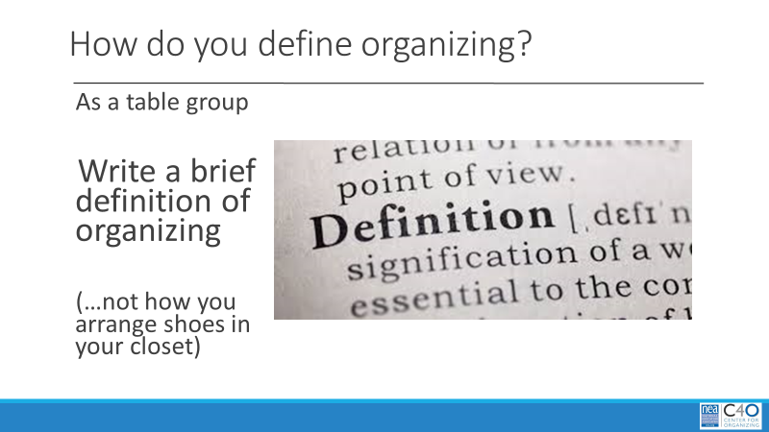  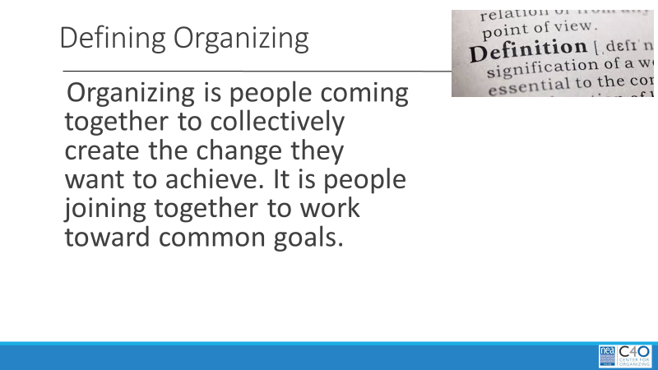  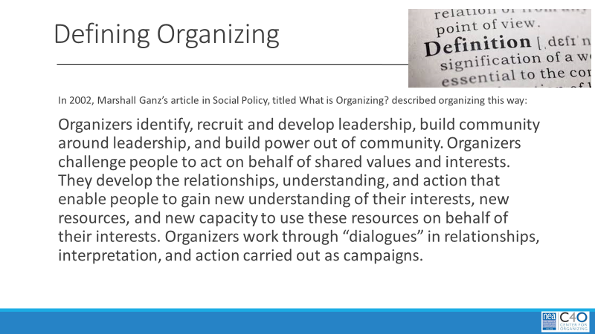  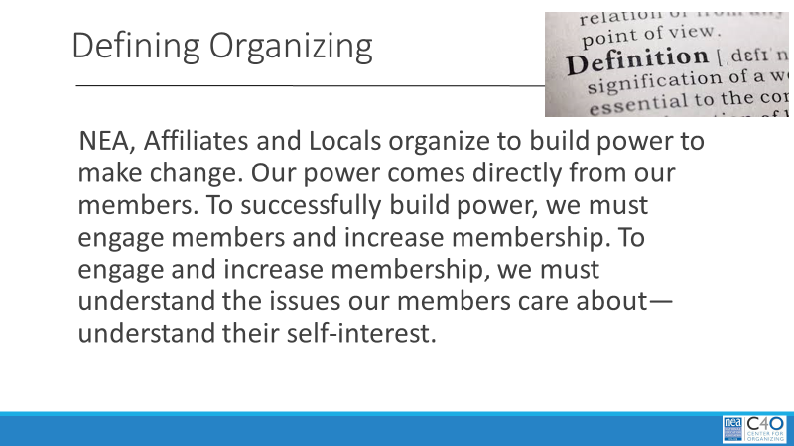  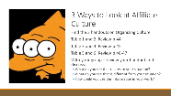  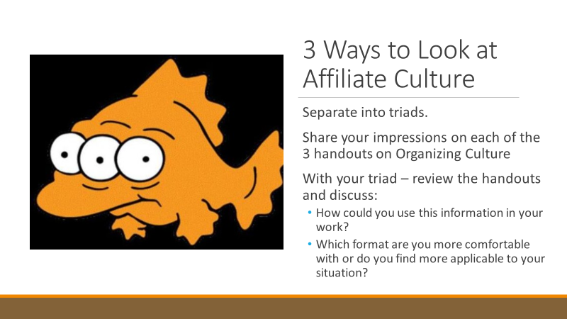  Jessica    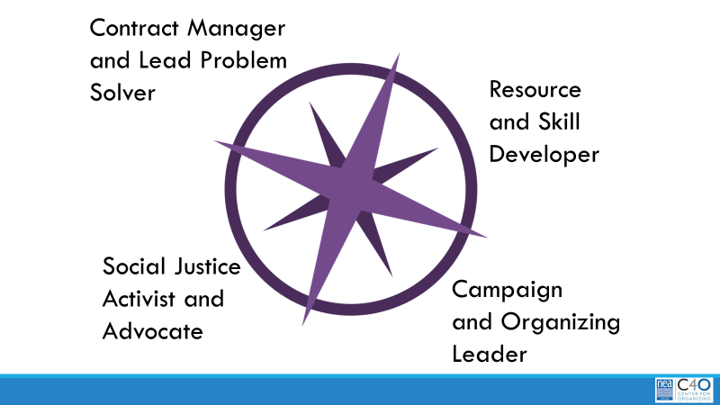  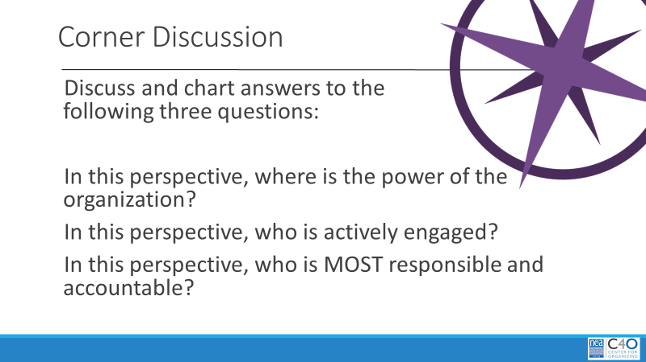   | What type of union am I currently working in? | Facilitator Resource What is Organizing  Handouts  3 Definitions of Organizing  Service and Organizing  Organizing Culture  Three Theories of Change  Three Frames of Unionism  4 Charts  Social Justice Advocate  Contract Manager and Problem Solver  Leadership Resource and Skill Developer  Campaign/ Organizing Director |  | 75 Minutes – Organizational Culture Reflection and Implications for Our Work (15 min after lunch)  5 min – Intro  - We have been looking inside ourselves and organizations to reflect on where we are in our thinking about justice and equity.  - We are going to continuing drilling into thinking about the organizations that we work for and how that can shape the work we do.  15 Mins - What is organizing? (they should refer to these pages in their handouts pgs 50  5 Mins – In table groups, draft your own definition of organizing and put it on a chart. One to two sentences at most. (p.50)  10 Mins – Debrief by hearing what each group’s definition is – ask participants to listen for what is common and then share the following slide from www.NEA.org/c4o:  - Organizing is people coming together to collectively create the change they want to achieve. It is people joining together to work toward common goals.  - In 2002, Marshall Ganz’s article in Social Policy, titled What is Organizing? described organizing this way: Organizers identify, recruit and develop leadership, build community around leadership, and build power out of community.  - Organizers challenge people to act on behalf of shared values and interests.  - They develop the relationships, understanding, and action that enable people to gain new understanding of their interests, new resources, and new capacity to use these resources on behalf of their interests.  - Organizers work through “dialogues” in relationships, interpretation, and action carried out as campaigns.  - NEA, Affiliates and Locals organize to build power to make change.  - Our power comes directly from our members.  - To successfully build power, we must engage members and increase membership.  - To engage and increase membership, we must understand the issues our members care about—understand their self-interest.  20 Mins – Looking at Organizing Cultures  5 Mins -Find the 3 handouts on Organizing Culture – There will be six groups and each group will be responsible for one of the following frameworks about organizing culture.  - Table 1 and 2: Review p. 51-52  - Table 3 and 4: Review p. 53-56  - Table 5 and 6: Review p. 59-62  - With your group – review your handout and discuss:  - What do you see that relates to your situation?  What do you see that is different from your situation?  10 Mins- Step 2 –  - Separate into triads with one person from each framework.  - Share your impressions on each of the 3 handouts on Organizing Culture  - With your triad – review the handouts and discuss:  - How could you use this information in your work?  - Which format are you more comfortable with or do you find more applicable to your situation?  5 Mins -Debrief – what did you notice at your tables?  25 Mins Before Lunch/15 Mins After Lunch – What is the role of the UD? - 4 Corners activity  5 Mins Introduction  - We are going to take a look at the organizing culture of your organization from another lens – that of the member or leader.  - You will see 4 charts around the room with the following headings: Social Justice Advocate, Contract Manager and Problem Solver, Leadership Resource and Skill Developer, Campaign/Organizing Director.  - From your perspective, and given what you currently know, how do you think your members primarily view your role with them?  - Go to that chart and then I will give you the rest of the directions.  (If there are groups that are too big – more than 10 at one chart, create a second grouping with the same heading. Don’t worry if no one shows up under certain headings – you can ask about it in debrief.)  10 mins – at the charts  Now that you are at your charts- you need to discuss and chart answers to the following three questions:  - In this perspective, where is the power of the organization?  - In this perspective, who is actively engaged?  - In this perspective, who is MOST responsible and accountable?  5 Mins Debrief:  Key points to be listening for and pulling out -  the most engagement comes when more of our members are directing and leading the work. Our organizations become more powerful the more work with do with other organizations that share our values. |  | Participants will learn a common definition for organizing.  Participants will reflect on and identify the type of organizing culture that they are working in.  Participants
12:00 - 1:00   | LUNCH
1:00-1:15  Jessica  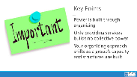 |  |  |  | 15 Mins- Reflection and Whole Group Discussion –  - So, what does this mean for the future of your work?  - How does the culture of organizing that your organization ascribes to drive what you do?  - Weave into the conversation the challenges of organizing in locals that are established versus scratch organizing.  - Organizing in established locals like renovating a home. Scratch organizing is like building on bare ground.  Key Points:  - Power is built through organizing  - Only providing services builds no collective power  - Your organizing approach shifts as a group’s capacity and structures are built
1:15-2:15  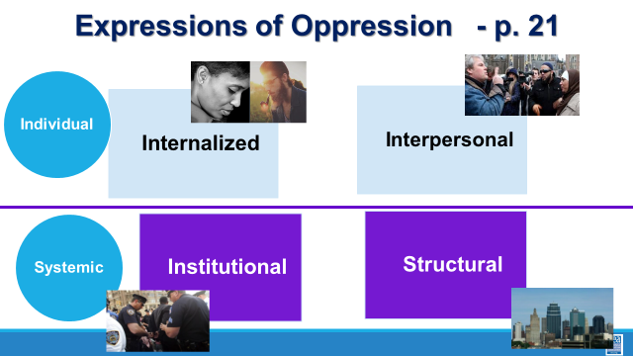  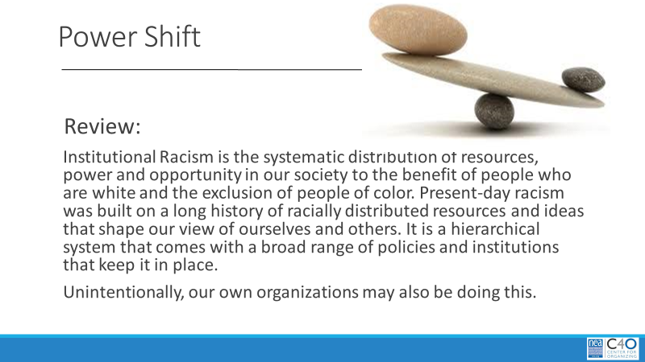  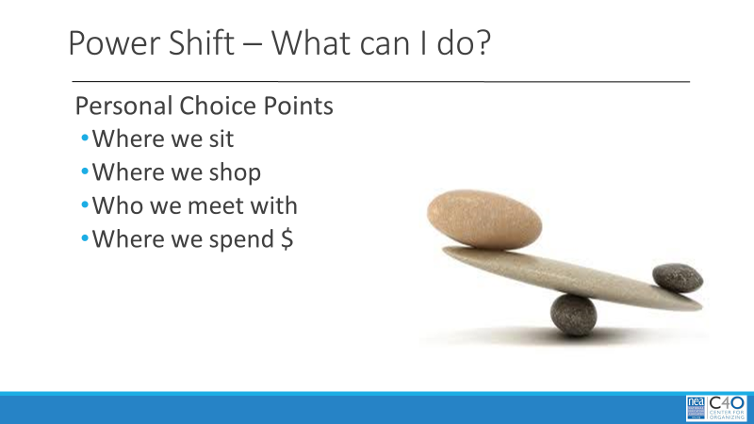  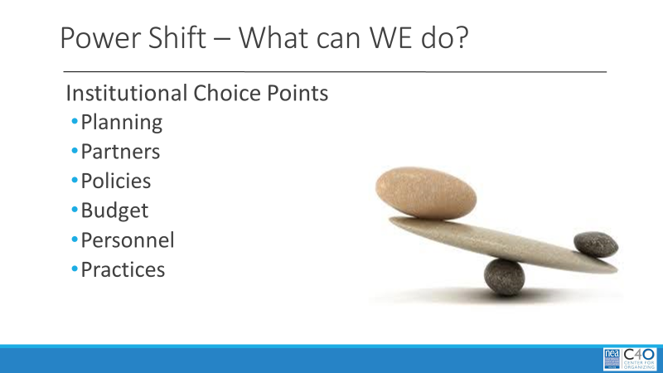  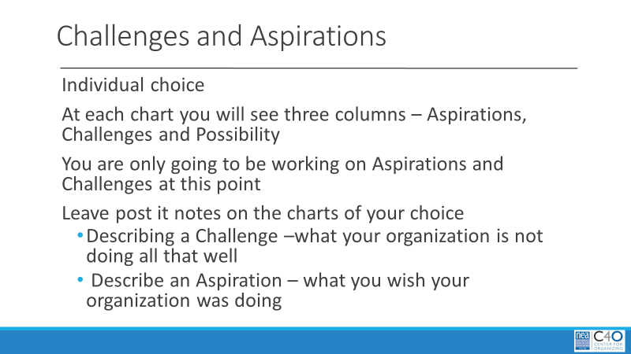  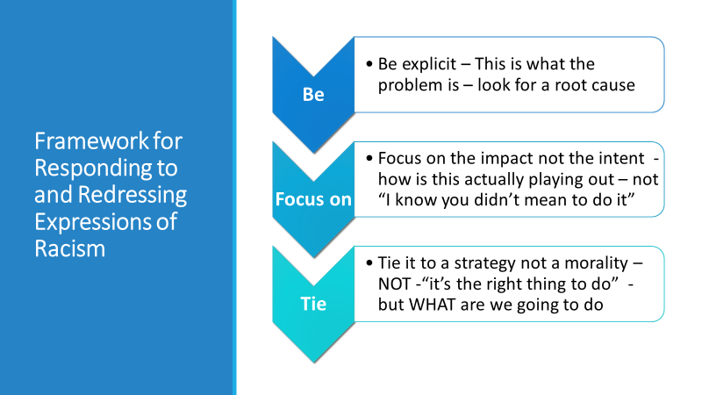  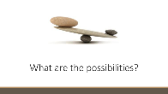  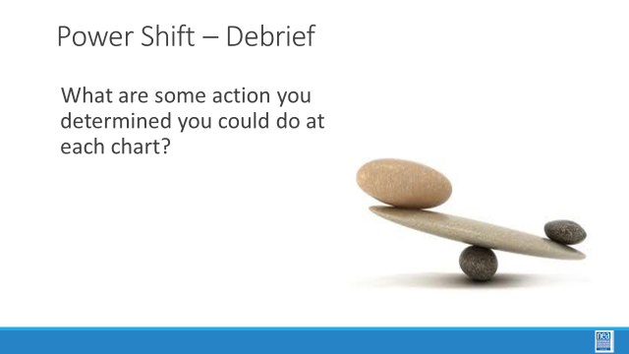  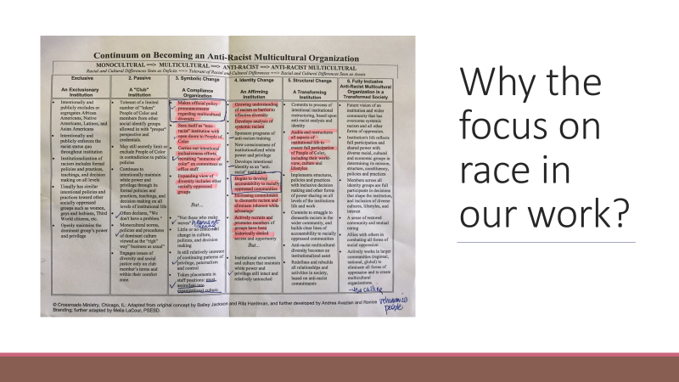  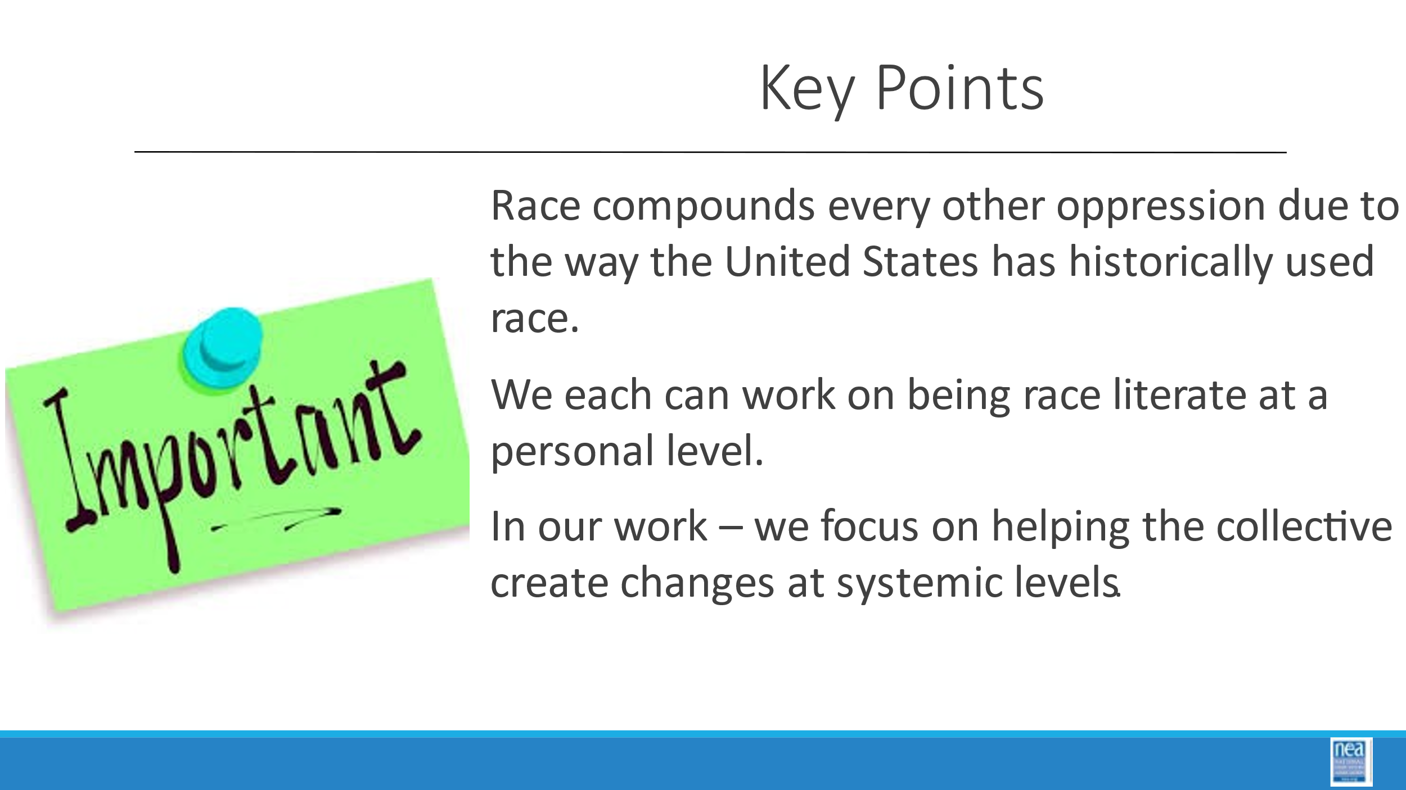 | What can I do to build an equity focused organization? | CHARTS  - Planning  - Partnership Work  - Budgeting  - Personnel  - Governance  - Policy Development  - Practices  PREWORK:  Handout Anti Racist Continuum |  | 60 Minutes What can we actually do about shifting power as it relates to RACIAL EQUITY?  5 Mins –  Let’s review – remember the levels of oppression from yesterday?  (Throwback to p. 21) We really only discussed the Individual, through conversations around bias, and not the systemic levels of this framework. We are going to look at how we think about and make change to the systemic levels. It is through the shifting of power that we make these changes.  - Unions have existed to provide a structure in which groups of people can come together around common causes and values, share their collective resources and make change – shift power.  - If this is done with intentional attention to ensuring equity – then we can begin to dismantle the structures in our own organizations that may perpetuate the oppression of particular groups of people.  - Institutional Racism is the systematic distribution of resources, power and opportunity in our society to the benefit of people who are white and the exclusion of people of color.  - Present-day racism was built on a long history of racially distributed resources and ideas that shape our view of ourselves and others.  - It is a hierarchical system that comes with a broad range of policies and institutions that keep it in place. Unintentionally, our own organizations may also be doing this.  We all have agency in large and small ways around the choices we make.  - We are primed by social cues in media, from our families, in our education to unconsciously, or consciously, make certain choices, continue certain practices or develop certain beliefs.  - Strategies for shifting power rely on making intentional changes in our own “choice points” - these are examples of PERSONAL choices we make - where we sit, where we shop, who we set up meetings with, where we spend money (provide some examples).  In our work, we are focused on supporting others to build power so that we can achieve meaningful changes – often within and across institutions.  - In this activity we are going to take a look at INSTITUTIONAL choice points as it relates to RACIAL EQUITY. We are all part of an institution, the union. So, in this activity, think through that lens. Your analysis can be limited to a local, or locals, with whom you work and/or broadened to your affiliate.  - As you look around the room, you will see Charts with columns – each with a “Category at the Top” that align with the categories on the slide.  - PLANNING - what to change and prioritize in mission, vision, programs and/or workplans?  - PARTNERSHIP WORK - what external community or organizational causes to get involved in?  - BUDGETING - what items to prioritize, add or cut?  - PERSONNEL - who to hire, how to train, retain, or team with?  - GOVERNANCE - who to identify, support and develop as leaders?  - POLICY DEVELOPMENT - what to propose or modify?  - PRACTICES - routines/habits to continue, change, or cut?  35 Mins Total for Activity –  10 Mins for step 1–  - I will split you into 7 Teams- One team at each chart.  - At each chart you will see two columns –  - Aspirations  - Challenges  - You will chart how YOUR organization, or the organization(s) with whom you work, is doing  - Example – on Personnel –  - A challenge – we cannot attract people of color to work in our state.  - Aspiration – we want to have a staff that is incredibly diverse.  You will only have 10 minutes to do this. YOU WILL ONLY BE LOOKING AT CHALLENGES AND ASPIRATIONS  15 Minutes 2nd step–  - For the next 10 minutes, we are going to work to be solution-oriented. Look at the challenges and think about what you can do to address them. Look at the aspirations and develop ideas of how to achieve them.  - We are going to brainstorm solutions using the following framework:  - Be explicit in ensuring that you are addressing the root cause(s) of the problem you have identified. For example, having a diverse staff may be the challenge. Retaining folks of color may be the issue. Your solution should address the WHY of this challenge. Maybe retention is a problem because folks feel isolated in the work; focus on that root cause. What would be a potential solution to this?  - Focus on the impact, not the intent. It doesn’t matter if the institution had good intent; you need to look closely to how it is playing out and what that means in terms of challenges and/or aspirations.  - Your solutions should be action-oriented, the actual WHAT needs to happen within the institution.  5 Mins Debrief-  So, what can each of us do?  - What are some solutions/approaches that your group developed?  - (Hear from each group)  - Address questions – expect “well, I can’t do anything about who gets elected or the policies that are put in place”  - Don’t get caught in trying to reshape someone’s reality or invalidate their experiences from the front of the room.  - Instead, use I messages, In My experience I found that I am able to ---, OR throw it back to the group – what do you all feel about that? Does someone have a different perspective?  So, why are we focusing on race?  20 minutes total for the activity  10 Min – Intro and prework review – pg. 49 (back at tables)  - Think of all the changes that any of your members might want to achieve – good healthcare, better pay, safe working conditions, fair testing, improved resources for all schools – each of these are within institutions in which race has shaped who has access and power and who does not.  - Activity: Go through Anti-Racist continuum chart on page 40 (this was assigned as pre-work) and reflect where your employer is on the continuum and circle – do this individually  10 Min – Turn and talk  - Discuss in pairs what was circled  5 Min – Anyone want to share an a-ha thought (do NOT do large group share out here)  Key Points:  - Race compounds every other oppression due to the way the United States has historically used race  - We each can work on being race literate at a personal level  In our work – we focus on helping the collective create changes at systemic levels |  | Participants will begin to see how they can contribute to intentional changes within their own organizations.
2:15-2:30  Break | BREAK
2:30-3:00  Barb  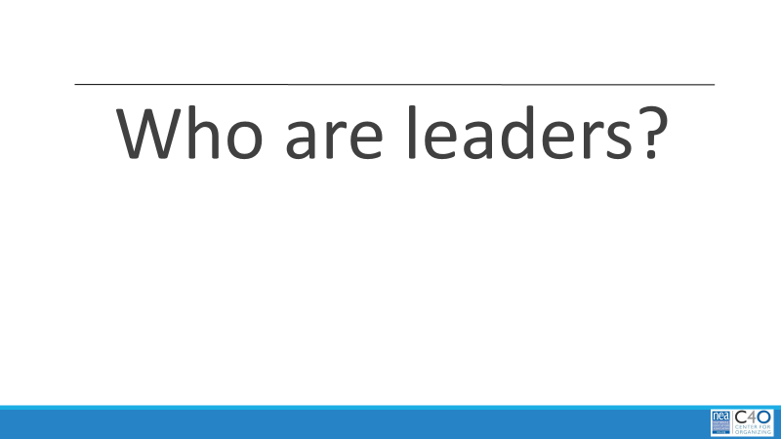  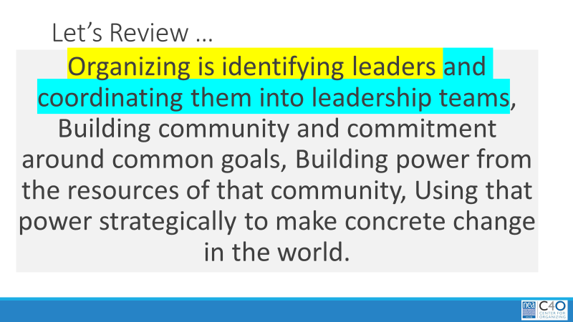  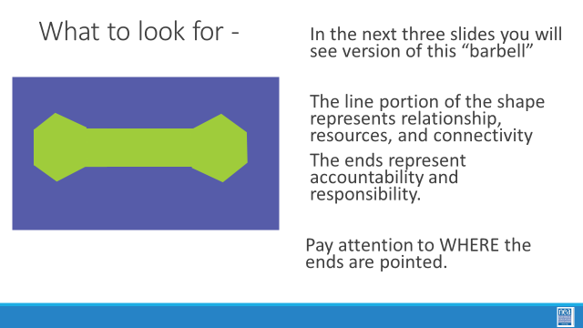  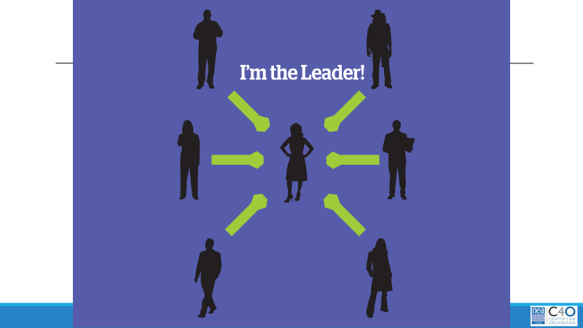  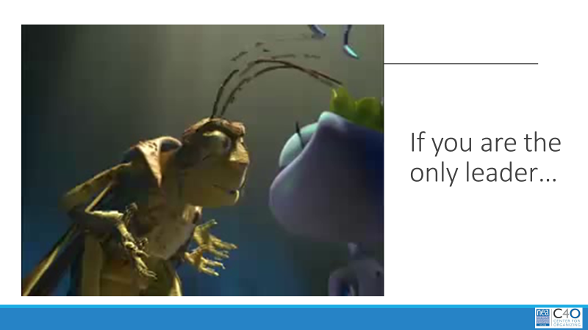  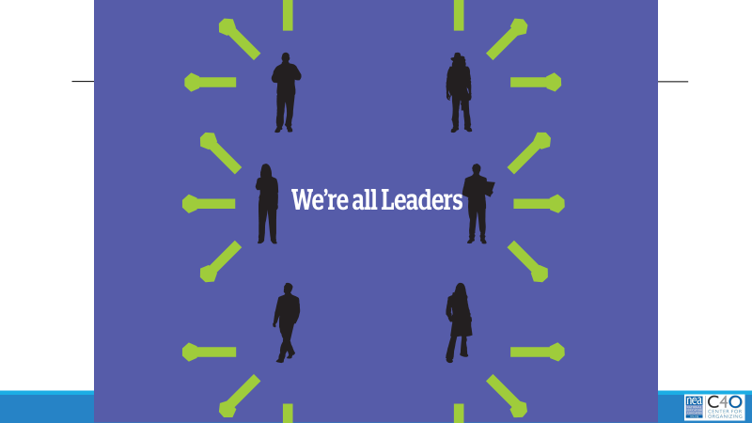    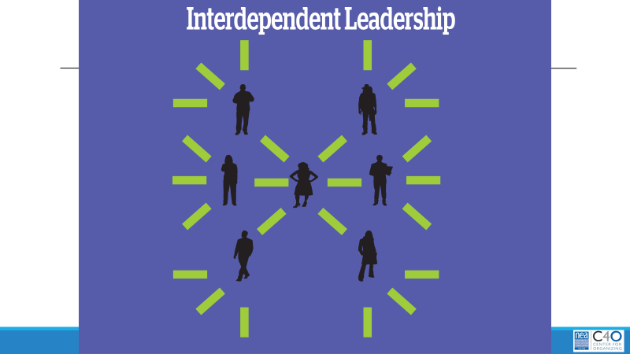  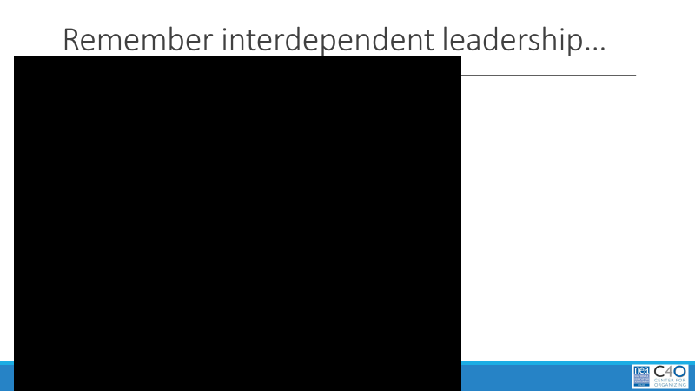  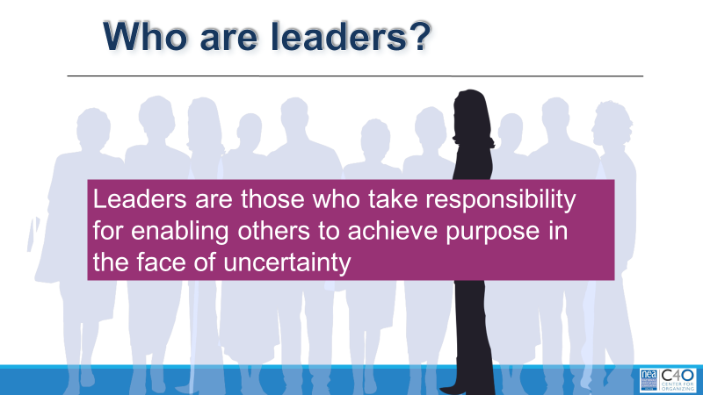  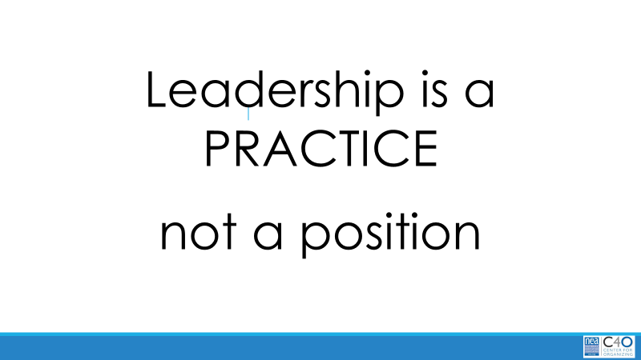    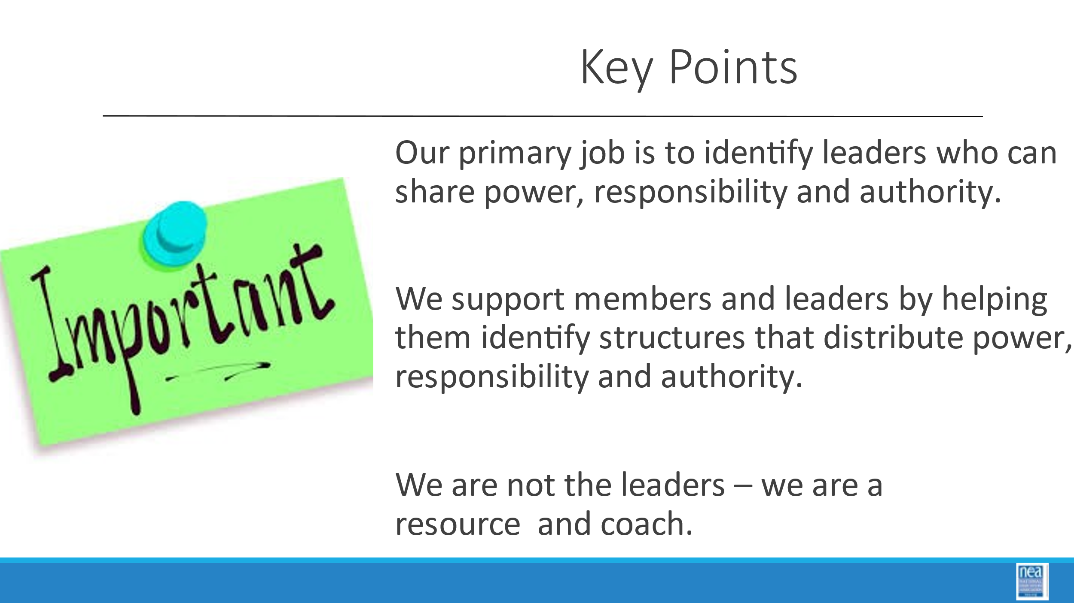 | What makes for effective leadership structures? | Videos  1st Rule of Leadership  https://www.dropbox.com/s/sfq1chv6sbafcb8/First%20rule%20of%20leadership_1.wmv?dl=0  Cat Herding Video  https://www.dropbox.com/s/s9jbebb6583g2kn/EDS%2C%20an%20HP%20Company%20%27Cat%20Herders%27%20%28deleted%203ccc9cec4fd7aa35335e58bd53e64397%29.mp4?dl=0  81 Parachute Video  https://www.dropbox.com/s/gid4oghrqonrbg0/81-WayStarburst.wmv?dl=0  Facilitator Reading  NOI - Leadership |  | 30 Mins - Structures of Leadership  1 min–  Begin by asking – who are leaders? (Take no more than three responses)  So, if we remember the first part of our Organizing definition: Organizers identify, recruit and develop leadership – I want to give you three structures to consider. As we move through these structures keep track of where the power is and what your job would look like in each of these structures.  In the next three slides you will see version of this “barbell”  The line portion of the shape represents relationship, resources, and connectivity  The ends represent accountability and responsibility.  Pay attention to WHERE the ends are pointed.  3 Mins  - Let’s take a look at the first model – the “I am the leader” model.  - Some things to notice in each slide – these lines represent relationships, and the ends of the lines represent “weight” like dumbbells – the weight of accountability, responsibility, direction of resources.  - In this slide – where is the weight? Where is the power? Is this a powerful or sustainable model? Who benefits from the resources?  - Let’s look at a short video to help you remember this model – First Rule of Leadership.  3 Mins  - Let’s take a look at another model – this is the “we are all leaders” model.  - In this slide – where is the weight? Where is the power? Is this a powerful or sustainable model – Who benefits from the resources?  - Let’s look at a short video to help you remember this model – Cat Herders  3 Mins  - Let’s take a look at our last model – this is the “Interdependent Leadership” model.  - In this slide – where is the weight? Where is the power? Is this a powerful or sustainable model – Who benefits from the resources?  - Let’s look at a short video to help you remember this model – PARACHUTE – Say as the video plays “  - In this video you see 81 parachutists who are each connected and focused on a common goal – getting to the ground alive.  - The organizers are actually NOT part of the diamond shape but are on the outside coaching, providing data and encouragement.” (MUTE VIDEO)  3 Mins  - Who are Leaders- we could take lots of time to arrive at a common definition of what a leader is – I am asking you to consider the following:  - Leaders are those who take responsibility for enabling others to achieve purpose in the face of uncertainty.  10 Mins  Debrief  How close to or how far away are your organizations from interdependent Leadership? How does your work shift across these leadership models?  5 Mins  p.40 Reference back to the leadership quotes around the room– How are these models of leadership connected to the quotes you see around the room  Key Point:  - Our primary job is to identify leaders who can share power, responsibility, and authority  - We support members and leaders by helping them identify structures that distribute power, responsibility and authority  - We are not the leaders – we are a resource/coach |  | Participants will identify leadership structures in their locals.
3:00 – 3:45  Hedy  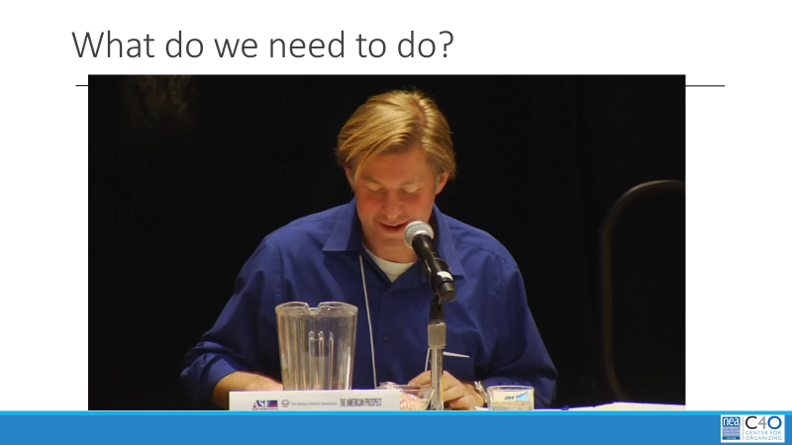  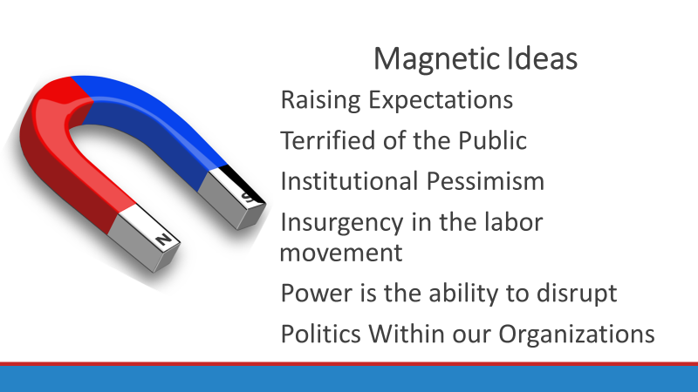  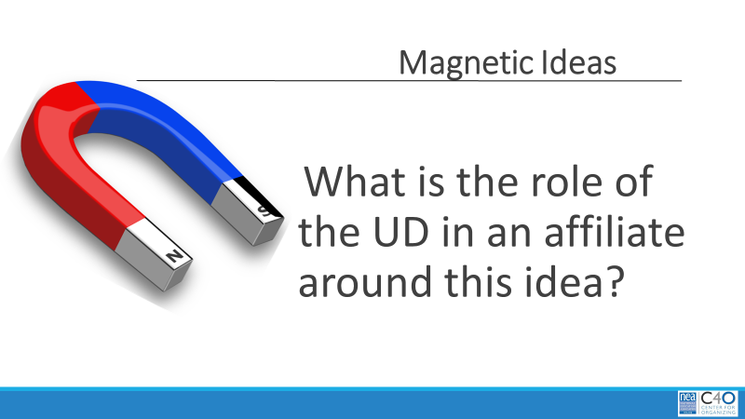  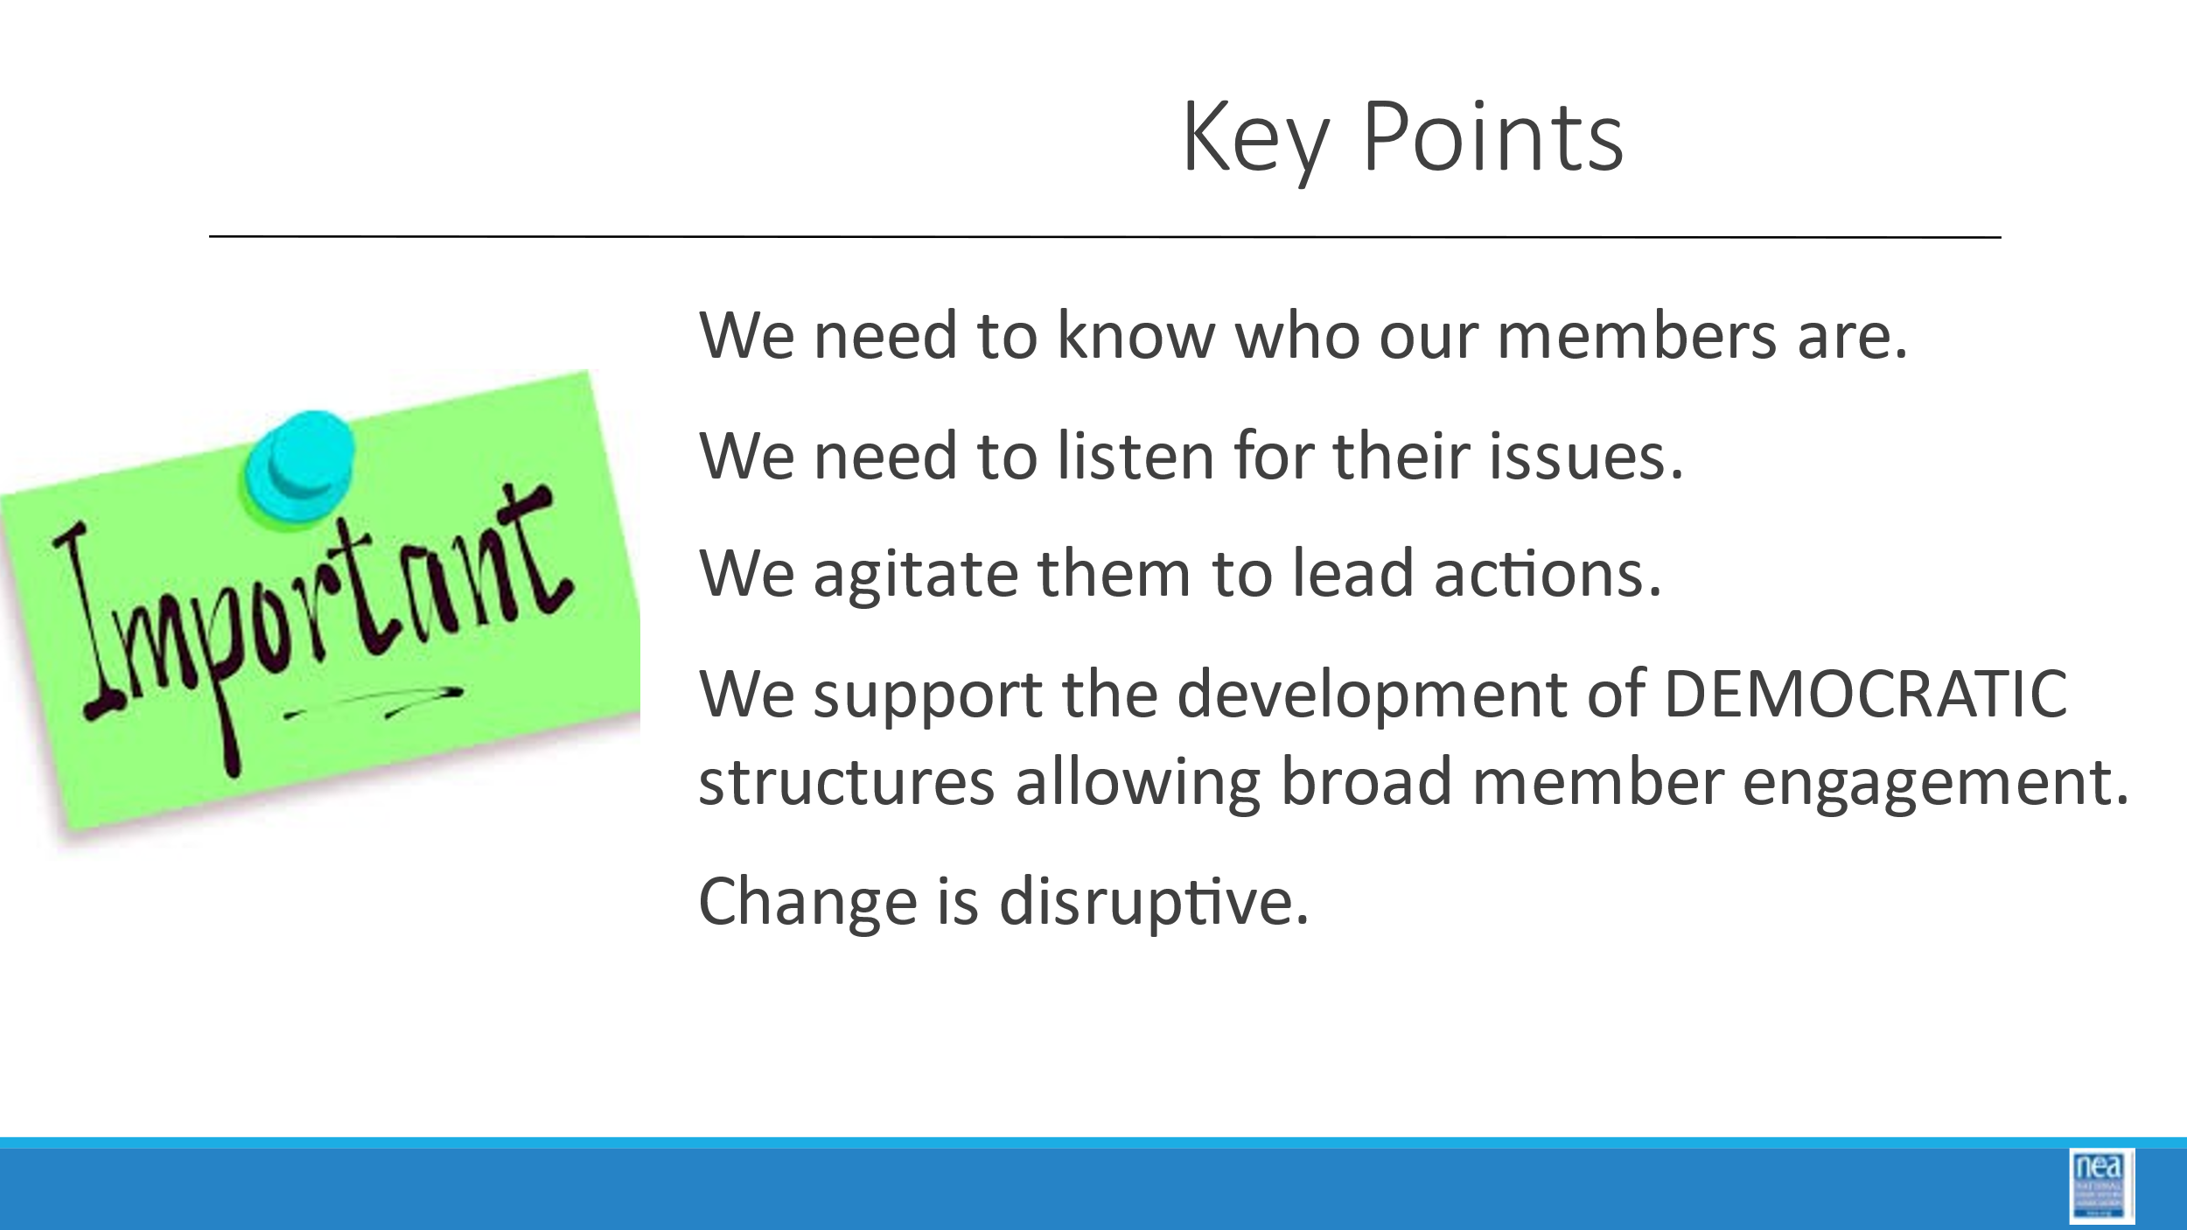  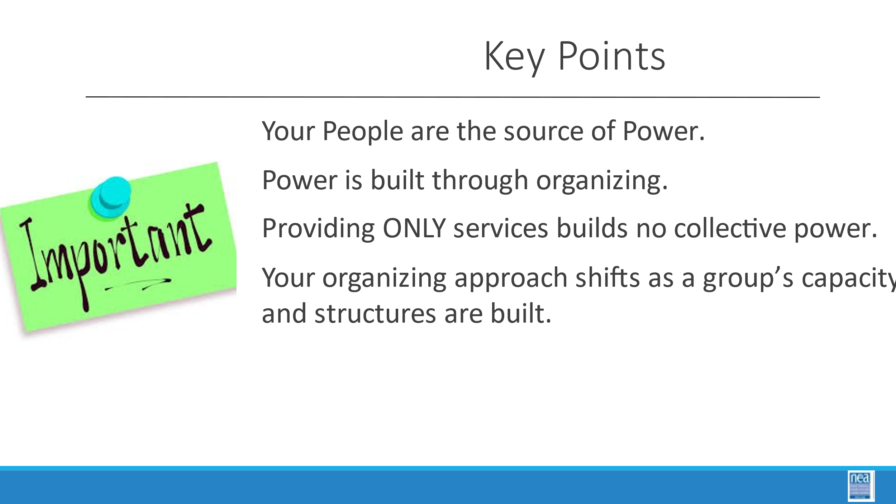  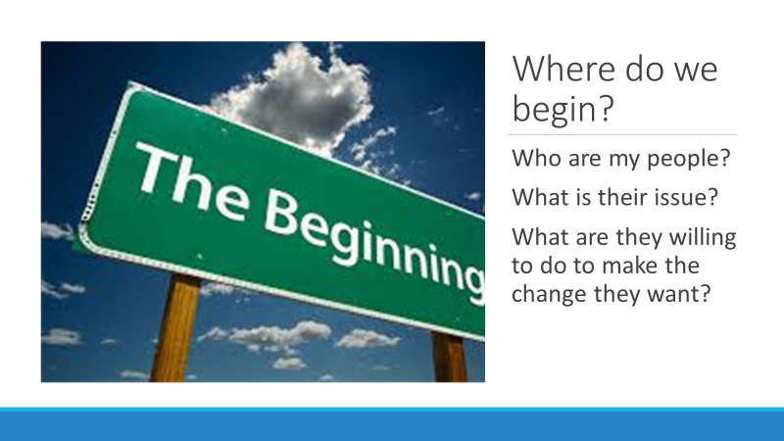  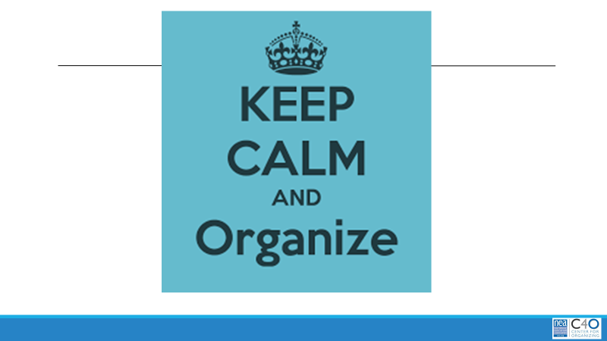 | How do I begin effective organizing? | Video  Charts for the Magnetic Activity  Raising Expectations  Terrified of the Public  Institutional Pessimism  Insurgency in the labor movement  Power is the ability to disrupt  Politics Within our Organizations  Possible Readings  Labor Notes  C4O Organizing Foundations |  | 45 Mins - Where does good organizing begin? What is the role of the UD? - Magnetic Issues Activity  2 Mins  - We have spent a brief bit of time looking at the current culture of your affiliate using three tools.  - We are going to kick off our next bit of work by watching a portion of a video of Mark Brenner of Labor Notes.  - Turn to p. 74 and write down the six headings on the charts that you see around the room. Be listening for each of these in the video – when you hear that phrase just jot a + or - based on how that statement makes you feel Also listen for what he has to say about who needs to be organized, how power can be developed and consider what that might mean for you in your work.  8 Minutes  Video  10 Mins TOTAL  Magnetic Ideas Charting Activity – You will see a number of charts around the room with a number of “magnetic statements” that Mark said in our video. Just like a magnet, some ideas pull you and some push you.  - Raising Expectations  - Terrified of the Public  - Institutional Pessimism  - Insurgency in the labor movement  - Power is the ability to disrupt  - Politics Within our Organizations  2 mins  - Your task – Without speaking to anyone else – this is an independent decision – go to the Magnetic idea that either pulled on you in a good way or pushed and challenged you.  - Once you make a choice – go to the chart and then I will give you the next set of directions.  8 Mins  - Now that you are at your chart Discuss what your role as a UD is in your organization around this Idea.  - Chart some of your key thoughts.  Debrief 10 Mins –  5 Mins  A few ideas from the charts then go over the big points (as you listen to what is shared – if they bring up a key point – then don’t report it out on your next set of slides)  Key Points: (Only hit on the ones the participants didn’t hit on)  - We need to know who our members are  - We need to listen for what their issues are  - We agitate them to lead action  - We support the development of structures allowing broad engagement  - Power is built through organizing  - Providing ONLY services builds no collective power  - Your organizing approach shifts as a group’s capacity and structures are built  It seems evident that there are really 3 key questions that UDs need to ask over and over as they are planning their work:  - Who are my people?  - What is their issue?  - What are they willing to do to make the change they want?  For the rest of this afternoon, we are going to focus on answering the first two questions that you need to ask  - Who are my people?  - Where they are?  - Who they are connected to?  - What are their issues?  - The ones that they have common desire to problem solve around.  Use the “keep calm and organize slide as a transition between this and the next speaker |  | Participants will understand the core behaviors of an organizing focused UD.
3:45-4:15  Grat   |  | Case Study in Organizing Scenario |  | 30 Min -Welcome to Enchanted County  - We are going to be working together to develop a habit of practice that is important to all of our work – planning.  - Why do we focus on planning?  - Work life balance is likely one of the greatest challenges that you are either already experiencing or may experience.  - The other reason we focus on planning is that it can make the difference from leaping from crisis to crisis and to a calculated building of leadership and capacity within our affiliates.  - For the next 30 Minutes, your task is to review the scenario of Enchanted County. There are enough issues in Enchanted County, that you should find something that would relate to the work you are engaged in within your own affiliates. (P. 63-73)  - Please, adopt a learner’s frame – look for where the connection from this scenario to your own work might be.  - As you look at the scenario – please begin making a list of the items you might like to focus on and develop a plan around – this is how we will form teams to share in the work of developing a plan.  - A few things we would like you to consider – one of the great benefits of UniServ Academy is the networking you experience here.  - Take advantage of working with those that may not be from your affiliate, may have very different views of the work and may have different backgrounds prior to becoming UniServ Directors.  - The goal for this next bit of time is for you to form a working team – 3 to 5 – and begin to select a focus of a plan you would want to work on.
4:15-4:30  Ellen |  |  |  | 15 Mins  Questions, Wrap-up and logistics
4:30 – 5:00 |  | Choice Networking Suggestion Board |  | Adult choice networking and learning – any location, any topic
5:00 | ADJOURN

