Foundations Academy Facilitator Agenda: Day #3
General Materials Needed: |  |  |  |  | Room Set-up:
1 Set of Handouts per Person  Name Tags  Table Tents  Sign-in Sheet  Agendas on the table (1 per)  Room signs |  | Chart Paper – Large Post-it Style  Post its – Regular size and large size (4’’x5”)  Index Cards – 3”x5”  Highlighters – 5 Colors – Pink, Orange, Yellow, green and blue  Chart Markers – non-permanent chisel tip  Pens and Pencils |  |  | Round Tables  Projector, Screen and Speakers  Carousel stations and reporting stations around the perimeter  40 people MAX  Material Boxes with Participant “toys” on each table  CHART PAPER:  four corners of room:  - Fear  - Hopelessness  - Confusion  - Division
Key Outcomes for the Day:
Understand the basic skills of mapping to support organizing
Understand the use of VAN or other digital tools in support of organizing
Understand the basic framework of “campaign” planning
Time | Essential Questions |  | Resources | Instructions, Activity and Debrief (Facilitators) |  | Outcomes
Time and slides | What question(s) should this learning section answer? |  | Charts, handouts, articles, materials, slide | What are you saying, what are they doing, what questions will you use to guide learning and make clear the important points  Include an estimate for how long each section of the learning will take |  | As a result of this section of learning, what will participants know or be able to do?
   |  |  |  | Entry Activity:  - Complete Day 2 of feedback if you haven’t yet.  - There is a brief but important article that will frame a good part of our learning today. Please read it as you get settled. It is called, “Apathy is Not Real” p.76-77
8:30 -9:00  Ellen  Grat/Jeny | What have we learned so far? |  | Key Learning Entry Activity | 10 Mins  - Welcome  - Review the feedback from the day before.  - Introduce the day’s agenda and take care of any logistics  - Revisit group agreements  20 Mins - People of Labor History Mixer  - 2 Minutes- Set up activity  - Give everyone a card, ask them to read who the person is. The task is to find a partner – you each introduce your Person of Labor History (90 seconds per person) then when we make the signal – switch to another partner and repeat – let’s try to do this three times.  - 18 Minutes for the activity. (90 sec per partner =180 seconds per round x 3 rounds)
9:00-9:55  Barb  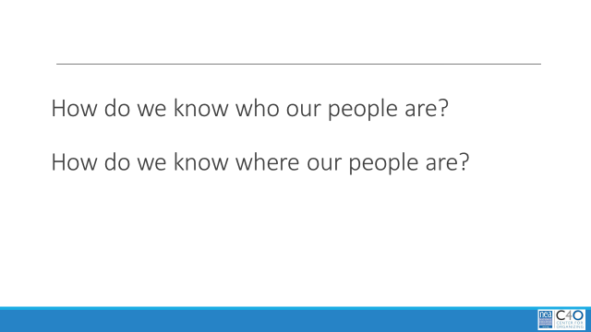    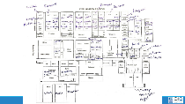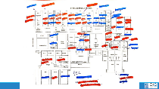  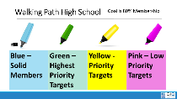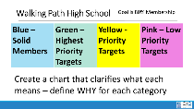    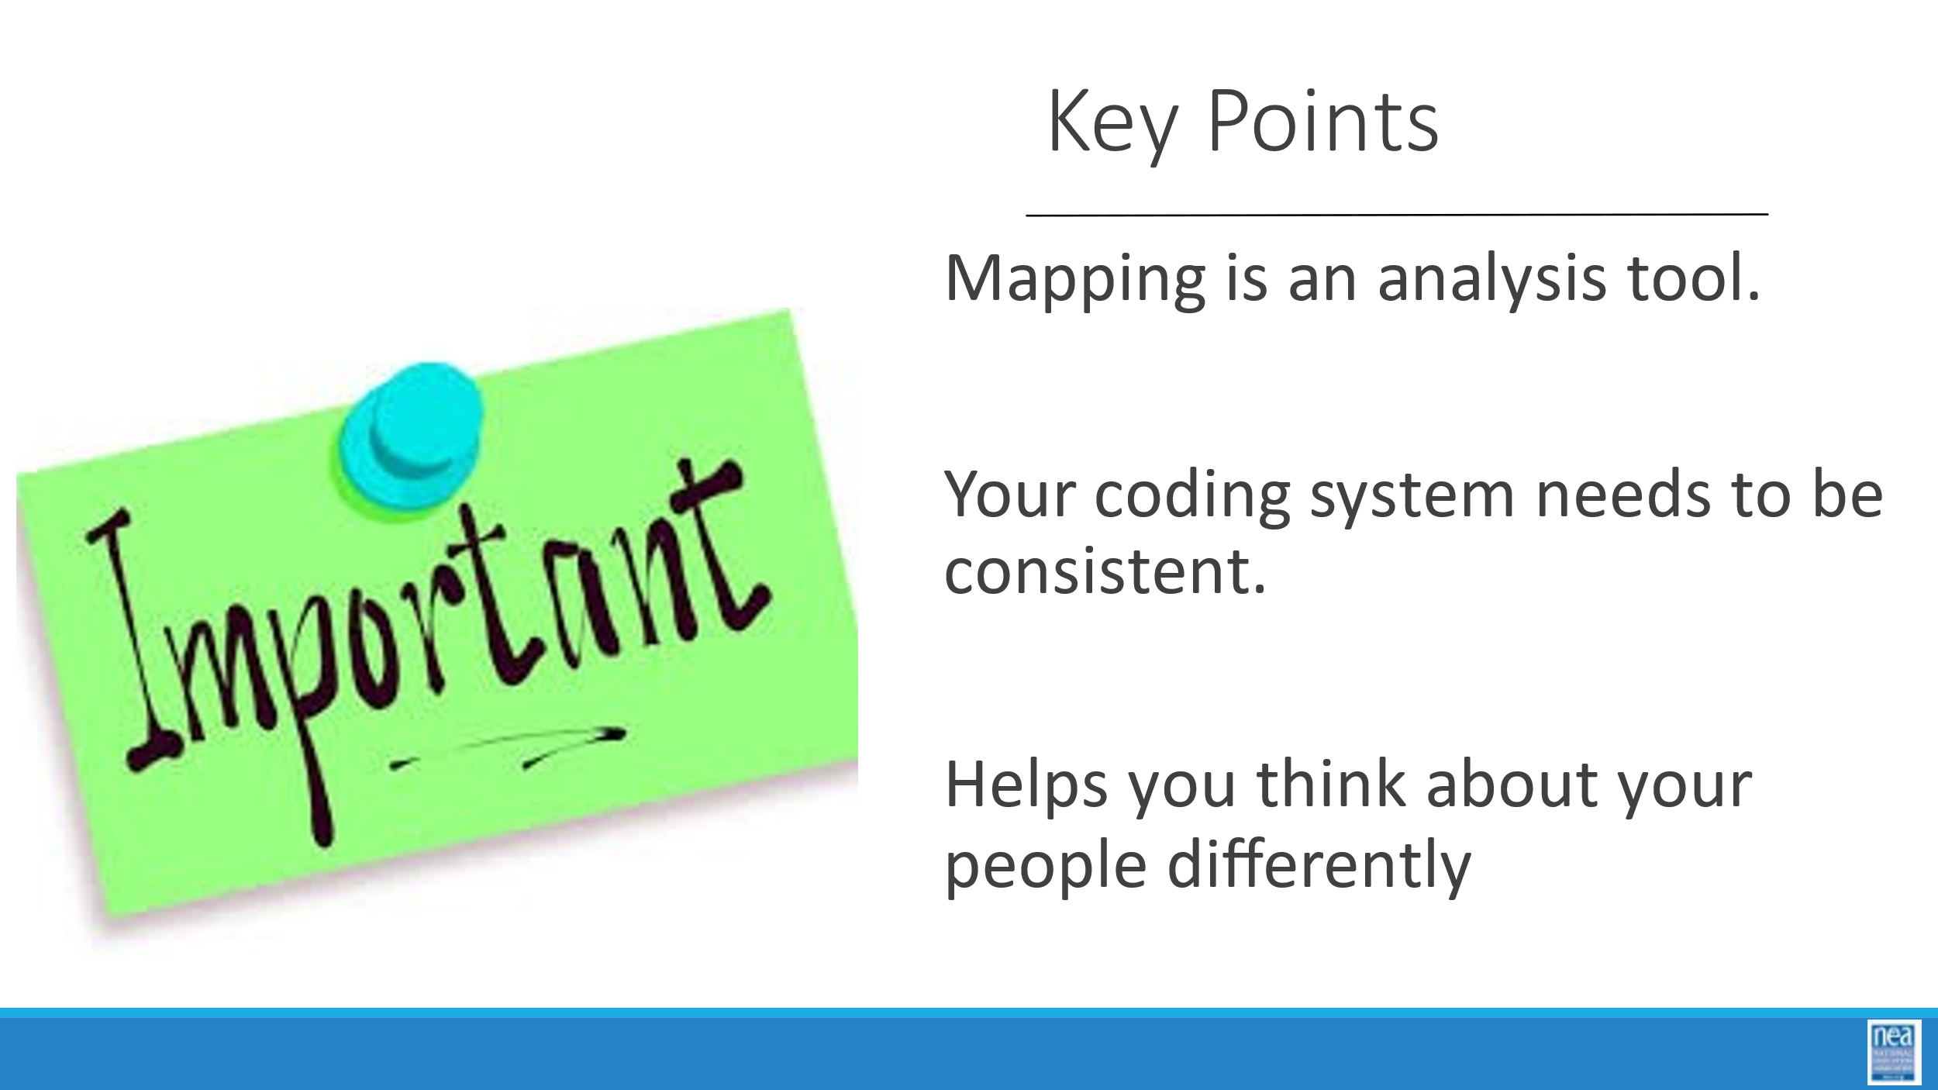 | Who are our People? |  | Walking Path Roster | Who are our people?  9 Mins – INTRODUCE MAPPING  - Ask the group  - Who are our people?  - Where are our people?  - Who are they connected to? Remember the barbells?  What are the types of maps you can create  - Building Mapping  - Relationship Mapping  - Engagement Mapping  - Effectiveness Mapping  - Power Mapping  - Pull out from conversation-  - Mapping tells us “who are our people”  - That is a physical depiction of the worksite that illustrates presence and physical proximity of staff by such factors as membership or activist status, age/seniority, job title, assessment status, social relationships, etc.  - Maps can also be used to depict the “engagement or effectiveness” levels of worksites within a local. For example, you may want to focus on developing structures. On a list of worksites, you code those with a full complement of building reps as green, those with limited reps as yellow and those with no reps as red.  - This is a way to help you decide where to focus your work. A system of mapping, once created, gives us a look at selected data from a bird’s eye view and provides a starting point for a strategic discussion of organizing.  4 Mins – INTRODUCE MAPPING EXERCISE  We are going to work in our “Scenario Teams” to dig into a a relationship mapping using a roster from Walking Path HS. We are going to use four colors of highlighters, blue, yellow, green and pink. For this activity we are coding out of concern on membership drops.  Our goal is to get membership in this building to at least 80%.  With this goal in mind here is how we will code the roster.  - Pink – Low Priority – Your group determines WHY this person is a lower priority than others  - Yellow Orange – Priority Targets – Your group determines WHY this group is a Higher Priority than others in meeting the 80% membership goal – this group will take some time and effort to get to join  - Green – Highest Priority Targets – Your group determines Why this group is the Highest priority – think of this group as those who should be easiest to bring into membership  - Blue – Solid Members – Your group determines WHY this group is the solid membership – it may be helpful to think of this group as those rock solid members who may be able to influence others – they won’t need much help from you.  25 Mins – MAPPING ACTIVITY  Teams work on coding their roster. Teams need to each create a chart that shows their Whys for each color code – and should be prepared to present how they plan to get to the 80% goal.  15 Mins- DEBRIEF  - Each team presents "“whys” and how they will get to their 80% goal.  - Whole group  - how would you use this in your own local?  - How does this help to answer the question, “Who are my people?”  2 Mins- WRAP UP/KEY POINTS  - Mapping is a tool to help you target your limited resources  - The colors and the “WHY” don’t matter as long as everyone understands the system of coding  - An analysis like this can help you identify things you might not necessarily see otherwise |  | Participants will learn a system for coding rosters that can support organizing planning.
9:55 – 10:15  Matt    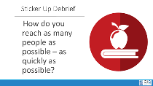  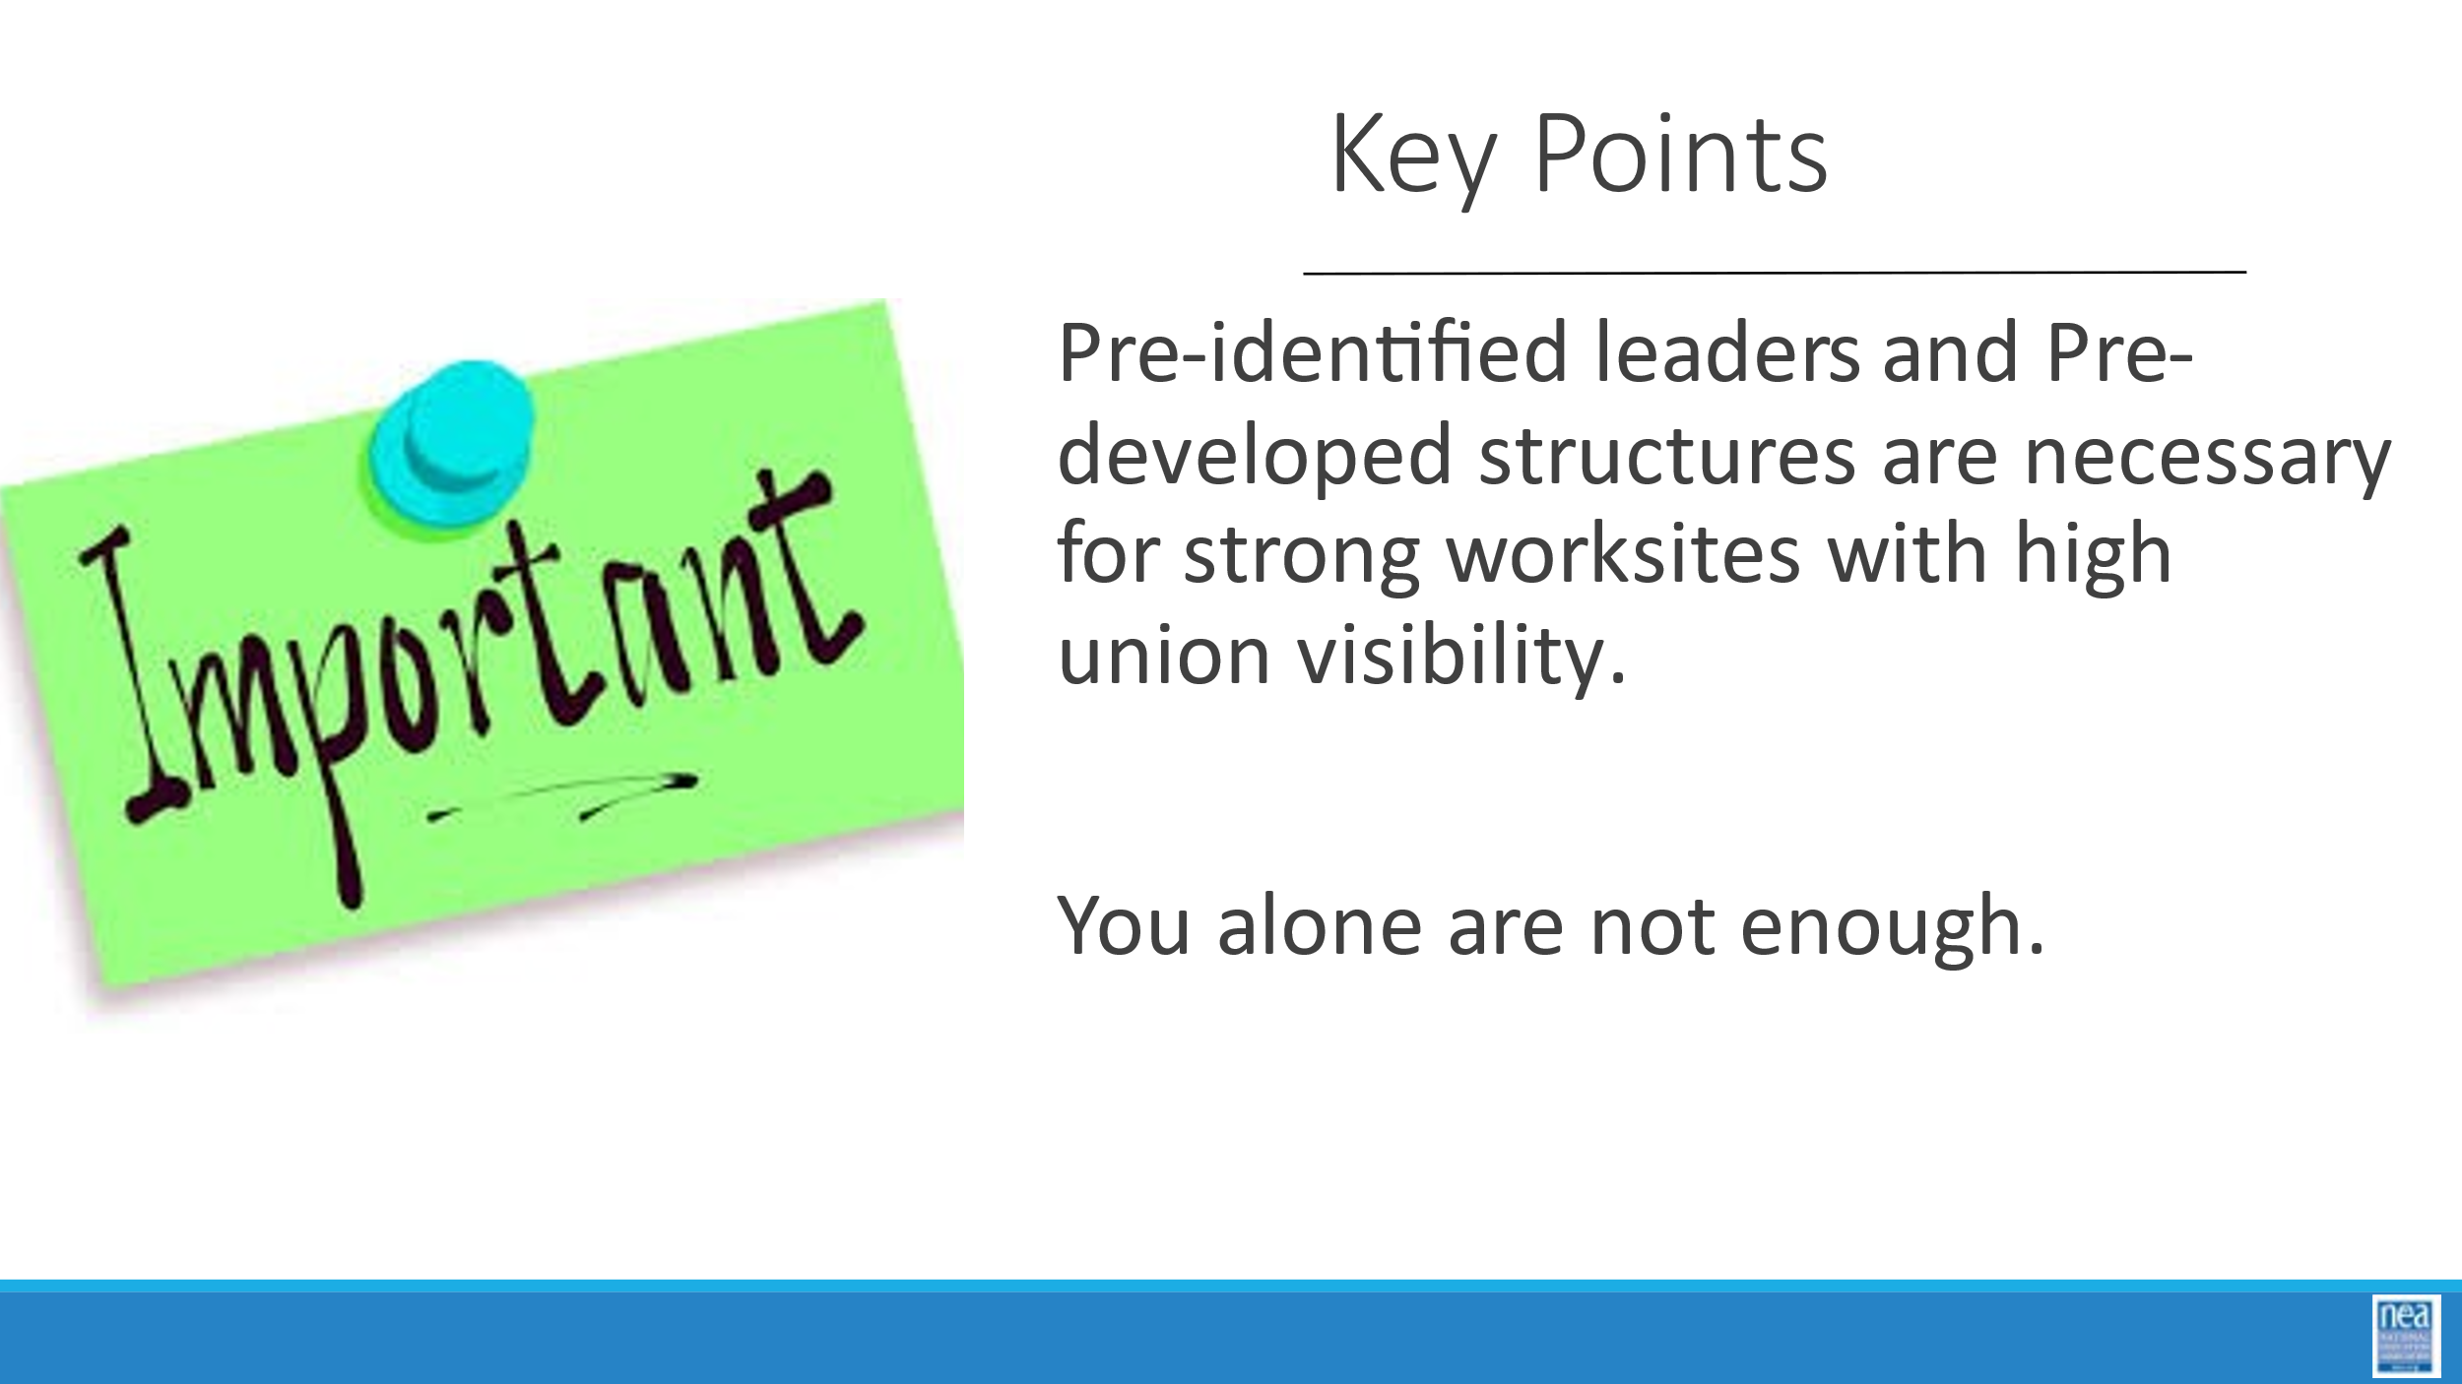 | How do we engage members? |  | Leadership ID Handout  Facilitator Resource Leadership ID Guide and KEY | How would we move people to act?/ Sticker Activity p. 93  2 Mins- SET UP ACTIVITY  Sometimes we get to choose the issues to organize around and sometimes the issues choose us.  Let’s start out by imagining that Walking Path HS has just learned that the district announced it has eliminated the HS school librarian positions, and laid off the two librarians, one 20-year educator and the other is your building rep. You have until the end of the day to get the word out about a sticker in support of the Library for High Schools campaign beginning tomorrow morning.  You want every member to be wearing a sticker (100%) at the start of and throughout the day of action. Because people can feel intimidated about taking action or confused about the issue, it’s best to hand out the stickers in person, not just leave them in a mailbox or lounge. It’s important for the union to explain the issue and answer questions before the principal or administration has a chance to get out their side of the story.  Think about how you would plan and execute the day of action.  • Who would you talk to and give stickers to?  • Who would you have a hard time reaching?  9 Mins – GROUP ACTIVITY  In your scenario groups - Think about a plan for Walking Path HS  8 Mins- DEBRIEF  Let’s hear a few examples.  - How would you reach as many people as possible, as quickly as possible?  - Who wouldn’t you be able to reach?  - What are the limitations of an email compared to a personal conversation?  - Ideally, who does the building mapping?  - How can you facilitate building mapping as the UD?  - What do you do with the information you get?  - Note ability to integrate technology and why we didn’t include  1 Min- WRAP UP/KEY POINT  - Without pre-known, pre-identified leaders and team structures YOU cannot effectively mobilize, communicate and activate. |  | Participants will plan how to quickly activate a group of employees.
10:15-10:30   | ***BREAK***
10:30 - 11:00  Jeny  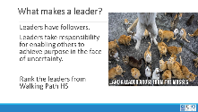  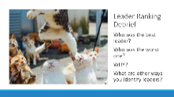  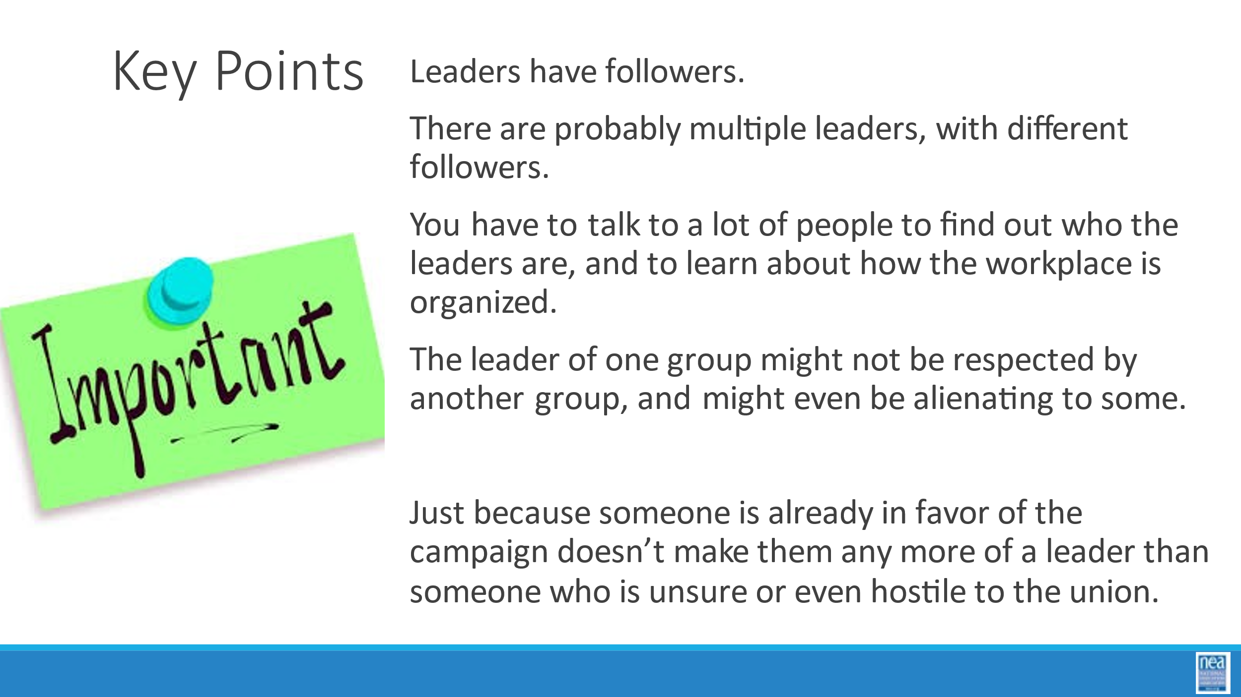 | What are qualities that we can look for in identifying leaders? |  | Leadership ID Handout  Facilitator Resource Leadership ID Guide and KEY | What makes a leader?  2 Mins- SETTING UP ACTIVITY  - Review definition of a leader  - We used a definition of a leader – Leaders are those who enable others to achieve purpose in the face of uncertainty. AND we discussed that leaders have followers and they move others to take action.  - We are going to take a look at a few leaders from Walking Path HS. In the handouts p.94-99 You will see scripts of responses from 1 on 1’s with people from walking Path HS. Your task is to identify the 3 strongest leaders, from strongest to lowest -given our definition of a leader. In other words:  Who would you recruit to your leadership committee?  Who would you NOT want on your leadership committee?  Your team must come to consensus.  15 Mins – GROUP ACTIVITY  12 Mins – DEBRIEF  Who did you think was the best leader and why?  The worst and why?  What are other ways that you use to identify leaders?  1 Min- WRAP UP/ KEY POINTS  • Leaders have followers.  • There are probably multiple leaders, with different followers.  • You have to talk to a lot of people to find out who the leaders are, and to learn about how the workplace is organized.  • This isn’t to say that people cannot become leaders, but we are starting from the assumption that there are already leaders in the workplace and we have to find out who they are.  • The leader of one group might not be respected by another group, and might even be alienating to some.  • Just because someone is already in favor of the campaign doesn’t make them any more of a leader than someone who is unsure or even hostile to the union. Our job as organizers is to identify people’s issues and move them with hope and a plan to win! |  | Participants will work to identify and rank a series of leaders from Walking Path HS.
11:00 to 11:30  Linda  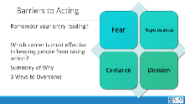  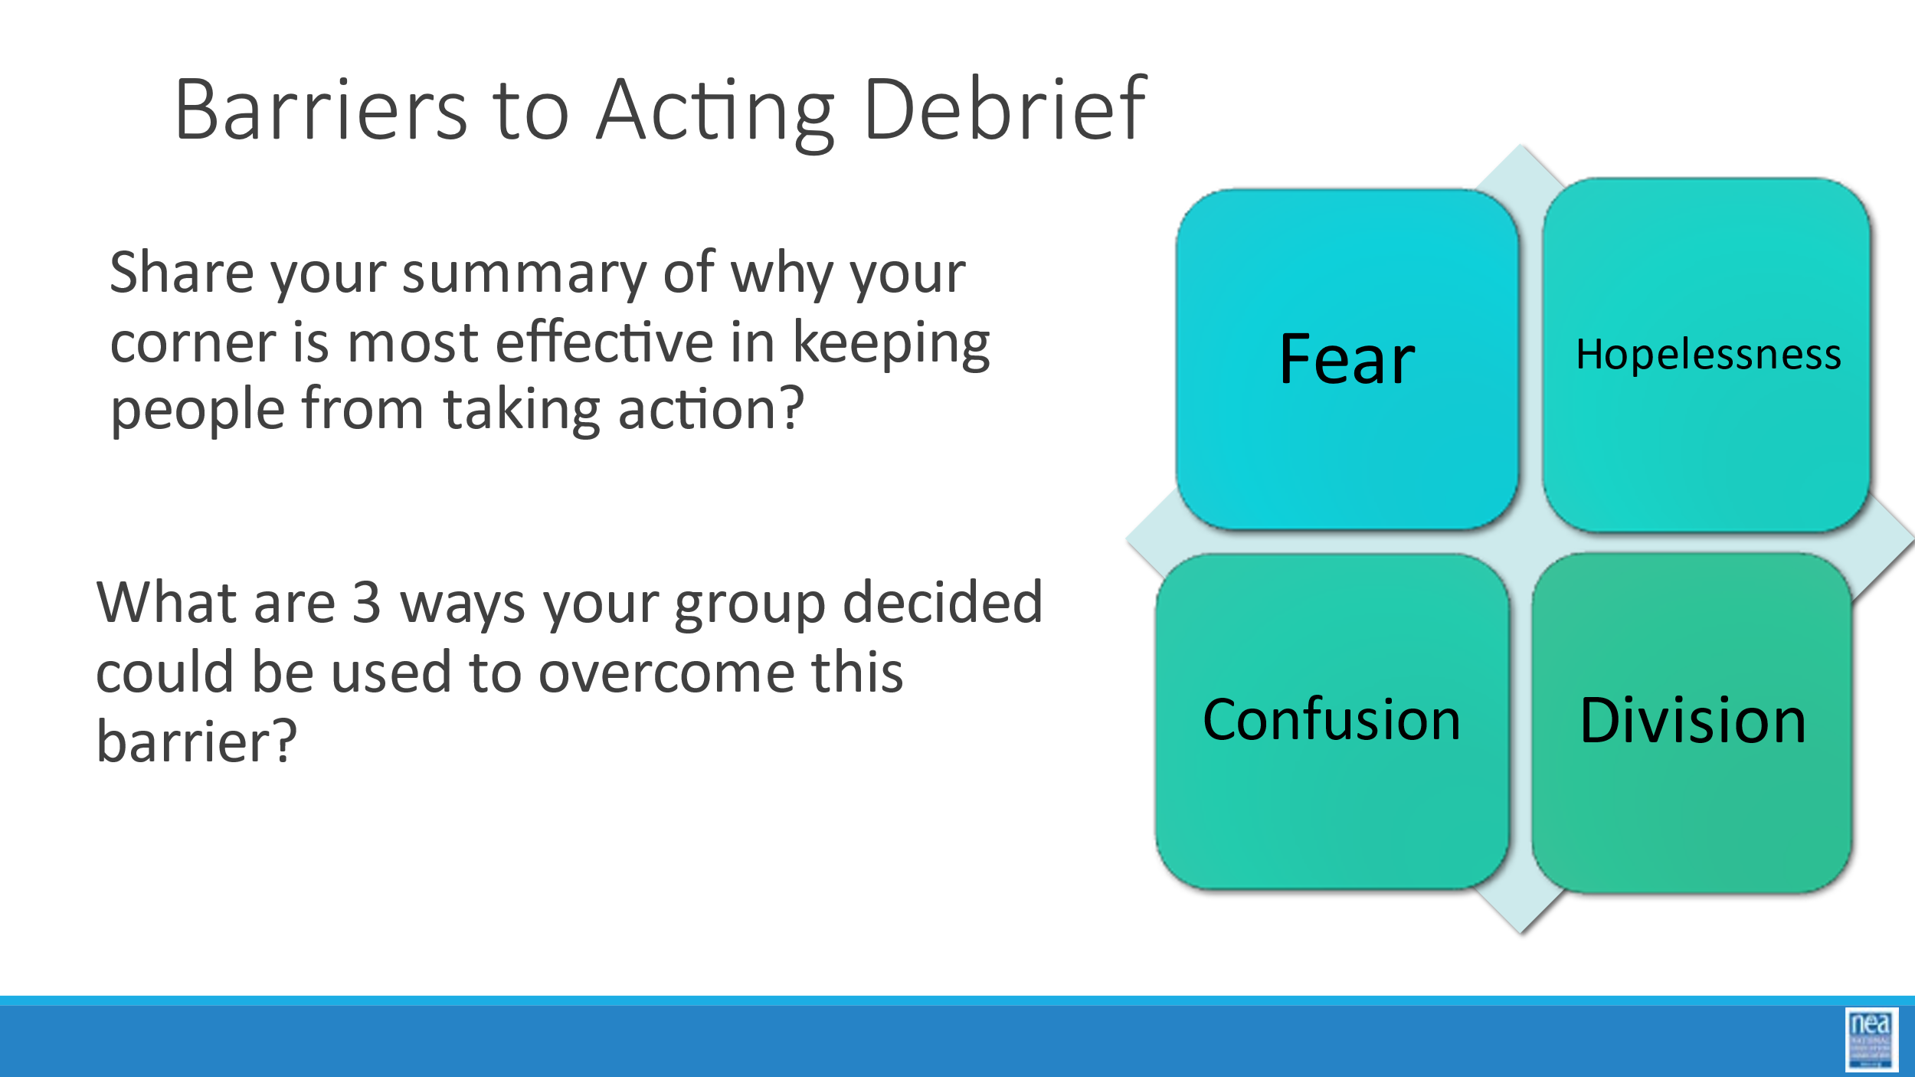  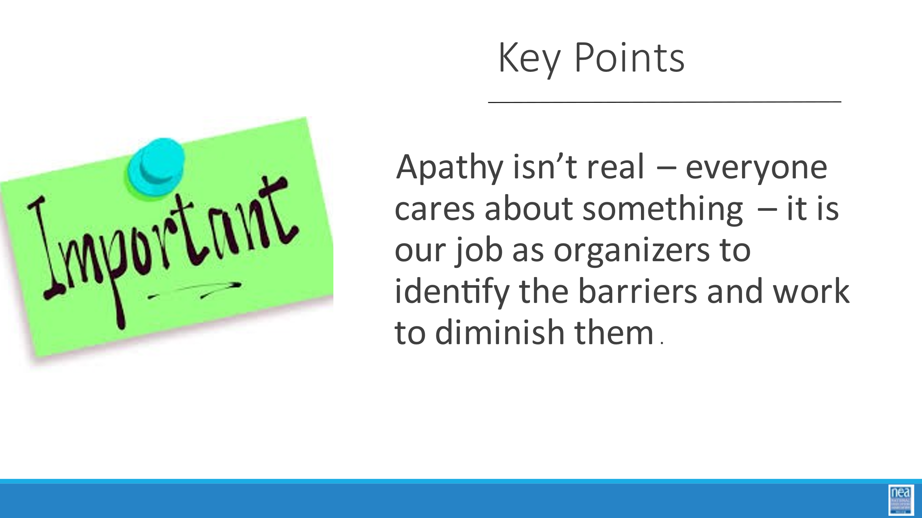   | Is apathy something that is real? |  | SET-UP  Need 4 Charts – one in each corner with the headings: fear, hopelessness, confusion, and division.  Connect Reading from Apathy Entry Activity as you Debrief  NEA Member Retention Findings | What keeps members from stepping up?  2 Mins- INTRODUCTION/ SET-UP ACTIVITY  - What keeps members from stepping up? Make an intentional connection to the morning’s short reading about Apathy.  - Next let’s talk about some of the obstacles that keep people from stepping up and taking on those in power. Depending on the issues we are facing, we can mean the principal, superintendent, school board, all the way to the governor and state legislature. Everyone cares about something. But there are very real reasons why our members are reluctant to take action. In fact, while we are trying to organize our members – other forces are working just as hard to keep them disorganized.  - SET-UP ACTIVITY:  In the four corners of the room you will see four of the tactics that those in power use to keep us disorganized: fear, hopelessness, confusion, and division.  Which of these four is the most effective at keeping people from taking action in your affiliates?  You’re going to vote with your feet. Everyone please get up and go stand in one of the four corners. Pick the one that has the biggest impact where you work. Once you get to your corner, you will develop a short summary to share with the whole group about why your group chose this corner. Also – come up with at least three ways you work to overcome this barrier  10 Mins – GROUP ACTIVITY  8 Mins – DEBRIEF  - Ask each corner to take 2 minutes or less to provide a summary of why that choose that corner and one of the ways they coach members to overcome this.  - Once you’ve heard from all corners, ask the corners to choose their favorite way to overcome this barrier.  - Ensure discussion addresses: There are stories and narratives about fear, hopelessness, division and confusion among your members. Those stories are being shared. Altering the narrative and building a new story of the local is the way to move beyond these issues. These issues change when a new story is created to tell about the work. Focus the story on victories, successes, hope, a new path forward.  1 Min- KEY POINTS  - Apathy isn’t real – everyone cares about something – it is our job as organizers to identify the barriers and work to diminish them.  10 Mins- MEMBER RETENTION HANDOUT Pg. 11  - Return to your seats.  - Direct them to the Member Retention Findings Handout and have them review it.  - Ask group:  - What do you see here that directly connects with our learning today?  - What stands out?  - What surprises you?  - What Challenges |  | Participants will understand 4 main barriers that prevent members from acting.
11:30 to 12:00  Hedy  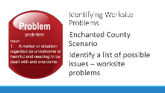 | What are the possible worksite problems?  ADD: WHEN THEY FINISH LISTING THE ISSUES HAVE THEM GO TO “A GOOD ORGANIZING ISSUE” TO ANALYZIE THEIR LIST |  | Case Study in Organizing Scenario | Organizing Team Scenario Work – Identifying possible issues  3 Min- SET UP ACTIVITY  You are going to spend the next 30 minutes working with your team on your particular part of Enchanted County.  As a team brainstorm a list of possible issues.  Keep the following in mind, we define issues as a workplace problem – they are not barriers – keep in mind what we just did – and they are not things like “low membership” or “lack of leaders” – those are goals or outcomes that you work to improve through the implementation a good organizing plan. We are NOT YET concerned with what might make a “good” organizing issue, just for you to identify possible worksite problems based on the information that you have.  27 Min- GROUP ACTIVITY |  | Participants will begin to brainstorm possible worksite problems.
12:00 to 1:00   | ***LUNCH***
1:00- 1:15  Hedy  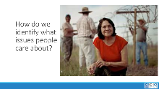  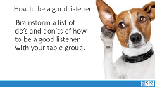    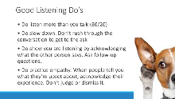  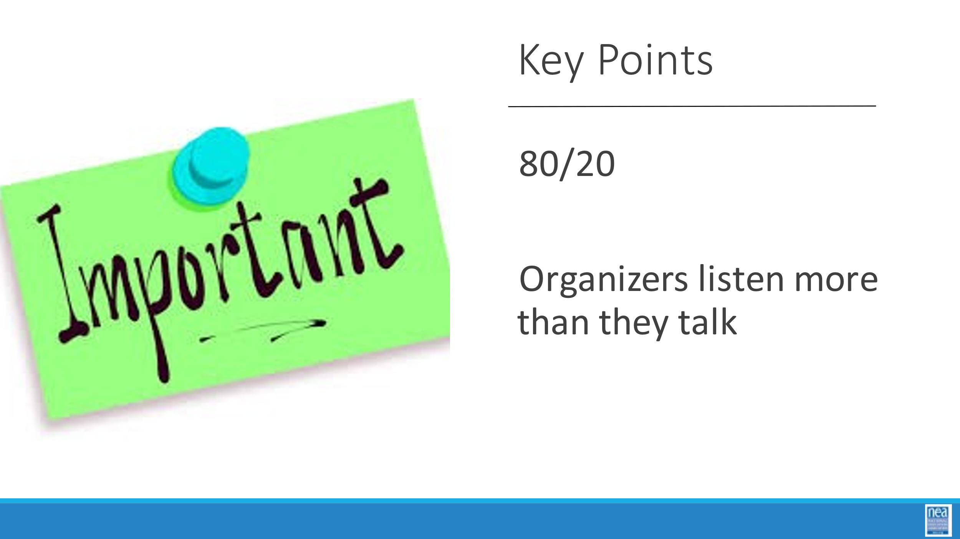 | How can we find out what are our people’s issues are? |  | Jacobin Article- Optional Reading  Issue ID Handout  Listening Resources | How do you identify your people’s issues?  3 Mins- INTRODUCTION  - How do we identify what issues people care about and what obstacles are holding them back? We have to talk to them! We do this by having organizing conversations – commonly called One on Ones  How to be a good Listener  2 Mins – SET UP TABLE DISCUSSION  - Has anyone heard of the 80/20 rule for conversations? Anyone know what that is? That’s right. We should be listening 80 percent of the time and talking 20 percent of the time. One of the most important parts of an organizing conversation is active listening. So what are some good rules for active listening?  - At your table, with a team brainstorm a list of do’s and don’t for how to be a good listener during an organizing conversation.  4 Mins – TABLE DISCUSSIONS  6 Mins – DEBRIEF  - I am going to present some do’s and don’ts let’s see how many your table came up with.  - DON’Ts  - Don’t assume you know the answers to questions. Let people tell you what they think is important. It might not be what you think.  - Don’t ask questions that are really statements: “Don’t you think what we need to do is go on strike?”  - Don’t go fishing—running through a laundry list of questions or issues: “So do you want higher wages, better health insurance, smaller class sizes?”  - Don’t talk like a salesperson: Selling union benefits that only a small number of teachers and school employees think they will need or use (example, liability insurance) might convince them they don’t need to be involved. Example: “All you need is one student making a complaint...”  - DOs  - Do listen more than you talk (80/20)  - Do slow down. Don’t rush through the conversation to get to the ask  - Do show you are listening by acknowledging what the other person says. Ask follow-up questions.  - Do practice empathy. When people tell you what they’re upset about, acknowledge their experience. Don’t judge or dismiss it.
1:15- 2:00  Grat  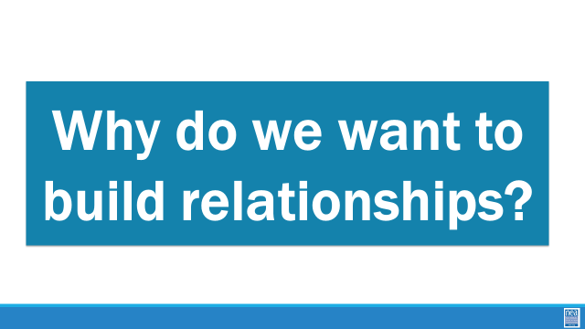  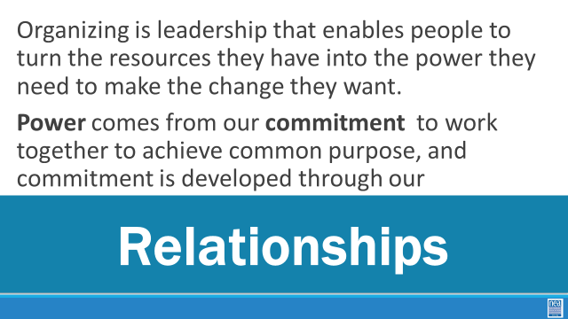  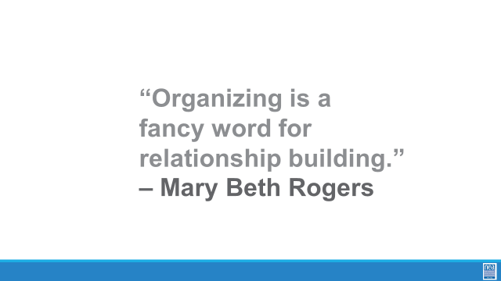  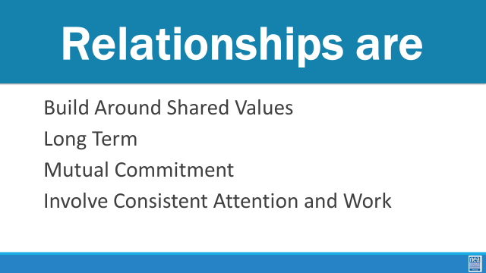  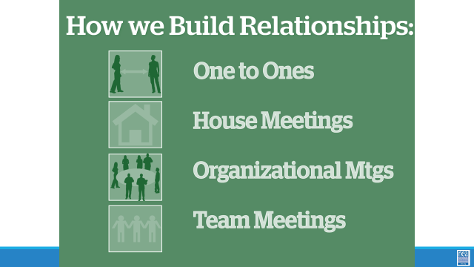  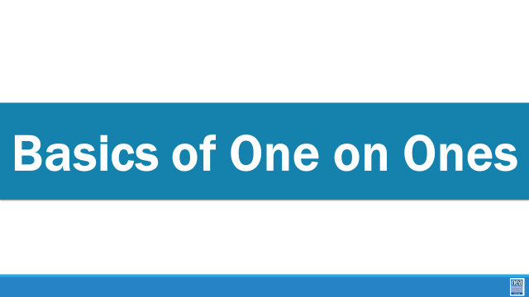  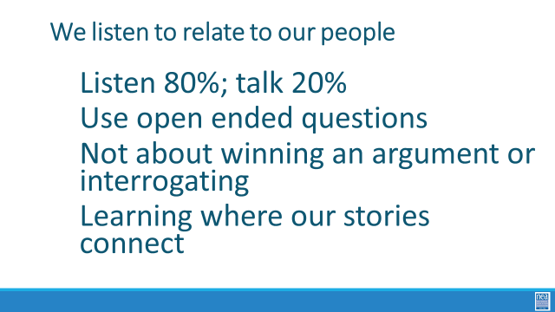  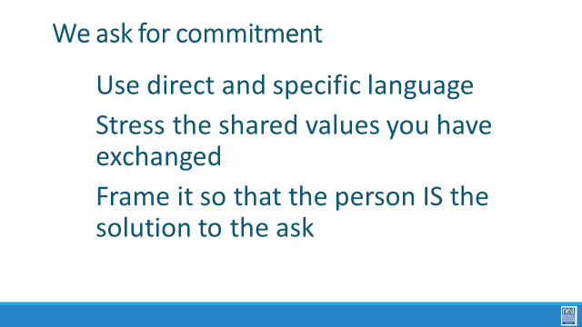  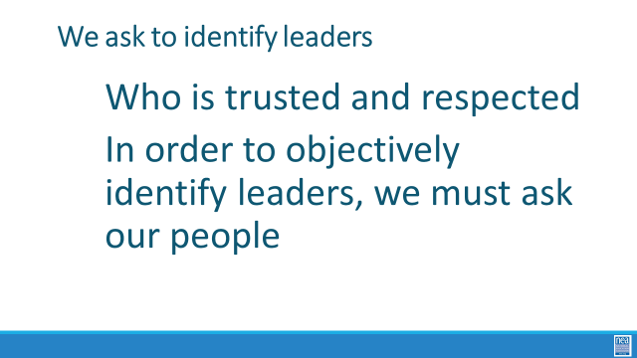  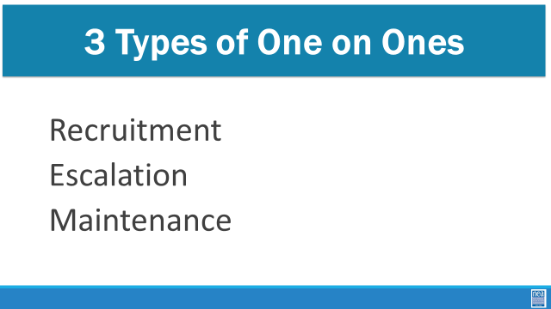  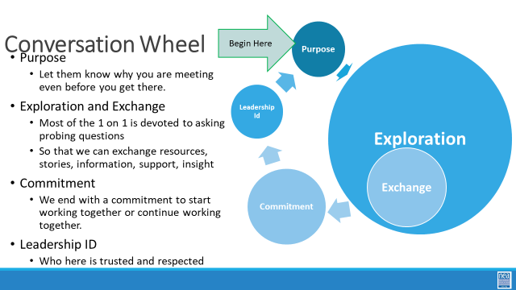      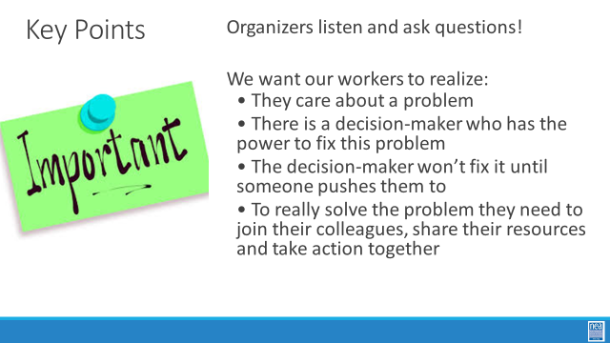 | How do we have effective organizing conversations to identify our issues? |  |  | - Minutes Total - ORGANIZING CONVERSATIONS  15 Minutes –Basics of One on Ones  Why do we want to build relationships?  Organizing is leadership that enables people to turn the resources they have into the power they need to make the change they want.  Power comes from our commitment to work together to achieve common purpose, and commitment is developed through our public relationships.  Show the quote – Organizing is a fancy word for relationships.  Relationships are Like in other parts of our lives, are based on shared values and shared purpose. Relationships are long-term. But remember, having shared values, a shared purpose and some skills & resources doesn’t mean that you have a relationship. If there is no commitment, there isn’t any glue in your relationship – it won’t last. A relationship with no commitment is not a relationship. If several people come to an association event but I don’t ask them to explicitly to make a commitment to joining me in this work, then they may have a relationship to with me, but not with the campaign or the association.  These are several ways you can build relationships but the one we will focus on now is the One-to-One. This is a great tool to identify leaders and recruit them into leadership teams. They are critical for building strong relationships in which both people grow and learn together over time. We use them to build community and commitment within a new leadership team. We use them to build deeper relationship with some people we may already know from other work.  Basics of One on Ones  We listen to relate to our people  - Listen 80%; talk 20%  - Use open ended questions  - Not about winning an argument or interrogating  - Learning where our stories connect  We listen to identify issues  - Use probing questions  - What’s not right?  - What would they change?  - How could our schools be even better for us and our students?  We ask for commitment  - Use direct and specific language  - Stress the shared values you have exchanged  - Frame it so that the person IS the solution to the ask  We ask to identify leaders  - Who is trusted and respected  - In order to objectively identify leaders, we must ask our people  There are three types of one on ones  Recruitment : These meetings happen at the start of a relationship to connect you and a new to you worker and establish a connection based on shared goals and values. The goals of the recruitment 1:1 are to make a personal connection, use your personal story to identify and gauge potential and interests, probe for a shared experience and connect on values, and lastly, pivot to engagement – that is, move the worker to action based on what you’ve discussed.  Escalation: These meetings are for workers who are ready to take the next step on the “ladder of engagement” in assuming more responsibility and taking on ownership of goals. First, recognize the accomplishments the worker has already made, then propose the idea of taking on this new leadership role. If all goes as planned and the  worker accepts, take the time to clearly lay out the responsibilities and expectations for this new role.  Maintenance: These meetings should occur regularly between you and each of your workers. This is an opportunity to catch up on a personal level, debrief recent actions taken by the workers and their team, and offer coaching. Maintenance 1:1s should be  scheduled regularly and proactively: do not wait for a problem to occur to schedule one. A good guidelineis to schedule a maintenance 1:1 every two weeks.  Having the conversation – The Conversation Wheel  Purpose- Let them know why you are meeting even before you get there.  Exploration and Exchange -Most of the 1 on 1 is devoted to asking probing questions So that we can exchange resources, stories, information, support, insight  Commitment -We end with a commitment to start working together or continue working together.  Leadership ID - Who here is trusted and respected  PRACTICE Organizing Conversations  30 Minutes for Activity  5 Mins - SET- UP ACTIVITY  Count off by 3s. 1’s are the organizers. 2 are the workers. 3 are the observers.  1’s form a line at the front of the room and all the 3’s will form a line at the back. 1s find a 2 that you want to recruit and have an organizing conversation with. -ONCE THAT IS DONE- 3s, find a pair to observe.  1s- Start a conversation and get to know this person – this is not a scenario. Get to know them as one union staff person to another. Work to identify shared values, their number-one workplace issue and find out as much as you can by only asking questions. It’s important that we use open-ended questions. Closed questions are yes/no questions.  Examples:  Closed question: “Do you like where you work?”  Open question: “What do you like about your job?”  Seek some sort of commitment  20 Mins- GROUP ACTIVITY- 1’s ask the questions, 2’s answer, 3’s observe  5 Mins- DEBRIEF/ WRAP-UP  - Whole group  - How did that go?  - What did we learn?  - Was it hard to only ask questions?  - Observers, what did you notice?  - KEY POINTS  - Listen and Ask Questions  - We want our workers to realize:  - They care about a problem.  - There is a decision-maker who has the power to fix this problem.  - The decision-maker won’t fix it until someone pushes them to.  - If your worker really wants this problem to be fixed, they have to join you and others in taking action.
2:00-2:15 |  |  |  | BREAK
2:15-3:00  Jessica & Halimah  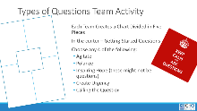  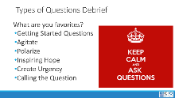  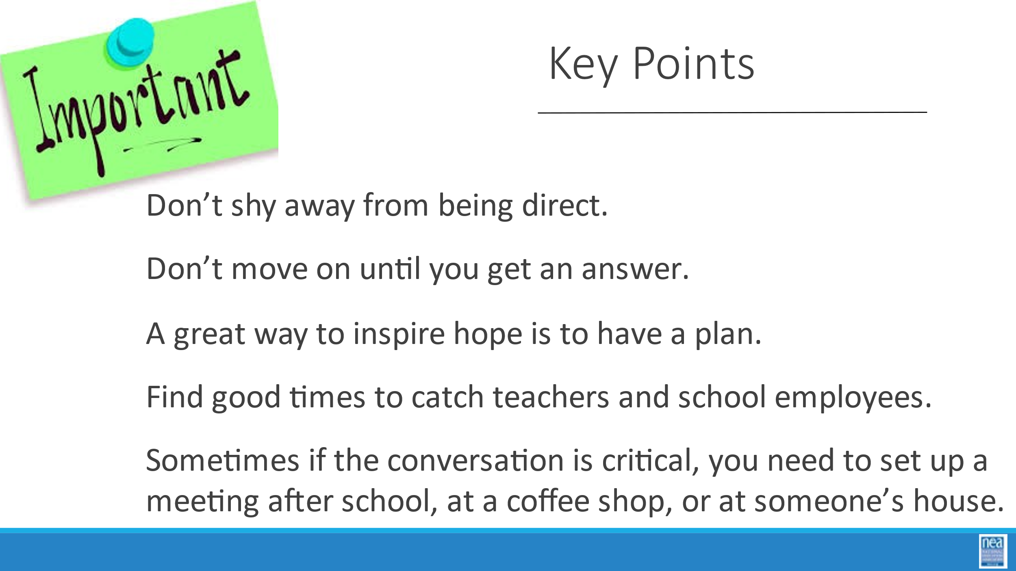   |  |  | SET-UP Blank Charts for Groups to Use | Types of Questions For Organizing Conversations  4 Min- ACTIVITY SET-UP  - Introduction: Nobody likes to be talked at or told what to think, but you can go really far in a conversation just by asking the right questions. Let’s review and brainstorm types of questions that are useful for having organizing conversations.  - Activity Setup:  - Working in teams you are going to create a chart with 5 sections AS SHOWN ON THE POWERPOINT  - In the middle section you will all write “Questions that start a conversation” Then, your team will choose four of any of the other types of questions listed:  - Agitate  - Polarize  - Inspiring Hope  - Create Urgency  - Calling the Question  - Define the different types of questions and their purposes  - Example: What does it mean to agitate and when would you use it?  15 min- GROUP ACTIVITY  - Facilitator notes in case they get stuck:  - Intro questions: What are some good questions to start a conversation?  - How is your day going?  - How long have you worked here?  - How have things changed since you started?  - Agitating questions: Once the other person has mentioned some issues, what are some agitating questions you could use to get this person fired up and figure out how strongly they care about an issue? (Brainstorm.)  - Is that okay with you?  - How long has that been going on?  - Is that how you would do things, if you were in charge?  - What would need to change to make your job more fulfilling?  - What would need to change for you to feel respected at work?  - Why do you think we’re having this problem?  - What does this mean for students?  - Polarizing questions: What are good polarizing questions you could use to get your co-worker to lay the blame for the problem, and move towards getting a commitment to action? (Brainstorm.)  - Who is in the position to fix this? What would they have to do?  - How much longer are you willing to put up with this?  - Is that ever going to get better if we do nothing  - Inspiring Hope: What examples can we share to inspire hope? (Brainstorm.)  - We have a plan for making this happen  - Do you know that other groups have done this before?  - I know there are others who feel the same way.  - Create Urgency  - The next step is the U in AHUY (urgency), connecting the plan to win to the need for immediate action. What examples can we share to inspire Urgency? (Brainstorm.)  - We can’t sit on problems.  - We have a timeline and we have to show the boss we are serious.  - Calling the Question  - And finally, getting a commitment is the “You” in AHUY. What kinds of questions can we use to ask for a commitment? (Brainstorm.)  - Can we count on you?  - Are you on board?  - Are you coming to the meeting?  5 Mins – DEBRIEF  - Share the best one for each category  3 Mins- WRAP UP/KEY POINTS  - Don’t shy away from being direct. Don’t move on until you get an answer.  - A great way to inspire hope is to have a plan. It’s the difference between praying it doesn’t rain and having ponchos and umbrellas ready to go. Having a plan inspires confidence.  - If we want to have quality conversations, we need to think about when we can reach people, when they will have time to talk.  - What are good times to catch teachers and school employees?  - Examples: Before school, during lunch, during prep time.  - Sometimes if the conversation is critical, you need to set up a meeting after school, at a coffee shop, or at someone’s house.  Review of the Rap for the Worksite Organizing Practice  4 Min- INTRODUCTION/SET-UP ACTIVITY  - Provide and Briefly review Worksite Organizing Practice RAP  - Ask everyone to pair up to practice the organizing conversation rap that will be used during the Worksite Organizing Practice.  - Explain that one person will play the organizer, and the other will be the worker.  - After 5 minutes you will let them know it’s time to switch roles and repeat the exercise. They may not complete the conversation, but they should get as far as they can.  10 Min- GROUP ACTIVITY  Group doing the rap in pairs. Have them switch in 5 minutes  4 Min- DEBRIEF  - Bring everyone back together as a large group.  - What was most challenging about the conversation?  - Do you think you got a sense of what the member’s issues and concerns were? How did you do this?  - What were some of the things you said that were effective in educating and agitating around the issue? What else could you have said?  - How did you specifically ask for the person’s commitment to participate? Did you get a firm commitment?
3:00-4:15  Jessica   | What is the purpose of our Worksite Organizing Practice? |  | Electronic Tracking to train  SET-UP: Chart for Setting Goals  Possible Materials  Website and Social media links for Local  General Summary of membership demographics  Overview of the Campaign the Worksite Organizing Practice s Supporting  Rosters, Scripts and any other Materials to be given out during Worksite Organizing Practice  Even though we are using VAN – have paper copies that allow participants to enter data using a pen and clipboard.  Rosters should include – Building Rep and Principal names and contacts,  Protocol for entering the building, address with zip code for GPS, Schedule of lunch times or planning times | Worksite Organizing Practice Prep  10 Min – Introduction and Overview of the Locals  20 Min – Context of the Campaign that the Worksite Organizing Practice is supporting  15 Min- DATA  How we will use NEA 360 (or other) and capture data.  What does this data look like at the end of the day.  5 Min. – SITE ASSIGNMENTS  Explain team assignments and how they will be assigned - this is also the place where the Worksite Organizing Practice lead will outline overall goals for the experience - and should prompt teams to set goals for their worksite. These will be recorded on a large chart at the front of the room.  10 Min- SITE MAPPING  - Exploration of the Team Folders - and team goal setting.  - Digest data provided  5 Min.- RECEPTION INFORMATION  Overview of who they are meeting at the evening reception and the purpose of who has been invited.  5 Minutes - Wrap up - show the overall goals for the visit  Note to Worksite Organizing Practice Lead –  As soon as you know the dates and target area that you will be doing be doing the Worksite Organizing Practice in, please begin ensuring that we will have access to the buildings, where and when we can talk to workers, and secure a leader that can serve as host to the site AND assist with driving the visiting team to the school. We usually have the teams be no larger than three – so that a leader can easily transport them in almost any vehicle to the worksite. NEA can provide – if needed- mileage for the drivers and up to $100 for a substitute if one is needed. A good target number is 10 to 15 worksites and 10 to 15 leaders.  About one month out from experience, please send a finalized list of names and numbers for WHO will be attending the evening reception to Ashley Spencer. This will allow her to contact them and make sure that there are no mobility or food issues she needs to make the conference facilities aware of.  About two weeks out, work with Ashley to determine any parking needs for the participants during the experience.  Two days out, reconfirm everything and everyone. |  | Participants will understand the context of a campaign in which their Worksite Organizing Practice is embedded.
4:15-4:30  Ellen   |  |  | Evaluation | Questions, Wrap-up and logistics  10 Mins- REFLECTION OF LEARNING  - How would this apply to your work?  5 Min- EVALUATION  - Access and complete Evaluation
4:30 – 5:00 |  |  | Choice Networking Suggestion Board | Adult choice networking and learning – any location, any topic
5:00 | ***ADJOURN***

