Foundations Academy Facilitator Agenda: Day #5
General Materials Needed: |  |  |  |  | Room Set-up:
1 Set of Handouts per Person  Name Tags  Table Tents  Sign-in Sheet  Agendas on the table (1 per)  Room signs |  | Chart Paper – Large Post-it Style  Post its – Regular size and large size (4’’x5”)  Index Cards – 3”x5”  Highlighters – 5 Colors – Pink, Orange, Yellow, green and blue  Chart Markers – non-permanent chisel tip  Pens and Pencils |  |  | Round Tables  Projector, Screen and Speakers  Carousel stations and reporting stations around the perimeter  40 people MAX  Material Boxes with Participant “toys” on each table  CHARTS :  Data from schools  Campaign plan
Key Outcomes for the Day:
Participate in a successful Worksite Organizing Practice debrief
Apply basic organizing campaign elements
Time | Essential Questions |  | Resources | Instructions, Activity and Debrief (Facilitators) |  | Outcomes
 | What question(s) should this learning section answer? |  | Charts, handouts, articles, materials, slide | What are you saying, what are they doing, what questions will you use to guide learning and make clear the important points  Include an estimate for how long each section of the learning will take |  | As a result of this section of learning, what will participants know or be able to do?
Jessica |  |  |  | Entry Activity- Affinity wall of issues and quantitative outcomes.  Team needs to make during the day of worksite visits:  - Chart with site locations and # of Cards and # of New Membership Forms #of conversation  DIRECTIONS: On the Worksite Charts add your team’s data to those On post-it notes, write work-site problems you heard while on your school visits. Please write one per post-it. Place these on the designated wall. As you put yours up, and you notice that it is similar to another one that is already posted, put yours near it… what we should achieve are groups of issues that are in the same category.
8:30- 8:40  Ellen  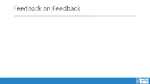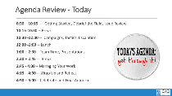  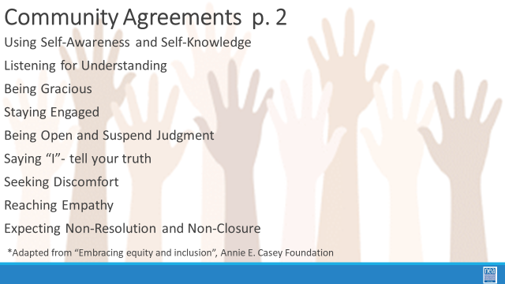 |  |  |  | 10 Mins- INTRODUCTION  Welcomes, review of agenda, norms, feedback and spirals |  | Final welcome and bring a burst of energy to the space.
8:40-9:00  Jessica & Halimah  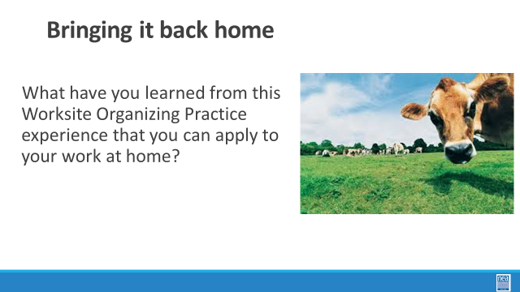    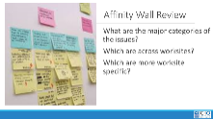  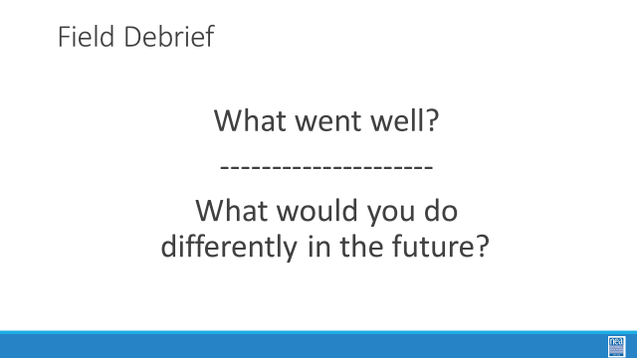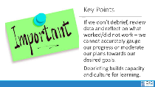 |  |  | SET-UP Chart of outcomes - Goals from the day before  SET- UP If possible, Pull up back end of data tracker to review outcomes. | Worksite Organizing Practice Visit Debrief  18 Mins- FACILITATED DISCUSION -DISCUSSION ABOUT APPLICABILITY  - What have you learned from this Worksite Organizing Practice experience that you can apply to your work at home?  - What are other strategies that you have for running a debrief?  2 Mins - WRAP UP/ KEY POINTS  - If we don’t debrief, review data and reflect on what worked/did not work – we cannot accurately gauge our progress or moderate our plans towards our desired goals.  - Debriefing builds capacity and culture for learning. |  | Participants will experience a well-designed debrief and
9:00-9:30  Jessica & Halimah |  |  |  | 30 Minutes--Affiliate Partner Debrief  - Celebrate the Outcomes  - What are the issue themes you surfaced  - What are challenges you surfaced  - Is there anything you can share that would help them next time  - Why is it important to debrief and not just move on to the next thing?
9:30-9:50  Hedy  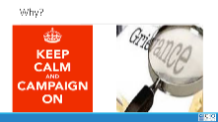  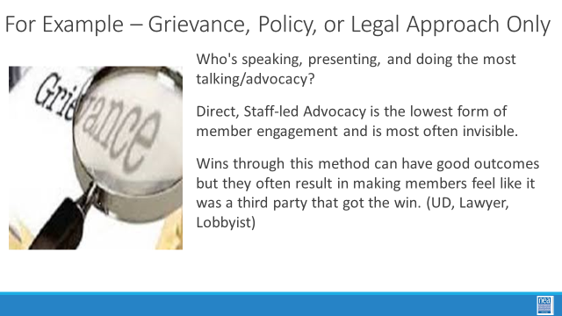  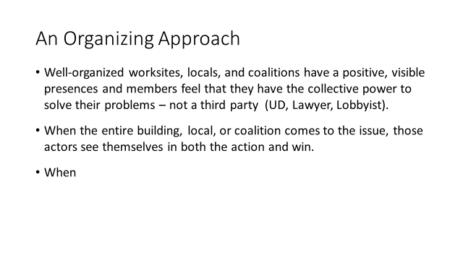  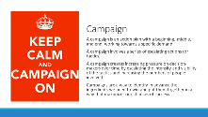  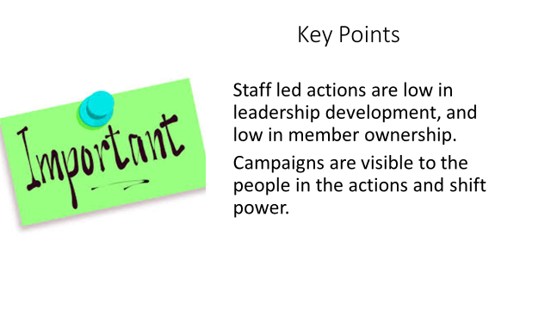 |  |  | Case Study in Organizing Scenario  Making a Plan (Labor Notes)  Campaign Worksheet | Why do we do campaigns--  Transition to Enchanted County- We are going to return to Enchanted County and the team that you have been working with. We will stay in these teams for the rest of our time. Please locate the list of issues that your team identified relating to the problem that your team has selected to focus on.  15 Mins – Content Presentation  - Why would we want to organize a campaign to solve an issue?  - Why not just file the grievance, get the lawyer to take the case, or have the lobbyist work with law makers?  - KEY POINTS TO PULL OUT-  - Grievances, Legal Actions, or Policy work done poorly and without members leading does not build power.  - These can build power when they are done right and help give people agency and voice.  - In your formal process you play a role, but how do you flip the power/focus in the room from you to a process that allows the member (coached and supported) to lead and self-advocate – this is when you help grow leadership and ownership  - Who is speaking, presenting, and doing the most talking/advocacy? When the entire building, local, or coalition comes to an action that is powerful!  - Direct, Staff-led Advocacy is the lowest form of member engagement and is most often invisible because there is very low leadership and ownership by the members – they are dependent on the staff for the outcome.  - Well- organized worksites, locals, and coalitions have a positive, visible presence and members feel that they have the collective power to solve their problems.  - Campaigns continually increase the amount of member leadership and member ownership of the issue, actions, and win. They build power.  4 mins – INTRODUCTION TO CAMPAIGN PLANS  - So why do we need campaigns? A campaign is an action plan with a beginning, middle, and end, working towards a specific demand that we want to win.  - A campaign has a target, someone who can give us what we want. It usually involves a series of escalating actions (or tactics), which means that we progressively turn up the heat.  - A good campaign creates increasing pressure on decision-makers over time by escalating the intensity and visibility of the tactics and increasing the numbers of people involved.  - Campaigns are a way to identify in advance the ingredients we need to win and put them together in a way that maximizes our chances of success.  - One isolated action may not be enough to solve the problem.  - Campaigns help us to shift the balance of power in our workplaces and build members’ confidence.  - Many issues that members care about can’t be solved with grievances.  - Besides, grievances are invisible to most members, because they don’t usually involve collective action.  - We need our actions to be participatory and public.  We are going to go through each of the key components of an organizing campaign and apply each to our scenario. Then, at the end, we will compile and present our final campaign plans for our scenarios.  1 MIN- WRAP UP/KEY POINTS  - Grievances are typically singular and don’t build people power  - Campaigns involve lots of people are member led and increase power and visibility of the union |  | Participants will think about how advocacy and organizing work together.
9:50 -10:20  Grat  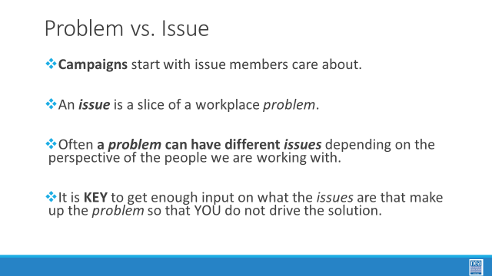  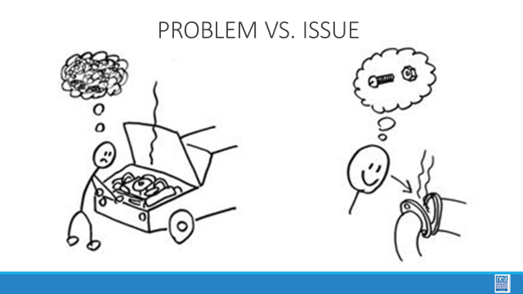  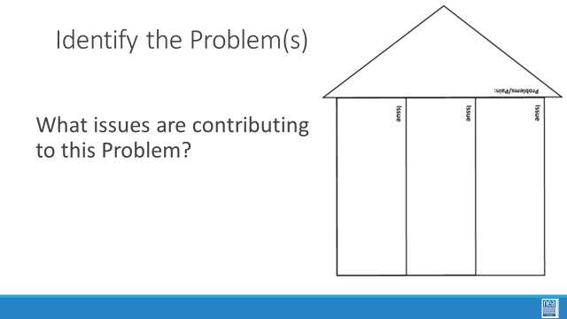  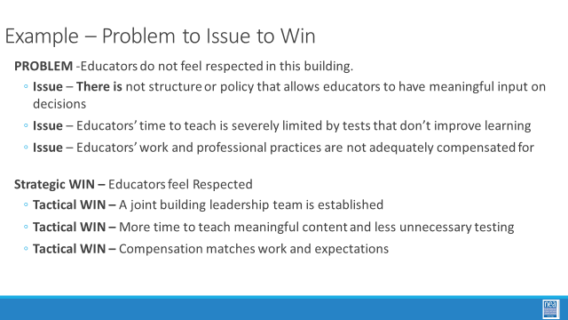  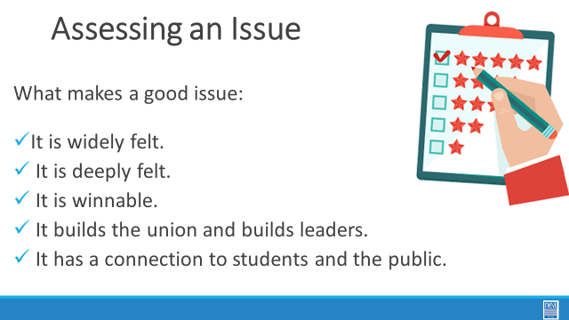  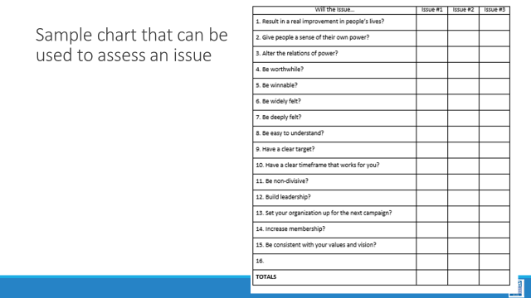  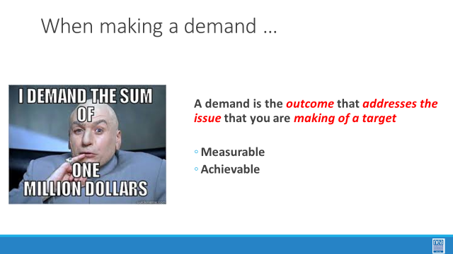  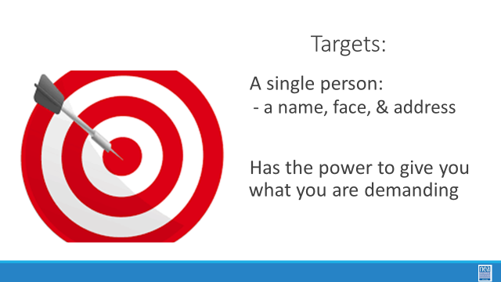  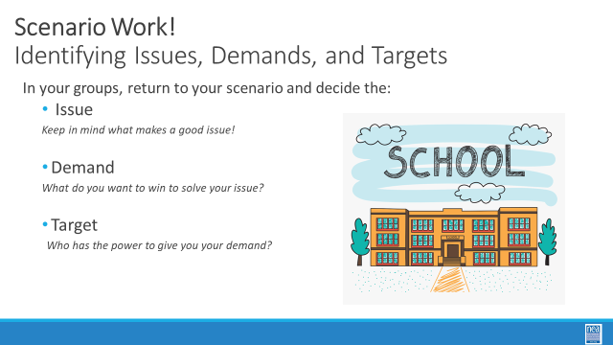  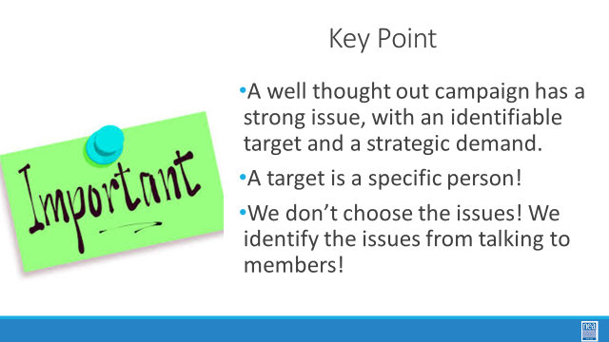 | What makes good organizing issues?  What is a demand?  How do we identify a target? |  | Case Study in Organizing Scenario  Making a Plan (Labor Notes)  Campaign Worksheet | 30 Minutes – Issues, Demands, Target  5 Min- IDENTIFYING AN ISSUE/ ACTIVITY SET-UP p104,111,112  PROBLEM vs. ISSUE, p. 105  - Campaigns start with issues members care about.  - An issue is a slice of a workplace problem.  - Often, a problem can have different issues depending on the perspective of the people we are working with.  - It is key to get enough input on what the issues are that make up the problem so that YOU don’t drive the solution.  - A staff-driven solution may not meet the needs and commitment of the people you are working with.  How to select an issue, p. 104  - Since there may be many issues confronting workers on the job, we have to also think about what makes a good issue to organize around.  - CRITERIA:  - It is widely felt.  - It is deeply felt.  - It is winnable.  - It builds the union and builds leaders.  - It has a connection to students and the public.  3 Mins Total- INTRODUCE DEMAND and Set Up p.107  - A demand is what the group wants– the win –  - A demand is the outcome that addresses the issue you are making of the target  - If the issue is what is wrong, the target is what we want that will fix the issue.  3 Min- INTRODUCE TARGET p. 107  - The last idea that we want to cover is Targets.  - TARGET: A target is a single person with a name and an address. The target is the person with the power to give the workers the change they are asking for. A target has a name, a face and an address.  17 Mins – GROUP WORK  In your groups, return to your scenario and decide the:  Issue Keep in mind what makes a good issue!  Demand What do you want to win to solve your issue?  Target Who has the power to give you your demand?  2 Min- WRAP UP/KEY POINTS  - A well thought out campaign has a strong issue, with an identifiable target and a strategic demand.  - A target is a specific person!  - We don’t choose the issues! We identify the issues from talking to members!
10:20-10:55  Jeny  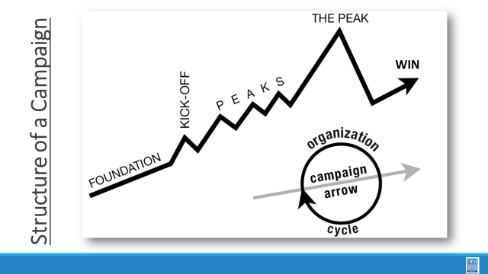  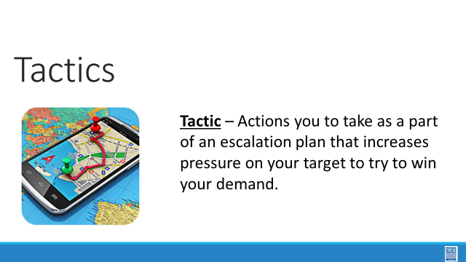  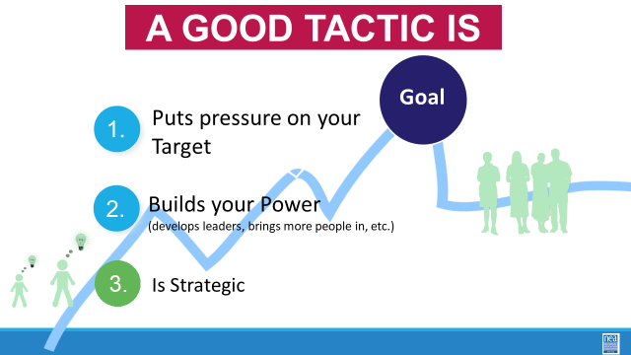  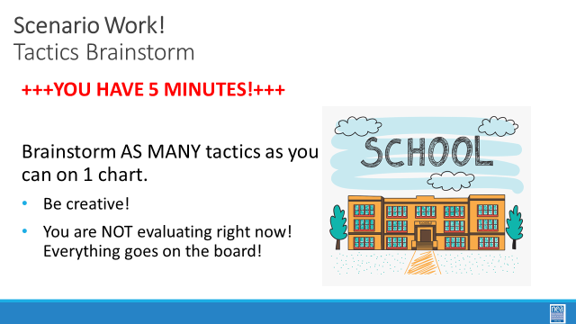  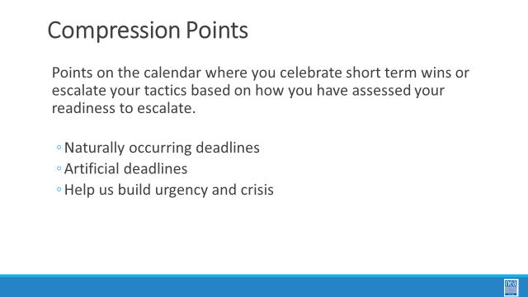  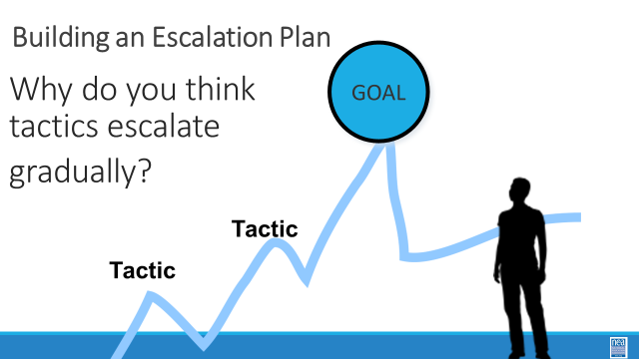  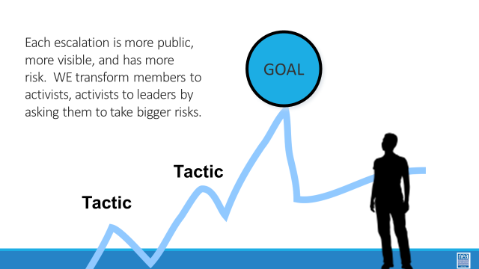  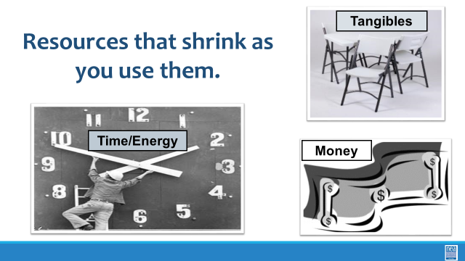    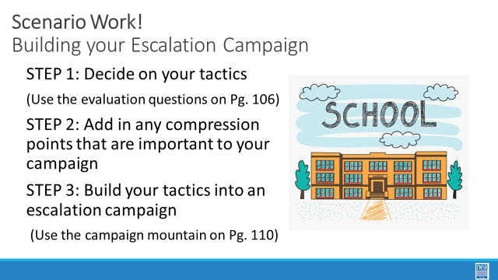  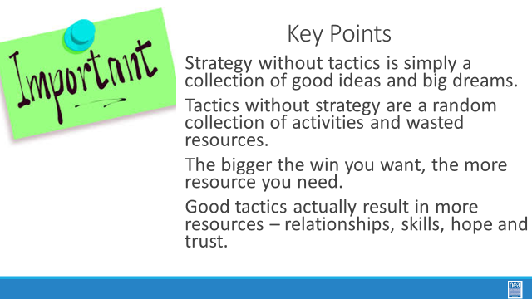 | What are the strategic actions and use of resources we will use to achieve our demand? |  | Case Study in Organizing Scenario  Making a Plan (Labor Notes)  Campaign Worksheet | 35 Minute Total –Tactics and Escalation  Tactics – p 111  Escalations – p 112, 113-114  5 Mins- INTRODUCE Campaign Mountain p. 103, 108-110  - Foundation – gather info, id issues, id leadership team  - Kick-off –public event that indicates what the issue, demand, and targets are  - Escalating peaks of activity that should escalate in  - Risk  - Capacity (people, resources, engagement)  - Increase leadership and ownership  - Campaign Compression Points  - THE PEAK – The most public, risky, momentum, engagement, and resources  - The Win- We achieve our demand  - Debrief, regroup, and continue to climb  2 Mins- INTRODUCE Tactics  Next we are going to talk about Tactics.  Tactic are Actions you to take as a part of an escalation plan that increases pressure on your target to try to win your demand.  What are some examples of tactics? (Have a few people share out some tactics)  We are going to model a tactics brainstorm that you can use when working with members.  5 Minutes Scenario Work  Brainstorm AS MANY tactics as you can on 1 chart.  - Be creative!  - You are NOT evaluating right now! Everything goes on the board!  We are going to have 5 minutes to list as many tactics as you can. Extra points for super creative ideas. WE ARE NOT. NOT. NOT. Evaluating tactis at this time. If someone says something (example- We are going to wear the same clothes without washing them until we get what we want) you right it down and move on. All ideas get on the board. Again, this is a brainstorm. NO EVALUATING.  YOU HAVE EXACTLY 5 MINUTES. After 5 minutes put your pens down.  Open your phone and actively start a timer. “ON YOUR MARKS. GET SET. GO”  Excellent! We now have a whole list of tactics. Next. We are going to assess our tactics. For this, I encourage you to use a list of questions like this-  3 minutes- How to evaluate a tactic  - Does the action relate to your issue?  - Will it increase the pressure on the decision-maker?  NOTE! This means that we have to engage in actions that make our target uncomfortable. SOOOOO the same old tactics WON’T WORK! They are used to them!  - ^{Is it visible?}  - ^{Is it timed for effect?}  - Is it new and different—or tried and true?  Note! SEE above. If a tactic is the same as always, your target has likely become comfortable with it AND it won’t develop new skills in your members and therefore build your power.  - Are enough people ready to do it?  - ^{Will it unify people?}  - ^{How will management react?}  - Does it violate the law? (If so, are we prepared for the consequences?)  NOTE! This doesn’t mean that it is off limits. Historically, breaking laws has been a big part of social justice movements. ESPECIALLY THE LABOR MOVEMENT! However, we have to consider if an unlawful tactic is the right tactic and whether you have the power to mitigate/absorb the consequences.  - ^{Will it be fun?}  Folks want to engage in things that fill them up! Many of the same old  10 minutes- Evaluating your tactics  You have 10 minutes. Look at your list of tactics.  - Circle the ones that you think are strategic, when looking at these questions.  - Cross out the ones that are NOT strategic.  2 Minutes – Compression Point Definition  - Points on the calendar where you celebrate short term wins or escalate your tactics based on how you have assessed your readiness to escalate.  - Naturally occurring deadlines  - Artificial deadlines  - Help us build urgency and crisis  2 Minutes – Turn and Talk  We keep saying that tactics should escalate gradually why do you think that is?  2 Minutes – Debrief  Each escalation is more public, more visible, and has more risk. WE transform members to activists, activists to leaders by asking them to take bigger risks  2 Minute – Just a word about resources  RESOURCES: Resources are what are available to the people who are part of the campaign to use to achieve their demand.  Resources that shrink as you use them  - Time/Energy  - Tangible Items – materials  - Money  Resources that Grow as you use them  - Relationships  - Skills  - Hope  - Trust  2 Minute on Key Points  - Strategy without tactics is simply a collection of good ideas and big dreams.  - Tactics without strategy are a random collection of activities and wasted resources.  - The bigger the win you want, the more resource you need.  - Good tactics actually result in more resources – relationships, skills, hope and trust. |  | Participants will practice creating a campaign plan with all the required elements.
10:55-11:30  Barb  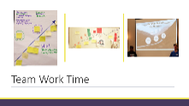 | What does a campaign look like? |  | Making a Plan (Labor Notes)  Campaign Worksheet | Team Time to Complete a Campaign Plan Visual and prep to present to other teams.  - STEP 1: Finalize the tactics you are going to use  (Use the evaluation questions on Pg. 106)  - STEP 2: Add in any compression points that are important to your campaign  - STEP 3: Build your tactics into an escalation campaign  (Use the campaign mountain on Pg. 110)  You should build a chart with your campaign plan on it to present!  Debrief-  Have each group present their plan. Breakup as needed for time allowance. |  | Participants will practice creating a campaign plan with all the required elements.
11:30-12:00  Barb | What have we learned? |  | Team Coaching Handout | 30 Mins Group Presentations  Groups of Teams - following the guidance document, you will each present your plans
12:00- 1:00  Ellen     | Who do we remember and thank? |  | SET UP- Room with chairs in a circle. NEA support staff prepares the final certificates, and these are placed randomly under the seats | 5 mins – FACILITATOR GRATITUDE/FAREWELL  - Presenters take a few minutes to give their gratitude/farewells to the group before transitioning to the circle.  50 Mins -Celebration Circle  SET UP- Room with chairs in a circle. NEA support staff prepares the final certificates, and these are placed randomly under the seats – leave seats without any certificates under them for the facilitators  - Tell participants to sit in a chair that has a piece of paper under it  - Ask people not to look at the paper under their chair until you tell them to.  - It is time to share gratitude for our time together and for each other. We came here as learners and leaving as a community that is still learning. Along the way, we have each had the opportunity to engage with everyone in the room.  - Please take the certificate from under your seat, read the name to yourself. IF you have gotten your own, raise your hand, and I will make the trades.  - As soon as someone is ready, they will volunteer to describe a memory from this week, a gratitude or some other positive affirmation about the person named on the certificate you are holding. The first person presents, and THAT person that was presented to, presents and so on. If there comes a time when there is a break – then just ask for another willing person to restart.  5 Min. FINAL CLOSING  - Thank participants, bid them farewell, remind them of the and remind them to check in for other UniServ Development Opportunities.
1:30 | ***ADJOURN***

