Facilitator Agenda: Advancing LGBTQ+ Justice Day # 3
General Materials Needed: |  |  |  |  | Room Set-up:
1 Set of Handouts per Person  Name Tags or Name Tents  Sign-in Sheet  UBL Form Folder  Agendas on the table (1 per)  Room signs, sign in signs |  |  | Chart Paper  Markers  Post its  Index Cards  Highlighters – 3 colors  Chart Markers – non-permanent  Pens and Pencils |  | Round Tables  Projector, Screen and Speakers  Carousel stations and reporting stations around the perimeter  50 people
Key Outcomes for the Day
Participants will be able to build a campaign of escalating of tactics designed to target an LGBTQ+ issue within a scenario
Participants will understand that collective action is the way to address systemic issues of injustice
Time | Essential Questions | Resources |  | Instructions, Activity and Debrief (Facilitators) |  | Outcomes
 | What question(s) should this learning section answer? | Charts, handouts, articles, materials, slide |  | What are you saying, what are they doing, what questions will you use to guide learning and make clear the important points  Include an estimate for how long each section of the learning will take |  | As a result of this section of learning, what will participants know or be able to do?
8:30-8:50  Ellen  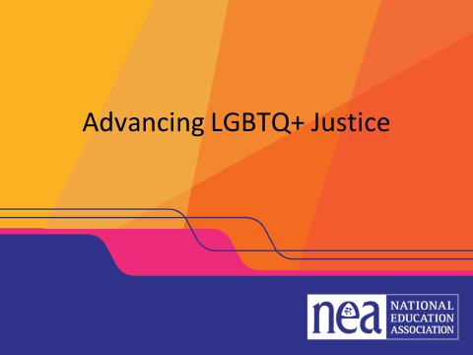  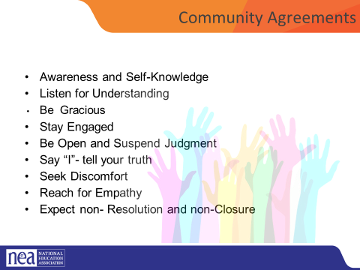    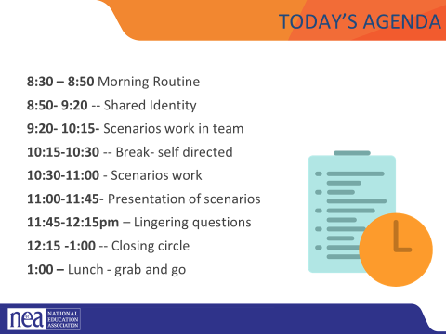 |  |  |  | -START- 8:30 am  - Intro, revisit group agreements, feedback/ Questions/Needs/Etc. Last minute logistics (20 minutes) |  | Participants will understand how their learning for the day will be structured.
8:50-9:20  Colleen/Michelle    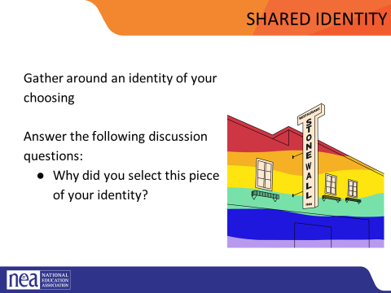  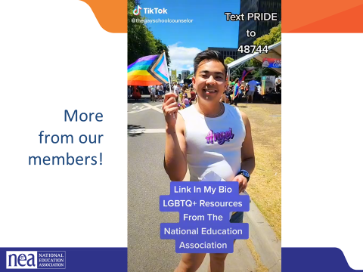  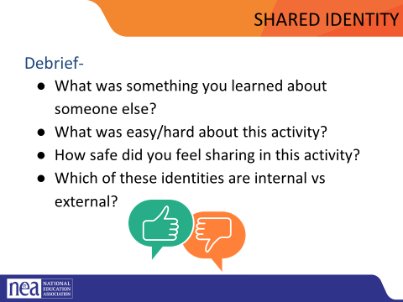  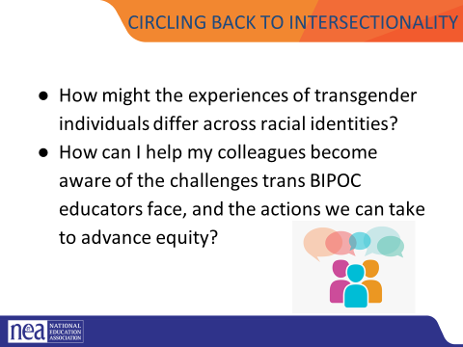 |  | Video  https://docs.google.com/presentation/d/1iw4K2ibF4PRp79A-CN9qeqv6b-VoNe6T/edit#slide=id.p86 |  | Shared Identity Activity - Highest risk, content groups (30 minutes)  Post the following identities around the room:  - High risk (day 3) – religious, spiritual, agnostic, immigrant, LGBTQ+, non-traditional family, first in your family to...  Participants will get up and gather around an identity of their choosing (2 min instructions), then they will answer the following discussion questions (8 min):  - Why did you select this piece of your identity?  - What are some challenges you face with this identity?  Share out/debrief (5 min)  - What was something you learned about someone else  - What was easy/hard about this activity?  How might the experiences of transgender individuals differ across racial identities?  How can I help my colleagues become aware of the challenges trans BIPOC educators face, and the actions we can take to advance equity? |  | Participants will reflect on how the intersectional aspects of each person’s identity continue to inform their relationship to privilege and oppression.
9:20-10:00  Sara    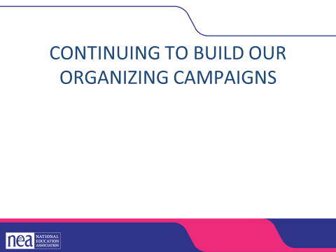  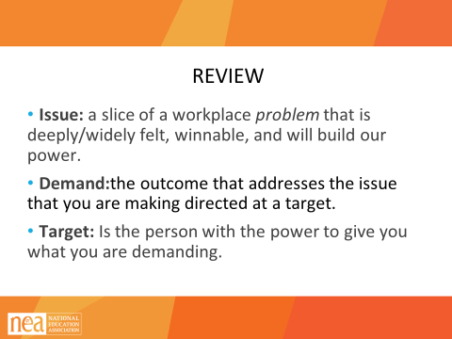  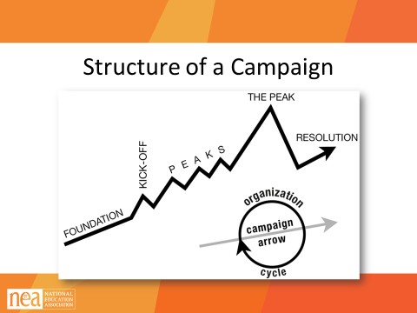  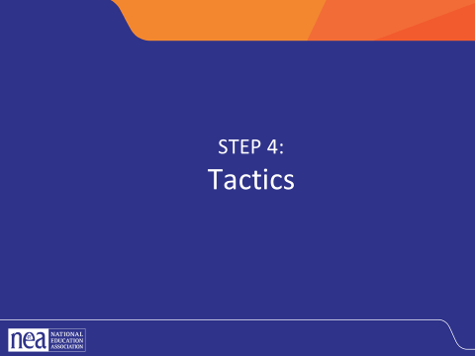  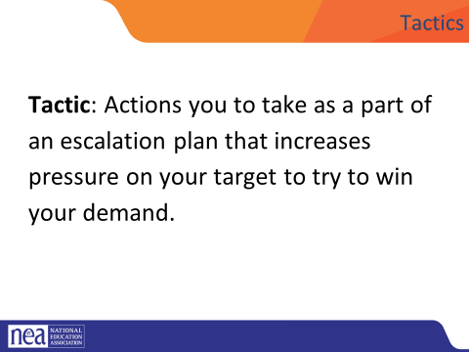  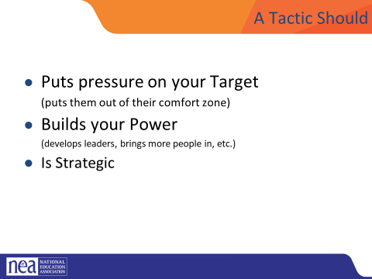  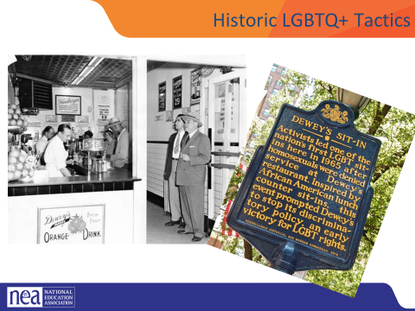  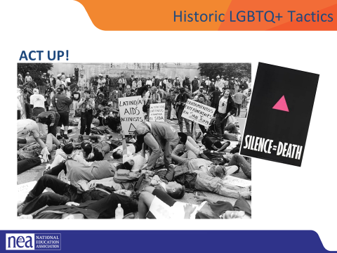  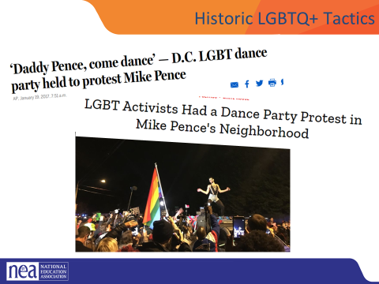  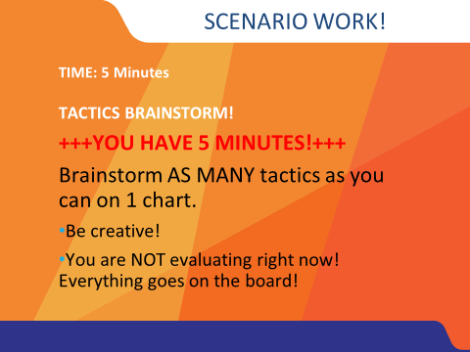  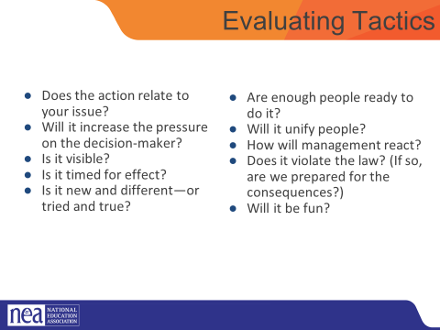  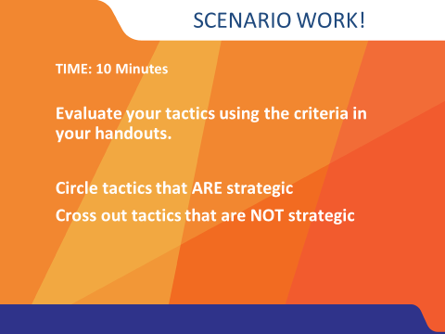  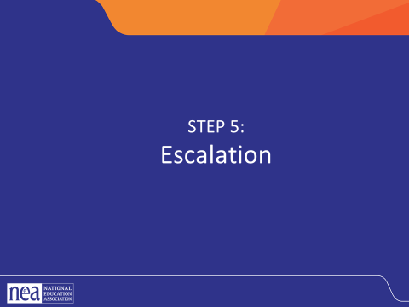  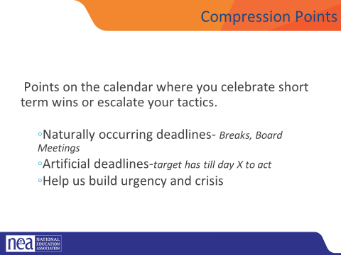  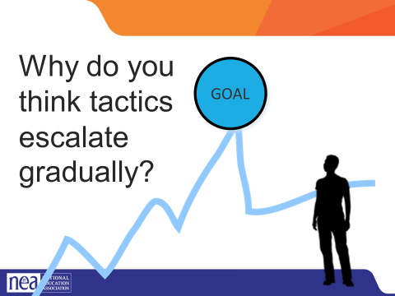  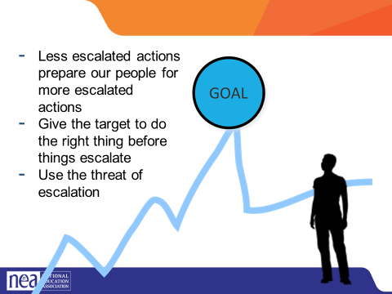 |  |  |  | Tactics and Escalation (40 Mins)  Mins- INTRODUCE Campaign Mountain  - Foundation – gather info, id issues, id leadership team  - Kick-off –public event that indicates what the issue, demand, and targets are  - Escalating peaks of activity that should escalate in  - Risk  - Capacity (people, resources, engagement)  - Increase leadership and ownership  - Campaign Compression Points  - THE PEAK – The most public, risky, momentum, engagement, and resources  - The Win- We achieve our demand  - Debrief, regroup, and continue to climb  1 Mins- INTRODUCE Tactics  Next we are going to talk about Tactics.  Tactic are Actions you to take as a part of an escalation plan that increases pressure on your target to try to win your demand.  A tactic should  Puts pressure on your Target  (puts them out of their comfort zone)  Builds your Power  (develops leaders, brings more people in, etc.)  Is Strategic  What are some examples of tactics? (Have a few people share out some tactics)  look at some historical LGBTQ+ tactics - creative, engaging, maybe fun, and very public  We are going to model a tactics brainstorm that you can use when working with members.  5 Minutes Scenario Work  Brainstorm AS MANY tactics as you can on 1 chart.  - Be creative!  - You are NOT evaluating right now! Everything goes on the board!  We are going to have 5 minutes to list as many tactics as you can. Extra points for super creative ideas. WE ARE NOT. NOT. NOT. Evaluating tactic at this time. If someone says something (example- We are going to wear the same clothes without washing them until we get what we want) you right it down and move on. All ideas get on the board. Again, this is a brainstorm. NO EVALUATING.  YOU HAVE EXACTLY 5 MINUTES. After 5 minutes put your pens down.  Open your phone and actively start a timer. “ON YOUR MARKS. GET SET. GO”  Excellent! We now have a whole list of tactics. Next. We are going to assess our tactics. For this, I encourage you to use a list of questions like this-  3 minutes- How to evaluate a tactic  - Does the action relate to your issue?  - Will it increase the pressure on the decision-maker?  NOTE! This means that we have to engage in actions that make our target uncomfortable. SOOOOO the same old tactics WON’T WORK! They are used to them!  - ^{Is it visible?}  - ^{Is it timed for effect?}  - Is it new and different—or tried and true?  Note! SEE above. If a tactic is the same as always, your target has likely become comfortable with it AND it won’t develop new skills in your members and therefore build your power.  - Are enough people ready to do it?  - ^{Will it unify people?}  - ^{How will management react?}  - Does it violate the law? (If so, are we prepared for the consequences?)  NOTE! This doesn’t mean that it is off limits. Historically, breaking laws has been a big part of social justice movements. ESPECIALLY THE LABOR MOVEMENT! However, we have to consider if an unlawful tactic is the right tactic and whether you have the power to mitigate/absorb the consequences.  - ^{Will it be fun?}  Folks want to engage in things that fill them up! Who had a tactic that they would be excited to participate in?  10 minutes- Evaluating your tactics  You have 10 minutes. Look at your list of tactics.  - Circle the ones that you think are strategic, when looking at these questions.  - Cross out the ones that are NOT strategic.  2 Minutes – Compression Point Definition  - Points on the calendar where you celebrate short term wins or escalate your tactics based on how you have assessed your readiness to escalate.  - Naturally occurring deadlines  - Artificial deadlines  - Help us build urgency and crisis  2 Minutes – Turn and Talk  We keep saying that tactics should escalate gradually why do you think that is?  2 Minutes – Debrief  Each escalation is more public, more visible, and has more risk. WE transform members to activists, activists to leaders by asking them to take bigger risks  Some points to make if they are not said by the group  - Less escalated actions prepare our people for more escalated actions  - Give the target to do the right thing before things escalatee the threat of escalation |  | Participants will create a campaign composed of escalating tactics.
10:00-11:00  Grat    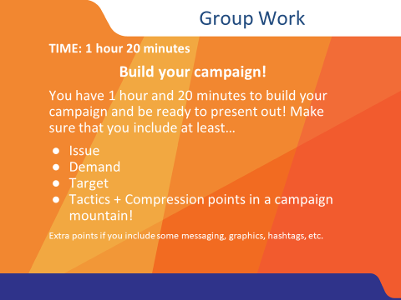 |  |  |  | Team Time (60 Minutes)  - Work on scenario- in teams  - Scenario description in day two- can be placed here for reference or here in enough time is not available in day two |  | Participants will create a campaign composed of escalating tactics.
10:15-10:30 | BREAK- self directed
11:00-11:45  Barb    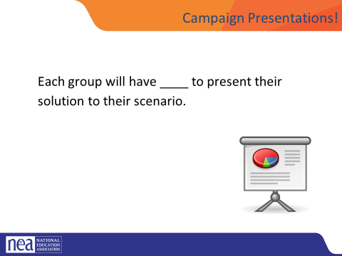 |  |  |  | Present Scenario work |  | Participants will create a campaign composed of escalating tactics.
11:45- 12:15  Jeny/Linda    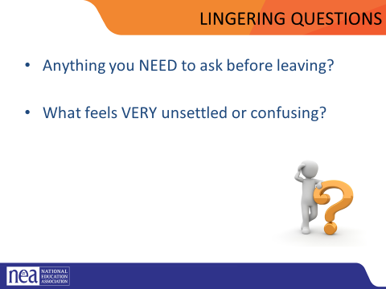 |  |  |  | A possibility –  Have the same campaign groups look at their scenario and try to apply a legal approach. What would that look like? What are the limits of doing that? What are the benefits of doing that? How many and who are engaged in this approach?  HOLD: If anything comes up, etc. If not....  Lingering questions/Bringing this work back home- Some sort of gallery walk/Affinity wall, etc.
12:15 | Circle |  |  | Closing activity- circle
1:00 | Bagged LUNCH
 | ADJOURN

