Facilitator Agenda Day 2 - Effective Worksite Leadership Systems
General Materials Needed: |  |  |  |  | Room Set-up:
1 Set of Handouts per Person  Name Tents with the Norms  Sign-in Sheet  Agendas on the table (1 per)  Room signs, sign in signs  One ream of white photocopy paper  Chart Paper (4 to 5 full w Sticky Strip) |  |  | Materials Box for each table with:  Markers (Mr. Sketch variety)  Post its – 3x3” and 4X5” sizes  Index Cards  Highlighters – 4 colors  Pens and Pencils  Participant “toys” |  | Round Tables  Projector, Screen and Speakers  Carousel stations and reporting stations around the perimeter  50 people
Key Outcomes for the Event:
Participants will learn a number of strategies for identifying and tracking leaders
Participants will learn about task design and its importance in testing and developing leaders
Participants will learn key concepts of effective coaching and its importance in developing teams
Participants will explore and be able to design the types of structures required to effectively build and use power
Time | Essential Questions | Resources |  | Instructions, Activity and Debrief (Facilitators) |  | Outcomes
 | What question(s) should this learning section answer? | Charts, handouts, articles, materials, slide |  | What are you saying, what are they doing, what questions will you use to guide learning and make clear the important points  Include an estimate for how long each section of the learning will take |  | As a result of this section of learning, what will participants know or be able to do?
7:00-8:30 | Breakfast, Facilitator Prep
Entry Activity  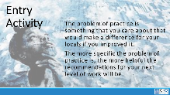 | What is your leadership development or leadership structure challenge that you brought from home?
8:30 - 9:00  Ellen (Heidi)  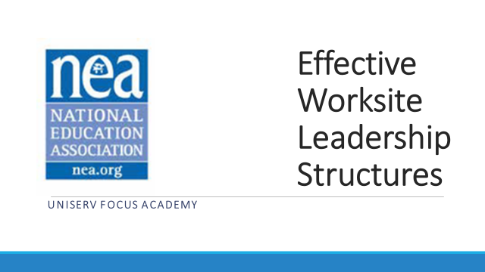  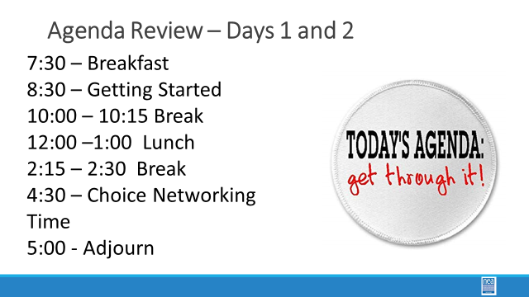  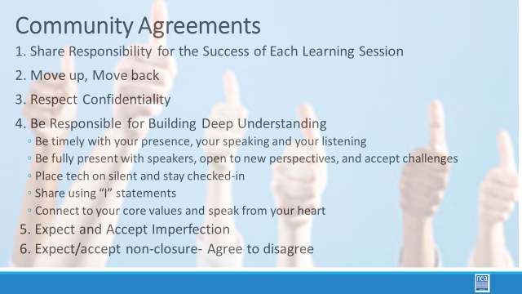  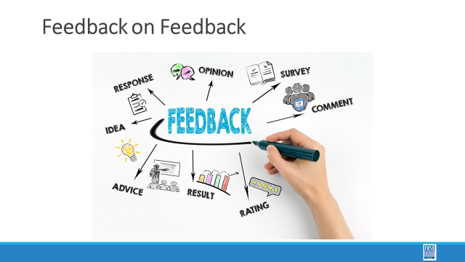 | What have you been thinking about so far? |  |  | 30 min- Welcome back  Norm Review  Reentry  Feedback on Feedback  Today, we are going to turn again to looking at leaders and structures but with more of an eye towards coaching and testing – here is what we mean by testing – if you agreed you would do it, did you? Why or why not? |  | Participants will re-enter the learning environment.
9:00 – 9:45  Albert  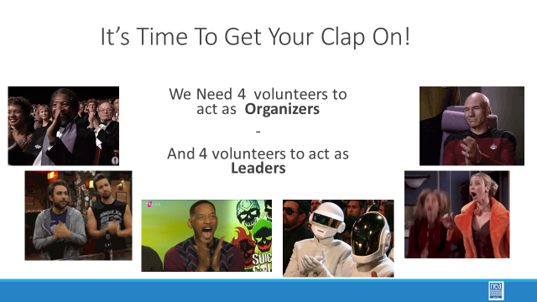  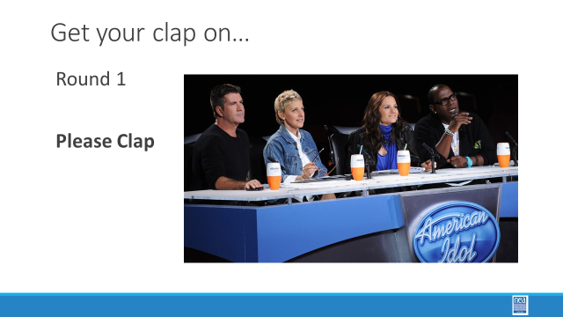  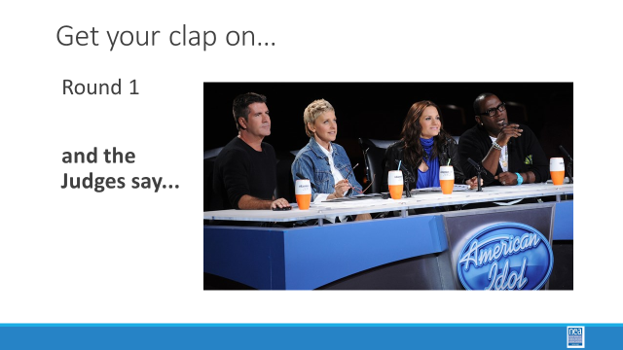  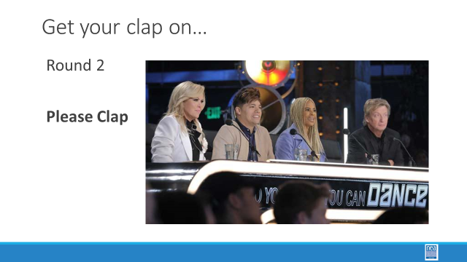  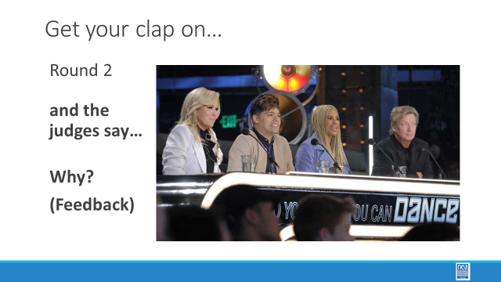  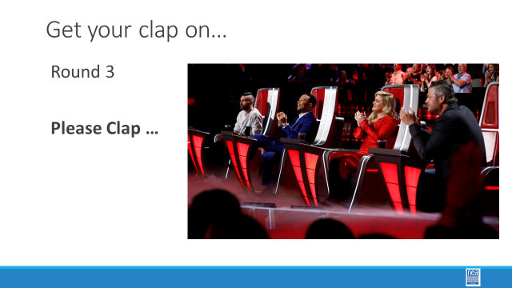  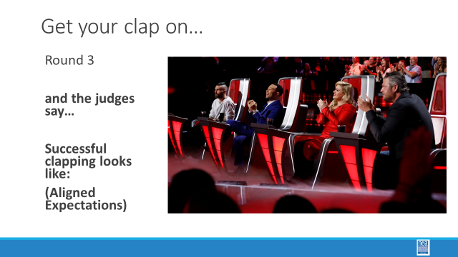  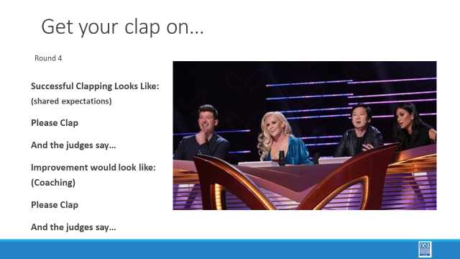  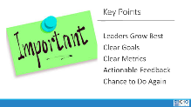 | Why does it matter what we ask for and how we follow up? | Facilitator Directions for Clapping Activity  https://neahq-my.sharepoint.com/:w:/g/personal/eholmes_nea_org/EeYQnxJT0cNLuiPHo7o2X3kBWiaXMmWhwAvfiSoqpuPH2g?e=TrvNwl |  | 45 Mins TOTAL - Leader Development  20 Mins Activity  Need: 4 Organizers and 4 Potential Leaders  Chart and markers for keeping score of each performer and recording criteria that judges set.  Place four chairs at the front of the room for the Organizers to sit. Send the four potential leaders out of the room where they cannot hear – and have a facilitator colleague ready to get them when it is their turn. (Lakilia and Heidi)  Directions to the Potential Leaders:  Please leave the room and I will be calling you back one at a time.  Directions to the Organizers:  Come to the four chairs at the front of the room. You may not ask me any questions and you may not discuss anything with each other until I prompt you to. You will be assessing each of the four Potential Leaders ability to clap. You will give them a score of 1 to 4.  Round one: Ask the first person to enter to clap. Answer no clarifying questions. Please clap. Turn to the organizers and say - With no discussion amongst yourselves, give the person a score of 1-4. You may not give feedback to the clapper. (just a number)  Facilitator records scores on chart in Column 1.  Round two: Directions to the Organizers – I am going to ask the second person to clap. This time - Without discussion amongst yourselves give the person a score of 1-4 AND you may tell the person why you gave the score you did. (provide feedback)  The second leader comes in, is asked to clap – no clarifying questions in advance. Facilitator records scores in column 2 then asks the Organizers to say WHY they gave the score they did.  Round Three: Before you ask the third person to clap, ask the organizers to take 3 minutes and identify some criteria/goals for the scores. Facilitator records criteria on a sheet under the score sheet and does not share them with the Leader. Ask the third person to clap, don’t answer any clarifying questions, organizers give them a score and let them know why they got the score they did BASED on the criteria they had discussed. Record the scores in column 3. (Prior alignment of expectations and feedback for improvement)  Round Four: Using the criteria you set before, ask the fourth person to come in and share the criteria that they will be judged by. Ask them to clap. Give them a score of 1-4 with feedback about how they could improve – record those scores and then ask them to repeat their performance and repost scores.  (System of expectations, ability to commit to the expectation and feedback that causes growth)  Facilitator posts criteria, posts scores, records feedback, posts scores  10 Mins Debrief -  Key points-  Clear Goals and Actionable Feedback help people become leaders  We grow best when we know the target and receive clear coaching |  | Participants will understand the link between clear expectations, accountabilities and actionable feedback and the development of leaders
9:45-10:15  Yvie and Zac  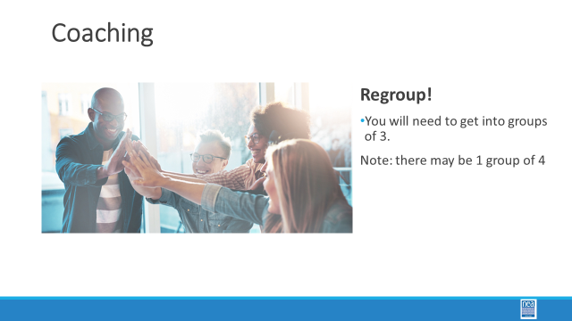  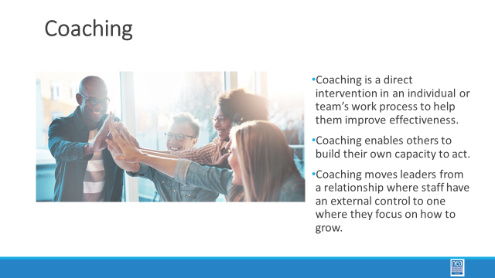  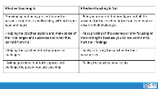  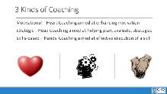  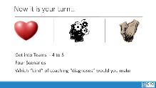  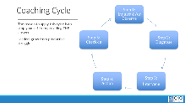  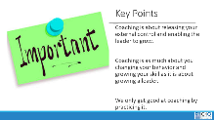 | How do move from external control to growth? | Coaching Cycle Content  https://neahq-my.sharepoint.com/:b:/g/personal/eholmes_nea_org/EVpxb9PHbGlJjVpBObxnlYwBA3-yw699g01SAEaviGncEg?e=ZWlG4v  Coaching Cycle  Handout  https://neahq-my.sharepoint.com/:f:/g/personal/eholmes_nea_org/EnXc1RlLN91Fk32_9zu876oB4kHXrBzpk6s_wV_G8pGJyw?e=jnBdCn |  | 60 Mins Why is coaching an important practice?  10 mins – Content for coaching (All comes from the content handout, pp) - Provide the definition of coaching we are going to use in this training. Share why we think this model of coaching is useful, and what is the difference between good coaching and bad coaching.  25 Mins – Teams will work through the four scenarios and identify which of the three types of coaching might be required. (p.43-49)  Game time decision on breaking them up or allowing them to select groups.  20 Mins – Debrief by going over the responses from the teams. Facilitate dialogue and questions between teams as opposed to you “leading and lecturing. “  5 min Key points to draw out – when we coach we are releasing the external control we have and allowing for the individuals to grow. It is really step 4 and 5 that several struggle – for a variety of reasons. We only get good at coaching by doing it. We use a coaching framework to break the habit of “diagnose and direct” which takes away the person’s ability to rise as a leader. |  | Participants will understand a framework for coaching in organizing and apply it to scenarios.
10:15 – 10:30   | BREAK
10:30-11:00  Continuation from Above |  |  |  | 60 Mins Why is coaching an important practice? (Continued from before Lunch)
11:00-12:00  Terri  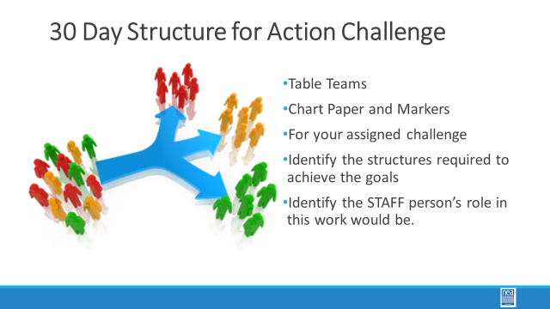  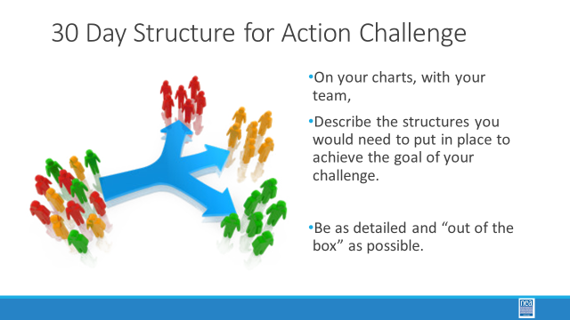  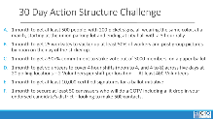  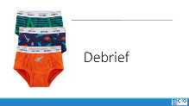  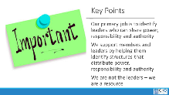 |  |  |  | 60 Mins TOTAL Structure design activity:  5 Mins – Each Table will tackle on of the action challenges (A-F) Teams will identify the kinds of structures that would be required to achieve each of these goals AND will discuss what the STAFF person’s role in this work would be.  Count participants off by 6 to get into teams.  Some assumptions you can make – this is a local with a group of engaged leaders who readily “own” the work of the union. There is a healthy union presence and they already are used to doing some member led organizing – in other words – presume some leadership and some basic structures already exist these are not “dead” or non-present locals.  30 Mins group work - How will the action get done Scenarios –  - 1 month to get 500 people, with 200 picket signs, all wearing the same color, at a march, starting at the union parking lot and ending at city hall with a 3 hour rally  - 1 month to get 25 worksites to sticker up at least 50% of workers and post group pictures by noon on the day of the sticker up.  - 1 month to get a 90+% commitment to strike vote out of 3000 members  - 1 month to get volunteers to cover 200, 4 hour shifts (noon to 4, and 4 to 8) across five days at 20 polling locations  - 1 month to get 10,000 certified signatures for a ballot initiative  - 1 month to secure 50 canvassers who will do a GOTV including a lit drop in your endorsed candidate’s district.  25 mins Debrief and discussion-  Present their chart. 2 minutes to share out.  Key Points:  - Our primary job is to identify leaders who can share power, responsibility and authority  - We support members and leaders by helping them identify structures that distribute power, responsibility and authority  - We are not the leaders – we are a resource
12:00 to 1:00  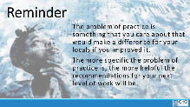   | LUNCH – Problem of Practice  (Reminder to have one).
1:00 – 2:00  Lakilia  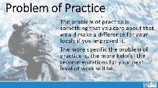 | How does coaching grow and develop leaders? | Consultancy Protocol p.50  https://neahq-my.sharepoint.com/:w:/g/personal/eholmes_nea_org/EauwG9NzWr5NgvF65GmM5UkBMrwWZwo38I6sP_wKEK6q9Q?e=Eg0Xs8  Page of the handout |  | 60 Minutes Total - Consultancy Protocol Coaching of Your Issue from Home  60 Minutes -  Presenter needs to explain the protocol in depth and set up the participants. (10 minutes)  Working in Triads – Each Person will have about 5 Minutes to Discuss their problem, the context and the specific challenge you are faced with. Using the Coaching Learning that we have been exposed to, the other two will ask questions and possibly suggest interventions that could be applied to solve the problem (50 minutes)  Depending on times, share their reflections on the process. Ask for one or two feedbacks. |  | Participants will understand basics of coaching and apply their learning in a scenario.
2:00-2:15 | BREAK
2:15 – 3:45  Jessica  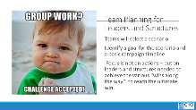  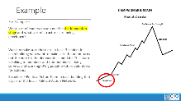 | How do we focus on structure development in a campaign plan? | Scenarios for Planning  https://neahq-my.sharepoint.com/:w:/g/personal/eholmes_nea_org/EftHjDsquutDoqv9rId2hWsBJHZ2F9YkFjaM_ufiLfaL2Q?e=1ap5tr  Reminder of the shape of a Campaign  https://neahq-my.sharepoint.com/:b:/g/personal/eholmes_nea_org/Ebix5g3mQQNJl3z9Y3ovPNoBvZL7NqiNE6acl0Tv0WCrCQ?e=BDZ5cu |  | 90 Minutes -Team Planning Work  Teams will select a scenario. They will identify a goal for the scenario and a basic campaign timeline. Page 30-39.  5 scenarios.  - Select what you like, but we will need to keep the groups balanced- teams of 3 or 4  The focus that you will to report out on is the structures you would put in place to achieve the various “wins along the way” to reach the ultimate win.  - What Structures will you need to engage?  - Timeline?  - Name the structure, describe what is needed for this structure functional?  - How will it connect members to other members to solve the issue/concern. |  | Teams of participants will develop a campaign plan that focuses on development of leaders, teams and structures.
3:45- 4:15  Jessica     | What is the state of our learning so far? |  |  | Report out on campaign design work so far  Seminar time – what are you learning and what do you have to share?  What have we learned in the past two years about how to best utilize electronic media to build structures? |  | Participants will reflect, question and share their understandings.
4:15 – 4:30  Ellen (heidi)  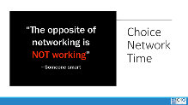 | What is the expertise among my colleagues? |  |  | 15 minutes  Networking on campaigns, structures and strategies for developing worksite teams  PLUS/DELTA  House keeping  Flights  Check out in the AM, Taxis.  Cannot leave before 1pm. |  | Participants will make useful connections with staff from other affiliates.
4:30 - 5:00 | ADULT NETWORKING AND ADJOURN

