Facilitator Agenda: Advancing Racial Justice (the remix) Day #1
General Materials Needed: |  |  |  |  | Room Set-up:
1 Set of Handouts per Person  Name Tags and Name Tents  Sign-in Sheet  Pens and Pencils |  |  | Chart Paper  Markers  Post its  Index Cards |  | Round Tables  Projector, Screen and Speakers  Carousel stations and reporting stations around the perimeter  50 people
The NEA Center for Organizing and the NEA Center for Social Justice are partnering to provide a training designed to build participants’ skills through awareness of implicit bias, interpersonal racism and institutional racism. Participants will learn how to deepen this awareness in others, how to navigate issues of race that surface in our work, and how to access valuable resources on addressing racism. UniServ Directors will learn how to help themselves and others:

· Establish a common language for talking explicitly about race
· Develop a shared understanding of the levels of racism and its impact
Develop a common toolset for next steps in applying an equity lens to our work
Time | Essential Questions | Resources |  | Instructions, Activity and Debrief (Facilitators) |  | Outcomes
 | What question(s) should this learning section answer? | Charts, handouts, articles, materials, slide |  | What are you saying, what are they doing, what questions will you use to guide learning and make clear the important points  Include an estimate for how long each section of the learning will take |  | As a result of this section of learning, what will participants know or be able to do?
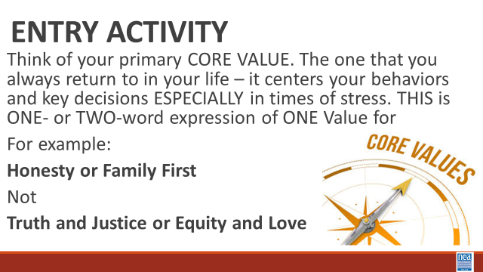 | What are our core values? |  |  | Entry Activity – Think of Core Values  Core values are the fundamental beliefs of a person. These guiding principles dictate behavior and can help people understand the difference between right and wrong. These are going to be expressed in one or two words that support that SAME IDEA – example Honesty, Protect Home – NOT Love and Justice
8:30 – 9:25  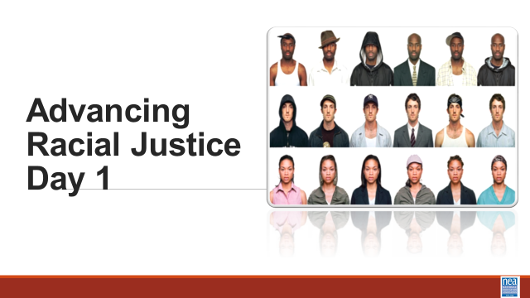  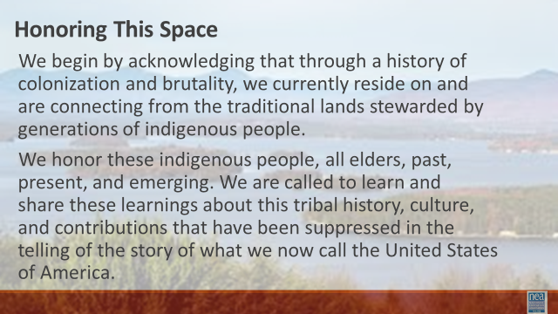  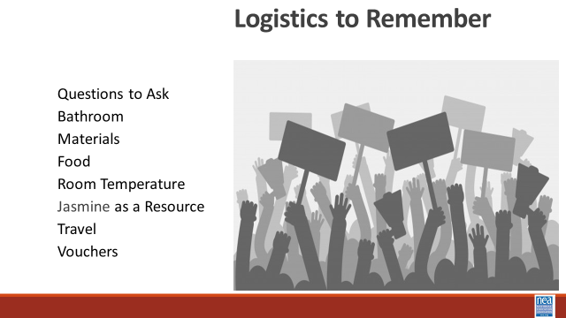  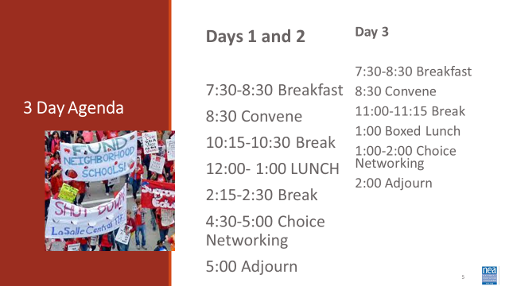  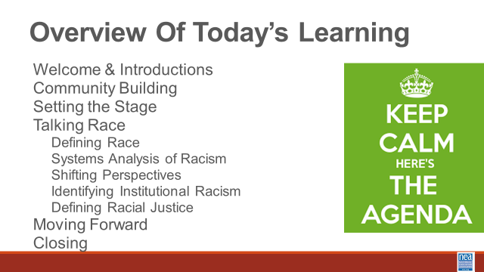  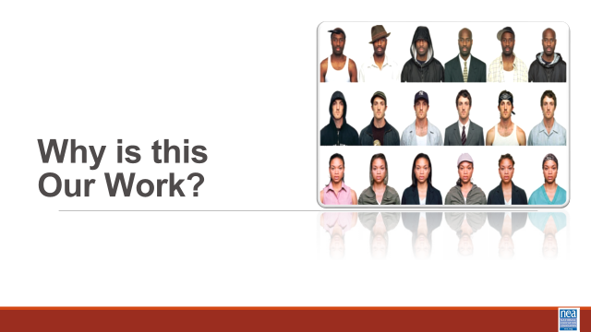  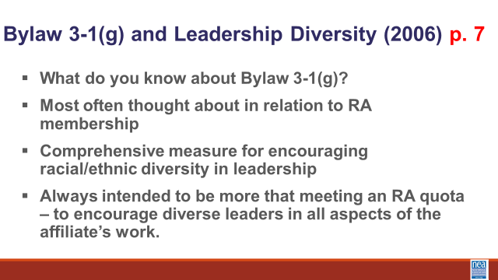  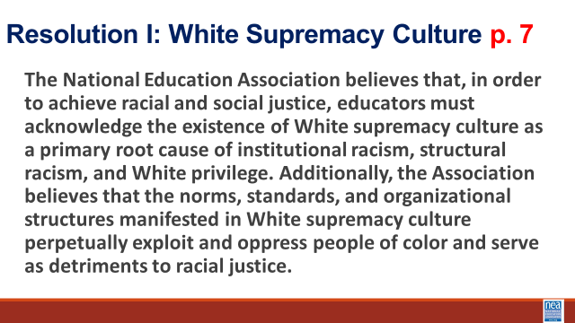  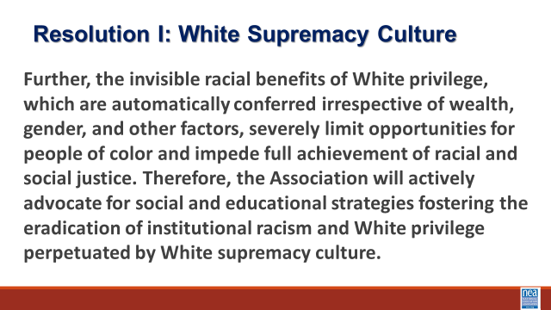  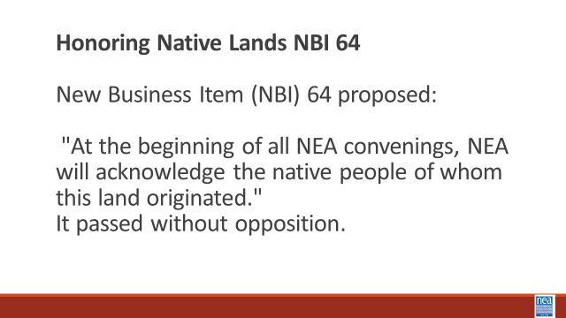  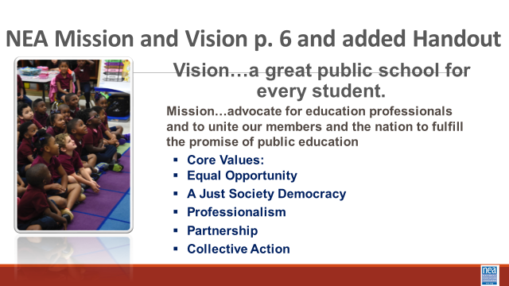  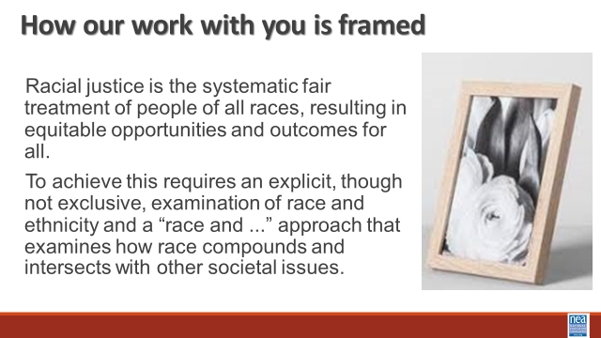  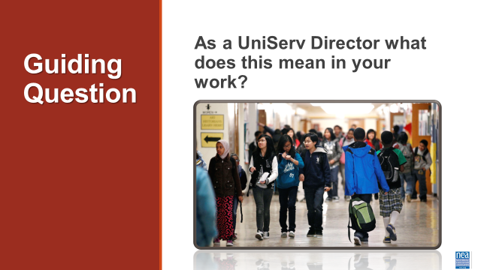  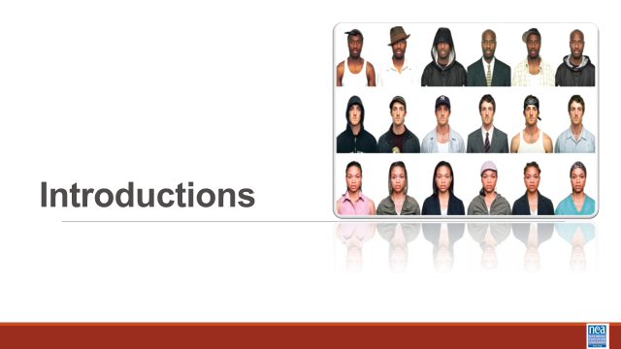  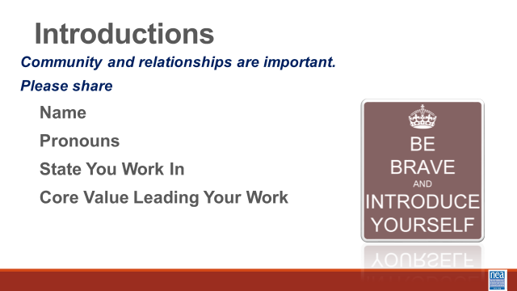  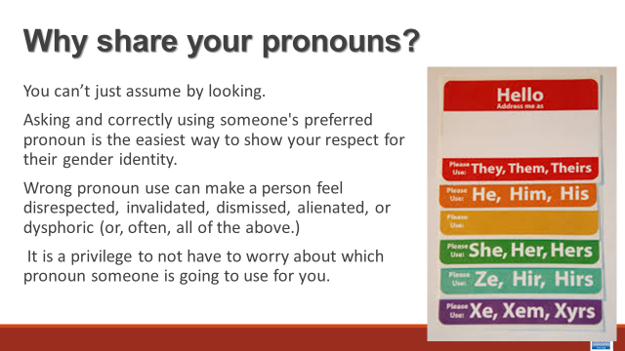  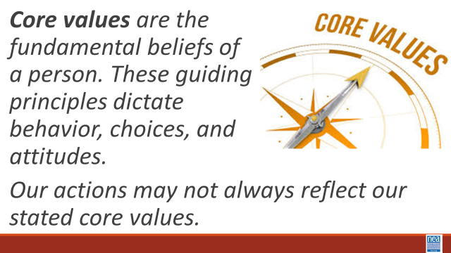  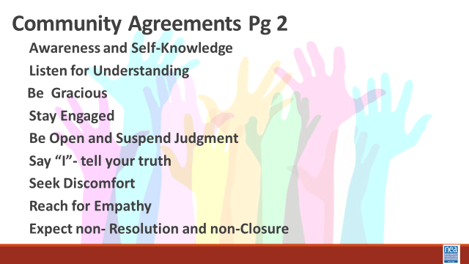  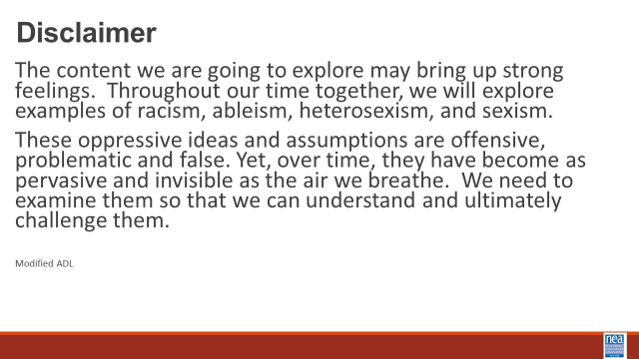 | As a UniServ Director what does racial justice mean in your work?  What are we going to be learning? Who are we as a community?  How will we agree to participate in this community? | 2 Charts for core Values  Participant Handouts:  Pronoun Guide that is a separate handout  Framework for Change p. 8  Community Agreements p. 2-3  Resolution 1 – P 5  NBI b – P. 5  Vision Mission Values – p. 6  Bylaw 3-1(g) p.7  Added handouts that are separate are  Safe Just and Equitable schools |  | 45 Minutes Total - Greet Gather Ground  15 Mins – Welcome, honor the space, overview of learning goals, overview of days agenda and logistics –  Why are we here - Framework for Change - P. 8  We move through stages of awareness, capacity building into action. In this training we are helping you become aware of where you are in regards to racial justice, we will be increasing our capacity by building our skills and understanding, and we will begin to make plans for actions we can take.  8 Mins- Why this is our work? P. 4-7  2 minutes each on Resolution I – Overview of NEA 3.1 G, NBI B 2015, Build the understanding that NEA views racial justice as a priority. Provide a brief each overview of each: Resolution 1 - 3.1 G, NBI B 2015.  Safe, Just and Equitable Schools – Adopted in 2022  In our time together over the next couple of days, we will take a more in depth look at racial justice. Racial justice is the systematic fair treatment of people of all races, resulting in equitable opportunities and outcomes for all. In order to have this discussion, we need to do an explicit, though not exclusive, examination of race and all aspects of our identity and look at how it compounds and intersects with other societal issues.  Our essential question throughout this examination is this: as a UniServ Director what does racial justice mean in your work?  10 Mins -Introductions around the room – Share Name, work location, pronouns, and core value (refer to pronoun sheet)  Pronoun explanation is dropped in by the facilitator just in case it is needed BEFORE THE facilitators model-We cannot assume how someone identifies, we must allow them to tell us their preference and honor that. We need to be inclusive of all genders and non-genders.  Show the Preferred Pronoun slide and say:  You can't always know what someone’s Preferred Gender Pronoun is by looking at them. · Asking and correctly using someone's preferred pronoun is one of the most basic ways to show your respect for their gender identity. · When someone is referred to with the wrong pronoun, it can make them feel disrespected, invalidated, dismissed, alienated, or dysphoric (or, often, all of the above.) · It is a privilege to not have to worry about which pronoun someone is going to use for you based on how they perceive your gender. If you have this privilege, yet fail to respect someone else's gender identity, it is not only disrespectful and hurtful, but also oppressive.  Trainers will begin by modeling what is expected - briefly introduce themselves, their preferred pronoun, the state they are from and their Core Value (Core values are the fundamental beliefs of a person. These guiding principles dictate behavior and can help people understand the difference between right and wrong – one or two words) as a way of modeling for participants – less than 20 seconds per person.  Make sure that there is help for the facilitator in charting the Core Values. Charters places their own core value on chart.  2 Mins – After all have introduced themselves and the two charts have been populated – Facilitator points out - The opposite of these core values that I see gathered on our chart are – inequality, exclusion, division, dehumanization, and hate – these “opposites” from the basis for racism, sexism and other “isms”)  20 Mins - Community Agreements for Our Time – Give this about 5 to 10 minutes -Ask participants to review the community agreements sent in advance and to review the three questions that they were asked to think about. Have a small table conversation in preparation for a whole group commitment.  Awareness and Self-Knowledge  Listening for Understanding  Being Gracious  Stay Engaged  Be Open and Suspend Judgment  Say “I”- tell your truth  Seek Discomfort  Reaching Empathy  Resolution and Closure  Allow about 5 to 10 Mins – Participants will share their responses, suggestions, changes, etc. Then facilitator will call for a visual community commitment. This is a shift from colonizer norms that aim to preserve the order of the conversation and maintain the focus of the power. These are commitments that we have each reviewed and will change as needed. By consensus we will agree to work with these until we need to make a change. Consensus means we all agree that these are good enough to get us moving. Show your thumbs and hold them up and keep them up until I have had a chance to view the whole room. Up thumb means – love it, nothing needs to change for me. Sideways thumb means – I can live with it for now. Down thumb means I cannot move forward until we discuss and come to a decision about…- and the down thumb leads the discussion on that UNTIL it can at least become a sideways thumb.  Before we dive into what this means to you, we begin with a disclaimer. If we do this right, you are going to be uncomfortable. The content we are going to explore may bring up strong feelings. Throughout our time together, we will explore examples of racism, ableism, heterosexism, and sexism. These oppressive ideas and assumptions are offensive, problematic and false. Yet, over time, they have become as pervasive and invisible as the air we breathe. We need to examine them so that we can understand and ultimately challenge them. |  | Participants will understand how we are going to work together as a learning community.  Participants will understand that this priority is embedded in our core beliefs, policies and budgets.
9:25-9:55  LaQuita  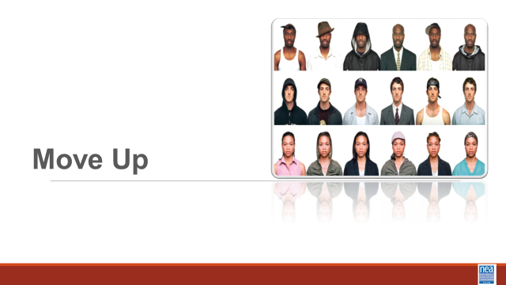  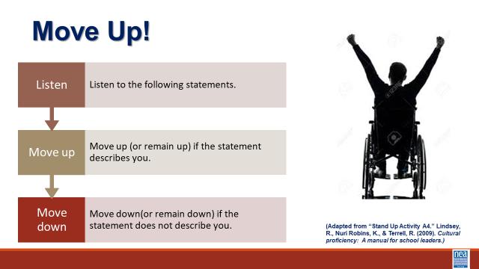  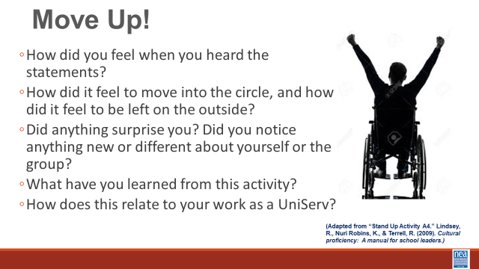  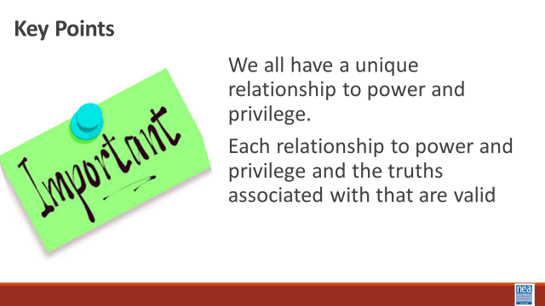 | What is THIS community’s relationship with power and privilege? |  |  | 30 Minutes Total: Move Up Activity –  2 mins intro - I am going to say a number of statements. If you agree with the statement, move into the circle. If you do not, you are unsure, or you are not comfortable answering, stay in your spot. Please feel free to remain on the edge of the circle for all of the statements if you feel safe enough to vulnerably share your truth.  10 Mins of Activity - (Facilitator NOTE – you should work with the team to select low risk questions from this list. They should begin by being very low risk and move to higher risk. )  KEY INSTRUCTION FOR FACILITATOR - State the prompt – wait for the movement – and then ask folks to look around to see how the circle has moved – ask them to think- not respond just think – what does this tell me? REPEAT THIS WITH EACH prompt.  - If you were able to access this space without any difficulty.  - Your family owned their own home.  - Your parents graduated from college or university.  - You studied the history and culture of your ethnic ancestors in elementary and secondary school.  - You can access washrooms easily without worrying about finding a gender-­‐ neutral or accessible washrooms.  - You were raised by your parents.  - You have never had to tell anyone your sexual orientation (you never had to ‘come out’).  - Your family told you that you could do, or be, anything you wanted.  - You have never felt like an event is closed to you because you cannot access the space it is in.  - You attended art galleries, museums, or theatre plays growing up.  - You are a Citizen.  - You have never felt judged because of the size or shape of your body.  - Most of your friends are the same racial or ethnic background as you.  - The people in power in your city look like you.  - The holidays you get at work or school are holidays you celebrate.  - You are able to communicate verbally.  - You can walk down the street with your partner anywhere in our country without being afraid to hold hands.  - When people hear you speak, they don’t ask you where you are from.  You feel pretty safe walking home at night regardless of what you are wearing.  15 Mins Debrief – Ask participants to return to their tables and select a number of the following that you want to debrief on.  - How did you feel when you heard the statements?  - How did it feel to move into the circle, and how did it feel to be left on the outside?  - Did anything surprise you? Did you notice anything new or different about yourself or the group?  - What have you learned from this activity? Share any insights or reflections if you’re comfortable.  - How does this relate to your work as a UniServ  Key Points  We all have a unique relationship to power and privilege.  Each relationship to power and privilege and the truths associated with that are valid |  | Participants will be reminded or become aware of our relationship to power and privilege, and the ways in which people experience advantages and disadvantages in our society.
9:55-10:15  Salina  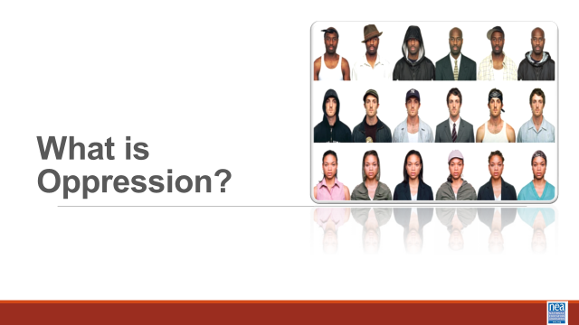  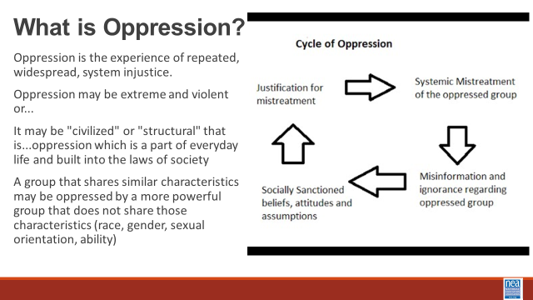  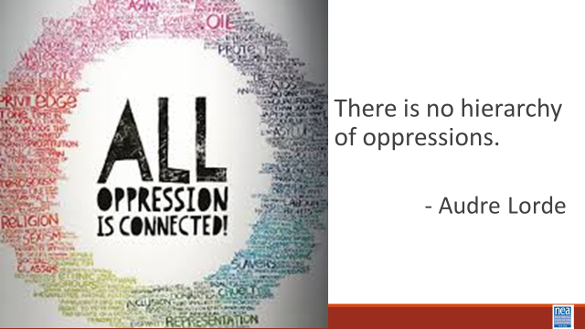  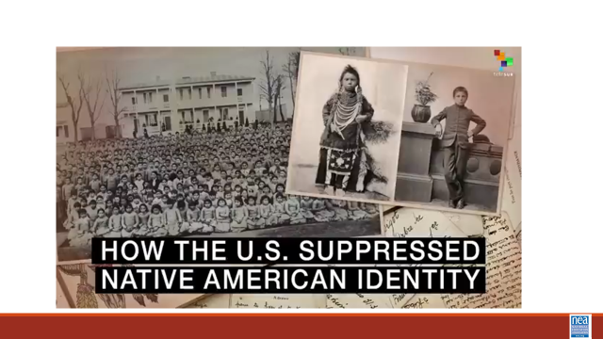 | What is our relationship with systems of oppression? | Types of Oppression 109 |  | 20 Minutes Before Break- and 20 minutes After Break - What is Oppression?  Before we dive into what this means to you, we want to remember our disclaimer.  When we say words like oppression” and “oppressive ideas and assumptions” what exactly are we talking about? Oppression is the experience of repeated, widespread, system injustice.  It may be extreme and violent or...It may be "civilized" or "structural" that is...oppression which is a part of everyday life and built into the laws of society  A group that shares similar characteristics may be oppressed by a more powerful group that does not share those characteristics (race, gender, sexual orientation, ability)  How it works is cyclical. Misinformation and ignorance regarding an oppressed group leads to socially sanctioned beliefs, attitudes and assumptions which are used as justification for mistreatment and results in the systemic mistreatment of the oppressed group. The systemic mistreatment leads to misinformation and ignorance which becomes socially sanctioned, and on and on and on.  While there are many types of oppression, “black, lesbian, mother, warrior poet” Audre Lord (her description not ours), said clarifies that there is no hierarchy of oppressions. All oppressions must be recognized and fought against simultaneously. Although we possess different identities, we are all connected.  Now we are going to take a look at this video and talk a little bit more about this cycle of oppression.  Video – How the US suppressed Native American Identity: https://youtu.be/FFAQBUCNEtg  This will continue after Break – take this time to reflect, breathe, and reconnect |  | Participants will be able to describe what oppression is and how systems of justice construct and use oppression.
10:15-10:30 | BREAK
10:30-11:05 Salina and Natasha  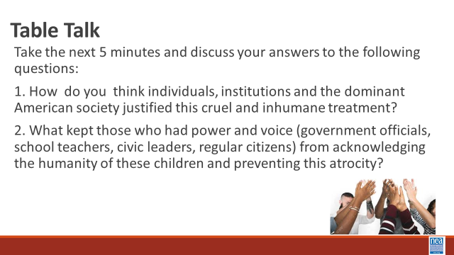  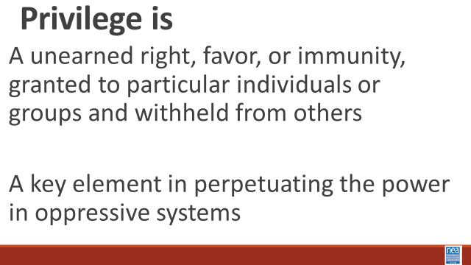  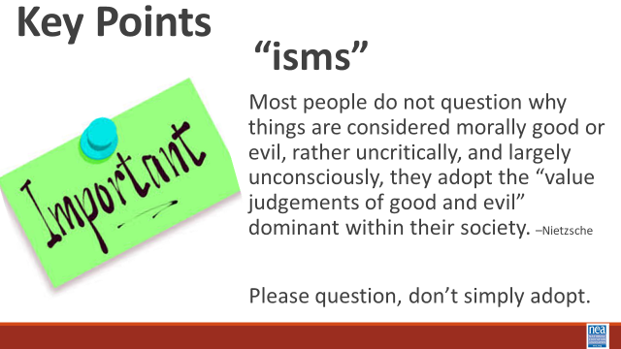 |  |  |  | 35 Minutes Before Break- and 20 minutes After Break - What is Oppression?  15 Minute Discuss  Take a moment and discussion with you tablemates the answers to the following questions.  - 1. How do you think individuals, institutions and the dominant American society justified this cruel and inhumane treatment?  - 2. What kept those who had power and voice (government officials, school teachers, civic leaders, regular citizens) from acknowledging the humanity of these children and preventing this atrocity.  Are any ideas that you want to put into the room? Allow 1-2 responses from each table.  Privilege is -A unearned right, favor, or immunity, granted to particular individuals or groups and withheld from others  A key element in perpetuating the power in oppressive systems  An agent in a justice system uses privilege to make change or prevent change—they are the power holder  Ask participants the following question, “what role, if any, do you think that privilege played in the way that this history unfolded?”  20 Minutes Types of Oppression Pg 109  Turn to page 109 in your participant handouts. Assign two categories to each table to focus on ---In teams, you are going to go through each category and determine if you can describe how to be an agent of oppression using privilege and how you experience oppression.  Ask the following debrief questions when we the teams come back together:  How does it feel to have or not have certain privileges? Did you become aware of any privileges you had not previously considered?  Key Points  Most people do not question why things are considered morally good or evil, rather uncritically, and largely unconsciously, they adopt the “value judgements of good and evil” dominant within their society.  - -Nietzsche  Please question. Do not just adopt.
11:05–12:00  Jessica  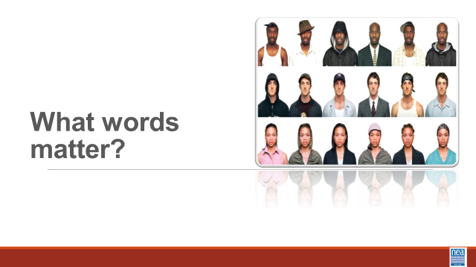  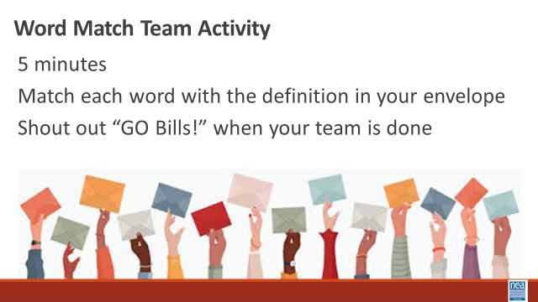  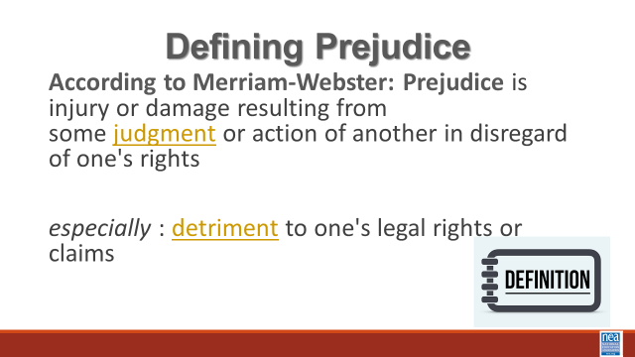  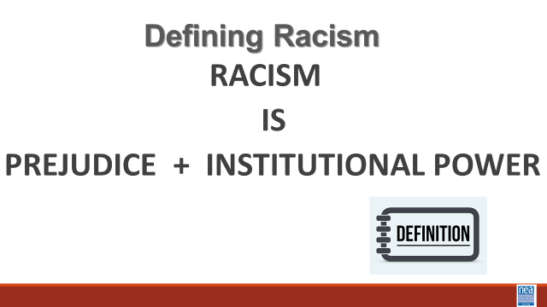  Shelly  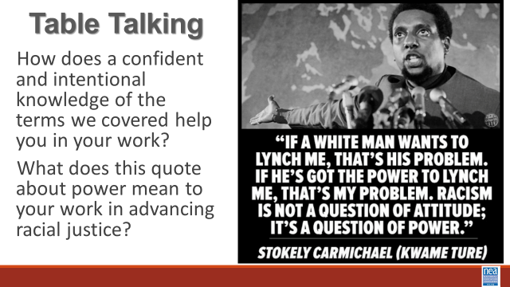  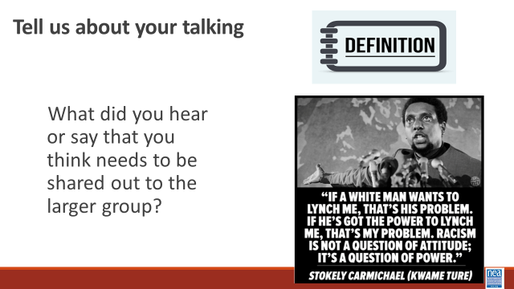 | What are the words I need to know to talk about race? | Need to Make the Definitions and Terms for the Envelopes  Suggest using the terms found on either of the following files:  Handout Pages 21-25 have Definitions for LGBTQ+  10 Things to know about Race Page 16 |  | 45 Minutes Total – What words matter when talking about racial justice  10 Mins – Racial Justice Vocabulary Activity  2 Minutes Intro -Faclilator explains, It is important to understand some key words and concepts as we discuss this topic. we are going to do this with a little movement, a video and short lecture. Let’s get a little healthy competition going here. We are going to break up into teams to play a round of vocabulary match-up. In the envelope that is on your table, you will find words and definitions. As a team, you must match the vocabulary word with its definition. When you believe that you have matched the vocabulary and definitions correctly, all team members must raise your hands and shout “Go Team!” (or some other cue when Shelly is not leading this) We will set the timer for 5 minutes. The team that finishes first, with the most correct answers wins!  Terms and definitions in envelopes: Race, Ethnicity, Nationality, Prejudice, Racism, Sexism, Ableism, Nativism, Privilege and Classism (see links in the column to the left to determine what we are going to put into the envelopes) IS THIS LINKED TO THE TABLE IN THEIR HANDOUTS FOUND on P. 19 IF yes, then these should be the terms in the envelopes.  When time is up: You should be considering the words that are going to be most important for supporting future conversations in this room and outside of it.  20 Mins – Video about Race, Ethnicity, and Nationality – Were going to look at three basic definitions that get conflated in everyday use.  Share the video (3 Min)  4 Mins Take two to three responses about the following:  How is race different from nationality and ethnicity? Why do you think they get confused?  A good Resource for you is the Page 16 in your handouts “10 Things to Know about Race”  This video will illustrate the implications of how these definitions play out in what we cal The UniTed States of America. Share the video 5 Mins)and then say - Let’s take a look at the definition for race that we are going to focus on:  Race is not biological. Race is a powerful social construct that gives certain people more opportunity and advantages. Can you hear how privilege and oppression work within these definitions?  5 Mins for Prejudice and Racism – show next two slides (Show and Ask them to read them or you can read it to them)  We also need to define the term Prejudice: SHOW SLIDE  According to Merriam-Webster: Prejudice is injury or damage resulting from some judgment or action of another in disregard of one's rights  especially : detriment to one's legal rights or claims  Our final vocabulary term that we need to be clear on is Racism: SHOW SLIDE  Racism is the combination of Prejudice and Institutional Power  20 Minutes - Racism is About Power  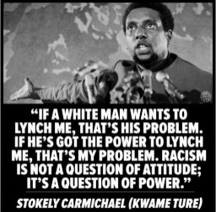  2 Mins – Intro to Final Discussion for this section -SHOW SLIDE to Support a Discussion  10 Mins - At your tables discuss How does a confident and intentional knowledge of the terms we covered help you in your work? What does this quote about power mean to your work in advancing racial justice? Think about what you want to stay to the room for our final 5 minutes on this section.  5 Mins – Report Out - What did you hear or say that you think needs to be shared out to the larger group?  Key points –  In our society, people have been taught that we should not say the word, “race.”  Race is a construct developed to support oppression within a system of white supremacy.  Once you recognize the existence of oppression and understand how it operates, you can learn how to resist and challenge oppression in all forms. |  | Participants will work on the development of their working vocabulary for race and racial justice concepts.
12:00-1:00 | Lunch—Jessica, make the announcement about reserving rides for this afternoon.
1:00-1:25  Ben and Ellen  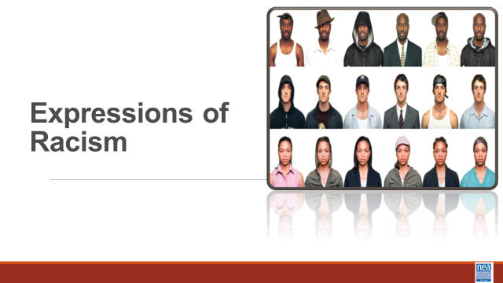  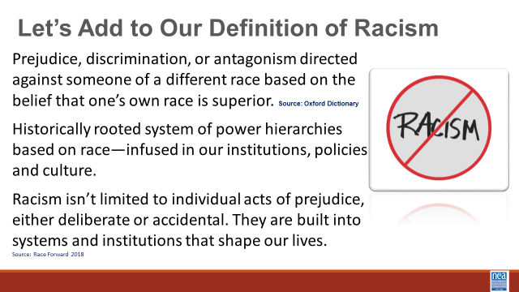  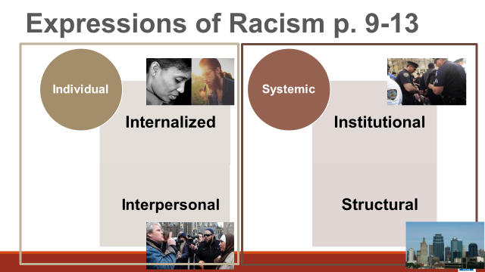  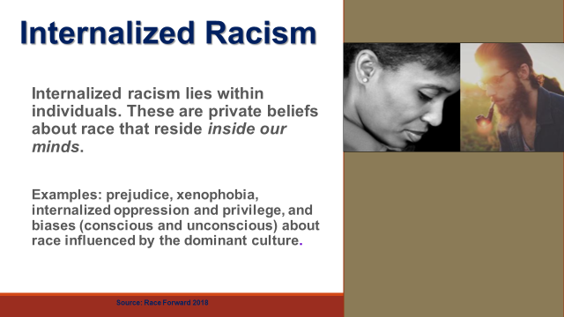  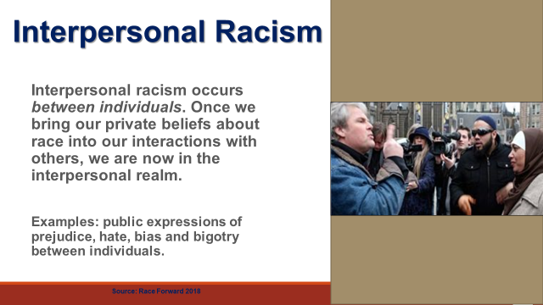  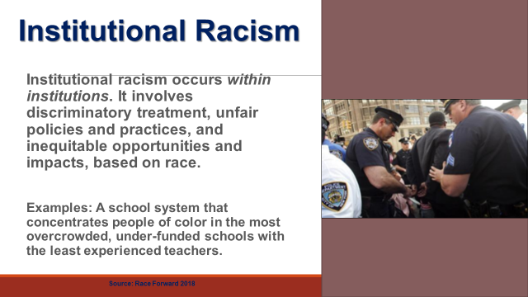  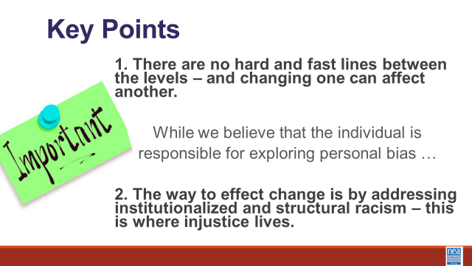  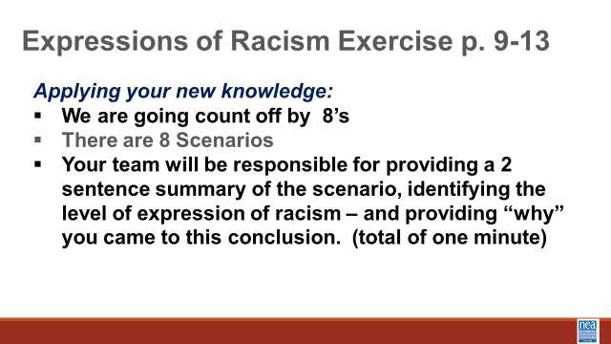  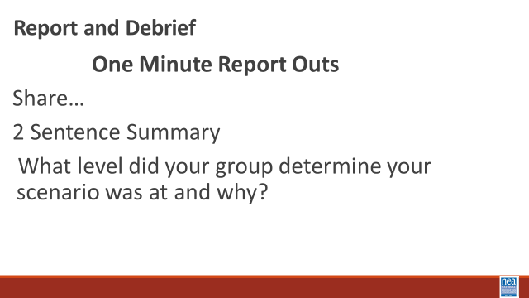  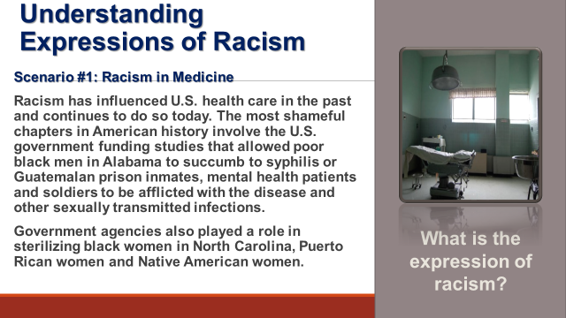  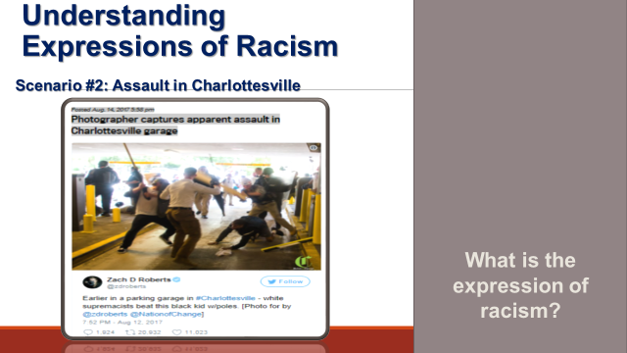  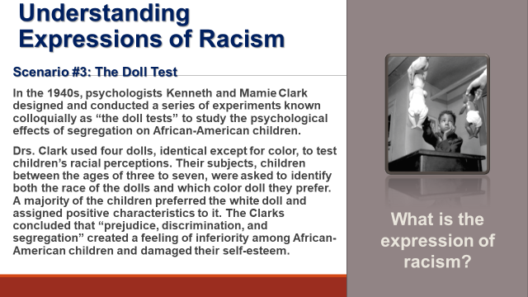  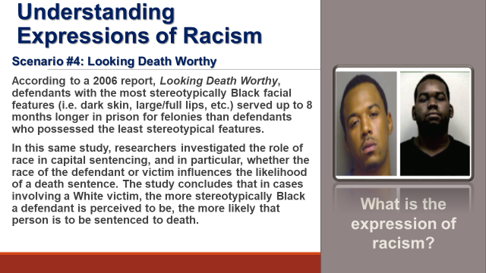  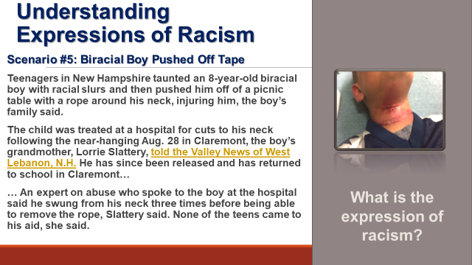  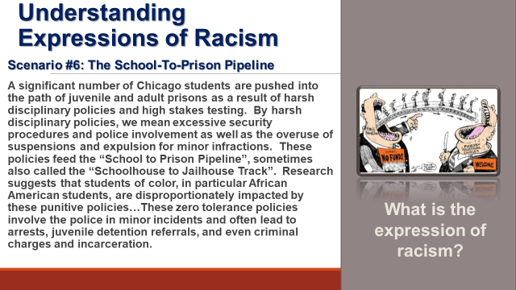  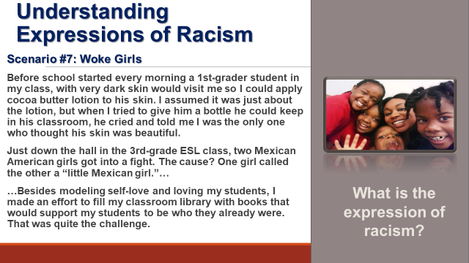  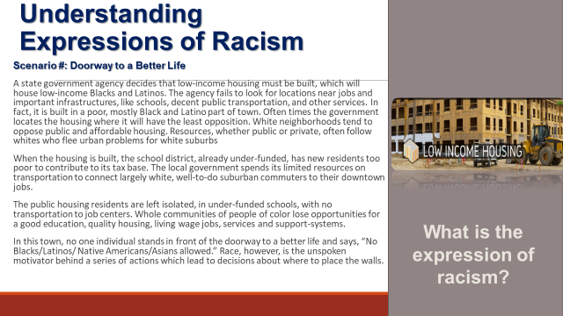 | How can you advance and improve racial justice beyond your own growth and development? | Post 2 separate Poster(s) of the Foundation Points  Key Point 1 - "There are not hard and fast lines between the levels - and changing one can affect another".  Key Point 2 - "The way to effect change is by addressing institutional and structural racism - this is where injustice lives".  Levels of Racism Scenarios Handout p. 9-13 |  | 25 Minute Total - Expressions of Racism  5 Mins Using the slides – Remember our definition of racism – let’s add a little to that Prejudice, discrimination, or antagonism directed against someone of a different race based on the belief that one’s own race is superior.  Historically rooted system of power hierarchies based on race—infused in our institutions, policies and culture. Racism isn’t limited to individual acts of prejudice, either deliberate or accidental. They are built into systems and institutions that shape our lives. This is a framework for how racism is expressed and the reason why we are showing this is to understand the level of resource and effort need to address these issues.  We are going to look at four-tiered framework for understanding how racism – or other oppressions are expressed. This framework is helpful not in IDENTIFYING the events of racism – but in understanding the magnitude of the solution we would need.  Share Definition and the examples for each of the four levels.  Traditionally, institutions only focus on the individual side, NEA, takes the approach that if we don’t re-examine and change the systems, then we will be forever combatting all three of the other types of racism.  Internalized Racism lies within individuals. These are our private beliefs and biases about race and racism, influenced by our culture.  Interpersonal Racism occurs between individuals. Once we bring our private beliefs about race into our interactions with others, we are now in the interpersonal realm.  Institutional Racism occurs within institutions and systems of power. It is the norms, policies and practices that are structured into political, societal and economic institutions that have the net effect of imposing oppressive conditions and denying rights, opportunity, and equality to identifiable groups based upon race or ethnicity.  Structural Racism is racial bias across institutions and society. It’s the cumulative and compounded effects of an array of factors that systematically privilege white people and disadvantage people of color.  Key points – there are not hard and fast lines between the levels – and changing one can affect another. While we believe that the individual is responsible for exploring personal bias – the way to effect change is by addressing institutionalized and structural racism – this is where injustice lives. Remember that Resolution I new business item refers to the institutional racism (white supremacy is structural)  20 Min Defining Expressions of Racism Activity - Use the Handout Levels of Racism Scenarios p. 9-13.  2 Min Intro –Count off by 8, move to new group and bring your book. The number of your group is the scenario that you will review. You will discuss and decide which level of racism each case belongs to. Please ensure there is consensus in your group in your answers.  10 Minutes to work on Activity- your outcome is a 2 Sentence summary of the scenario and which level you identified that it represents and WHY – not longer than 60 seconds. .  8 Mins: Debrief – (Facilitator will show the slide that goes with each group BUT nothing is said about the slide) Provide the summary of the scenario to the larger group, what level your group determines your scenario was at and why.  Facilitator ends by lifting up what every group always comes to – each of these can be representatives for all the levels – because it takes all the levels to ALLOW these to happen.  Key point - there are not hard and fast lines between the levels – and changing one can affect another. While we believe that the individual is responsible for exploring personal bias – the way to effect change is by addressing institutionalized and structural racism – this is where injustice lives. |  | Participants will understand Key Point 1 - "There are not hard and fast lines between the levels - and changing one can affect another".  and  Key Point 2 - "The way to effect change is by addressing institutional and structural racism - this is where injustice lives".  And that it takes all levels to permit oppression.
1:25 –1:55  Shelly  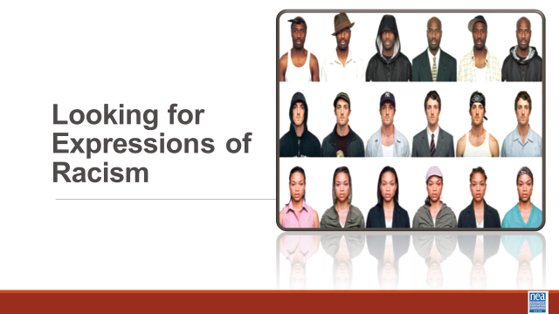  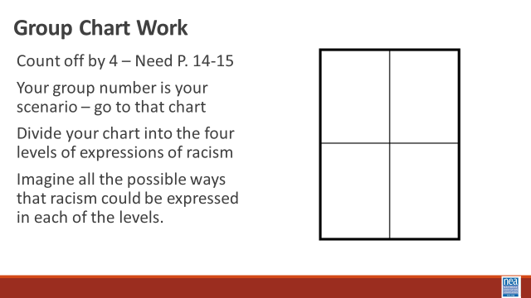  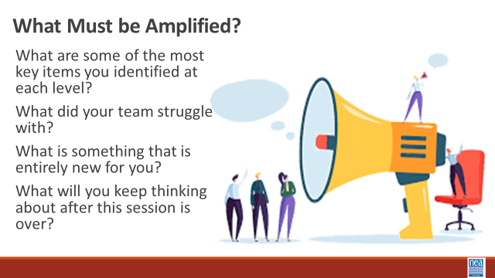  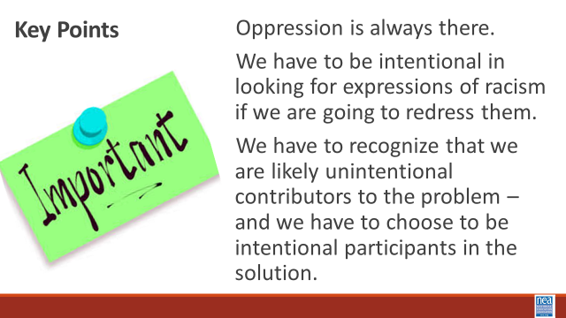 | How can you advance and improve racial justice beyond your own growth and development? | UD Focused Expressions of Racism p. 14-15  Chart for each group |  | 30 Mins Looking for Expressions of Racism  5 Minutes Introduction – This morning we have worked on some of the foundational understandings needed to advance racial justice. We are going to begin thinking about how to apply them. We said this morning that an NEA core belief of this work is an intentional focus, though not explicit focus on the ways that race is used to oppress others. We just took a look at how racism is expressed in 4 levels. NOW we are going to imagine how this might show up in our work. We are going to count you into 4 groups. (count off and then have them move.) Now that you are in your new groups, the number of your group IS the number of the scenario you have been assigned. Your task is to imagine the possible ways that racism COULD be expressed or “at play” in each of these – remember that “individual” will be within the UD or within another individual in the scenario.  15 Minutes Work Time  10 Minutes Report Out  What are some of the most key items you identified at each level?  What did your team struggle with?  What is something that is entirely new for you?  What will you keep thinking about after this session is over?  Key point:  Oppression is always there.  We have to recognize that we are likely unintentional contributors to the problem – and we have to choose to be intentional participants in the solution |  | Participants will be able to identify expressions of racism in particular scenarios.
1:55-2:15  Natasha | What does race have to do with where you live? |  |  | 15 Mins - Understanding Systemic Levels of Racism – Housing and Redlining  2 Mins –What does race have to do with where you live and the type of house you live in? We are going to take a look at one example of systemic racism that impacts our members and their jobs – real estate and the history of redlining. We explored income and how there is an intentionally built system that builds inequity.  Show video about the history of housing and oppression in what we now call the United States of America.  Debrief: Why are we including an economic lesson in a training about racial justice? What was the number one factor for the intentional development of the systems we have explored?  Key Point  The systems of income and wealth have been intentionally built to shift power and opportunity away from those in the lowest Quintiles to those in the top. This is further compounded when you look at the intersection of race and income.  Collective action (people power) has led a number of institutional solutions in the past and could do so again. |  | Participants will understand how the structural nature of racism persists.
2:15-2:30 | BREAK
2:30-3:00  Ellen and Natasha  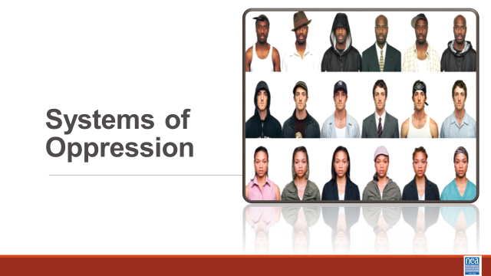  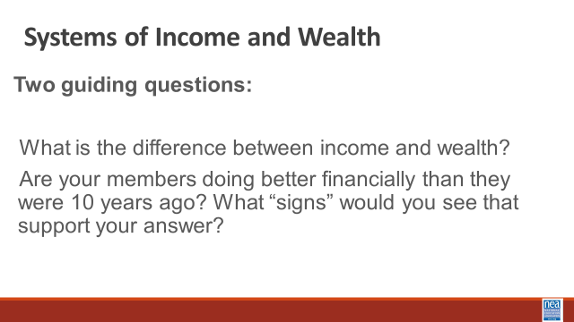  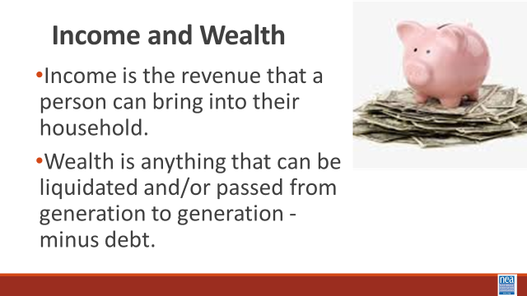  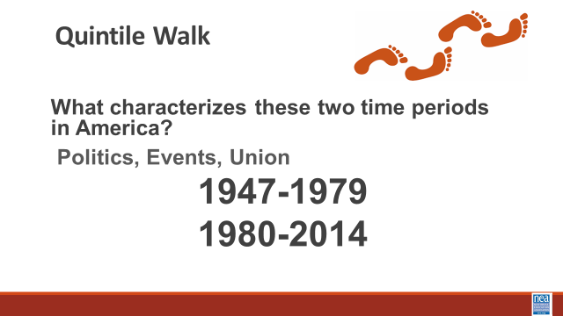  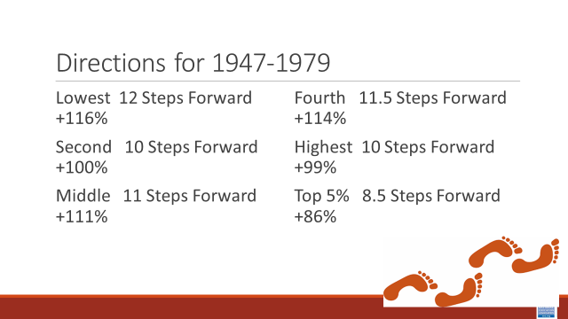  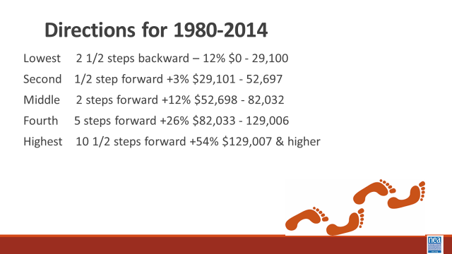  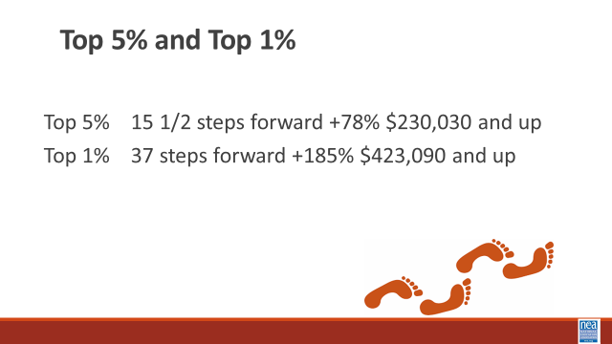  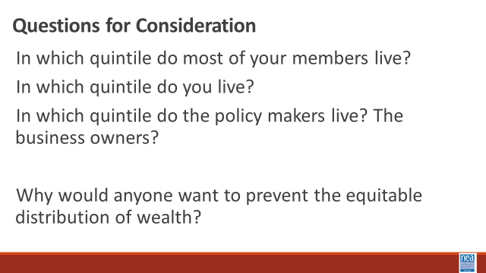  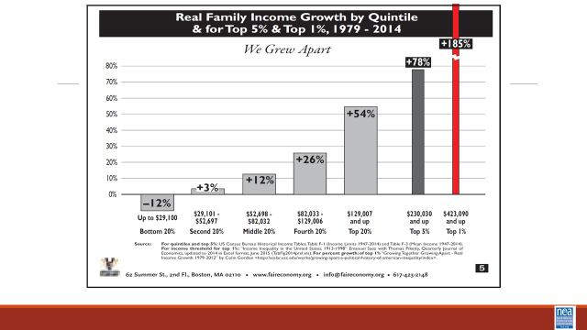  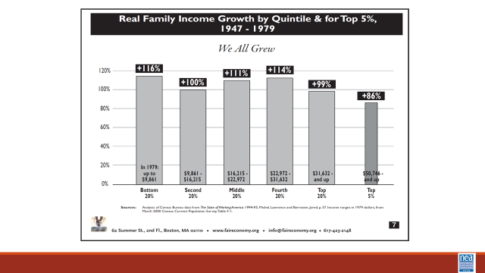  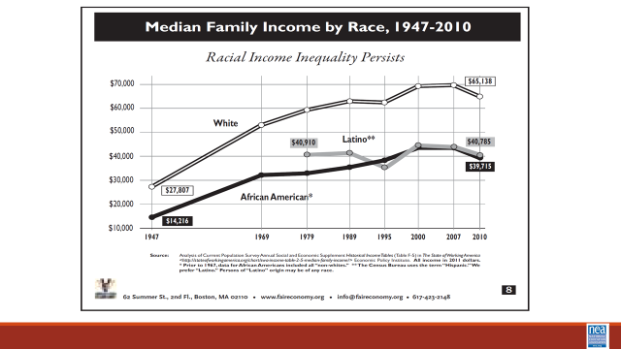  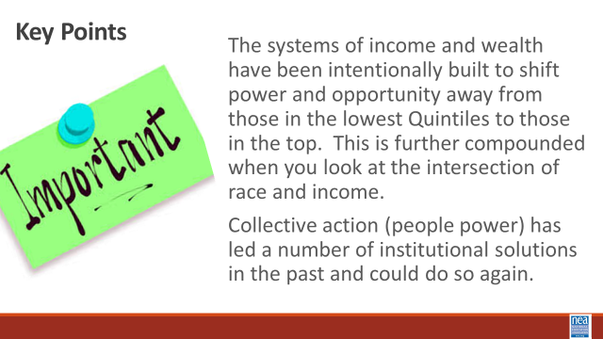 | How does race affect your income? | Quintile Signs  Quintile Facilitator Guide  Economic System p. 156- 158  Economic System p. 146-153  Quintile Walk Facilitator Guide |  | 30 Mins – Systems of Oppression – Income and Wealth  2 Mins– We are going to take a look at one example of systemic racism that impacts our members and their jobs – income. Take just a moment in your mind and consider the following question – in the last decade, has the income that your members receive been improving? How do you know?  2 Mins- What is the difference between wealth and income? What are some examples of income? (wages, salary, savings account interest, social security check, rent from owning real estate, capital gains from selling investments, dividends from stocks, gifts, etc.)  /  5 Mins - We are going to look at the changes in family income during two recent periods of economic growth. What can you tell me about the history, policies, unions from 1947-1979 --- now what can you tell me about 1979-2014?  15 Mins – The Quintile Walk Activity (see full guide at link in the left column)-Now let’s have five volunteers come to the front of the room. Please stand shoulder to shoulder. Each gets a sign showing the income range — in pre-tax, year 2014 dollars — of the quintile they represent.  We are going to watch how income has changed over quintiles in the population – Economists talk about the U.S. population in “quintiles” or “fifths”. They imagine the entire population of the U.S. lined up in order, from the lowest income to the highest. They then divide that line into five equal parts. This activity looks at what happened to the incomes during two periods of economic growth: 1947-1979 and 1979-2014.  Take a look at the signs the volunteers are holding – this number represents median Family Income – what jobs would be in each of these? What economic challenges would each have? Where are our members – pay attention to job classes and state differences. Each volunteer, representing a quintile or fifth (20 percent) of the U.S. population, will step forward or back according to whether their income gained or declined. Each step equals a five percent change, so, for example, two steps forward would indicate an income gain of 10%.  5 Minutes Discussion -  - In which quintile do most of your members live?  - In which quintile do you live?  - In which quintile do the policy makers live? The business owners?  - Why would anyone want to prevent the equitable distribution of wealth?  Key point slide  The systems of income and wealth have been intentionally built to shift power and opportunity away from those in the lowest Quintiles to those in the top. This is further compounded when you look at the intersection of race and income.  Collective action (people power) has led a number of institutional solutions in the past and could do so again. |  | Participants will understand that policies have been adopted that intentionally limit the ability for people to acquire wealth – and that these policies can be intentionally undone
3:00-3:15  Laquita  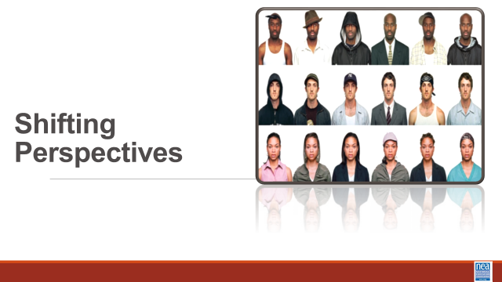  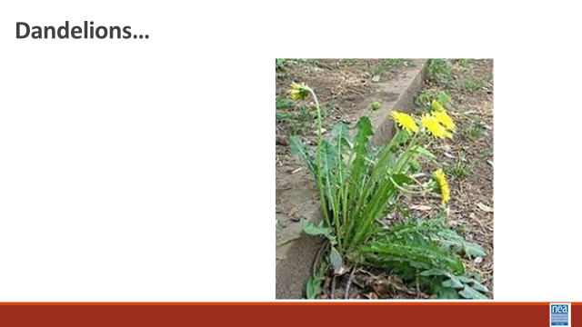    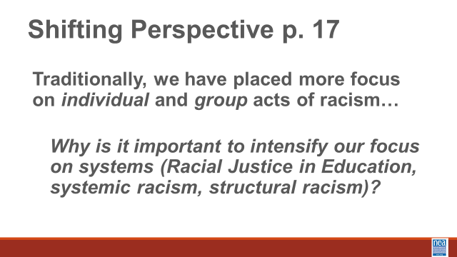   |  |  |  | 15 min – Shifting Perspectives (Take a look and tell me what you think about the changes)  5 Mins Asking Different Questions  Some of us have to do battle with dandelions in our lawns each summer. We have two choices: mow them down or dig them up by the roots. Which method will permanently remove the weed?  In order to completely eradicate the weed, any weed, you have to remove it by the root. They are a persistent perennial  When we do the work of advancing racial justice, we act to remove the “weed” that is racism by the root. The way to do that is to shift our perspective and ask different questions. We have to refocus our analysis to a systems level.  An example of how to shift perspective can be seen in the way that a “blackface” controversy was handled by to different companies. [Provide brief background if participants do not know what blackface is: The origins of blackface date back to the minstrel shows of mid-19th century. White performers darkened their skin with polish and cork, put on tattered clothing and exaggerated their features to look stereotypically “black.” The first minstrel shows mimicked enslaved Africans on Southern plantations, depicting black people as lazy, ignorant, cowardly or hypersexual, according to the Smithsonian’s National Museum of African American History and Culture (NMAAHC). The performances were intended to be funny to white audiences. But to the black community, they were demeaning and hurtful.]  In 2019 Megan Kelly made the remark that she did not know why black face was so offense – NBC did not know what to do at first – eventually they let Kelly go with a big payoff, she was terminated. Gucci in the same year came out with this shirt design – and they took a multi-level multi-prong approach – When Gucci advertised a blackface sweater for sale, the company issued an apology letter; had a meeting with Harlem designer Dapper Dan and other community leaders; implemented a global cultural awareness program in the company and created a scholarship to increase diversity in the design ranks. Which company has a better chance addressing racism at the root?  We shift perspectives by asking different questions.  Instead of looking to place BLAME, we look at what is the CAUSE of the inequity.  Instead of looking at INTENTIONS, we look at the IMPACT of the action.  Instead of focusing on the PREJUDICE of the individual, we look at the SYSTEM that allowed the prejudice to occur.  Finally, instead of focusing all of our energy on the GRIEVANCE, we spend substantial energy on SOLUTIONS.  10 Mins Practice the Shift-  Let’s return to the original scenarios and all take a look at Scenario #3: Let’s try asking different questions that would allow us to shift our perspective from one of identifying the problems to defining solutions. Take a couple of minutes to write down some questions that would get to the root and then we will come together and talk a bit more about it. Get started on this.  From To  Blame – Who’s a racist Causes – What is causing the racial inequity?  Intentions – What did they mean? Effects - What were the actions?  What was the their attitude? What are the Impacts?  Prejudice- What beliefs made them do it? Systems – What institutions are responsible?  Grievances- How can we fix what happened? Solutions- What are proactive strategies?  Give participants five (5) minutes to review the scenario and write questions. For report out, acknowledge that this type of analysis is much more challenging and start with members from the group that originally looked at this scenario to begin discussion. Seek at least one question for cause, effect, systems and solutions.  Key points to remember: Advocating for racial justice requires us to shift perspectives and begin asking different and deeper questions. Real change occurs when we move from saying what or who the problem is to identifying what caused the problem and addressing that root. |  | Participants will apply a racial justice lens to strategy and problem-solving conversations.
3:15 – 3:50  Shelly  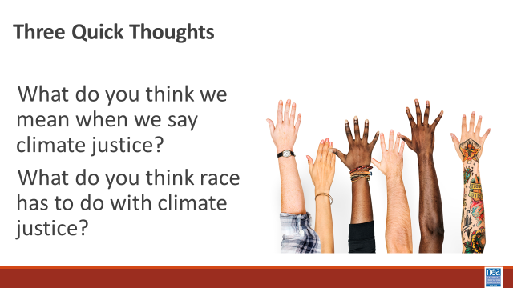    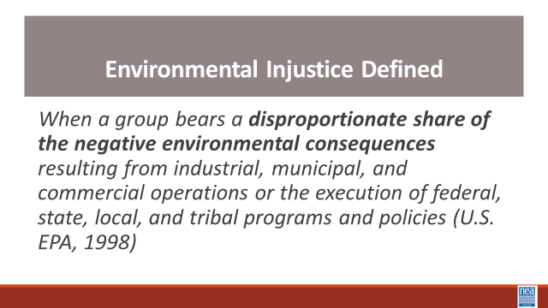  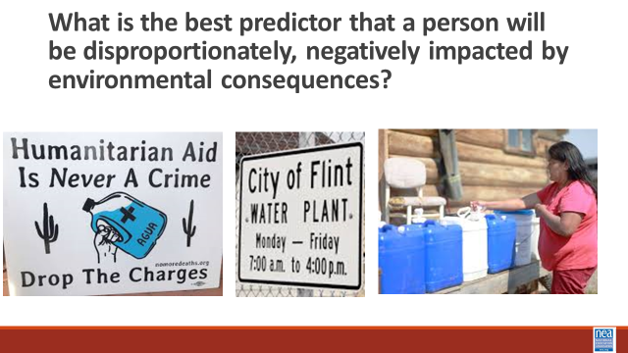  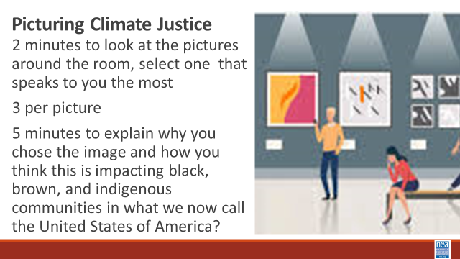  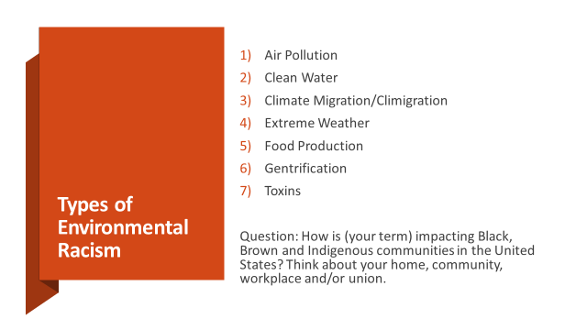  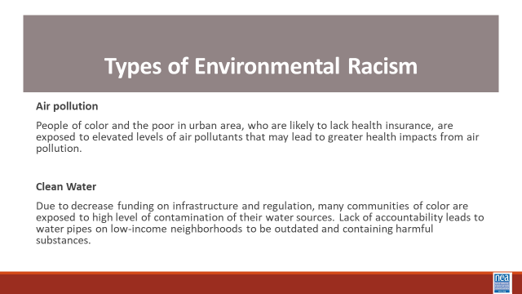  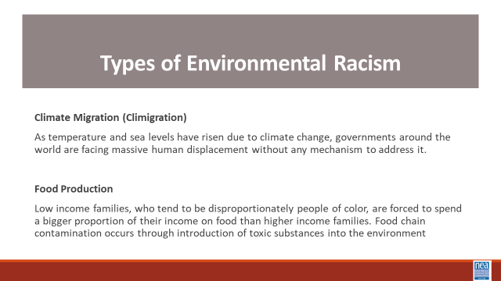  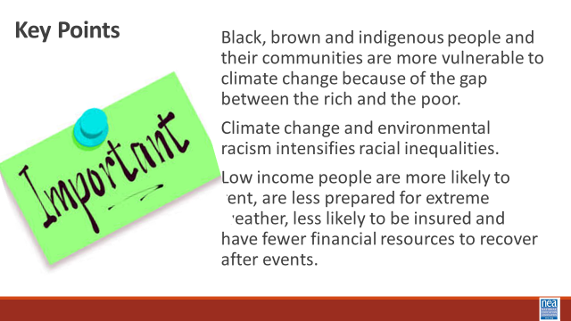 | What does your experience with climate change have to do with race? | Have images printed on letter size paper (8 ½ x 11 inches) or larger in color and have them posted around the workshop room.  Post a chart under each image for round  Handouts – How Workers Can Demand Climate Justice  Climate Justice Background p. 215-233 |  | 40 Minutes Total Systemic Level of Racism – Environmental Justice  10 Min intro - We are going to take a look at another system of oppression – Climate justice. Turn in at your tables and take just 3 minutes to have a quick conversation about these two questions:  What do you think we mean when we say climate justice?  What do you think RACE has to do with climate justice?  Let’s take about 5 minutes to hear three quick thoughts for each of the questions.  Show Video -History of Climate Justice Video (5 mins)  Show the slide with the following definition - When a group bears a disproportionate share of the negative environmental consequences resulting from industrial, municipal, and commercial operations or the execution of federal, state, local, and tribal programs and policies (U.S. EPA, 1998)  20 mins - Picturing Climate Justice Activity – Round 1  Intro – 2 mins -what is the best predictor that a person will be disproportionately, negatively impacted by environmental consequences? That is right, race.  Activity- 15 mins You have two (2) minutes to go around the room and look at each image. After you have seen them all, please take a seat by the image that speaks to you the most when you think about climate change and environmental racism.  No more than 3 per picture.  With those at your image, You will have five (5) minutes to briefly do the following as a group: explain why you chose this image; how does this image relate to environmental racism? Don’t write on your chart yet – that is for round 2.  10 min – Report out from each  Where there any similarities?  40 Minutes total for Round 2 -Types of Environmental Racism- Round 2  2 Min- Intro  Stay in your image groups for round 2. \Note: there should be at least seven groups. As a small group, you will have ten (10) minutes to:  - Read term/definition  - Answer the question by writing and/or drawing on flip chart paper. Please draw in large letters so others can read your answers when the chart papers are posted.  - Prepare to present your definition and answer to the rest of the participants. Each group will present in under two (2) minutes. Groups should decide if they want to present as a group or have a spokesperson in advance.  Question: “How does your image linked to one of these terms impacting black, brown and indigenous communities in the United States? Think about your home, community, workplace and/union.”  7 Types:  - Air pollution  - Clean water  - Climate Migration/ “Climigration”  - Extreme weather  - Food production  - Gentrification  - Toxins  Encourage groups to address impact in terms of home, community, workplace and/or union rather than focus on one aspect.  10 Min - Activity  15 minutes - Group report out  Key Points:  - Black, brown and indigenous people and their communities are more vulnerable to climate change because of the gap between the rich and the poor.  - Climate change and environmental racism intensifies racial inequalities.  - Low income people are more likely to rent, are less prepared for extreme weather, less likely to be insured and have fewer financial resources to recover after events. |  | Participants will understand  Black, brown and indigenous people and their communities are more vulnerable to climate change because of the gap between the rich and the poor.  Climate change and environmental racism intensifies racial inequalities.  Low-income people are more likely to rent, are less prepared for extreme weather, less likely to be insured and have fewer financial resources to recover after events.
3:50-4:15  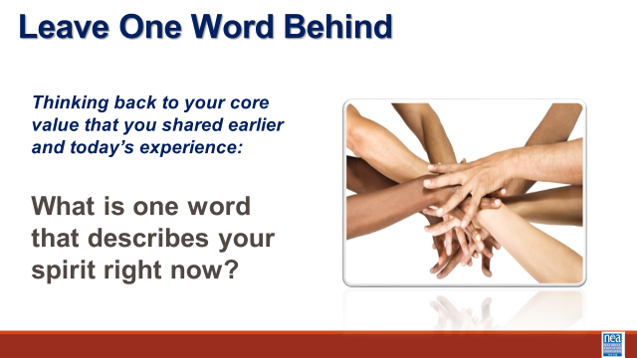 |  |  |  | 10 Minutes Day One Reflection and Connection  10 Mins -– Connections  Open Room discussion of the following questions. Record your thinking. What did you experience today that affirmed your understandings? What did you experience that challenged your understandings? What questions do you still have? |  | Participants will reflect on their learning and engage in a conversation with their colleagues.
4:15 | Adult Choice Networking and Reflection
5:00 | Adjourn

