Facilitator Agenda: Advancing Racial Justice (the remix) Day #2
General Materials Needed: |  |  |  |  | Room Set-up:
1 Set of Handouts per Person  Name Tags and Name Tents  Sign-in Sheet  Pens and Pencils |  |  | Chart Paper  Markers  Post its  Index Cards |  | Round Tables  Projector, Screen and Speakers  Carousel stations and reporting stations around the perimeter  50 people
Key Outcomes for the Day
Participants will practice restorative circles
Participants will understand the connection between identity, intersectionality and oppression
Participants will understand systems of racism and explore possible ways to disrupt them
Time | Essential Questions | Resources |  | Instructions, Activity and Debrief (Facilitators) |  | Outcomes
 | What question(s) should this learning section answer? | Charts, handouts, articles, materials, slide |  | What are you saying, what are they doing, what questions will you use to guide learning and make clear the important points  Include an estimate for how long each section of the learning will take |  | As a result of this section of learning, what will participants know or be able to do?
8:30 -8:40  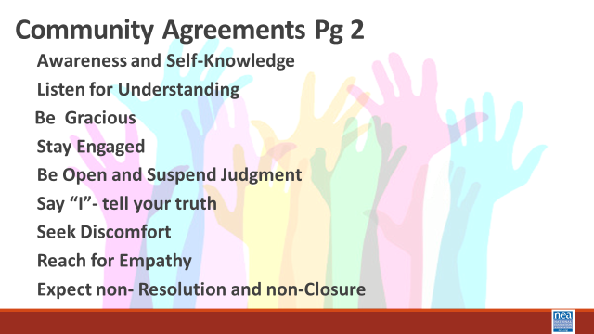    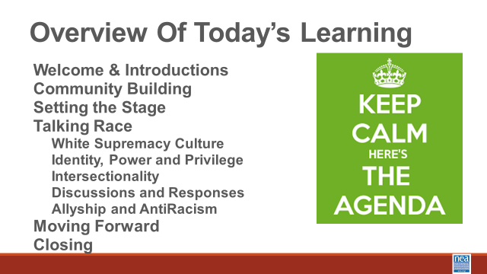 | How will we work together? |  |  | 10 Minutes – Regroup and Ground (IN A CIRCLE OF CHAIRS TO MOVE INTO NEXT SECTION)  Review the Community agreements  Feedback on Feedback  Day 2 Agenda  Any logistics |  | Participants will reflect on Day1 and understand any changes made for Day 2.
8:40-9:10 | What are Restorative Processes?  How can you use Restorative Processes to build Community?  How can you use Restorative Processes to build collective knowledge? | Circle of Chairs for Participants  Restorative Practices Resource p 28-92  Talking piece  Circle norms same as group |  | 30 Mins – Restorative Practices Introduction (p. 28-92)  Facilitator says  5 minutes  Ask participants to form a circle.  “I’d like to welcome you to the circle.“  Read quote from Chief Black Elk aloud (slide)  “Everything the power of the world does is done in a circle. The sky is round, and I have heard that the Earth is round like a ball and so are all the stars. The wind, in its greatest power, whirls. Birds make their nests in circles, for theirs is the same religion as ours. The sun comes forth and goes down again in a circle. The moon does the same and both are round. Even the seasons form a great circle in their changing and always come back again to where they were.”  Chief Black Elk, Holy Man of the Oglala Sioux  “Resolving our issues and discussing our experiences is an indigenous practice that is still in use. At one point it was actually outlawed because it was so antithetical to the dominant culture. Think of how most classrooms have been arranged – rows – hierarchy. In a circle there is no hierarchy, and everyone is equal. The process that we are going to engage in is one that you can use to engage colleagues and members in deeper conversations. To engage in deeper conversations about race and social justice, we need to build a community of trust and respect. We will begin to build our community here in this circle. To ensure safety we say that what is said in the circle stays in the circle. Stories stay in the circle, but the lessons are taken out and shared with others.”  Reminder of Agreements  “We will come to the circle throughout our time together, and just as we have norms for the training, we have norms for the circle.” Plus – the use of talking stick, and the ability to pass.  *PLAY VIDEO*  Community Pass One  - The participants in this video mentioned that while avoiding certain labels or ways of identifying people might avoid surface-level conflict, we ignore people’s experiences that are connected to those labels. Are the labels that you hold most closely to your sense of self those that hold more privilege or less privilege? I’ll start, to model this for us. *SHARE*  (*For the facilitator: focus on the more privilege/less privilege, not the specific labels in the modeling.*)  - Internal weather check-in. We want to check in to see how you are all feeling today and rather than asking it directly, we want you to use a weather term or weather terminology to describe how you are feeling. I will model this for you. Today, I am partly sunny. (Pass the talking piece, listening to how everyone is feeling.) When pass is complete, facilitator summarizes the weather terms heard in the circle. This helps us to know the general mood in the room, and if we need to check in with specific people or the entire group.  Community Pass Two  - Share an a-ha moment you had from one of the activities or videos yesterday. (pass the talking the piece)  Community Pass Three (pick one)  - What is your privilege and what role does it play in your life?  - When do you feel powerless and why?  Circle Closing  Facilitator – What are you taking away from this Circle about labels and recognizing our complexities? |  | Participants will cultivate a reflective mindset.  Participants will begin to build a reflective, trusting community that allows for honest conversations about advancing racial justice.  Participants will be introduced to the Restorative Practices circle process and begin to make the connection about how to use this process as they work
9:10 – 9:15  Natasha  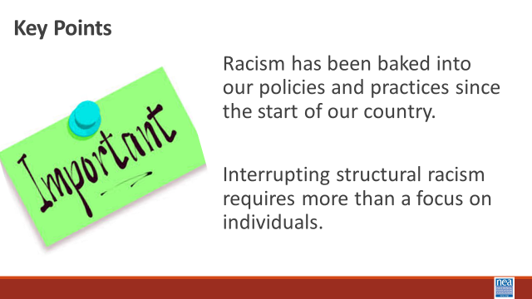 |  | Need the PPT s |  | 5 Minute Total - Timeline Bridge  Official Eurocentric Colonizer’s description of United States history begins with 1612 – and goes through 2022 –  1 Min – Key points  Racism has been baked into our policies and practices since the start of our country.  Interrupting structural racism requires more than a focus on individuals. |  | Participants will discuss illustrating the development of structuralized racism in what we now call the United States of America.
9:15-10:15  Ellen  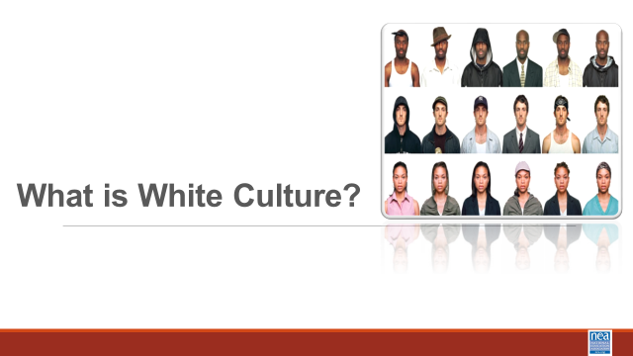  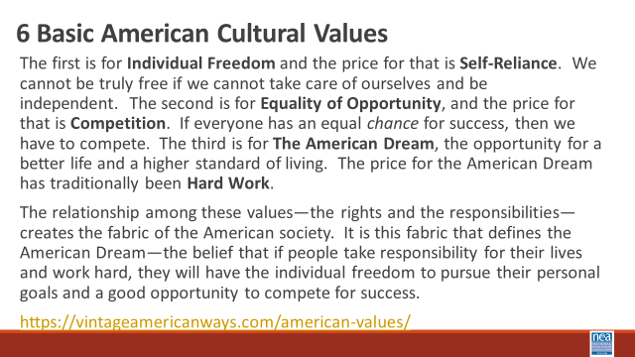  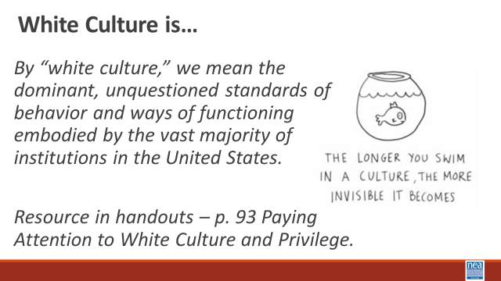  Ben  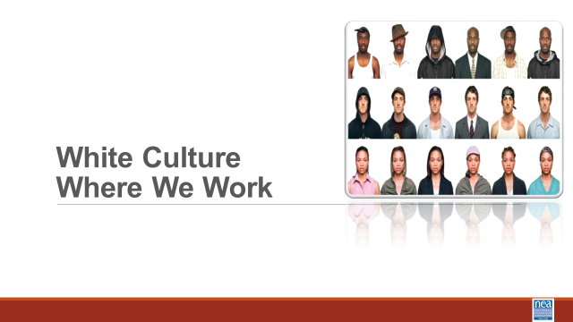  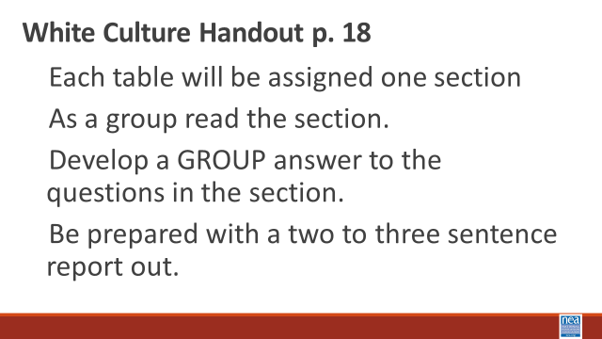  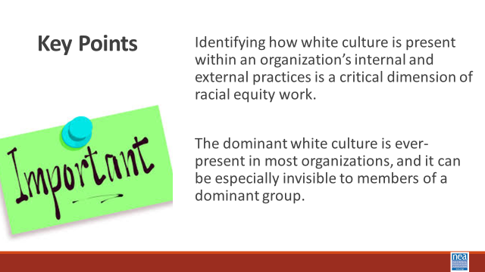  Natasha    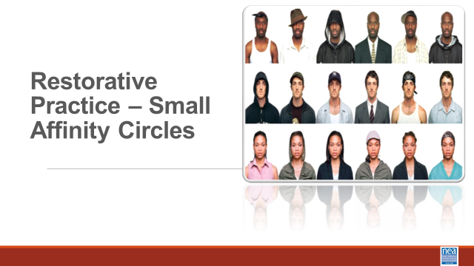  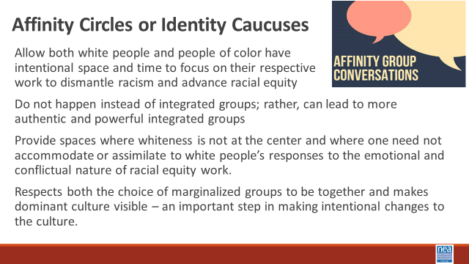 | Do white people have a culture?  What is the work that we need to do to become anti-racist?  How do we provide spaces where this work can be done? | Attention to White Culture and Privilege p. 93-106  Page 18 White Culture Handout  Paying Attention to White Culture and Privilege – P. 103-105 |  | 60 Minutes Total – What is White Culture  15 mins- What is White Culture?  2 mins –Intro  We are going to dig into some thinking about what makes discussing race so difficult. To do that we are going to begin by looking through the window of White Culture. At your tables, read the following slide to yourselves – in about one minute – turn to those folks you are sitting with and discuss what stands out as things you agree with and things you don’t agree with – We will take a total of 5 minutes at your tables for this discussion.  (Give them 10 minutes to discuss – then 3 minutes to share out)  “6 Basic American Cultural Values  - The first is for Individual Freedom and the price for that is Self-Reliance. We cannot be truly free if we cannot take care of ourselves and be independent. The second is for Equality of Opportunity, and the price for that is Competition. If everyone has an equal chance for success, then we have to compete. The third is for The American Dream, the opportunity for a better life and a higher standard of living. The price for the American Dream has traditionally been Hard Work.  - The relationship among these values—the rights and the responsibilities—creates the fabric of the American society. It is this fabric that defines the American Dream—the belief that if people take responsibility for their lives and work hard, they will have the individual freedom to pursue their personal goals and a good opportunity to compete for success. Found at https://vintageamericanways.com/american-values/  During the 3-minute report out move to the Slide that defines white culture Report out - Ask for 3 to 4 people to share something that they heard or said at their table. –at this point you are simply getting people to discuss the concept of white culture. At this point, let them know that this comes from Vintage American Ways, a SS curriculum that is easily found and for use in teaching. GTS and be afraid. Pg. 93 as a resource  20 Mins – White Culture Where We Work  1 Min Intro - We are now going to extend our discussion to a set of questions about White Culture. Using the White Culture Handout found on page 18 we are going to get into groups. (no more than 4 or 5) – Once in groups I will give you the directions –  Show the slide with these directions.  - Each group will be assigned one section  - As a group read the section.  - Develop a GROUP answer to the questions in the section.  - Be prepared with a two to three sentence report out.  8 Minutes in your groups  5 Mins - Group Sharing of your answers.  1 Min – Key Points  Identifying how white culture is present within an organization’s internal and external practices is a critical dimension of racial equity work.  The dominant white culture is ever-present in most organizations, and it can be especially invisible to members of a dominant group.  5 Mins – This is a powerful poem to continue our thinking and feeling about this work as we move into our next section.  10 Mins – Move to Racial Identity Caucuses or Affinity Groups– pg. 103-105  5 Mins - Intro and Content (Facilitator needs to read the following and put it into their own words as they share the bulleted points slide.) - One tool we have found to be very helpful, especially in acknowledging and supporting some of the emotions that naturally occur in racial equity work, is racial identity caucusing. The value of caucusing is so both white people and people of color have intentional space and time to focus on their respective work to dismantle racism and advance racial equity. Caucusing does not happen instead of integrated groups; rather, caucusing can lead to more authentic and powerful integrated groups. Caucusing not only respects the choice of marginalized groups to be together, it also makes the dominant culture visible – an important step in making intentional changes to the culture. Further, working only in integrated groups puts an undue burden on people of color to be the teachers and obscures the responsibility of white people to do their own work. Both people of color and white people are needed to work collectively for racial equity. But they have different work to do, precisely because of their different experiences with and location relative to white culture and privilege. For people of color the caucus can be a space where whiteness is not at the center or a place where one need not accommodate or assimilate to white people’s responses to the emotional and conflictual nature of racial equity work. The caucus provides an opportunity to not only speak about the impact of racism and white culture within an organization, but also about how oppression is internalized on an individual, intergroup, and institutional level. This space can build solidarity among diverse people of color while at the same time allowing that full diversity to emerge and be celebrated. This caucus can be a liberating place for people of color to heal, bring their full selves, and consider how to collectively work for racial equity.  5 Mins – Make the move and remember why we are making this move Get settled and then take your break.  (*For the facilitators: Keep an eye out for the potential for an “affinity group of one,” so none of our participants feel isolated or singled out.*) |  | Participants will be able to describe the aspects of white culture – and actually recognize that there is a white culture.
10:15-10:30   | BREAK
10:30 -12:00  Natasha  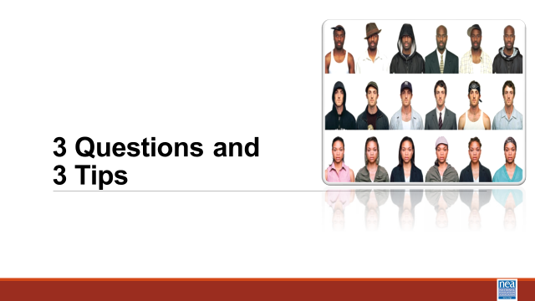  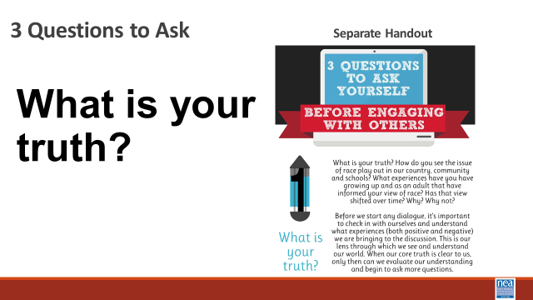  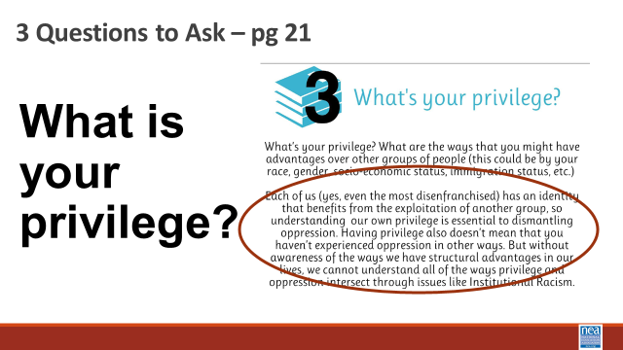  LaQuita  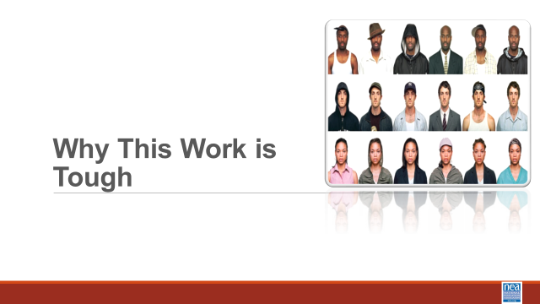  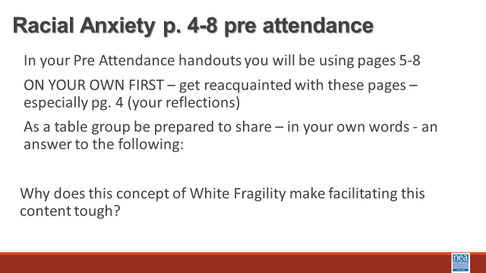  Salina  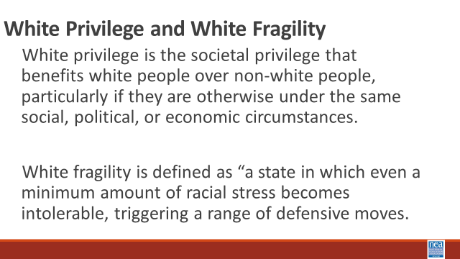    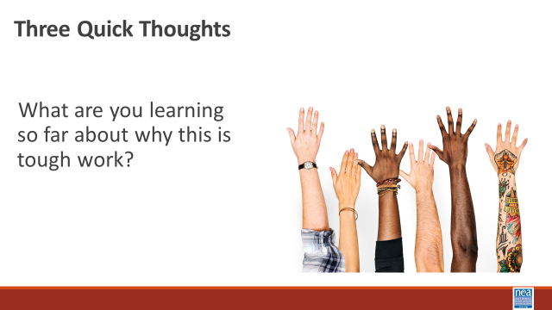  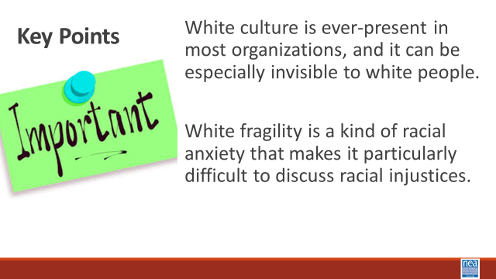  LaQuita  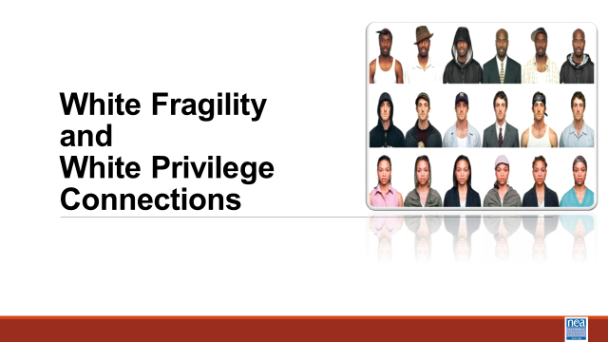  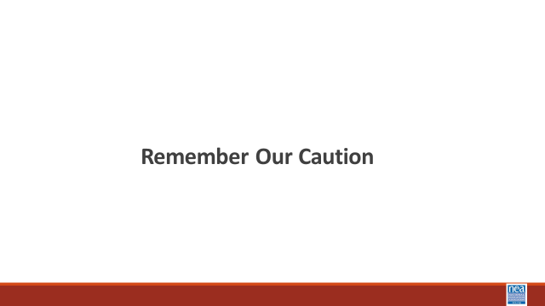  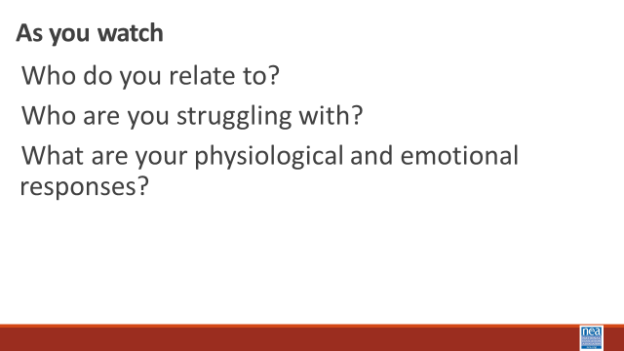  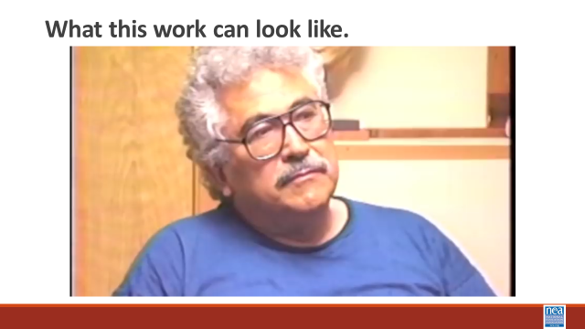  Salina  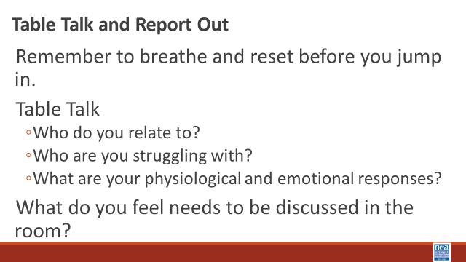  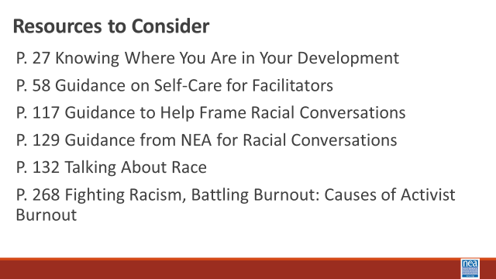  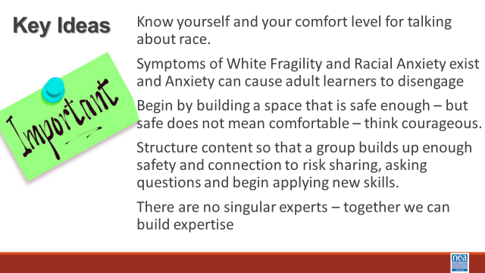 | Why is talking about race so difficult? | Three Questions and Three Tips p. 117  Pre Attendance  Racial Anxiety Assessment. 4-8  Pre Attendance What is White Privilege? P. 43-53  Attention to White Culture and Privilege p. 93 |  | 90 Minutes Total - Why This Work is Tough  15 Mins –Three Things to Know Pg. 117  1 min intro - A useful framework of questions (there is also a handout on Page 4 of the handouts) that can help support you as you begin tough conversations around Racial Justice are  2 Min -Show Slide – what is your truth? – I will wait while you read this -- What I want you to notice is that it is important to know what experiences you are bringing to the conversation.  2 min -Show Slide – What do you value?- I will wait while you read this -- What I want you to notice is that when we know our values it helps us be more sensitive and open during conversations that are tough  2 min -Show Slide – What is your privilege? I will wait while you read this -- What I want you to notice is each of us has an identity that has allowed for the oppression of others, and just because we have privilege does not mean that we have not experienced oppression.  1 Minute Key Points –  - You must know yourself and your comfort level for talking about race.  - You need to know that every other person is also assessing their own comfort level and trying to figure out who they are in this work.  When we do this work, we begin by building a space that is safe – but safe does not mean comfortable.  25 Minutes – Why this Work is Tough – Privilege and Racial Anxiety  5 mins – Introduction and video -We are going to take a closer look at the concept of privilege as you watch, consider how Privilege and Racial Anxiety are Connected.  Show video (5 Mins)  then immediately go to the slide about Racial Anxiety – ask them to access the Assessment that they took in their pre-attendance found on pages 4-8.  10 Mins – Table Talk -With your own table, What Surprised you about your assessment? Why does this concept of White Fragility make facilitating this content tough?  5 Minutes - Report out and look for the following points that participants might report – and share these if they don’t explicitly or implicitly talk about them.  - Symptoms of Racial Anxiety exists  - Anxiety can cause adult learners to disengage  - Being transparent will feel difficult and there will be some degree of non-closure and imperfection  - Attending to community development requires intentionality  - Building from low risk to high risk takes time  - This is an ongoing process and we all arrive at different times  2 Minutes – as a wrap up to this small section – share the video “what is racial anxiety”  10 Minutes –Connecting White Privilege and White Fragility – Share the slide with these two critical concepts to understand –  White privilege is the societal privilege that benefits white people over non-white people, particularly if they are otherwise under the same social, political, or economic circumstances. White fragility is defined as “a state in which even a minimum amount of racial stress becomes intolerable, triggering a range of defensive moves.  In this video the well-recognized author who has benefitted greatly from her own white privilege Robin D’Angelo, does a decent job of explaining the connection between white privilege and white fragility. (Share the video)  Move to slide – Three quick thoughts and take just three thoughts about what folks are learning about why this is tough work.  1 Minute – Key Points - White culture is ever-present in most organizations, and it can be especially invisible to white people.  White fragility is a kind of racial anxiety that makes it particularly difficult to discuss racial injustices.  35 Mins – What this Work can Look Like  REMEMBER OUR CAUTION  8 Mins Intro and Video - We are going to watch a segment from the 1994 movie “Color of Fear” that shows how 8 North American born men have the conversations that many of us fear.  As you watch notice if and when you begin to feel uncomfortable. Notice your breathing and your what your brain begins to tell you. What would your comfort level be for hanging into this conversation. Notice Who do you relate to? Who are you struggling with? What are your physiological and emotional responses?  Show video (5 Minutes)  10 Minutes to discuss reactions in small groups -Remember to breathe and reset before you jump in. Table Talk  - Who do you relate to?  - Who are you struggling with?  - What are your physiological and emotional responses?  10 Minutes Whole Room Discussion - What do you feel needs to be discussed in the room?  2 Mins – Resources to Consider as you begin this work  - P. 27 Knowing Where You Are in Your Development  - P. 58 Guidance on Self-Care for Facilitators  - P. 117 Guidance to Help Frame Racial Conversations  - P. 129 Guidance from NEA for Racial Conversations  - P. 132 Talking About Race  - P. 268 Fighting Racism, Battling Burnout: Causes of Activist Burnout  2 Mins Key Ideas –  Know yourself and your comfort level for talking about race.  Symptoms of White Fragility and Racial Anxiety exist and Anxiety can cause adult learners to disengage  Begin by building a space that is safe enough – but safe does not mean comfortable – think courageous.  Structure content so that a group builds up enough safety and connection to risk sharing, asking questions and begin applying new skills.  There are no singular experts – together we can build expertise |  | Participants will learn about racial anxiety and assess their own level.  Participants will understand three  foundational concepts and their contributions to why this is work is tough, white culture, privilege, and anxiety.  Participants will develop an understanding of what makes this work tough and learn basic steps to support their success in their future work.
12:00 to 1:00  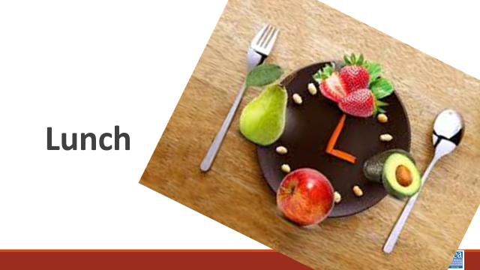 | LUNCH
1:00-2:15  Jessica  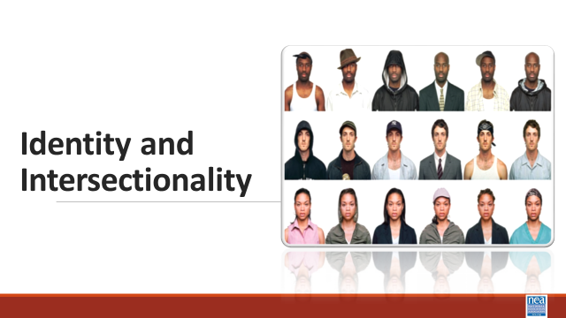  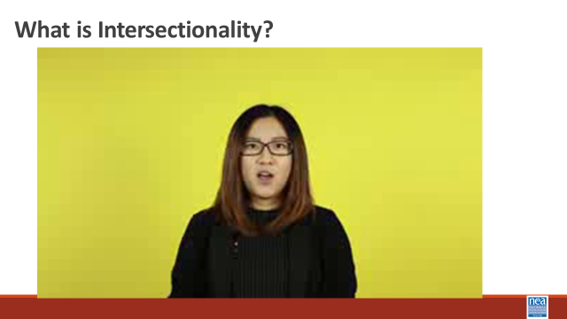  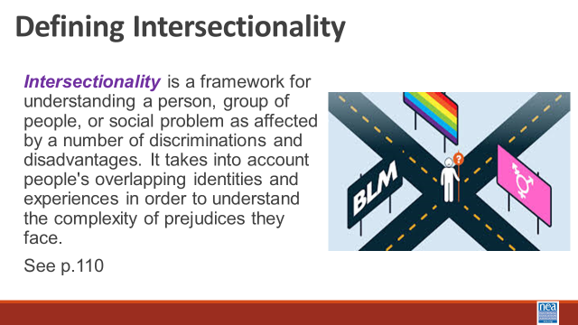  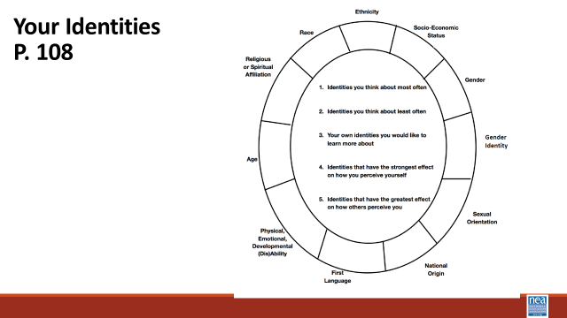  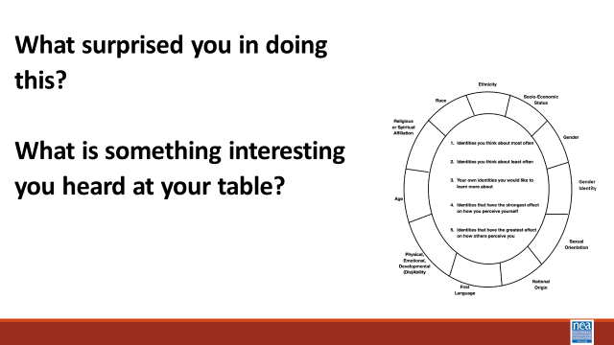  Salina  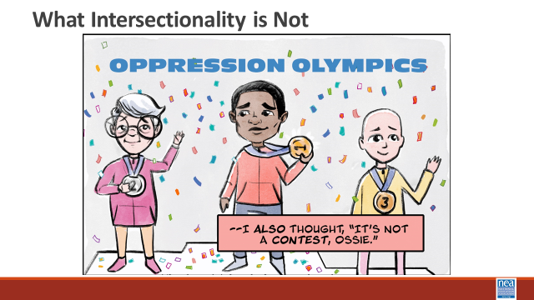  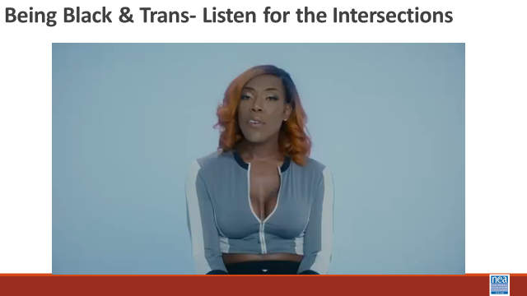  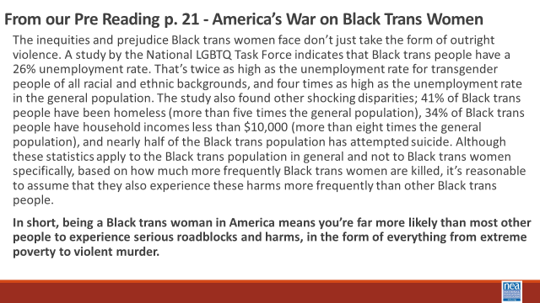  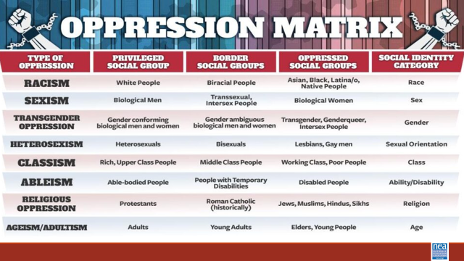  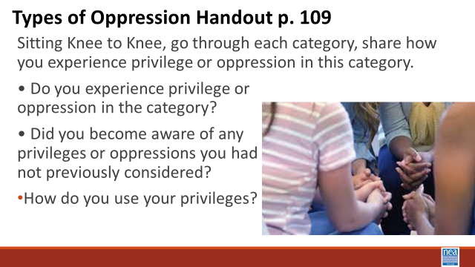  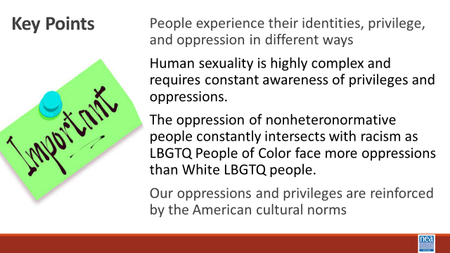 | What makes What is intersectionality? How do our identities intersect?  What are the oppressions that are involved with gender identity and sexual orientation? How do they intersect with racism? | Your Identities Circle worksheet p. 108  Teaching Tolerance: Intersectionality p 110  Pre Attendance America’s War on Black Trans Women p. 21 -26  Types of Oppression Chart p. 109 |  | 75 Mins Identity and Intersectionality  35 minutes for this first section  2 Minutes -Introduce topic with video and definition- What is Intersectionality?  We are going to move back into a couple of foundational concepts – identity and intersectionality.  Show intersectionality video  https://www.youtube.com/watch?v=EXJ4Dbdm1ks  Share the slide with the definition - Intersectionality is a framework for understanding a person, group of people, or social problem as affected by a number of discriminations and disadvantages. It takes into account people's overlapping identities and experiences in order to understand the complexity of prejudices they face. See p.110 for more information about this concept.  10 Mins – individual and then small group talk - Using the Personal Identities Handout p 108 –We are going to take a look at a number of the identities that make us who we are. Around the circle are a number of identities and in the middle are a number of questions. (*Notes to facilitators: the p.108 on in the participant guide does not currently match the slide. It’s missing the questions. Check this during your prep.*)  For the first 5 to 6 minutes, you are going to do this exercise on your own. You will Place the number of the question in the box by the identity or identities that best answers that question.  Once you are finished, share your circles with your table mates. We are going to share at our tables for about 10 minutes  What surprised you in doing this?  What is something interesting you heard at your table?  5 Mins – Three quick thoughts- (Facilitator just pick three) Is there anything that you said or that you heard that the room needs to hear?  5 Mins – Intro and video watching - What Intersectionality is not– We have talked about what Intersectionality is. Let’s take a minute and talk about what it is not. It is important to understand that Intersectionality is NOT the “Oppression Olympics.” Due to the complexity of our identities, it is common for people to be privileged in some areas and oppressed in others. For example, a white woman may benefit from white privilege and may experience sexism because she is a woman. I am going to share video and I am asking you to listen for how the intersections of this person’s identity inform and compound the oppressions that they face.  Show the video of Black Trans Person  5 Mins – Share the America’s War on Black Trans Women – and ask folks to read it to themselves. As the facilitator just read the bold part out loud as a way to bring closure to this section.  “The inequities and prejudice Black trans women face don’t just take the form of outright violence. A study by the National LGBTQ Task Force indicates that Black trans people have a 26% unemployment rate. That’s twice as high as the unemployment rate for transgender people of all racial and ethnic backgrounds, and four times as high as the unemployment rate in the general population. The study also found other shocking disparities; 41% of Black trans people have been homeless (more than five times the general population), 34% of Black trans people have household incomes less than $10,000 (more than eight times the general population), and nearly half of the Black trans population has attempted suicide. Although these statistics apply to the Black trans population in general and not to Black trans women specifically, based on how much more frequently Black trans women are killed, it’s reasonable to assume that they also experience these harms more frequently than other Black trans people.  In short, being a Black trans woman in America means you’re far more likely than most other people to experience serious roadblocks and harms, in the form of everything from extreme poverty to violent murder.”  Facilitator says -This is what intersectionality helps us understand.  40 Mins for this section– 2 minutes Intro and Discussion -We are a going to take some time to talk about identity, intersection, and oppression as you experience it in your workplace.  15 Minutes  • Do you experience privilege or oppression in your work? How does it show up?  • Have you become more aware of any privileges or oppressions you had not previously considered?  - How do you use your privileges in your work?  20 Mins – Whole Room Discussion – What have you been thinking about that you think the whole room needs to know about?  2 Minute – Key Points  Identities, privileges, and oppressions are intersectional.  The oppression of nonheteronormative people constantly intersects with racism as LBGTQ People of Color face more oppressions than White LBGTQ people.  Our oppressions and privileges are layered and reinforced by the American cultural norms |  | Participants will learn how intersectionality provides for an understanding of how overlapping identities inform our relationships with privilege and oppression.
2:15-2:30 | BREAK
2:30-3:00  Ben  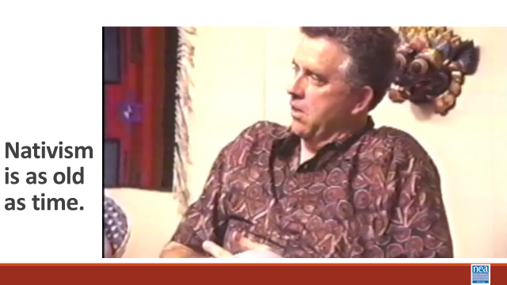  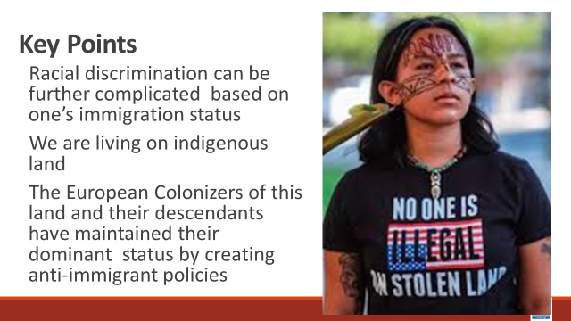 | What does it mean to be American? |  |  | 30 Minutes Total - Nativism and Immigration – consider adding movement here(maybe a gallery walk next time???)  6 minutes intro and video  The next “ism” that we’re going to discuss is nativism, which is the policy of protecting the inhabitants of established inhabitants against those of immigrants. We’re going to start our conversation by watching a video that explains the racist history of U.S. immigration policies.  Show The Racist History of US Immigration Laws video - 5 min  10 Mins - How does all this intersect with race?  What does this mean in our work?  Key Points  - U.S. immigration policies have fluctuated and been shaped by world events and economics  - Anti-immigrant rhetoric and policies are perpetuated by government-endorsed fear of others and of maintaining the country’s white supremacist status quo  5 Mins Let’s look at how nativism shows up in this conversation  Show video from Color of fear.  What did you hear in the video that exemplifies nativism  Key Points  - Racial discrimination can be further complicated based on one’s immigration status  - We are living on indigenous land  - The European colonizers of this land and their descendants have maintained their dominant status by creating anti-immigrant policies |  | Participants will explore the concept of Nativism.
3:00-4:15  Shelly  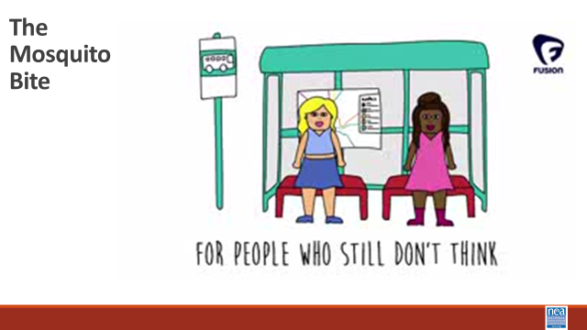  SHOW VIDEO ABOUT Responding to Microagressions  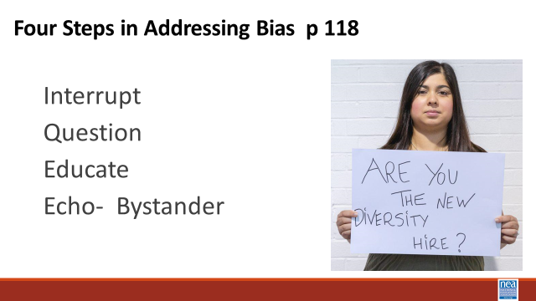  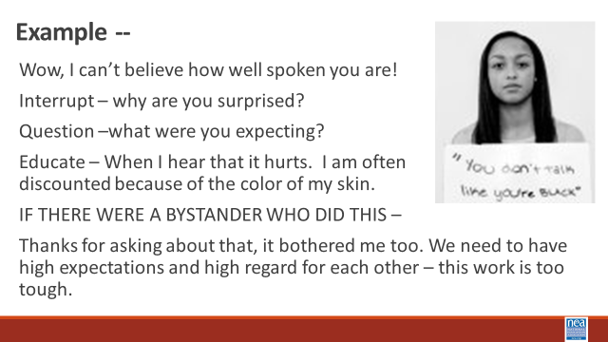  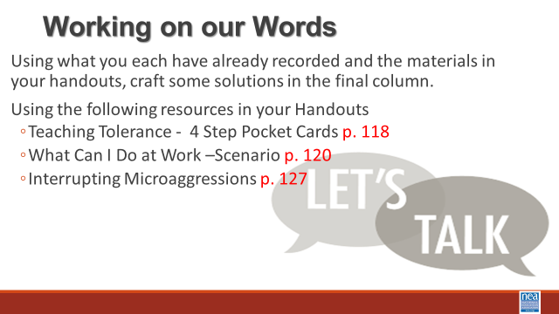  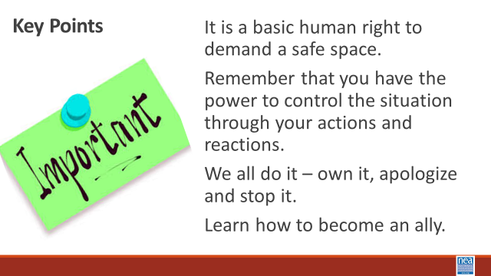 | How do I begin to interrupt the cycle of racism in my everyday work? | What can I Do at Work?  P 118-126  Interrupting Microaggressions p 127- 128 |  | 60 min – Disrupting Microaggressions  2 Minute Intro – In a bit we are going to be exploring at one of the most prevalent forms of racism – the micro aggression. The other most prevalent form of racism is bias. The research around our outward use of and acceptance of microaggressions says that they are the truest indicators of the unrecognized forms of bias we have. Microaggressions are the manifestations of bias.  3 Min video – Show video about how Microaggressions are like mosquito bites (2 minutes)  5 min - Before we get started, take a look at this video, listen: How do you respond to microaggressions? https://youtu.be/C3LFB4mJ0DI  P. 117-118 have some good suggestions for common types of microaggressions  5 mins – Introduce 4 step method for interrupting some common workplace microaggressions.  Interrupt, question, educate, ECHO if you are a bystander  Example - Wow, I can’t believe how well-spoken you are for an ESP Leader!  - Interrupt – why are you surprised?  - Question –what were you expecting?  - Educate – When I hear that it hurts. I am often  discounted because of the job I have. No one can believe that I have a college degree or that I can read, write, and speak.  - IF THERE WERE A BYSTANDER WHO DID THIS –  - Thanks for asking about that, it bothered me too. We need to have high expectations and high regard for each other – this work is too tough.  45 min - Responding to Microaggressions  Often participants will tell us that they are uncomfortable with addressing microaggressions when they occur because they don’t know what to say. Our next activity will give you the opportunity to practice what to say when you are a victim or witness to a microaggression.  5 min – Directions for Activity: The purpose of our next activity is to practice responding to microaggressions in a way that will ultimately lead to their reduction rather than reinforcement. This is extremely challenging, because it is hard to respond honestly without leading other people to become defensive or hostile.  This activity involves three roles – speaker, responder, and coach and all members should have at least one opportunity to play each role. The speaker is responsible for choosing a scenario (or making one up) and saying the remark that is a microaggression. The responder is given the challenge of responding to the remark in a way that reduces the likelihood of future microaggressions, and the coach is a social observer who provides candid feedback on the strengths and weaknesses of the response.  To get the most out of this exercise, it is important to spend as much time as possible practicing rather than simply discussion microaggression reduction, and the coaches should be as open as possible in their feedback. To begin the exercise, one person should play the role of the speaker, one should play the role of the responder, and the remaining group members should play the role of the coaches. Let the conversation build for a minute or so before the remark is made, and let it continue for a while after the response is given. Once the speaker and responder have concluded their interaction, the coaches should critique the response, and the roles should be rotated for another practice round with a new speaker and responder. Do not worry about getting through all the scenarios or adhering precisely to the scripted comments – the scenarios are simply designed as icebreakers to facilitate the activity.  30 min to work through scenarios in groups of 4. Facilitators will visit each of the groups to make certain that you are spending your time doing role playing and not holding discussion. This is a time to practice so that you WILL know what to say.  We will now divide into four (4) person groups. All group members should play each of the roles at least once, and that speaker should choose a new scenario with each rotation.  7 Scenarios  #1  Speaker: Union Membership Chairperson  Responder: UniServ Director  Background: New Member Orientation meeting where the UniServ Director has been asked to speak. You observe the membership chair ask a potential member the question.  Comment: “What are you? Where are you really from?”  #2  Speaker: Participant in a training session  Responder: Workshop Facilitator  Background: Break time during the training session and the participant comes over to talk about how great the training is so far.  Comment: “Someone asking to touch your hair because it is exotic.  #3  Speaker: A high school student  Responder: A teacher  Background: Comment was overheard during after-school study hall  Comment: “You must be good in math; can you help me with this problem.”  #4  Speaker: Your best friend’s co-worker  Responder: A white bystander  Background: Comment was made by friend of a friend at happy hour.  Comment: “How do Black people feel about affirmative action?”  #4-a  Speaker: A fellow colleague  Responder: UniServ Director on the job for 5 years  Background: Comment was made during lunch time with several people at the table.  Comment: “Of course she’ll get the promotion, she’s a minority.”  #5  Speaker: Union member  Responder: Union President  Background: Union member approached officer at the end of general membership meeting  Comment: Being told you speak English well when it is your first language.  #6  Speaker: A middle-age woman  Responder: Black woman  Background: Slightly busy hotel lobby with several people in line waiting to check in  Comment: Being mistaken for someone in a service role.  #7  Speaker: A middle-age uncle  Responder: A family member  Background: Comment was made during a family dinner in which the conversation turned to the topic of LGBTQ+ rights.  Comment: “All that lesbians need is a good-looking man to convert them.”  5 min - Report out on which responses were most effective and which strategies might minimize resistance on the part of the “mosquito”.  Facilitator Note: The Suggested strategies we are looking for in report out are below. If the groups do not come up with them on their own, then share with the group.  - Use questions such as “Why do you say that?” and “Do you feel that way about every person in that group?”  - Point out the difference between what the speaker said and how they behave or believe about themselves, “I’ve always thought of you as someone who is very open-minded”  - Tell the other person how you feel (it makes me uncomfortable to hear that) – it is a statement that cannot be refuted  - Approach the person with respect rather than indignation  Debrief questions:  Is the most effective response an immediate one, or is it better to wait?  Are public responses more effective than private responses?  Are there situations in which it is best to not respond?  1 min -Key Points:  It is a basic human right to demand a safe space.  Remember that you have the power to control the situation through your actions and reactions. |  | Participants will understand the link to bias and microaggression.  Participants will practice interrupting microaggressions using a 4-step process.
4:15 – 4:30  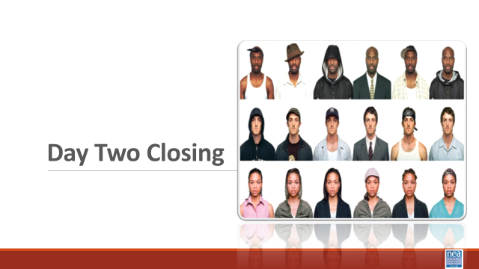  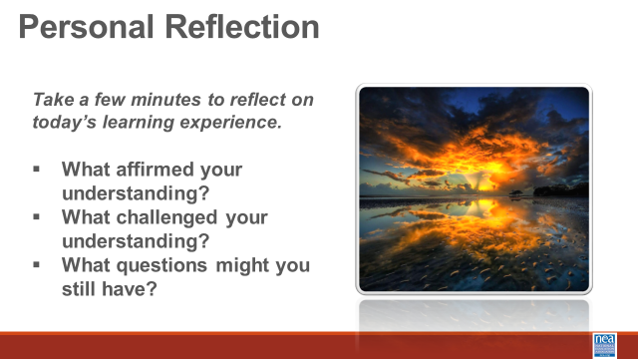  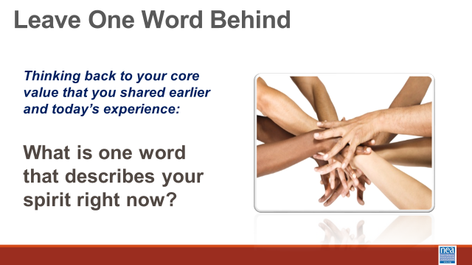 |  |  |  | 15 Minutes – Closing and Connections  What did you experience today that affirmed your understandings?  What did you experience that challenged your understandings?  What questions do you still have? |  | Participants will reflect on their learning and engage in a conversation with their colleagues.
4:30 | Choice Networking
5:00 | ADJOURN

