Facilitator Agenda: Advancing Racial Justice (the Remix) Day #3
General Materials Needed: |  |  |  |  | Room Set-up:
1 Set of Handouts per Person  Name Tags and Name Tents  Sign-in Sheet  Pens and Pencils |  |  | Chart Paper  Markers  Post its  Index Cards |  | Round Tables  Projector, Screen and Speakers  Carousel stations and reporting stations around the perimeter  50 people
Key Outcomes for the Day
Understanding the indicators of becoming anti-racist
Understanding what Allyship Is
Applying Learning in a Case Study Format
Time | Essential Questions | Resources |  | Instructions, Activity and Debrief (Facilitators) |  | Outcomes
 | What question(s) should this learning section answer? | Charts, handouts, articles, materials, slide |  | What are you saying, what are they doing, what questions will you use to guide learning and make clear the important points  Include an estimate for how long each section of the learning will take |  | As a result of this section of learning, what will participants know or be able to do?
8:30-8:45  Ellen  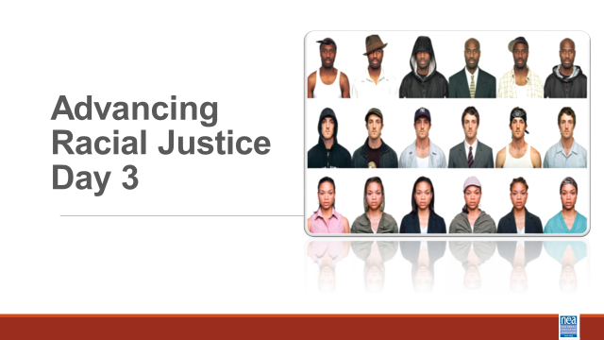  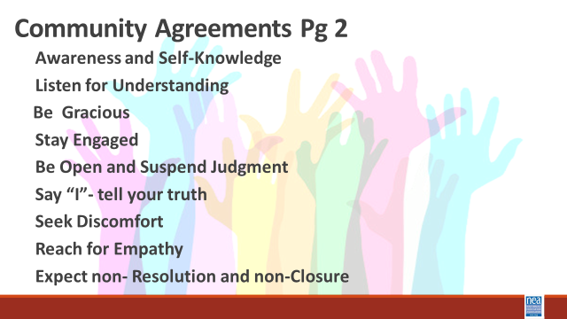    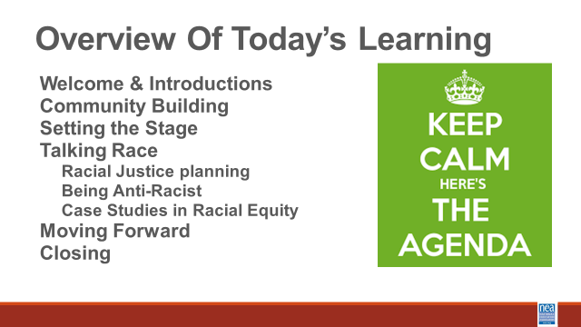 |  |  |  | 15 Mins Greet, Gather & Ground and Entry Activity  Welcome, overview of learning goals, overview of days agenda, feedback on feedback and revisit community norms.
8:45 – 9:45  LaQuita  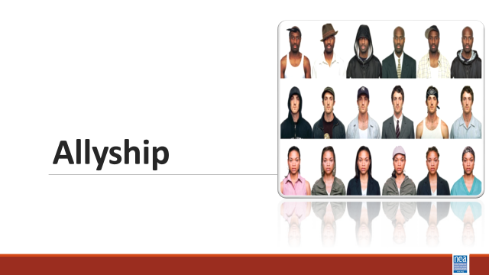  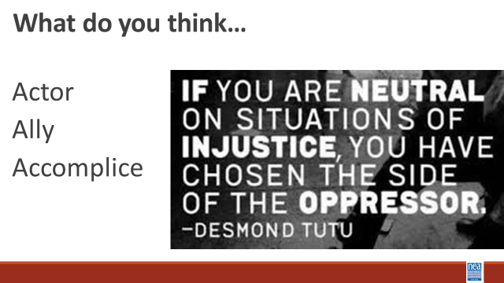  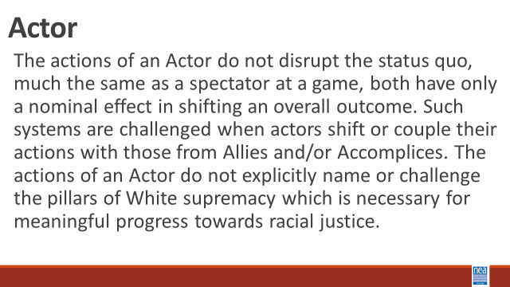    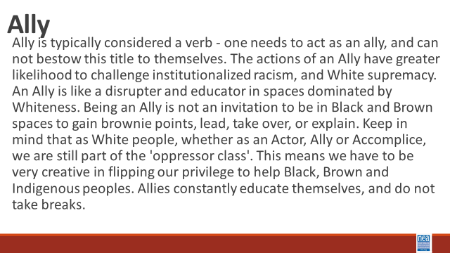  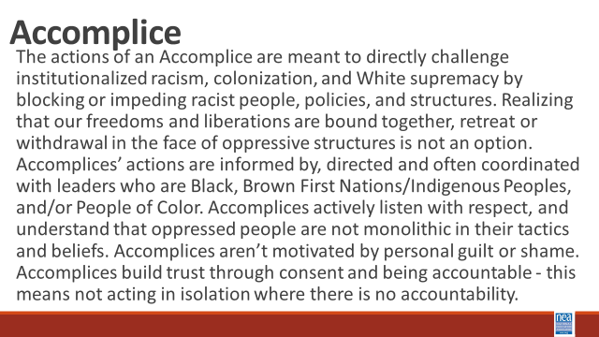  Jessica  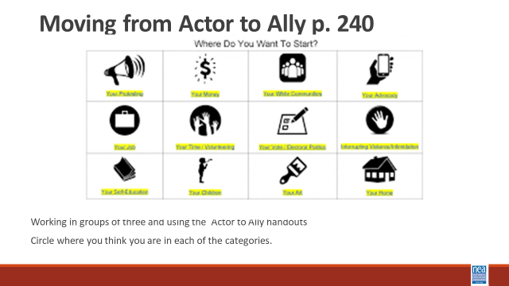  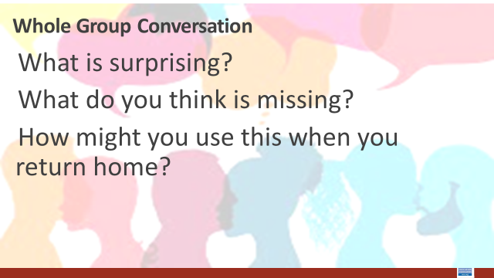 | How do I support racial justice efforts ? | Actor to Ally to Accomplice Chart p. 240  The Action Continuum p.245  So You Call Yourself an Ally p 246  Pre Attendance  How to be an Ally if you are a person of privilege – p. 54  Pre Attendance  Scaffolded Resources for White Allies  P. 79 |  | 60 Minutes Total –Planning and Prepping for Allyship  20 Mins intro and definitions –We are going to look at some continuums of growth towards becoming anti-racist. The first we are going to look at is the actor to accomplice. In small groups, let’ do some talking and development of “indicators and definitions” for each of the following - Actor, Ally and Accomplice. They will take 10 minutes to develop their definitions.  10 Mins Discussion and Sharing – Facilitator will take input from the room and THEN share the slide to see what the room added to or missed from the pre written definitions on our slide –  Share actor definition – discuss how was this similar or different from your thinking.  Show What does it mean to be an ally? Video  Share Ally definition and discuss how this was similar or different from your thinking.  [Show Using your White Privilege video - what video is this? ] Isn’t in the slideshow  Share Accomplice Definition – Discuss how this was similar or different from your thinking.  15 mins – intro, exploration, and report out – Find the Actor to Accomplice charts- p. 240 Let’s work for 10 minutes on your own, then come together with your triad for about 5 minutes to talk about what you are seeing. - Read the descriptions for Actor, Ally and Accomplice in each of the following categories. Circle the description that best matches where you currently stand- what are you currently doing and THEN Focus on what you might consider doing to move the next column. Give them cues for the 10 minutes on their own and then 5 minutes in small groups. Then open up  7 Mins Whole Group Discussion:  What is surprising?  What do you think is missing?  How might you use this when you return home?  3 Minutes – Share video of 5 things to remember about being an ally and then share the following key ideas - Actor, Ally, Accomplice – it’s a continuum  Authenticity comes from actions not announcements. |  | Participants will define and then assess where they currently stand as an Actor, Ally or Accomplice.
9:45-10:45  Ben  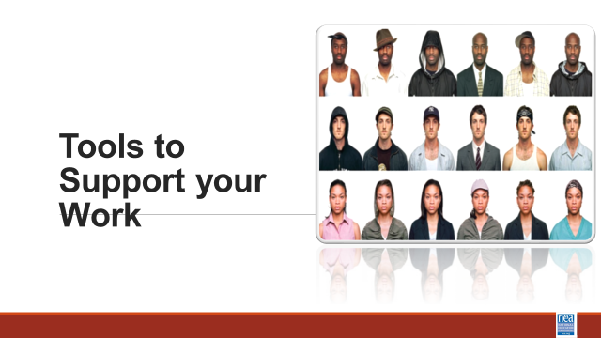  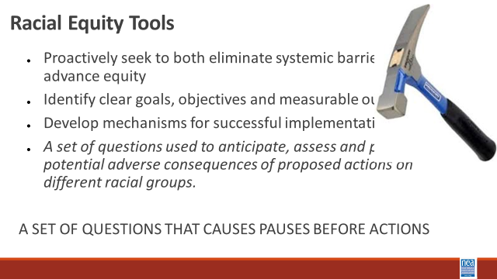  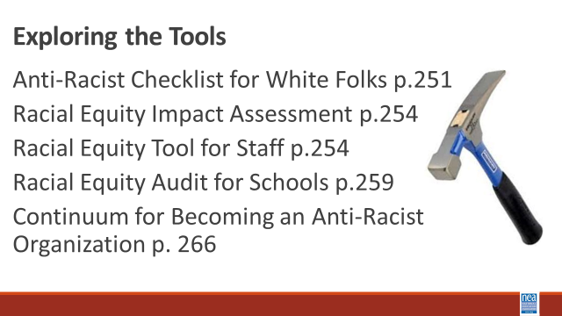  Salina  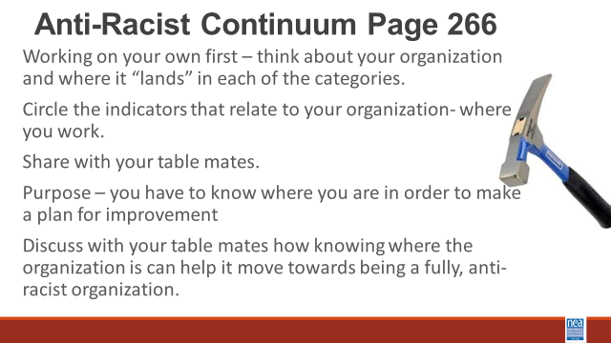  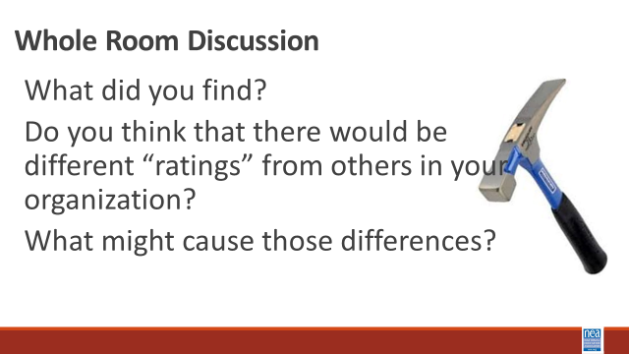  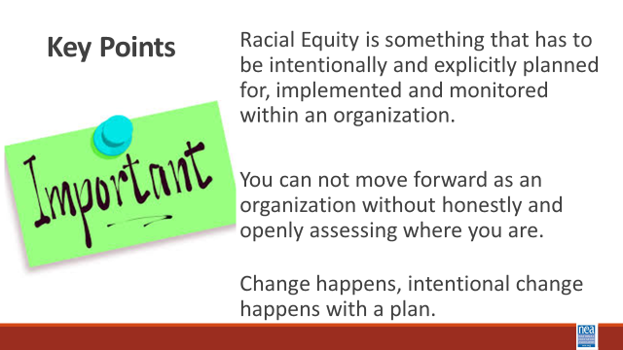 | How do we plan for this work? | Anti Racist Checklist p. 251  Racial Equity Impact Assessment p. 254  Racial Equity Tool for Staff  p.254  Racial equity audit p. 259  Continuum for Becoming an Anti-Racist Organization p. 266 |  | 60 Minutes Total Tools to Support Processes for Becoming Anti-racist  15 mins Intro of Tools - (Facilitator note – this section is simply a walkthrough of some frameworks and tools that can support intentional work with groups that are working to become anti-racist)  We have focused to this point in this training on foundational concepts and dispositions you will need to do this work when you return. We are going to turn our attention now to tools and process for applying your learning.  Let’s look a few tools in this guide you could use to support this work (Facilitator note – just show the slide, give the page number, and then allow folks to scan for a couple of minutes over each tool. Provide just one or two points for each tool)  30 Minutes – Group Work with Continuum for Becoming an Anti-Racist Organization – Take 2 minutes to introduce this tool – it is a way to BEGIN a conversation in an organization. This exact tool has been used in a number of places – a group of non-profits including the area NEA affiliates used this at one time to develop a stakeholder-wide approach to becoming anti-racist. You are going to take 10 minutes on your own first to look at each column and circle the indicators of where YOUR employer currently is. Then, take the next 15 minutes to talk as a group about what this means – note: the column in which you circle the greatest number of indicators is the column that YOU think the organization is currently operating – others might have a different perspective. Share your findings with your group and be ready for a short share out.  Whole Room Discussion  What did you find?  Do you think that there would be different “ratings” from others in your organization?  What might cause those differences?  2 Minutes – Key Points  Racial Equity is something that has to be intentionally and explicitly planned for, implemented and monitored within an organization.  You cannot move forward as an organization without honestly and openly assessing where you are.  Change happens, intentional change happens with a plan. |  | Participants will learn about several tools that can support organizational planning for becoming anti-racist.
10:45-11:00 | BREAK
11:00-12:30  Natasha  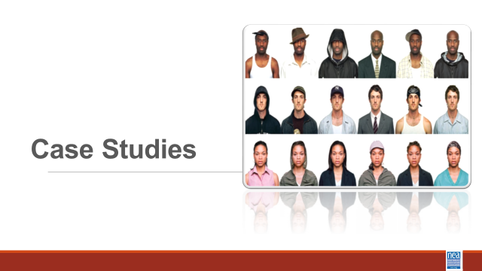  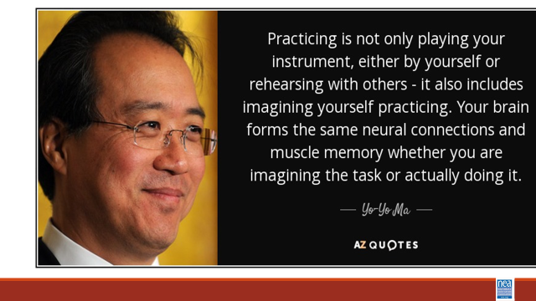  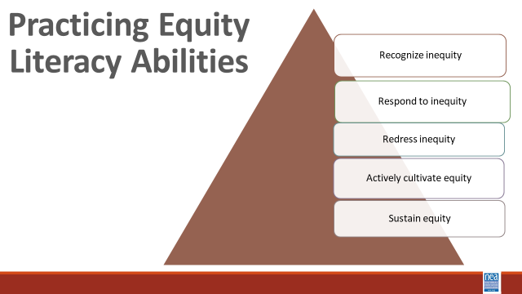  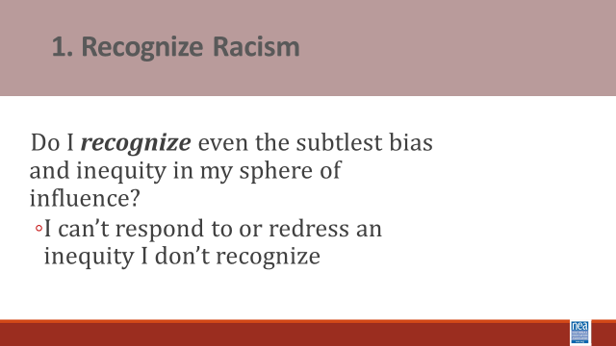  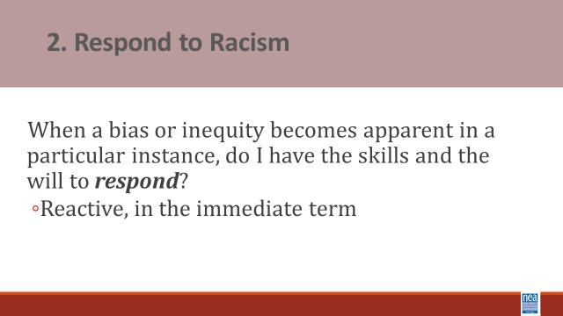  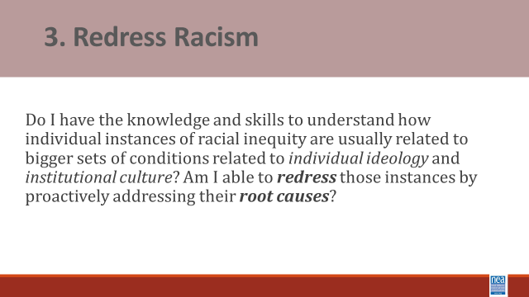  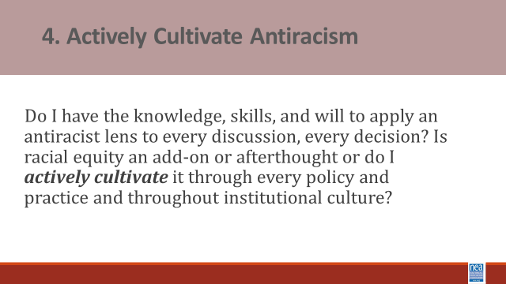  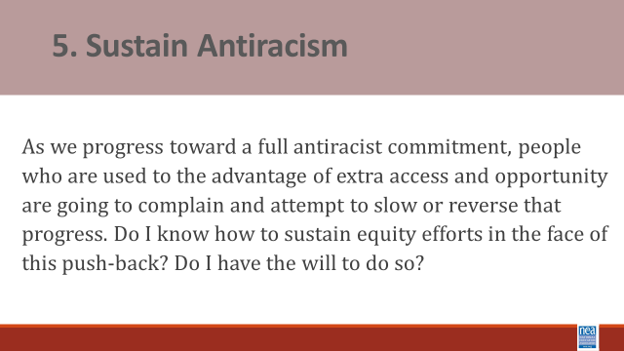  Shelly | How do we practice our learning so we can coach our locals through anti-racist work? |  |  | 90 Minutes -Practicing Becoming Anti-racist - Case Studies in Racial Equity  10 mins Introduction and Content Sharing of what case studies are and the 5 abilities we are working to cultivate - The case method enables us to practice stepping through a process of considering a range of perspectives and angles, to practice seeing the full complexity of school and classroom situations, and as a result to consider a more focused manner in how we might respond.  Cases do not have ONE correct answer or obvious solution. We learn to think carefully, to listen to the points made by others and to evaluate those arguments, to review alternative courses of action and their efficacy, and to interpret real-world experience.  The case method provides opportunities to bolster our abilities to think, teach, lead, and advocate more equitably and justly.  Equity literacy refers to the knowledge and skills we need as educators to be a threat to the existence of bias and inequity in our spheres of influence. It refers to the knowledge and skills that prepare us to root bias and inequity our of our classrooms, schools and communities.  Case studies allow us to practice what Paul Gorski of the Due East Educational Equity Collaborative calls the Equity Literacy abilities:  The purpose of the 5 abilities is to  - allow us to apply a strong equity lens to everything we do; and  - they provide an outline for what the thrust of equity professional learning ought to focus on important abilities:  - The ability to recognize even the subtlest bias and inequities. Equity literate people notice even subtle bias in classroom materials, classrooms interactions and school policies and they reject deficit views that associate outcome inequalities (test scores, graduation rates) with students’ “mindsets” or “cultures” rather than disparate levels of access to resources and experiences in and out of school.  - The ability to respond to biases and inequities in the immediate term. Equity literate people have facilitation skills and content knowledge needed to interview effectively when biases or inequities arise in classrooms, faculty meetings and other contexts. They also foster conversations with colleagues about bias and inequity concerns at their schools.  - The ability to redress biases and inequities in the long term. Equity literate people advocate against inequitable school practices and identify ways to mitigate structural barriers that impede educational engagement.  - The abilities to actively cultivate and sustain a bias-free and equitable school environment. Equity literate people express high expectations for all people and demonstrate a willingness to withstand complaints about changes meant to redistribute educational access and opportunity more equitably.  10 Mins intro to - Seven Steps Script and Group Process - These case studies can be viewed through the following perspective – we often have to help the people in our locals problem solve around difficult issues. These cases allow us to practice the coaching, questioning, and problem solving we might use with those people. This is a process to help you practice using your unique insights, your knowledge about public schools, and our expertise with school and classroom dynamics in order to respond as effectively and equitably as possible, to the types of bias and inequities that inevitable crop up our schools.  We go through these exercises as a group because it is important to reflect upon why people with different combinations of identities and life experiences might interpret the cases differently.  Step 1 – Many biases and inequities students face in school are implicit and unintentional, hidden in day-to-day practices, school traditions, and quiet interactions. It can be especially difficult to recognize the sorts of challenges students or families face when you have never faced those challenges yourself. During this step, I urge you to read between the lines. Practice recognizing conditions and contexts you might not usually recognize or seeing what you might be conditioned not to see. Begin by naming biases, inequities, or otherwise troublesome conditions that are immediately apparent to you. Once you have a grasp of the more surface level dynamics, dig deeper. Look for less explicit, not so obvious examples of existing or potential bias, inequity, stereotypes or presumptions.  Ask yourself : What does the case tell us about school or classroom policy, about instructional or leadership practices, about individuals’ attitudes and perspectives that might hint at something deeper than surface-level biases and inequities?  Step 2 – The cases have at least a couple of obvious stakeholders who might have different perspectives on what is happening. In every case, we should consider not only the people immediately involved, but also those within earshot and eyeshot.  Start with the immediate participants and then, at the very least, the ring of constituents around them.  Focus on marginalized communities and privileges communities.  Then take it one step further. What if something was shared on social media – you have to consider the perspective of someone seeing this on SnapChat.  Step 3 – Our next task is to identify potential challenges and opportunities present by the situation. Start with the individuals involved. Remember to use your analysis from Steps 1 and 2 to inform your assessment of challenges and opportunities.  Step 4 – Building on the understandings we have gained by talking stock of stakeholders’ perspectives and considering possible challenges and opportunities, we begin imagining positive and equitable outcomes. [take time to clarify difference between equity (fair) and equality (same)].  Remember to think both immediate term and long term. What can be resolved right now, on the spot, and what will equity look like once it is resolved? Consider long-term outcomes as well. And finally, be specific – identify very specific, on-the-ground outcomes, how specifically will things be different in the school or classroom if we commit to resolving the issue and all its nuances equitably?  Step 5 – We begin brainstorming strategies to get us there.  Step 6 – We develop longer term strategies often for more substantive change. Record whatever ideas come to mind.  Step 7 – During our final step, we craft our brainstorms into specific actions we believe will result in the equitable outcomes we outlined in step 5 –  - What would we do in the immediate terms?  - What would we do that might a little longer term equity project?  - How would we respond to ensure, to the best of our knowledge and power, justice for everybody involved?  In summary, the point is not to memorize these steps or to step through them carefully in every instance, rather the ideas is to use them to practice our equity literacy skills by reflecting on classroom and school conditions through a social justice lens.  30 Minutes – Teams will work on assigned cases and be prepared to share their findings.  30 Minutes – Group Reporting and Discussion |  | Participants will practice a case study process.
12:30-1:00  Ellen  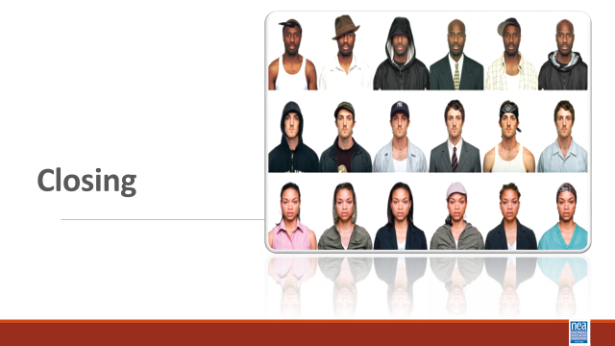  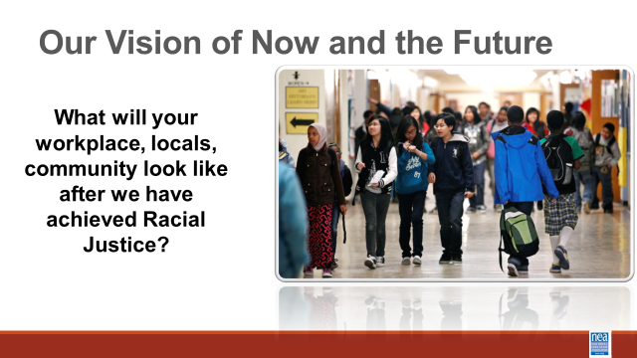  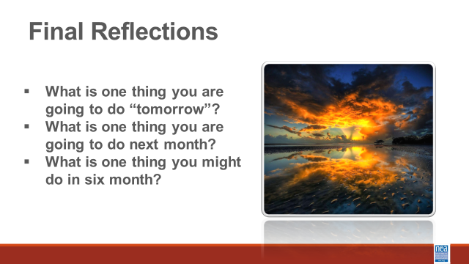  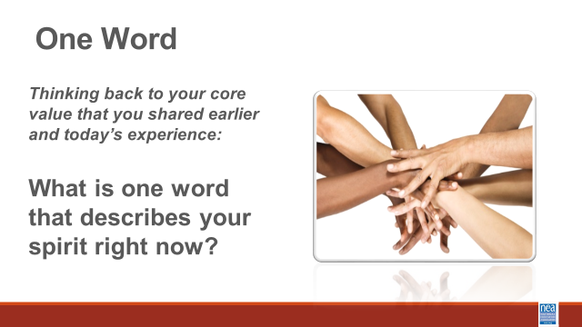 |  |  |  | 30 Minutes Total - Final Closing Circle  What will your workplace, locals, community look like after we have achieved Racial Justice?  - What is one thing you are going to do “tomorrow”?  - What is one thing you are going to do next month?  - What is one thing you might do in six months?
1:00-2:00 | Boxed Lunches, Networking, 2:00 PM Adjourn

