Facilitator Agenda Day 2 – Teachers Unions and Social Justice
General Materials Needed: |  |  |  |  | Room Set-up:
1 Set of Handouts per Person  Name Tents with the Norms  Sign-in Sheet  Agendas on the table (1 per)  Room signs, sign in signs  One ream of white photocopy paper  Chart Paper (4 to 5 full w Sticky Strip) |  |  | Materials Box for each table with:  Markers (Mr. Sketch variety)  Post its – 3x3” and 4X5” sizes  Index Cards  Highlighters – 4 colors  Pens and Pencils  Participant “toys” |  | Round Tables  Projector, Screen and Speakers  Carousel stations and reporting stations around the perimeter  50 people
Key Outcomes for the Event:

Big Ideas for Day 2 –
Understanding Financialization
Understanding Institutionalized Racism
Understanding Institutionalized Power – maybe the picture walk, maybe the pillars of power, financialization
(Theory of Change) Strategies for Winning
Natural Leader ID
Structure Tests
Time | Essential Questions | Resources |  | Instructions, Activity and Debrief (Facilitators) |  | Outcomes
 | What question(s) should this learning section answer? | Charts, handouts, articles, materials, slide  RED is for Facilitator  BLUE is for Participant |  | What are you saying, what are they doing, what questions will you use to guide learning and make clear the important points  Include an estimate for how long each section of the learning will take |  | As a result of this section of learning, what will participants know or be able to do?
7:00 -8:30 | Breakfast, Facilitator Prep
Entry Activity   | What does it mean to seek justice?
8:30 -8:55  Ellen  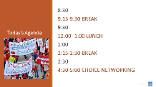  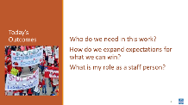  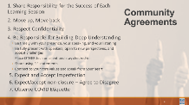   | How will we work together to support learning? |  |  | 30 Mins Total  Check in, review of norms, and logistics for the day  Reminder of last day check out, getting to the airport etc.  PAST FAC GROUP TO FUTURE FAC GROUP: It may be important to acknowledge that, while a lot of today’s content will be educational and academic for some, it evokes generational trauma and is the lived experience for many. Participants should take care of themselves and take space and time when necessary and please let the facilitators know if we can support you. (Possible use of Pillars Activity) |  | Participants will know how we are going to work, the basic schedule, and the logistics relevant to the training.
8:55-9:45  11:10-12:00  Jessica  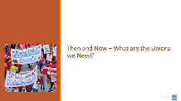    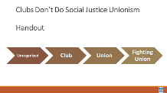  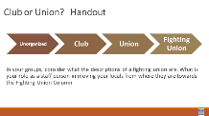  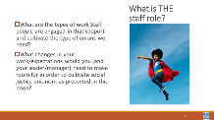  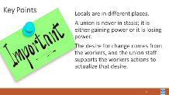 | What are the kinds of unions we need to achieve the wins we want? | Club to Union Handout  https://neahq-my.sharepoint.com/:w:/g/personal/eholmes_nea_org/EVrLDCQgRRZNrktgEmRrcgEBPmPl8EYy0leK8BMH84IIiA?e=MDfLYo |  | 50 Minutes - Then and Now – What are the Unions we Need  30 Minutes – Participants will use Margaret Haley’s essay in the (Pg. 67-69) They will need the Then and Now Handout (10 minute)s of work with the article to complete the handout.  They will discuss at tables (10 Minutes) the following three questions  - What does Margaret Haley describe in her essay that are still problems today?  - How well do you think our unions have achieved wins around these issues?  - If we could bring her here, what would you want to tell her about your work for a union that makes you proud?  Debrief (10 Minutes) What are big ideas and themes that came out of your table conversations?  20 Minutes – Club or Union  Need the club or union handout. As individuals first (5 minutes) circle the descriptors in each row that BEST fit a local that you work with. As a table group (7 minutes) discuss what you saw and what this would mean for you as a staff person to move them to the “fighting union level”  Debrief - 8 minutes - How does the “fighting union” connect with what is needed in the Margaret Haley essay?  Key Points  - Locals are in different places.  - A union is never in stasis; it is either gaining power or it is losing power.  - The desire for change comes from the workers, and the union staff supports the workers actions to actualize that desire. |  | Participants will understand the club to fighting union and assess where they are on that.
12:00-1:00 | LUNCH
1:00-1:45  Albert & Ellen  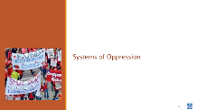  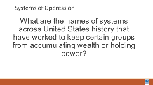  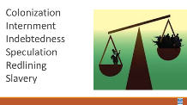  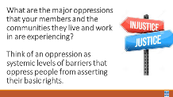  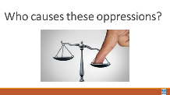  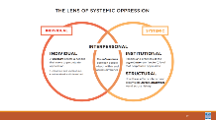  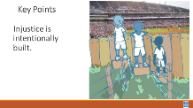  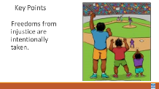 | Why does it feel like we can’t get ahead? | Lens of Oppression Handouts  https://neahq-my.sharepoint.com/:b:/g/personal/eholmes_nea_org/EYQHnRLm2DRGqBqdnAPj0UoBDpyTQ9xvJHMaE3jDEooT3w?e=uDSdVh |  | 15 minutes Systems of Oppression (Mini Lecture)  This book is about Social Justice which requires a look at social movements. Social movements are focused on broader issues of injustice, shared across groups from different sectors of society – students, teachers, communities  Quick – 2 minute turn and talk at your table what are the names of systems across United States history that have worked to keep certain groups from accumulating wealth and power?  Ask tables to report the names of systems they named – show the slide that lists some that have been pre-populated  Quick 2 minute turn and talk – who causes these oppressions?  Ask table to report the names of people they have named – show the slide that lists some that have been pre-populated  Let’s look at a framework for understanding Systemic Oppressions (Handout) – such as Racism -- there is an individual and systemic component. We are going to focus on the systemic level of this framework. The institutional level is oppression that is supported by policies and practices WITHIN a an organization or sector. (within a school)  The structural level is how the effects ACROSS institutions and history interact and accumulate – (such as the school to prison pipeline)  Key points – People in power intentionally build, support, and defend policies practices and systems that oppress others.  Liberation from these oppressions can be intentionally taken through mobilization and organizing across sectors. |  | Participants will be able to identify systems of oppression.
1:45- 2:30  Albert & Ellen | What are the oppressions facing our public schools? | Picture Walk Facilitator Guide  https://neahq-my.sharepoint.com/:f:/g/personal/eholmes_nea_org/Ejx_czVhVnhKs8soxqhAjeIBYCSEY2sec8n-GJH7vfS2VA?e=RKVJy1  Picture Walk Posters  https://neahq-my.sharepoint.com/:f:/g/personal/eholmes_nea_org/EsHM--LBsttHku0Hdc8C-OcBZJOWq8f1EVEuqsCjknAACQ?e=4LFRpY  Picture Walk Handout  https://neahq-my.sharepoint.com/:w:/g/personal/eholmes_nea_org/ERc7PSOTTqNMpV5LQpwYPxIBi2TvYSK_ZK0YrMzis66jqQ?e=ZxXgRw |  | 60 Minutes Economic Oppression  2 minutes – Let’s talk for just a minute at our tables - what is the difference between income and wealth? Ask for a definition of each – then provide the following – Income is the revenue that a person can bring into their household. Wealth is anything that can be liquidated and/or passed from generation to generation. Income examples (wages, salary, savings account interest, social security check, rent from owning real estate, capital gains from selling investments, dividends from stocks, gifts, etc.) Wealth examples – (house without mortgage, jewelry, gold, stocks, insurance payout, inheritance)  With this understanding - let’s discuss our next topic.  5 Minutes -Take just one minute – first on your own for one full minute- consider the following question – In the last decade, has the wealth and income that your members experience been improving? How do you know? what are the visible signs? Take examples for about 4 minutes with a focus on the visible signs.  5 Minutes – What characterizes these two time periods in the United states – Take a number of answers – Then Sum it up by saying – the first time period is typically marked by economic growth for all ---- if you were white. The second time period is marked by – Trickle-down economics – a backlash of primarily white wealthy powerholders who work to hoard wealth with the most-wealthy.  20 Minutes – Facilitator will move whole group to a large space that allows for spectators to see a a group of individual volunteers take a long walk.  I am going to need five volun-tolds come to this starting point - all lined up on this starting line and facing the same direction. Please stand shoulder to shoulder. Each gets a sign showing the income range — in pre-tax, year 2014 dollars — of the quintile they represent.  We are going to watch how income has changed over quintiles in the population – Economists talk about the U.S. population in “quintiles” or “fifths”. They imagine the entire population of the U.S. lined up in order, from the lowest income to the highest. They then divide that line into five equal parts. This activity looks at what happened to the incomes during two periods of economic growth: 1947-1979 and 1979-2014.  Take a look at the signs the volunteers are holding – this number represents median Family Income – what jobs would be in each of these? What economic challenges would each have – what are the signs we would “see”? Where are our members – pay attention to job classes and state differences. Each volunteer, representing a quintile or fifth (20 percent) of the U.S. population, will step forward or back according to whether their income gained or declined. Each step equals a five percent change, so, for example, two steps forward would indicate an income gain of 10%.  Facilitator Script for the Five People --- 1947 to 1979  NOW ADD TWO MORE VOLUNTEERS – the top 5% and Top 1% --  Now let’s reset our volunteers to the starting line – and explore 1979-2014  10 mins Debrief and Key Points  Which of the quintiles do most of your members reside?  Which of the quintiles do your families live?  Which of the quintiles do policy makers live?  Which quintile controls power? How do you know?  Key Points –  From 1947 through 1979 our policies were more about lifting all economic boats – if you were white. Everyone who was white did better together.  From 1979 through today or policies are a result of systematic efforts to take back any gains made by black and brown people during the years following the Civil Rights Movement. The birth of trickle down.  10 Minutes – 1 Minute intro - Here is an example of how several systems have created oppression around the accumulation of wealth – as you watch consider the following – who are the power holders in the system? What are the unjust polices and practices? Who is being oppressed? What is the overall impact on society?  6 Minutes -Show PBS Redlining Film  3 Minutes- Key Points – and any reactions  The systems of income and wealth have been intentionally built to shift power and opportunity away from those in the lowest Quintiles to those in the top.  This is further compounded when you look at the intersection of race and income. |  | Participants will understand the pervasive ways that powerful elite have built systemic oppressions.
  Quintile | Steps | Percent Change | Yearly Income Range (2014) (family income before tax)
  Lowest | 2 I/2 steps backward | - I2% | $0 - 29,I00
  Second | I/2 step forward | +3% | $29,I0I - 52,697
  Middle | 2 steps forward | +I2% | $52,698 - 82,032
  Fourth | 5 steps forward | +26% | $82,033 - I29,006
  Highest | I0 I/2 steps forward | +54% | $I29,007 & higher
  Quintile | Steps | Percent Change | Yearly Income Range (family income before tax)
  Top 5% | I5 I/2 steps forward | +78% | $230,030 and up
  Top I% | 37 steps forward | +I85% | $423,090 and up
  Quintile | Steps | Percent change
  Lowest | 12 Steps Forward | +116%
  Second | 10 Steps Forward | +100%
  Middle | 11 Steps Forward | +111%
  Fourth | 11.5 Steps Forward | +114%
  Highest | 10 Steps Forward | +99%
  Top 5% | 8.5 Steps Forward | +86%
2:30-2:45 | BREAK
2:45 - 3:45 | What does economic oppression look like? | The Financialization of Chicago Public Schools  https://neahq-my.sharepoint.com/:b:/g/personal/eholmes_nea_org/EeOiEmGheMRAoRrVwGxutRABtEIx844jOxtu4kmkPD0jQw?e=hfiGLC  Content for the Quintile Walk  https://neahq-my.sharepoint.com/:f:/g/personal/eholmes_nea_org/EjLhBmrg971Pt3p7J1O1ZZcBJSDrKSDp4Ndo_94BbO165g?e=j94Te7 |  | 45 Minutes – Poster Walk  Feedback from last training:  - Switch Poster Walk with Economic Oppression (Quintile Walk)  - New Schedule:  - 10:15-11:00..... Economic Oppression (Quintile Walk)  - 11:00-12:00..... Poster Walk (Let people do the walk and debrief after lunch)  - Lunch (to allow for participants to process)  - Debrief Poster Walk (participants talked about the poster walk left them sort of hopeless but the pillars of power gave them hope or showed them that things would get better)  - Use Pillars of Power format to allow for full processing of feedback  *As of 6/15-16/2022  PAST FAC GROUP TO FUTURE FAC GROUP: Acknowledge to the group that this might be an especially tough activity for some (harken back to the morning)  35 Minutes - There are five stations of posters, graphs, and quotes located around the room.  Process for each station:  - Your group will have approximately 6 minutes at each station to view the illustration or graphic images and discuss the questions.  - At each station, start by giving the group 60 seconds to look at the image without speaking..  - After the full minute of observation has passed, use the next five minutes to discuss the questions posted at each station  - There is a handout to support you as you move through each station.  - At the signal move to the next station  10 mInutes of debrief and sharing of the key ideas  - The wealth gap in our country is huge and growing, leaving everybody at the bottom further and further behind.  - Banks and corporations are taking resources from our communities and hoarding them to increase their own profits and politicians are letting it happen.  - Corporate greed and tax breaks and loopholes lead to fewer resources for public services and public schools.  - The wealth gap between the rich and working people by race is even larger than it is for white people. This gap shows up in our classrooms every day. If we want to achieve true economic justice, we must address racial disparities and racism in our country.  - Privatization of schools does not improve outcomes or segregation. There is a strong link between school segregation and school choice programs.  PAST FAC GROUP TO FUTURE FAC GROUP: Consider taking a small break to allow participants to decompress after the activity (requested from some of our participants who are people of color)
 | LUNCH
1:00 -1:30  Linda & Sara  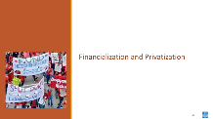    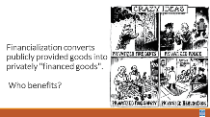    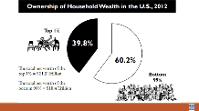    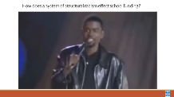   | Who benefits from our economic system? | The Financialization of Chicago Public Schools  https://neahq-my.sharepoint.com/:b:/g/personal/eholmes_nea_org/EeOiEmGheMRAoRrVwGxutRABtEIx844jOxtu4kmkPD0jQw?e=hfiGLC  Content for the Quintile Walk  https://neahq-my.sharepoint.com/:f:/g/personal/eholmes_nea_org/EjLhBmrg971Pt3p7J1O1ZZcBJSDrKSDp4Ndo_94BbO165g?e=j94Te7 |  | PAST FAC GROUP TO FUTURE FAC GROUP: THINK ABOUT SHIFTING THE FINANCIALIZATION/PRIVATIZATION, STANDARDIZED TESTING, & INTENTIONAL PLAN TO DISMANTLE PUBLIC SCHOOLS SECTIONS TO BE GROUP STUDIES WHERE DIFFERENT GROUPS PROCESS THE INFORMATION FROM THE RESOURCES AND THEN TEACH THEIR COLLEAGUES.  30 Minutes- Financialization and Privatization  Begin by defining what Financialization and Privatization are  Financialization converts publicly provided goods into privately financed goods. Think about how fire departments are beginning to be privatized in forest fire prone areas of California – if you are wealthy enough you can adequately protect your home. Who benefits from this?  Let’s watch what Robert Reich has to teach us about privatization  What is an idea so important from this you would want to have it put on billboards along every major highway in the United States?  Financialization is what has allowed for the 1% to accumulate wealth that is greater than the 99% --they are the where the people who are actively working to dismantle public schools come from - see your handouts “Mapping the Movement to Dismantle Public Education, The Financialization of Chicago Public Schools, and Pages 304 to 310 in your book.  Let’s watch how all of this comes together to impact local school funding.  Consider who are the power holders, who is being oppressed, how are unjust policies and practices being used? And What is the overall impact on our society?  Show the Video  Key Points:  - Our system is designed to extract wealth and power from the lower levels of our system and move it to the top.  - Financialization benefits the wealthiest. |  | Participants will be able to identify how financialization effects their own work with locals.
1:30- 1:45  Beth  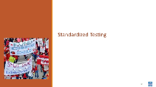          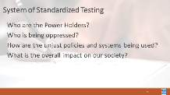  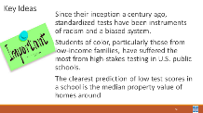 | How has standardized testing created a system of oppression? |  |  | 15 Minutes - Standardized Testing Mini Lecture  Jesse Hangopian is one of the key leaders in Seattle’s anti standardized testing movement that is highlighter on pages 324-327 of your book. Let’s watch him speak about that.  Why do we have standardized testing?  What are the racist foundations of standardized testing?  Discussion –  - Who are the Power Holders?  - Who is being oppressed?  - How are the unjust policies and systems being used?  - What is the overall impact on our society?  Key Ideas –  - Since their inception a century ago, standardized tests have been instruments of racism and a biased system.  - Students of color, particularly those from low-income families, have suffered the most from high-stakes testing in U.S. public schools.  - The clearest prediction of low test scores in a school is the median property value of homes around the school |  | Participants will understand that standardized testing has racist roots.
1:45 – 2:00  Jessica & Sara    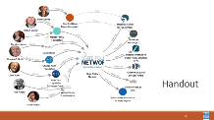  \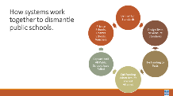  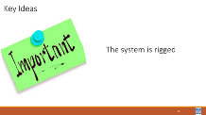 | Who creates and maintains the systems that prevent justice in our communities? | Mapping the Movement to Dismantle Public Schools  https://neahq-my.sharepoint.com/:b:/g/personal/eholmes_nea_org/Ea-24mR2OCJApu1wnoAMnJsBdGIcmGt0rtyDYhrtFb6khQ?e=QHXsjR |  | 15 Minutes Total –The Intentional Plan to Dismantle Public Schools  Refer to the Handouts – The Financialization of Chicago Public Schools and the Mapping the Movement to Dismantle Public schools. AND Pages 315 -318 – the Many Faces of Privatization  These an outline the intentional system created by member of the 1% wealthy elite in the United States.  They effectively promoted a narrative of failing schools that was supported by the development of high standards, matched by tests designed to measure those standards, public policy that tied school funding to test scores, then cut funding when results are not met. Repeat until all public schools have failed, allow public funding to drain to private schools/vouchers/charter schools  Key Points  - Individuals and organizations in each part of the plan to dismantle public education are often the same wealthy elite, funded by the same wealthy elite, or elected by the same wealthy elite  - The system is rigged. |  | Participants will become aware of who are the power holders working to dismantle public education.
2:00-2:15  Shelly  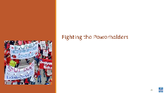  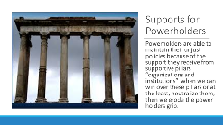  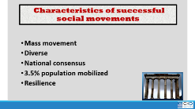  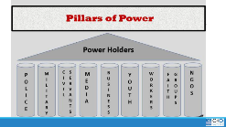  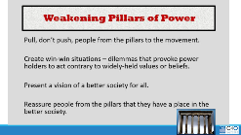  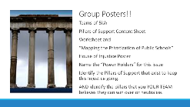 | How do the powerholders maintain the status quo and what can be done about that? | Pillars of Support Worksheet and Content  https://neahq-my.sharepoint.com/:w:/g/personal/eholmes_nea_org/EeSkVjg32StHrQWjTN4pMzYB7YS4uWG-XkFEwu_R8jGv3g?e=UYmdpc  Article – Mapping the Movement to Dismantle Public Schools  https://neahq-my.sharepoint.com/:b:/g/personal/eholmes_nea_org/Ea-24mR2OCJApu1wnoAMnJsBdGIcmGt0rtyDYhrtFb6khQ?e=QHXsjR |  | 60 Mins - Pillars Activity (Before and After Break)  15 Minutes Before - give directions, get set up in groups go over which sections and then get started. 45 Minutes will be AFTER break)  10 mins – Powerholders are able to maintain their unjust policies because of the support they receive from supportive pillars “organizations and institutions” when we can win over these pillars or at the least, neutralize them, then we erode the power holders grip.  30 Mins - We are going to work in teams of 5ish to examine the pillars of support that exist to uphold the privatization of public schools. You will need the Pillars of Support Content Sheet, Worksheet and the article called “Mapping the Privatization of Public Schools” MAY ALSO USE THE ESSAY that is called “EDUCATIONAL DEBT” and the Essay – The Many Faces of School Privatization  Using these resources, your team is going to create a House of Injustice Poster. In the top you will write the “Power Holders” for this issue AS YOUR TEAM SEES IT. You will identify the Pillars of Support that exist to keep this Injustice going. AND you will then identify the pillars that you YOUR TEAM believes they can win over or neutralize.  CONTINUED AFTER BREAK |  | Participants will analyze the pillars of support for a particular social problem -privatization of schools – and identify the pillars they believe they can win or neutralize.
2:15 -2:30 | BREAK
2:30-3:15  Shelly  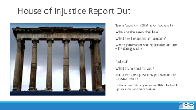  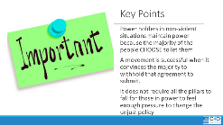 | How do the powerholders maintain the status quo and what can be done about that? | Pillars of Support Content and handout  https://neahq-my.sharepoint.com/:w:/g/personal/eholmes_nea_org/EeSkVjg32StHrQWjTN4pMzYB7YS4uWG-XkFEwu_R8jGv3g?e=UYmdpc  Article – Mapping the Movement to Dismantle Public Schools  https://neahq-my.sharepoint.com/:b:/g/personal/eholmes_nea_org/Ea-24mR2OCJApu1wnoAMnJsBdGIcmGt0rtyDYhrtFb6khQ?e=QHXsjR |  | CONTINTUED FROM BEFORE BREAK –  30 Mins - We are going to work in teams of 5ish to examine the pillars of support that exist to uphold the privatization of public schools. You will need the Pillars of Support Content Sheet, Worksheet and the article called “Mapping the Privatization of Public Schools” MAY ALSO USE THE ESSAY that is called “EDUCATIONAL DEBT” - and the Essay – The Many Faces of School Privatization  Using these resources, your team is going to create a House of Injustice Poster. In the top you will write the “Power Holders” for this issue AS YOUR TEAM SEES IT. You will identify the Pillars of Support that exist to keep this Injustice going. AND you will then identify the pillars that you YOUR TEAM believes they can win over or neutralize.  10 Mins – Report out from each team – (3 Mins or less each)  Who are the powerholders?  What are the pillars of support?  Which pillars can you neutralize or turn – by doing what?  10 mins-Debrief  What stands out to you?  Are there any questions you would like to ask a team?  Is there any idea you would like to hold up as an awesome idea?  Key Points  Power holders in non-violent situations maintain power because the majority of the people CHOOSE to let them.  A movement is successful when it convinces the majority to withhold that agreement to submit. |  | Participants will map the pillars of support for a set of power holders.
3:15 – 4:15  Naomi & Sara    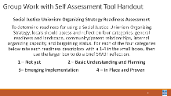  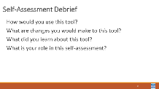  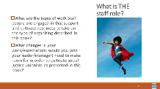 | Are you ready? | Self Assessment Tool.  https://neahq-my.sharepoint.com/:w:/g/personal/eholmes_nea_org/EcNc8MAlzr9Hi57nDhyZm5wB8QH-fB2TEVB5q_uj7eHFDw?e=mR84gy |  | 60 Minutes Total – Assessing Your Readiness  15 minutes - First on your own,  20 Minutes then as a group discuss your readiness to take on Social Justice Organizing. Complete the tool, discuss at your table and be ready to have a whole room discussion around your role in moving local leaders to readiness.  25 Minutes – Whole group |  | Participants will understand the readiness indicators for Social Justice Organizing
4:15-4:30  Ellen  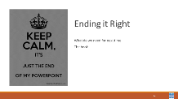 | How are we doing so far? |  |  | 15 Minutes - Ending it Right  Questions, Connections, Reflections  Housekeeping announcements  FOR TOMORROW – |  | Participants will be able to bring a little closure to their learning and provide feedback on the day.
4:30 – 5:00 | What is the expertise among my colleagues? |  |  | Choice Networking Activities |  | Participants will make useful connections with staff from other affiliates.
5:00 | ADJOURN

