Facilitator Agenda Day 3 – Teachers Unions and Social Justice
General Materials Needed: |  |  |  |  | Room Set-up:
1 Set of Handouts per Person  Name Tents with the Norms  Sign-in Sheet  Agendas on the table (1 per)  Room signs, sign in signs  One ream of white photocopy paper  Chart Paper (4 to 5 full w Sticky Strip) |  |  | Materials Box for each table with:  Markers (Mr. Sketch variety)  Post its – 3x3” and 4X5” sizes  Index Cards  Highlighters – 4 colors  Pens and Pencils  Participant “toys” |  | Round Tables  Projector, Screen and Speakers  Carousel stations and reporting stations around the perimeter  50 people
Key Outcomes for the Event:

Themes and Big Ideas for Day 3
Getting Started – Natural Leader ID, Common Good Tools
Setting a Timeline – What are the issues your locals could take on? What do you have in place, and what do you need?
What would you do? - Planning and Problem Solving
Time | Essential Questions | Resources |  | Instructions, Activity and Debrief (Facilitators) |  | Outcomes
 | What question(s) should this learning section answer? | Charts, handouts, articles, materials, slide |  | What are you saying, what are they doing, what questions will you use to guide learning and make clear the important points  Include an estimate for how long each section of the learning will take |  | As a result of this section of learning, what will participants know or be able to do?
7:00-8:30 | Breakfast, Facilitator Prep
Entry Activity   | What is required to win?
8:30 – 9:30  Ellen  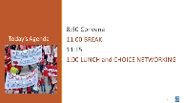  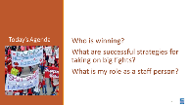  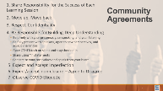     | What is the status of our learning? |  |  | 45 Mins Total - Welcome back  15 Mins Feedback on Feedback, Agenda Review, Norms Review  30 Mins Community building exercise – \  Head – What is something new you have learned  Heart – What is a belief that has been challenged  Hands – What are you feeling  Feet – Your Next Steps  Share out
9:30 – 10:30  Sara  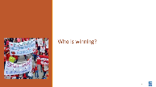  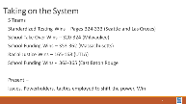 | How do our unions work at dismantling systems of oppression? | Make a chart of the campaign to win presented in the essays  Campaign Mountain  https://neahq-my.sharepoint.com/:b:/g/personal/eholmes_nea_org/ETrsZkuF5q5MhTs5Oygk1l0BGffCBWCoDonulpf7n2v4Vw?e=gRZweu |  | 60 Mins TOTAL – Examples of Taking on the System  ALL READ - 312-314 – Acheivement Gap Narrative  Privatization – Pages 315-319  School Funding – Pages 304 – 311  Standardized Testing Wins – Pages 324-333 (Seattle and Las Cruces)  School Take Over Wins – 320-324 (Milwaukee)  School Funding Wins – 353-362 (Massachusetts)  Racial Justice Wins – 165-168 (UTLA)  School Funding Wins - 362-365 (East Baton Rouge)  Using Milwaukee, Seattle, Massachusetts, Louisiana, and the pillars of support tool, teams would identify and report out on what they did to attack the systems of oppression they experienced.  Debrief:  What stood out to you about these five narratives?  What can you take away from one or more of these stories?  What is a piece of the story you’re curious about that wasn’t told? |  | Participants will identify the issues, the power holders, and the strategies that were used to shift power in the system to make change.
10:30 -11:00  Matt & Albert  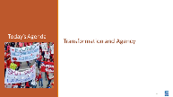  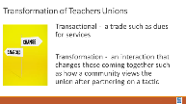  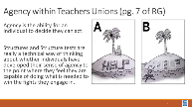  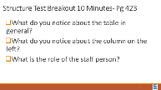 |  | Structure Tests Handout  https://neahq-my.sharepoint.com/:b:/g/personal/eholmes_nea_org/EQTvCIvUwcpCvRxYbiZ5NnsBVymGrMr4jssd6fXBnBrqSA?e=sSY4NZ |  | 30 Minutes Transformation  This book outlines the case for transformation.  Our purpose and that of our leaders is to get people to act. We do this by – to do the coaching people into believing they have the capacity to act. When they feel competent enough, they will use their agency to act. This is the basis for escalation. People take risks when they feel competent enough to act - to do the “test” you have requested. A test is simply a task or tactic.  Using the Jane McAlevey Table highlight the timeline that it took for UTLA to pull off its win.  Discussion -  What was the staff role in this work?  What FOUNDATION work was in place that supported this escalation? |  | Participants will understand how a timeline is developed and the purpose of tests.
11:00-11:15 | BREAK
11:15 – 12:00  Beth & Ellen  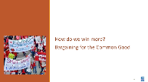    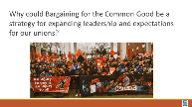  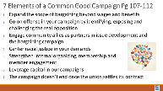    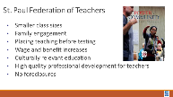  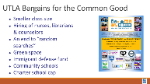  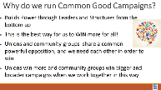  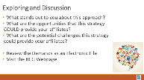  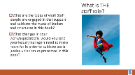 |  | Community Engagement Handout  https://neahq-my.sharepoint.com/:b:/g/personal/eholmes_nea_org/EZZOU7K8vg5Om5TqfdJYLtUBuio7YC0NCsVaExsGxysEQQ?e=RYKwWZ |  | 45 Minutes – Bargaining for the Common Good and Community Schools  10 Minutes of Discussion about what Bargaining for the Common Good Is  10 Minutes of Carousel Activity – 7 Components of Bargaining for the Common Good.  7 Groups: Each makes T-chart of opportunities and potential challenges of assigned element, then adds to each of the other charts. 3 minutes at each chart.  10 Minute overview of Community Schools (2 min video) and Resources around Allies and Coalitions (p 69-78)  10 Minutes Carousel Activity 6 pillars of community schools  3 min., T chart w/ opportunities and challenges  *As of 6/15-16-2022  5 minutes: Review wins, why we bargain for common good, and resources to explore independently
12:00 – 12:35 Jessica  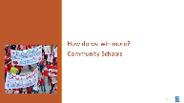  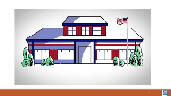  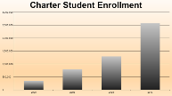  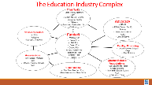  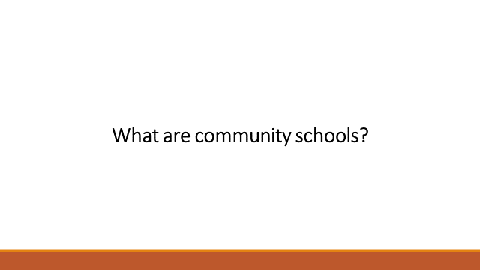  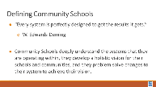  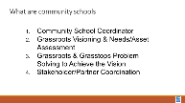  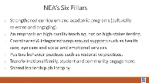  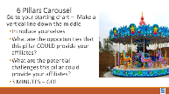  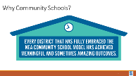  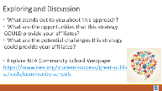  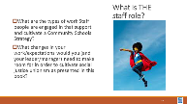  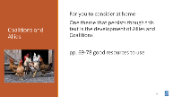  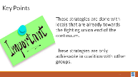 |  | Coalition Handout  https://neahq-my.sharepoint.com/:f:/g/personal/eholmes_nea_org/EvuhY5v36ZpDgZtpE4hR0pABnENdSR5d5ej9CgMGECiiHA?e=sWSIOe |  | 35 Minutes –Coalition Building with Other Groups  Add a component entitled: “Coalition Building and Partnerships with Other Groups”; there are some activities embedded in this component (see Steve’s presentation that is already embedded into the PowerPoint); also include how to do community mapping and power mapping activities also.  *As of 6/15-16/2022  5 minutes- Debrief |  | Participants will apply the consultancy protocol in the group presentation context.
12:35 -12:50 Shelly  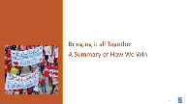  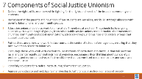  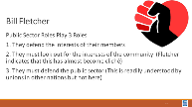    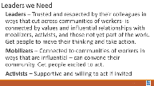  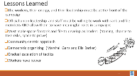  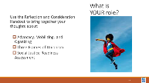  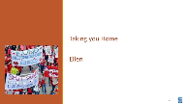  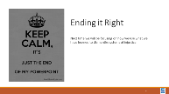 |  | Reflection and Consideration Handout  https://neahq-my.sharepoint.com/:w:/g/personal/eholmes_nea_org/ESkhCnaqeaJKjNdnbjye5v0BF26PnfQms4070IhtgtGeZA?e=fr4Ul1 |  | Summing it all up  A review of the theory outlined in the book.  A reflection on the three assessment tools presented.
12:50-1:00 Ellen |  |  |  | Ending it Well  Warm and Cool Feedback for the Team  Leave a Word in the Room  Voucher Reminders
1:00 | Adjourn with Boxed Lunches

