Writing the Next Chapter

The Center for Organizing and Affiliate Support

Introduction

Executive Summary
This paper reviews our membership trends over the last 10 years, the current work of the Center, and the external and internal challenges and opportunities we face. It outlines a plan for a more coordinated and strategic approach to strengthening and growing our state and local affiliates; along with a re-organization of the Center.
THEORY ON THE CASE: Educator voice depends on union strength. Union strength is directly correlated to union density. We will align C4OAS programs, staff, and resources within a Coordinated Organizing Plan to build union density. We will do this through a three-pronged focus on member organizers, member organizing committees, and worksite leaders.
  - Expand and develop the YRO Member Organizers program to maximize affiliate capacity to recruit new hires and potential members across all affiliates
    - Continue to drive innovation in digital engagement, social media, telephonic, data and in membership systems processing
  - Prioritize majority status campaigns in bargaining states, led by member organizing committees, to win exclusive recognition and first contracts in locals without them – thereby driving measurable increases in union density
  - Build affiliate sustainability in prohibited bargaining states:
    - through a focus on worksite leadership: expanding the ranks of building reps helps build the bench – building future capacity. It puts trusted and respected worksite level leaders at the forefront of member engagement.
    - by supporting affiliates in moving from payroll deduction of dues, to direct eDues, to gain independence from hostile politicians.
Fundamentally, the charge of the Center for Organizing and Affiliate Support (C4OAS) is to support the growth and strength of NEA’s state and local affiliates. This work is grounded in NEA’s vision, mission and Strategic Plan and Budget. Most of the Center’s work is enhancing organizational capacity.
President Pringle’s priorities for 2022-2023 include advancing our strategic vision, uniting our members, securing the environment and creating safe, just and equitable schools. C4OAS’s work touches all of those priorities. In November, at our virtual Center-wide staff meeting, we reviewed the Strategic Plan and Budget and where all of C4OAS’s activities and work fit in.
Since its founding, the Center has worked to build a culture of organizing across our affiliates. A culture of organizing prioritizes member recruitment, engagement and growth. As we begin the next chapter in the Center’s development, this is an opportunity to reflect on what we have accomplished, what the union’s challenges and opportunities are today, and how we can continue to advance our work and get to even greater scale.
There’s no single definition of organizing. It means different things to different people and in different contexts. I gravitate to the definition that organizing means empowering workers and changing lives. At the end of the day, it is about enabling members and potential members to exercise their voice and collective strength to make change.
Fred Ross Sr., an icon to many organizers, once said “the duty of the organizer is to provide people with the opportunity to work for what they believe in”. Our job is to create those opportunities. The members will build their union.
I have learned important lessons about organizing from a wide range of mentors and earlier efforts: the UFW, IAF, SNCC, ACORN, SEIU, the Highlander Center. We need a wide range of skills, strategies, and tools in the fight for justice.
There is no one right way to organize. But there are best practices; things we can learn. As organizers we must reflect and engage in constant discussion about what works and what doesn’t, in order to improve our skill, our craft, our effectiveness and our success. That is the meaning of continuous improvement, of being a learning organization, and of good organizing practice. In everything we do we must ask: how are we empowering members – and changing lives?
There is widespread agreement inside the Center that we are driving good work in lots of different places; but that it can be challenging because it feels isolated, siloed, and uncoordinated.
The environment in which we operate radically changed five years ago. The Janus decision creates a completely new world and a different set of challenges than we faced back when the majority of our affiliates had the security of agency fee protections. How we operated in earlier years is not the answer. “Let us not return to what was normal, but reach toward what is next”.
To address these new challenges, and build upon the progress that has been made over the last ten years, this paper outlines a plan for the Center that aligns the various C4OAS organizing programs and activities into a coordinated and strategic approach to strengthening and growing our state and local affiliates.

Tom Israel, Senior Director
NEA Center for Organizing & Affiliate Support

--------------------------------------------------------------------------------------------------------------------------------------------------------

Membership Trends: the Last 10 Years
TRENDS IN ACTIVE MEMBERSHIPS
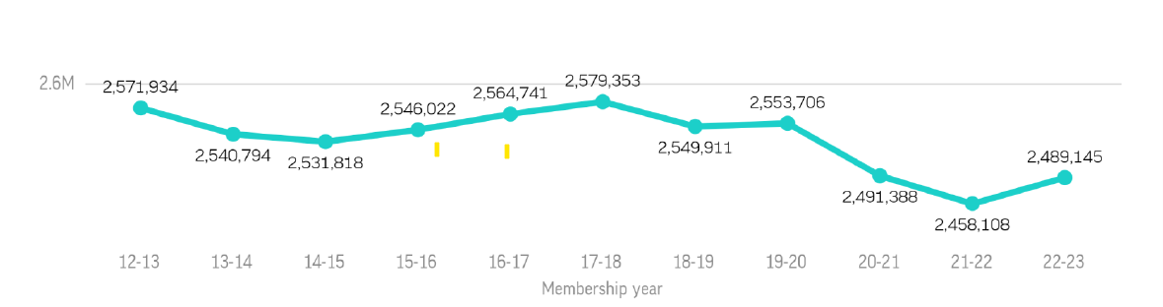

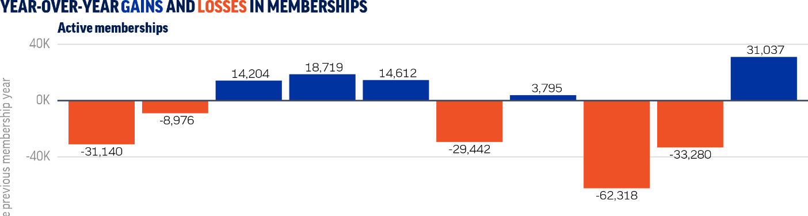

The Great Recession that started in 2008-2009 led to a sizeable loss of public sector jobs and ultimately NEA active members. C4OAS began its work in 2012, helping affiliates stop the bleeding of members and return to net growth. Then we faced the exigent threats from the U.S. Supreme Court in the twin cases challenging agency fee dues, Friedrichs vs. CTA and later Janus v. AFSCME. We survived the Janus decision far stronger than many feared, and our opponents had hoped for. The pandemic caused a greater drop in membership, as education employment numbers across the country decreased sharply (2.4% loss in year 1). This year we are beginning to see a recovery in our membership as we emerge from the worst years of the pandemic.

Throughout, C4OAS has understood that our most immediate challenge was to expand affiliates’ practices of membership recruitment, which too many took for granted under the protection of agency fee laws and contracts.

We understood that recruitment needed to be planful, needed to occur throughout the year, and that development of best practices in the habits and mechanics of recruitment could significantly increase member density. This was especially important at a time when the vast majority of our affiliates were losing agency fee, turnover was increasing in our professions, and retention of members was suffering.

The loss of agency fee protections has transformed the relationship between the union and most of our members. We are a voluntary organization of 2,880,290 members (total). Each member now has to make an active decision to join, and they are free to leave. That new relationship underscores the union’s need to engage, involve and listen to its members. To not do so is at the union’s peril.

The effort to reverse membership loss drove C4OAS to develop recruitment projects through the seasonal organizing campaigns of Ed Summer, New Ed, Winter Worksite and Early Enrollment, which have evolved into the current Year-Round Organizing and Member Organizers program. After seven years, C4OAS has done what few thought we could do – build a nationally coordinated program with the voluntary buy-in across virtually all state affiliates. We have made significant progress in assisting affiliates to develop and execute recruitment campaigns throughout the calendar year.

The Member Organizers program is a core element of the overall strategy. No one is better positioned to recruit new members than a trusted and respected educator who already works at that worksite.

The fact that we now have 48 state affiliates participating, and that participating locals are showing significantly greater membership growth than the rest of the union, is a testament to that success. And the capacity to recruit, train and support 1,200 member organizers a year is an awesome accomplishment.

At the same time, we have continued to support state and local affiliates in a myriad of other ways: including training, strike support, contract campaigns, scratch organizing campaigns, legislative campaign field support, issue organizing campaigns, member GOTV, constituency organizing, grant support, conferences, and even hurricane recovery.

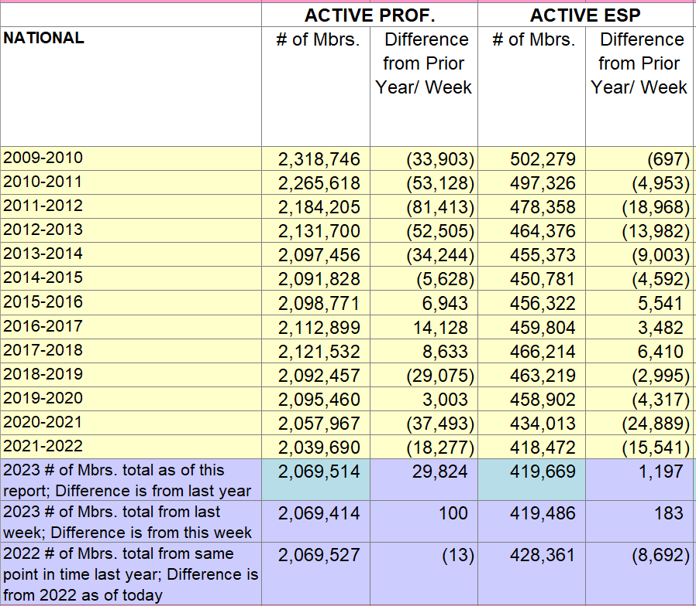

During this past September and October, we have taken time to reflect on what we are accomplishing, what challenges we face today, and what the opportunities are to increase our effectiveness. All C4OAS staff were also invited to provide feedback via an anonymous online survey. Virtual meetings were held with each of the seven staff teams in the Center for discussions of those questions.

What We Are Accomplishing
* The Year-Round Organizing program is running what may well be the largest Member Organizer Program in the labor movement: currently tracking 1,190 member organizers working in 43 states. The program is running in 48 states and 552 locals, recruiting 33,689 new members a year in targeted locals. (by members, for members)
* We are developing an Innovative Strategies Lab to test new uses of digital communications in membership recruitment and engagement, as well as identifying opportunities to improve the mechanics, work flows, and efficiency of our membership processing systems.
* We are expanding a Telephonic Join program that is successfully enhancing affiliates recruitment, along with promising pilots to increase PAC contributions.
* We are winning issue organizing campaigns in places like New Mexico, Texas, Nevada, Hawaii, California and Idaho; winning things like pay scale compression, student supports, and special ed investments. In New Mexico, we helped win a statewide $15/hr. minimum wage for all school employees and a 7% raise for all public-school employees and higher education faculty; in Austin - a $16/hr. district minimum wage, a $21/hr. starting wage for bus drivers, and a $2.50/hr. pay raise for all ESPs; and in Las Vegas, an increase of $6.6 million in the districts contribution to ESP healthcare costs, preventing healthcare costs from rising during the 22-23 SY.
* We are training 120 new local presidents a year in partnership with NCUEA
* We are supporting majority status recognition campaigns in Virginia and Colorado.
* We are supporting scratch organizing campaigns in Florida, Michigan, Pennsylvania, Maryland and New Mexico.
* We are providing support to Aspiring Educator chapters across the country.
* We are coordinating Advocacy Training Programs in partnership with 12 state affiliates.
* We are partnering with the Center for Racial and Social Justice and We Make the Future, to build professional learning communities for leaders and staff in state affiliates around race/class narrative.
* We are assisting a local rebuild and emerge from a voluntary trusteeship.
* We are training 300+ affiliate field staff a year in basic organizing skills, along with Advancing Racial Justice in UniServ Work, Teacher Unions and Social Justice, and Organizing Strategies for ESPs.
* We are building grow-our-own programs to help affiliates to hire a more diverse field staff to better reflect our members and our students; through both the National Organizing Fellows Academy (a yearlong fellowship) and the Pre-UniServ Academy (a 12 week, job-embedded professional development course).
* We are supporting multiple state affiliates in transitioning from payroll deduction to direct eDues payment systems.
* We are supporting affiliates on issue campaigns in Mississippi around safe drinking water in Jackson, and in South Carolina on a tax abatement campaign.
* We have been supporting our Lee County Florida regain ESP local to increase density and leader identification, in order to majority status and preserve recognition.
* We’ve been assisting seven states across the southeast in rebuilding dormant local affiliates.
* We are assisting six state affiliates in increasing retiree engagement in the work of the union.
* We are supporting Wisconsin in rebuilding a statewide field program, following its transition from a fully local-option state to one with the ability to coordinate centrally.
* We are supporting higher education affiliates in Florida, Rhode Island, Michigan, Alabama, Maryland, New Mexico, Montana, and Nebraska.
* We have staff on loan to state affiliates to fill in as interim state executive directors during transitions.
* We provide crisis support to locals on strike: most recently in places like Seattle, Kent and Columbus.
* We support our affiliates on the campuses of HBCUs and MSIs, in Alabama, Florida, California, the District of Columbia, and New Mexico.
* We partner with state affiliates to support state board capacity through strategic planning and training.
* We provide in excess of $5 million a year to affiliates to support member recruitment and engagement organizing projects, across a range of grant programs.
* We have responsibility for executing multiple NEA conferences each year, including the Higher Ed Conference, the Retired Conference, the UniServ Managers Conference, and the two NCUEA conferences.
* We administer a range of programs to support affiliates, including the Shared Staffing Program for mutual affiliate assistance, the Solidary Loan Program for strike loans for members, the Small States Grant Program to support small state affiliates, as well as the UniServ Program.
The Current Moment
The resurgence of a fascist movement threatening our democracy looms large. There has long been a white, racist sub-culture on the fringes, and at times in the halls of power, in American society. 60,000 KKK members marched in Washington DC in 1925. Emmett Till’s lynching in 1955 was just one of thousands in a very long history of white nationalist political violence. Today we witness Charlottesville and the January 6th insurrection. There is a lot at stake.
Our mission - to unite our members and the nation to fulfill the promise of public education – is an essential part of the fight to defend democracy. There is a reason they ban books, try to whitewash the teaching of American history and the history of race, attack publicly elected school board members, and seek to privatize and undermine public education. Public education is indeed a bulwark of democracy.
Unions – organizations of working people – have long been the backbone of civil society movements to defend democracy around the world. Public education unions can and must play an especially critical role, not only in the defense of democracy but also in the advancement of racial justice for our students and their families. Universal, quality public education is essential for both.
Just before the pandemic hit, the Red for Ed movement swept the nation with walkouts by educators in West Virginia, Oklahoma, Arizona, as well as Colorado, Kentucky, North Carolina, Indiana, Oregon, South Carolina, Denver, Little Rock and Los Angeles). Tens of thousands of educators willing to strike and walk out to defend our schools, our students and their families.
In 2018, our enemies and our friends thought the Janus decision would be a crushing setback for teacher unions. We have lost some members, but far less than anticipated. We survived Janus and we have survived a pandemic that disrupted our work, our schools, our communities, and the lives of our members.
More harmful than the Janus decision has been the loss of payroll deduction of dues in specific states – devastating membership density. These affiliates are adapting to new ways of collecting dues and staying connected to members, while a growing number of state affiliates face this existential threat.
Confidence in institutions is eroding across the spectrum: from government to the media, churches, business, political parties, banks and corporations. Yet “nationwide support for organized labor has reached a high-water mark not achieved since the 1960s”. Support is highest among Gen Z and Millennial women – our core constituencies. Even young Republican women support unions at a higher rate than their predecessors ever have - now a majority.
There are ambitious new union drives in the service sector (Starbucks), warehousing (Amazon), retail (REI), in the white-collar private sector (Vox Media, etc.) and in non-profits.
As we emerge from the worst years of the pandemic, with historically low employment and an infusion of federal dollars into the economy, there is an upsurge in union organizing drives. We are seeing a spike in union elections overall (2,510 NLRB election petitions alone in FY22, a 53% increase over the prior year).
Just this year, we have seen educator strikes in Minnesota (Minneapolis), Washington (Seattle, Kent, etc.), Ohio (Columbus), and Massachusetts (Brookline, Dedham, Malden, Haverhill). In Massachusetts, the striking educators faced off against court injunctions.
All of these strikes, like the RedforEd walkouts before them, included student-centered demands – bargaining for the common good as well as our own.

“Organized labor has never been able to predict or trigger the developments that have led to its revival and reinvention over the course of two centuries… It has had to be opportunistic, acting boldly at the right time by using the best ideas, models, and language at its disposal to build new forms of power for those who lack it.
But it has had to be decisive when these windows of opportunity have opened, for they have never stayed open for long. Confronted as they are by enemies, unions must seize the opportunities that these recent teachers’ mobilizations have presented”.

There must be a sense of urgency to our work. The times demand it. It is our responsibility to act boldly – to seize the moment as best we can. Complacency is not an option.
Our members, our students, our schools, our communities, and indeed today - in 2022 - our nation and democracy itself, depend on it.
As the anthropologist Margaret Mead once commented,

Never doubt
that a small group of thoughtful, committed citizens can change the world.
Indeed, it is the only thing that ever has.

Strategic Building Blocks of C4OAS
- Align programs, staff and resources within a C4OAS Coordinated Organizing Plan
Focus on increasing union density in order to increase the power of our affiliates and the voice of our members. We will advance this goal by:
- Maximizing member recruitment across all affiliates
- Prioritizing majority status campaigns to win bargaining rights
- Building worksite leadership networks and protecting threats to density from loss of payroll deduction of dues, in prohibited and weak bargaining states
- Targeting ‘deep dive’ states for coordinated support
- Maximize affiliate capacity to recruit new hires and potential members across all affiliates
  - expand and develop the Year-Round Organizing member organizers program
  - drive innovation in digital engagement, social media, telephonic, data and in membership systems processing
- Focus on opportunities across bargaining states to run majority status campaigns to win exclusive representation and first contracts. (in both permissive and mandatory bargaining states). Expansion of majority status bargaining rights directly correlates with increased member density and thereby increased member voice and power. Recognition campaigns expand the union.

- Focus in prohibited and weak bargaining states on building sustainable capacity:
  - Worksite leadership systems: helping state affiliates expand and train building rep networks for locals and regions – building the bench
  - eDues transition: for independence from threats from hostile politicians
- Develop a set of targeting criteria to identify ‘deep dive’ states where we align resources to qualitatively move the needle on growth, engagement and expansion.
Over the last ten years, a primary goal has been persuading affiliates that recruitment was not just done during the Back to School season and at new employee orientations, but rather should happen throughout the entire calendar year. The various C4OAS teams (GLUE, MSMV, Zones) developed organizing programs and tools to help build an organizing culture of member and potential member engagement among our affiliates.

A laser-like focus on recruitment is essential. We must continue to coach and support affiliates in running robust and larger member organizer programs, and building them in to their own program funding. We must continue to innovate and take advantage of new tools and strategies. It is essential. We have to recruit 250,000 new members a year just to maintain current levels of union density.

We also know that union density and strength are correlated with exclusive representation and collective bargaining. States with near universal contracts have higher density than states with permissive bargaining laws, almost all of whom have higher density than states where collective bargaining is prohibited. The more widespread collective bargaining is, the higher our membership density. Among our certificated membership:
- we are at 61% density across all the mandatory bargaining states
    - 10 states are above 80%
- We are at 39% density across permissive bargaining states
- We are at 12% density across prohibited bargaining states

We have hundreds, if not thousands, of local affiliates in permissive and in mandatory bargaining states that do not have exclusive recognition and bargaining rights. Winning recognition and bargaining rights inevitably result in increased membership, density and strength.

Members and potential members are rarely more engaged than during campaigns for recognition and first contracts. These can be critical compression points for increasing membership, engagement, and strength.

Leaders are developed through action. Campaigns for recognition and first contracts are powerful crucibles for the identification, testing and validation of trusted and respected worksite leaders. Successful recognition campaigns are led by effective member organizing committees. And they build effective worksite leadership networks.

Our ability to assist locals without bargaining rights, to win exclusive recognition and first contracts can qualitatively expand and strengthen the union.

Our 500 largest locals (>900 members) represent 41% of our overall active membership. Systemically expanding collective bargaining in those locals can increase our membership and our density in both permissive and mandatory bargaining states.

Help more of our members win the right to bargain collectively, and they will advance their own self-interest, bargain for the common good, and fight for the safe, just and equitable schools our students deserve. Winning the right to bargain empowers workers and changes lives. Focusing on that, makes everything else possible.

States where collective bargaining is prohibited, by their very nature, call for a different strategy. The good news is that we are seeing record-breaking membership growth in states like South Carolina, Georgia, Arkansas and Mississippi. But prohibited bargaining states also have the highest membership turnover rates.

The need in prohibited bargaining states to improve retention demands a ‘high-touch” approach to existing member engagement, from across the enterprise. Member-led professional development can be an important part of the value proposition in these states. For C4OAS, our ability to help states scale up more robust worksite leadership systems will build sustainable capacity. The goal is a distributive leadership model of teams of building reps in individual schools and worksites, with differentiated roles and responsibilities. Expanding the ranks of building reps/teams helps build the bench – building future capacity. And it puts trusted and respected worksite level leaders at the forefront of member engagement.

In addition, many of our states face existential threats from conservative politicians to kneecap them through loss of payroll deduction of dues. Building financial independence from hostile politicians is a critical priority for the future sustainability of affiliates in states with ultra-conservative Republican legislatures. Failure to do so risks their very survival.

Glossary of Terms, On the Meanings of Organizing.
Axioms for Organizers, by Fred Ross Sr., www.FredRossSr.com .
New Day Lyric, Amanda Gorman, January 1, 2022.
At the start of October, Lee County took the brunt of Hurricane Ida’s landfall. 50,000 residential and commercial buildings were destroyed and damaged. Schools throughout the Ft. Meyers region included. An estimated $5 billion in losses in Lee County itself.
4,400 documented lynchings, by the Equal Justice Institute, www.eji.org
The Closing Gender, Education, and Ideological Divides Behind Gen Z’s Union Movement, Aurella Glass, Center for American Progress, 10/5/2022.
Before the Chalk Dust Settles: Building on the 2018 Teachers’ Mobilization. Maurice BP-Weeks, Stephen Lerner, Joseph A. McCartin & Marilyn Sneiderman. The American Prospect, April 24, 2018
SC, GA, AR & MS – Increases of 15%, 8%, 9% and 10% respectively over the end of last year (8/31/22).

