Facilitator Planning Day 1
General Materials Needed: |  |  |  | Room Set-up:
1 Set of Handouts per Person  Name Tents with the Norms  Room signs,  One ream of white photocopy paper  Chart Paper (4 to 5 full w Sticky Strip) |  | Materials Box for each table with:  Markers (Mr. Sketch variety)  Post its – 3x3” and 4X5” sizes  Index Cards  Highlighters – 4 colors  Pens and Pencils  Participant “toys” |  | Long Rectangle table at back for facilitators  Round Tables for participants  Projector, Screen, mics, and Speakers  Carousel stations and reporting stations  No podium, table with projector big enough for laptop  50 people max
Key Outcomes for the Event:
Participants will be able to choose two specific learning events that they most need to improve their practice as a facilitator
Participants will assess their leadership, communication, and instruction style to better understand how they show up in teams and as learning leaders.

Overview of Content, Time, and Facilitator Assignment
8:30-9:00 Entry and Welcome, Community Agreements, Fold the Line  9:00-9:15 Peer to Peer Expectations, Teamwork in this Program  9:15 –9:45 Leadership styles  9:45-10:00 Break  10:00 – 12:00 First Breakouts  12:00 –12:45 Lunch | Ellen  Hedy and Yvie  Melissa and Albert |  | 112:45-3:00 Second Breakouts  3:00 –3:45 Purpose of this Program  3:45-4:00 End it Right  4:00 Adjourn |  | Ellen and Lucy  Ellen Leads

Time Slides Facilitator | Resources | Instructions, Activity and Debrief (Facilitators) | Essential Questions and Outcomes
 | Charts, handouts, articles, materials, slide | What are you saying, what are they doing, what questions will you use to guide learning and make clear the important points  Include an estimate for how long each section of the learning will take | What question(s) will this learning answer? What will participants know or be able to do?
7:00 -8:30 – Breakfast, Ellen and Karla set up room
Entry Activity – remind to have community agreements completed, aspire to sit with folks you don’t know well, have your homework completed

8:30 -9:15 |  | 45 Mins TOTAL Getting Started
Ellen | Norms in Handouts  Agenda on Slides  Parking Lot Chart  Name Tents  Handout Package | 15 Minutes – Welcome, Quick Whip Intro and Community Agreements  15 Minutes – Fold the line Intros (see the slide for directions)  Line up in the following manner in an arc around the room – then fold the line  Pre Ellen, Early Ellen Era, Pre Covid, During Covid, Post Covid, New Last Year, New this Year  Share Your Questions and Wisdom  Break Out Sessions Introductions - | Participants will know how we are going to work, the basic schedule, and the logistics relevant to the training.
9:00-9:15  Hedy and Yvie | Four Title Cards: Self, Manager, Members, Colleagues  Post its | 15 min:  Hedy: Tees up activity  - What occupies your time?  - You have 10 post its to distribute between four posters/cards  - Place your post-its on the card/poster in a way that reflects how your time is occupied and by whom.  Participants: Place post its and review  Review – what do you see?  Turn and talk  Yvie: Debrief  Key points:  - None of us are managers- key to authenticity, and requires respectful communication  - None of us are lone rangers- do not shoulder everything, but do your part  - Let’s protect and care for the space for us as UDs/Organizers doing this work  - Mention the connection to the next activity – Leadership styles | Participants will grok the collaborative nature of our work, and how individual expectations contribute to our authenticity and success
9:15- 9:45 |  | 30 Mins TOTAL – Leadership Styles
Albert and Melissa    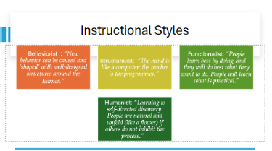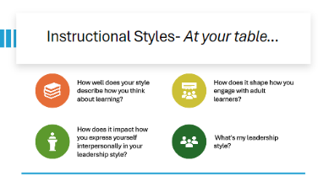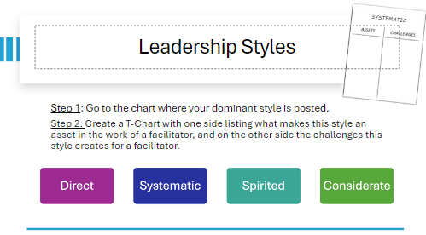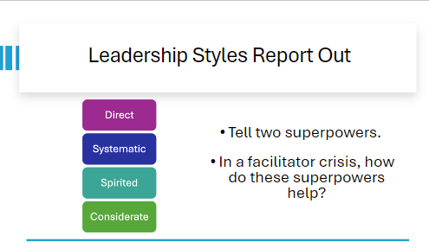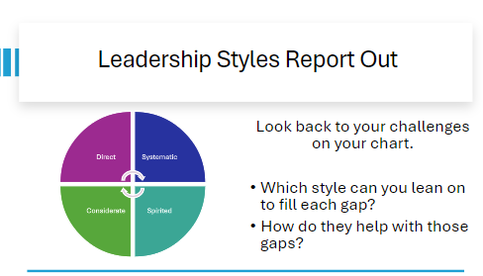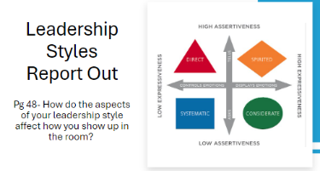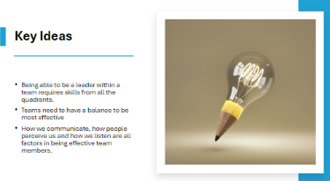 | Chart paper with the leadership styles and an asset/challenge chart for each | 30 Minutes  Instructional Styles – 10 Minutes  - We all possess these styles. There are some that tend to be dominant and others that tend to be recessive or show up based on the situation.  - Get a quick survey (show of hands) regarding which styles were the most dominate in the room  - Behaviorist  - Structuralist  - Functionalist  - Humanist  - At your tables, discuss the following questions: (Give at least 7 minutes if possible)  - How well does your style describe how you think about learning?  - How does it shape how you engage with adult learners?  - How does it impact how you express yourself interpersonally in your leadership style?  - What's my leadership style?  - Report out 3 things you feel needs to be shared in the room (Adjust the number based on timing, interest, etc.)  Leadership Styles – 17 minutes  - Give explicit instructions on going to their dominate style that is posted around the room  - Pro-tip: Split larger groups into smaller groups of the same style  - Create a T-Chart with one side listing what makes this style an asset in the work of a facilitator, and on the other side the challenges this style creates for a facilitator.  - Pro-tip: Be explicit that this is centering your work as a facilitator, not personal or in your role in your affiliate  - Leadership Styles Report Out  - Round 1:  - Tell two superpowers of your leadership style  - In a facilitator crisis, how do these superpowers help?  - Round 2:  - Look back to your challenges on your chart.  - Which style can you lean on to fill each gap?  - How do they help with those gaps?  - Round 3:  - Pg 48- How do the aspects of your leadership style affect how you show up in the room?  Key Ideas - 3 Minutes  - Being able to be a leader within a team requires skills from all the quadrants. (Reference assertiveness and expressiveness)  - Teams need to have a balance to be most effective  - How we communicate, how people perceive us and how we listen are all factors in being effective team members. | How does your instructional and leadership style inform how you interact with others as a facilitator?
9:45 – 10:00 BREAK

10:00-12:00 |  | First Round of Break Out Sessions
(Beth Anderson will be making sure we all get to our rooms and get started on time) |  | Adult learning (Ellen – Heidi) – This is a solid foundation and reminder about the best ways to work with adults in our trainings. We will hit the following - Principles of Adult Learning, Popular Democracy Techniques, Structuring Adult Learning, Directions, Questions, Feedback, Tough Scenarios  Debriefing, Coaching, Difficult Situations (Jessica and Linda) - within the learning community -- How do facilitators structure strong learning debriefs (more than a report out), How do facilitators provide coaching from the front, from the side, and within a group of learners, how do you address difficult situations for adult learners without derailing their learning.  Using Data and NEA 360 for Organizing (Randy Johnston and Beth Barton) - The purpose of this is discover ways that data can be used in our trainings and in organizing. this would be good for anyone who wants to improve the ways that we have included data in our programs – AND for opportunities that you know are missing where we can include it. It is a little bit of how to and a little bit of where would we do this in our programs.  Your Biases as a facilitator and handling when bias shows up in the learners - etc. (Shelly and Lucy) - Recognizing your own bias in your facilitator work, in your questions, in your follow up - or when you don't follow up and why. Interrupting the outcomes of bias when participants' biases show up. How to effectively call in and keep the learning flow happening. How to accept being called in and keep the facilitator flow moving.  Team Leads and Potentials (Barb, and Adam ) – Debriefing Teams, Convening Teams, Setting the norms for teams, Jumping in and jumping out, Herding the Cats- how to manage when you are not wearing an authority hat, Building community – what happens when Ellen doesn’t show up.
12:00 – 12:45 LUNCH
12:45 – 3:00 |  | Breakouts Round 2 With 15 Minute Break Built In | .
12:45 – 3:00 Break Outs – Some Repeat (break built in)
Best Practices for Online Learning (Brandy and Kricket – Chad) – 2 Hours
This is perfect for any of you who will be doing online training – and really that could be any of you. This is not about building content, necessarily, but it is about how you show up, how you maintain engagement, and develop an online flow.

Your Biases as a facilitator and handling when bias shows up in the learners - etc. (Shelly and Lucy ) - Recognizing your own bias in your facilitator work, in your questions, in your follow up - or when you don't follow up and why. Interrupting the outcomes of bias when participants' biases show up. How to effectively call in and keep the learning flow happening. How to accept being called in and keep the facilitator flow moving.

Adult learning (Ellen – Heidi) – This is a solid foundation and reminder about the best ways to work with adults in our trainings. We will hit the following - Principles of Adult Learning, Popular Democracy Techniques, Structuring Adult Learning, Directions, Questions, Feedback, Tough Scenarios

Debriefing, Coaching, Difficult Situations (Jessica and Linda) - within the learning community -- How do facilitators structure strong learning debriefs (more than a report out), How do facilitators provide coaching from the front, from the side, and within a group of learners, how do you address difficult situations for adult learners without derailing their learning.

Newish Folk Clinic (Hedy – Yvie) How did you get here, What are the expected beliefs and behaviors for being part of this team, How do you balance your work/manager/and this work, Where is all the stuff, How do I use the facilitator agenda, how do I contact someone, how do I prepare, What can I expect for support

3:00-3:45 |  | 45 Minutes – Purpose
Ellen and Lucy  (Grat and Anthony will be making sure you are all on time to the big room) |  | Why do we do this work?  Why this program works, our model, and New Programs Core Beliefs that Drive this Program  Diversity of our team and why it matters  Shared Values and Shared Purpose Statement  What Our Work Looks Like – LUCY and Her Graphs  (Ellen and then Lucy with a little on the Engagement coding) (20 Minutes) | Participants will understand how their values show up in the work and what our shared purpose is.  Participants will understand why we do the work the way we do.
3:45-4:00 |  | 15 Minutes - Ending it Right
 |  | Questions, Connections, Reflections  Description of Team Building Event (5 Minutes) – Sarah, Bekah, and Jeny  Overview of content teams process – Ellen - 10 Minutes | Participants will be able to bring a little closure to their learning and provide feedback on the day.
4:30 – 5:00 |  | 30 Minutes - Choice Networking Activities –
 |  | This is a time for participants to meet and discuss any issues they are thinking about with other members of the group. This is not led by facilitators and highly encourage to occur in any other space besides the conference room. | Participants will make useful connections with staff from other affiliates.
5:00 ADJOURN

Facilitator Planning Day 2
General Materials Needed: |  |  |  | Room Set-up:
1 Set of Handouts per Person  Name Tents with the Norms  Room signs,  One ream of white photocopy paper  Chart Paper (4 to 5 full w Sticky Strip) |  | Materials Box for each table with:  Markers (Mr. Sketch variety)  Post its – 3x3” and 4X5” sizes  Index Cards  Highlighters – 4 colors  Pens and Pencils  Participant “toys” |  | Long Rectangle table at back for faciliators  Round Tables for participants  Projector, Screen, mics, and Speakers  Carousel stations and reporting stations  No podium, table with projector big enough for laptop  50 people max
Key Outcomes for the Event:
Participants will know which presentation team they are on
Participants will construct content in pre assigned content teams

Overview of Content, Time, and Facilitator Assignment
8:30-10:00 Entry, Welcome, and Team Selection  10:00 – 3:30 Content Teams  Self Breaks  12:00-12:45 Lunch  Self Breaks  3:30-4:00 Report Out on What is left to accomplish  4:00 Adjourn  5:30-8:30 Group Event | Adam and Vanessa |  | (Heidi Miller will be making sure you are on time to your group and returning to the main room when needed)  (Ilissa will keep the report out process moving 😊 )

Facilitator Planning 2024 - LAST DAY
General Materials Needed: |  |  |  | Room Set-up:
1 Set of Handouts per Person  Name Tents with the Norms  Room signs,  One ream of white photocopy paper  Chart Paper (4 to 5 full w Sticky Strip) |  | Materials Box for each table with:  Markers (Mr. Sketch variety)  Post its – 3x3” and 4X5” sizes  Index Cards  Highlighters – 4 colors  Pens and Pencils  Participant “toys” |  | Long Rectangle table at back for faciliators  Round Tables for participants  Projector, Screen, mics, and Speakers  Carousel stations and reporting stations  No podium, table with projector big enough for laptop  50 people max
Key Outcomes for the Event:
Participants will complete content team tasks and make plans to support each other in the work that still needs to be completed

Overview of Content, Time, and Facilitator Assignment
8:30-12:00 Move Directly to Content Team Work  Self Break  12:00 –12:30 Meeting and Greeting of the Presentation Teams – Team Netflix Series Name  12:30 –1:00 Report out on plan for completing work and handing it off to the content team  1:00 adjourn | Ellen  Vanessa and Adam will herd these cats.  Ellen

