Facilitator Breakout: Leading Adult Learning
General Materials Needed: |  | Room Set-up:
1 Set of Handouts per Person  Name Tags or Name Tents | Chart Paper  Markers  Post its  Pens and Pencils | Round Tables  Projector, Screen and Speakers  Carousel stations and reporting stations around the perimeter  50 people
Key Outcomes for the Day
- Participants will learn to differentiate their leadership of learning events
- Participants will learn key characteristics of adult learners
- Participants will learn specific strategies that support strong adult learning
35 mins Big Ideas Ellen
35 mins Adult Learning Practice Heidi
15 mins Directions and Questions Ellen
20 mins Difficult Adult Learners Heidi
15 min Wrap up Ellen

Slides and Facilitator | Resources | Instructions, Activity and Debrief | Outcomes and Essential Questions
 | Charts, handouts, articles, materials, slide | What are you saying, what are they doing, what questions will you use to guide learning and make clear the important points  Include an estimate for how long each section of the learning will take | As a result of this section of learning, what will participants know or be able to do? What key questions will they be able to answer
Ellen |  | Big Ideas in Adult Learning – 35 Minutes Entire Section
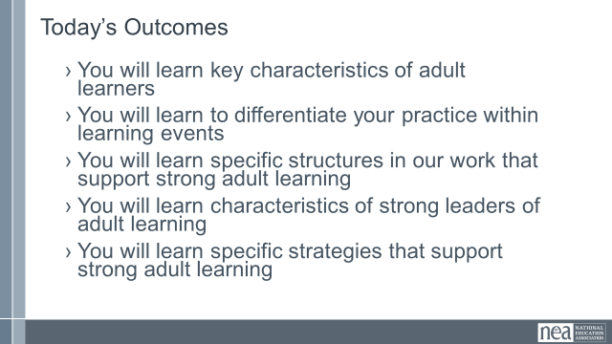      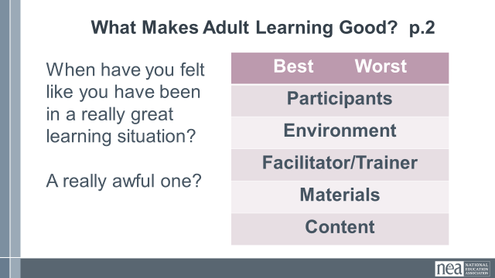  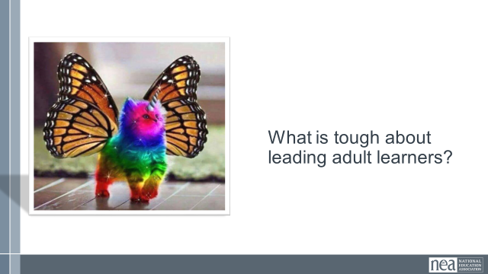  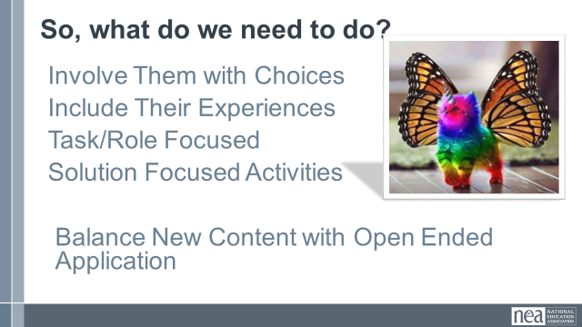  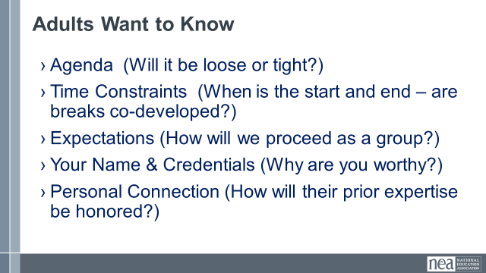  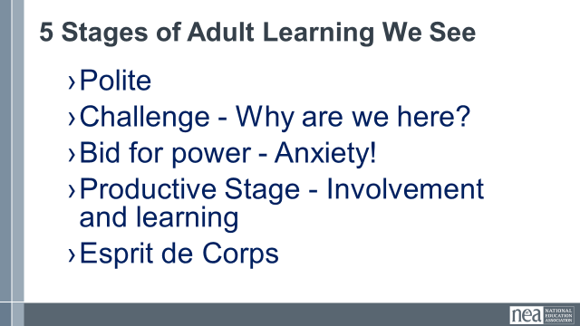  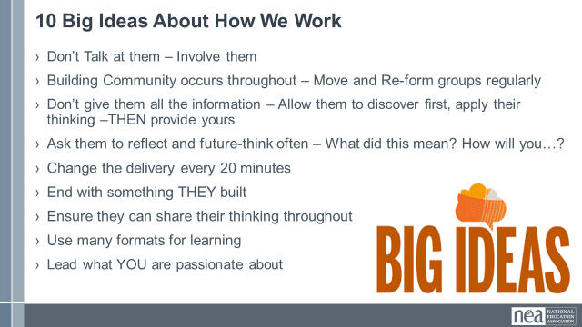  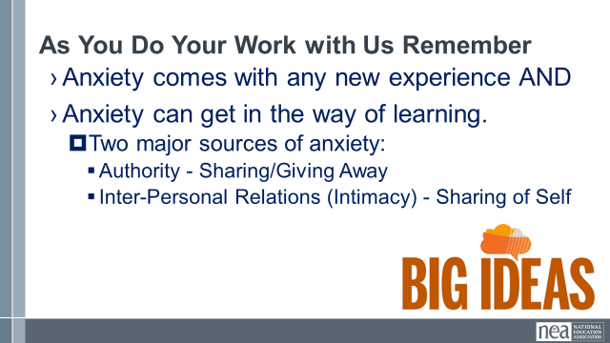 | Set of Participant Handouts  P. 1-6 of handouts | 2 minutes  Show the slide Today’s Outcomes and say – let’s review what we are going to learn today, as you read this, think about what you hoped you would learn and how close these are to those expectations  Let’s go over some of the Big Ideas for you to keep in mind as you work with us and others.  5 minutes  We are going to start with visiting an adult learning event you may be familiar with. Be thinking – what makes this good, and what makes this bad.  5 minutes to work and think – and about 5 minutes to report out.  Using page 2 of the handouts – think about the best and the worst adult learning you ever participated in. What made it that way? Keep in mind there are five major components that shape our judgements about good and bad learning – only some of these you can control. Talk with each other about this and then let’s hear what you’re thinking.  Turn and talk for 5 minutes - so, why is it tough to lead adult learners? Let’s just pop out some thoughts across the group. Likely responses –  They already know a lot and have a lot of experiences  They don’t like to be told what to do  They want to take over conversations  They want immediate, meaningful, concrete usefulness  They are distracted and busy  5 minutes  Given this, what do we need to do  Involve them in decisions about groups, movement, discussion, etc.  Include their experiences by asking them what they know first and then you fill in their gaps with your content after.  Be clear about what their role is for each part of their learning journey with you –  Ex. This time you are going to be in a triad developing a definition, For the next five minutes you are silently brainstorming and noting all the issues, etc.  Make it clear HOW the outcome you are moving them to is a SOLUTION they need  Make sure there is time to apply what you are teaching – scenarios, team product creation, actual skill practice – don’t just drop the content and move along.  Adults need to know a few things to limit their anxiety about their time with you. This varies from individual to individual – so we try to do all of these in support of everyone.  If you have been with us before you might recognize these stages that occur within our adult learners. The newest, driest, most theoretical content gets implemented first for this reason.  Adults come in relatively polite and open – then based on what they experience they stay that way or not.  At some point they need to know why they are here – they need to hear it from us and having a stated purpose and planned outcomes help them better link their why for attending with our intentions.  At some point there we have pushed them too far or they came primed to not want to be pushed and they will push back – it typically comes from a place of anxiety about time, commitment, feeling wrong or wronged, not wanting to look as though they don’t know what they are doing. In this case your role is to back down a bit and listen carefully – be clear about expectations and that there may be different ways to think about things.  Once you move past the bid for power – you move into a relatively productive stage of involvement and learning. You have built up enough situational relationship capital that there is a sense of Esprit de Corps.  Keep in mind we do have multi day sessions – and there is the old 3 Day rule - fish friends and family all have to go after three days. This is true for facilitators who come a day earlier than participants – we will each experience a lower energy, a lower tolerance for power struggles and may be feeling a little more anxiety.  In your handouts on pages 1-6 are some really timely and precise content pieces about working with adult learners. Here are 10 big Ideas to keep in mind  Here are the big ideas I want you to keep in mind for this section before I pass this to Heidi  Anxiety, well managed and at an appropriate level is good for learning and helps with engagement – but unmanaged and too high anxiety prevents us from leading good learning and from good learning to take root. | Participants will assess what makes for good adult learning and what can contribute to poor instances of adult learning.  Participants will be able to identify the 10 big ideas for leading adult learners.
Heidi |  | Adult Learning Practice – 35 Minutes Entire Section
  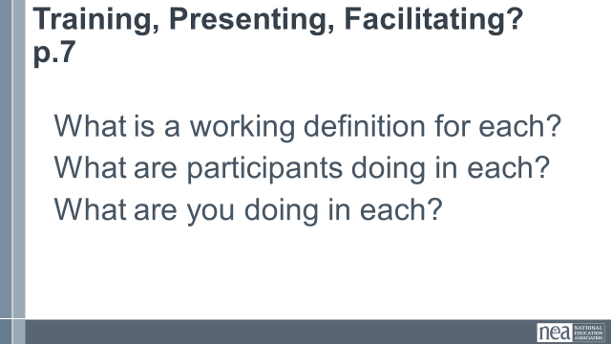  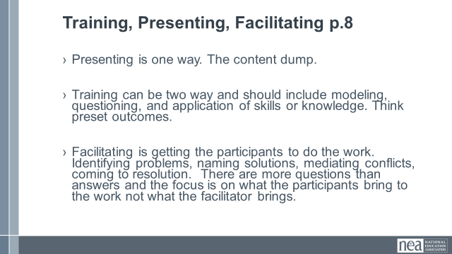  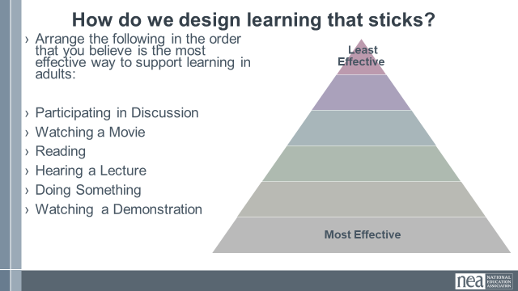  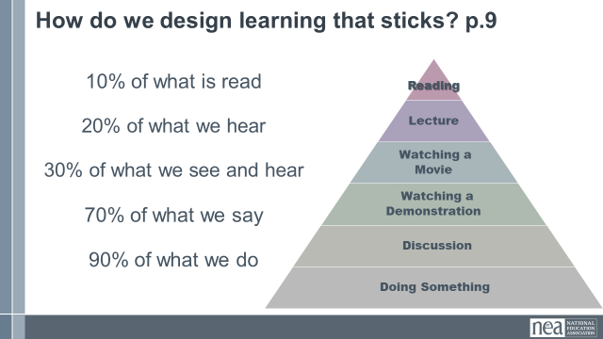  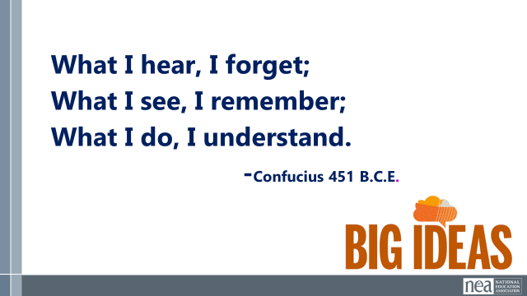  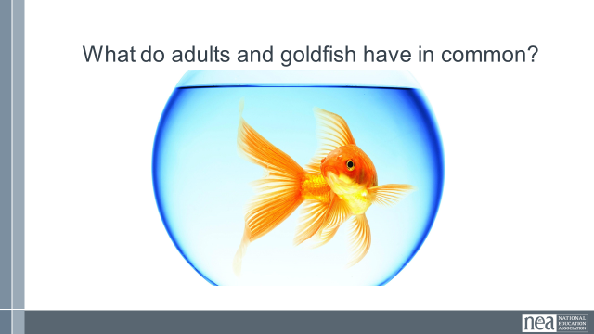  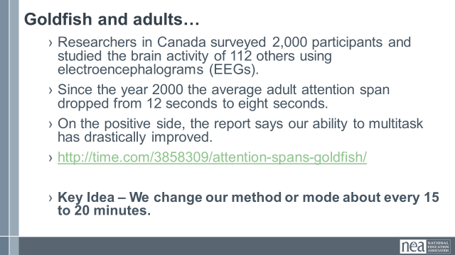  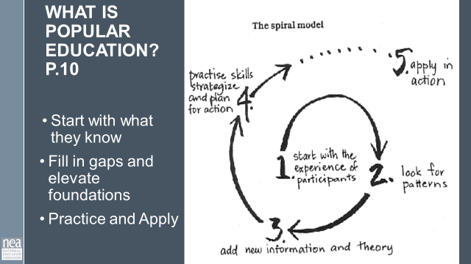    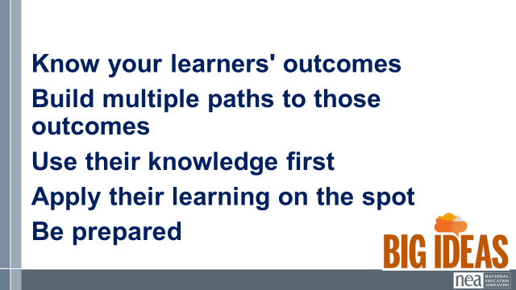 | P. 7- 20 of the handouts | We are going to look at three methods of leading adults – Training, Presenting, and Facilitating. You need to know that all three are needed, one is not better than the other, AND they need to intentionally be used to match the type of learning outcomes you are trying to get.  In small groups – using page 7, answer these questions, then we will report out what you think.  Here is a summary of what you all discovered and reported. Presenting is best when you just need to tell someone something and no feedback is requied – information dump. Training is when you are wanting to develop a new skill or way of thinking and is best done through modeling and in the moment practice with feedback. Facilitation is getting participants to solve their own problems and apply their own resources, knowledge, and skills to the task. We work to stay in the training and facilitation method MOST of the time.  Small Groups – Take a look at the six types of learning on the screen. Arrange them from the bottom up – from most effective way for an adult to learn on the bottom – all the way up to the top of your list as the least effective way for an adult to learn. Take about 5 minutes to arrange these.  At the end of five minutes - Say – Ok, let’s do a quick whip through the groups – when I point to your group tell me you MOST effective – the one your group put on the bottom (Move through all the groups, affirming their answers) Now let’s do the same thing – this time though, when I point tell me the learning that you put on the top of your list as LEAST effective. (whip through, affirming their answers)  Show the slide – Big Ideas and SAY—this is very simple reminder for how you need to design learning events for adults. They need to be doing and applying as much as possible and you need to be lecturing and showing slides as little as possible.  Show the slide – What do adults and goldfish have in common? And SAY – Turn to the person next to you and come up with your best answer to this question.  I will give you about 2 minutes to come up with an answer. (wait two minutes)  Say – Let’s hear five answers – here is the challenge – if yours has been said, then don’t volunteer your answer – we want to be additive not repetitive.  Show the Slide Goldfish and Adults and SAY – Let’s read about Adults and Goldfish (allow participants to read the slide) Here is the Key Idea – We change our mode for instruction about every 15 to 20 minutes. We move from me talking to your talking to videos to small groups to charting to reflective writing – etc. It is more than you seated, watching me read PowerPoint slides.  The main theory of instruction that we build our work around is something called popular education. In a nutshell it follows a number of the best practices we have talked about already. It begins with the experience of the participants and presumes that they are the best people to determine how they will solve their challenge. Your role then is to start by giving them time to tell you what they know – and you look for patterns of what they do and don’t know so that you can bring in the new information that they may want to consider. You then provide them an experience in which they can practice skills, analyze thinking, and strategize plans for action. They are then prepped to apply their learning in action. P. 10 in your handouts says the following, “Popular education is a collective effort in which a high degree of participation is expected from everybody. Facilitators and learners aren't two distinct groups; rather, everyone teaches and everyone learns! Learners should be able to make decisions about what they are learning, and how the learning process takes place. A facilitator is needed to make sure that new ideas arise, progress, and don't get repetitive, but this isn't at all the same thing as a teacher. In popular education, then, we can't teach another person, but we can facilitate another's learning and help each other as we learn.”  One final, critical idea about our adult learning practices is going to be modeled by Rick Perry. Who Remembers Rick Perry?? Let’s see if you really do.  Key Idea here – be prepared. Practice long before, with your team the day before, and in your room the night before.  Here’s our big ideas for this section.  Know your learners' outcomes  Build multiple paths to those outcomes  Use their knowledge first  Apply their learning on the spot  Be prepared | Partipants will identify and understand the intentional switch between three methods of adult learning.  Participants will explore six kinds of learning that adults use and assess which are most effective for retention of content.  Participants will understand why we switch methods and modes of delivery every 15 to 20 minutes.
Ellen |  | Directions and Questions 15 Minutes
  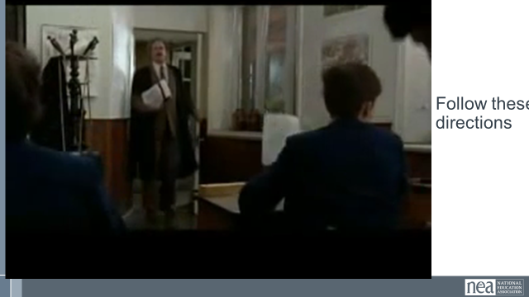  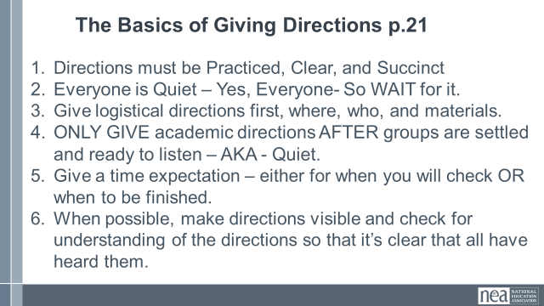  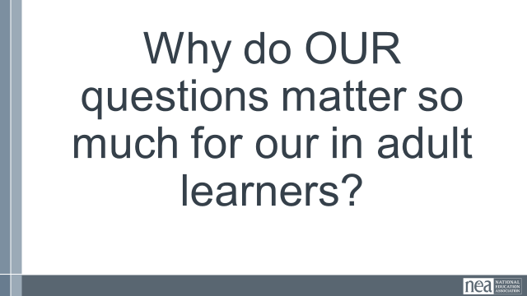  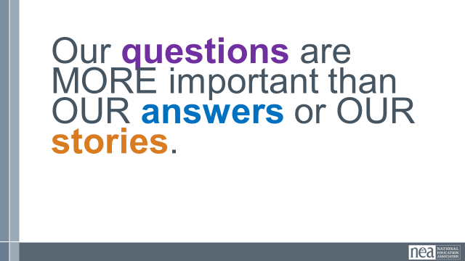  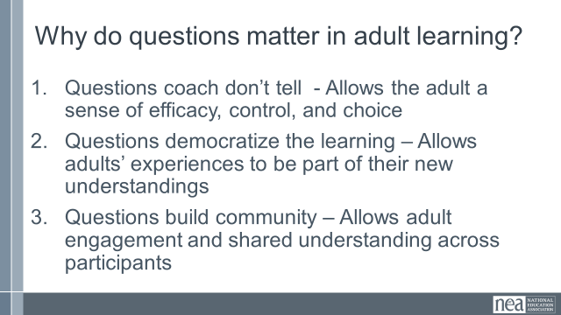  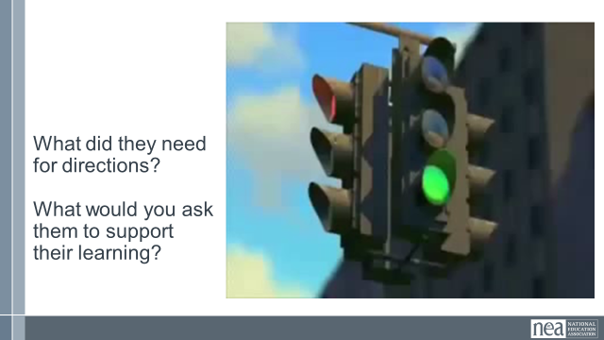  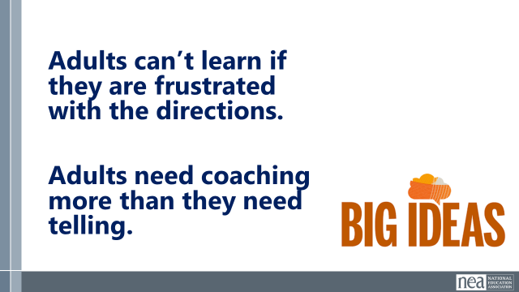 | p. 21-33 of Handouts | Show the slide – Listen to the directions - SAY – Probably the most challenging thing when leading adults is giving directions that they can follow. We are going to watch a video that is an example of what NOT to do. (show the video)  Show the slide – The basics of giving directions and SAY - Here are six of the best tips for you to remember when giving directions. Take a minute and read these to yourself before I go through them.  - Planning and practicing directions is the best work you can do in advance.  - Adults need to be quiet and looking in your direction when you give direction  - Give adults directions about moving, materials or pages BEFORE you tell them what they are going to do.  - Give learning focused directions immediately before they are going to execute them.  - Let people know how long you think it is going to take to complete the task  - Provide the directions in writing, on a slide, handout or chart. Ask if they understand.  Turn and Talk – Why do our questions as learning leaders matter so much for our adult learners?  Show the slide our questions and SAY – Keep in this tip in mind, adult learners are more engaged answering your questions than they are when we are lecturing to them about our stories or our answers.  Show the slide Why do questions matter and SAY – Pg 23 has a great selection of questions for you to use to keep your learners engaged. Just like directions – a key tip for you to remember is to plan out and practice the questions that you want to ask your learners. These 3 points on the slide are the reasons (allow them time to read the three points)  Show the slide – What did they need for directions – and SAY – I am going to show you a group of learners that have a task to achieve – cross the street. As you watch, think about the type of directions you would have provided to improve their execution of the task, AND think about what you would ask them to help them learn from their experience. You will have time after the video to work at you tables on directions and questions. ( show the video)  Say – Now working at your tables – come up with directions and questions for these learners. You will have about 5 minutes to do this.  At the end of 5 minutes SAY – Let’s hear from your tables what are the directions you would provide – (go the first table and ask them to report out – then as you go to each next table – ask them to only add if they had something different) Now that we have heard all the directions, let’s hear the questions you would ask these learners (go the first table and ask them to report out – then as you go to each next table – ask them to only add if they had something different)  Show the slide big ideas – and SAY – here are your two big ideas for this section. | Participants will be able to develop clear and concise directions for complex learning activities.  Participants will understand the connection between asking good questions and strong adult learning outcomes.
Heidi |  | Leading Difficult Adult Learners – 20 Minutes for Section
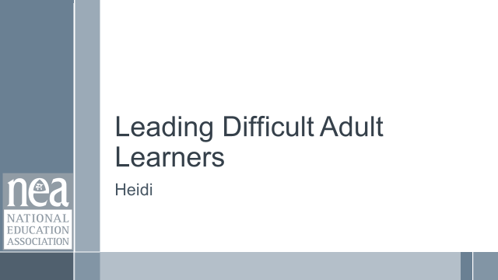  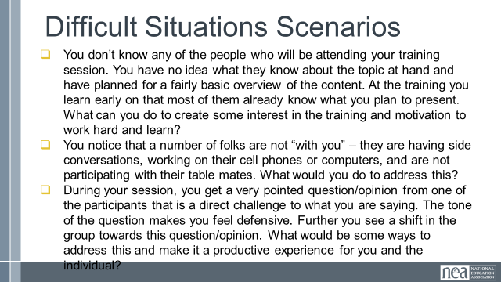  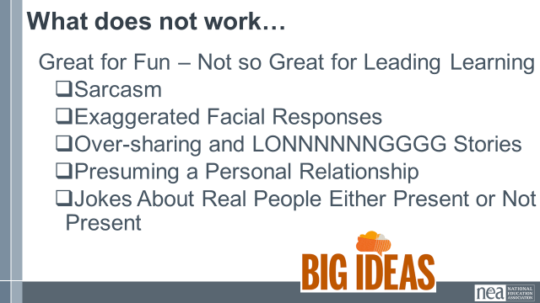  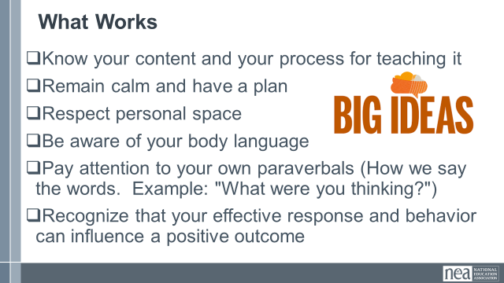 | P. 34-38 of handouts  34-37- strategies  38 scenarios | Some Participants are Difficult – and we are going to meet a few adults that I think almost always show up every event I have ever led. See if you recognize these people. (play the video) Raise your hand if you know these folks?  Show the slide – Difficult Situations Scenarios – Pages 34-37 have some suggestions for dealing with difficult situations while you lead adult learners. Now – let’s all turn to page 38. You will see 6 scenarios but we are only going to work on three of these. Your group will be responsible for the scenario you are assigned. Your group is to use what we have learned and what might be in pages 34-37 to come up with a great solution for the situation in the scenario. You will have 10 minutes to prepare your solution.  (give them 10 minutes or less if they appear done )  Say - Alright let’s hear from each of the teams  Show the Slide – What does not work and Say – so let’s provide some general do’s and don’ts for dealing with difficult situations – Here are some strategies that just don’t work when trying to deal with difficult situations and people.  Show the slide – What works and SAY -- here are ideas that ALWAYS help out when the going gets tough. | Participants will work with teams to diagnose and plan what they would do to solve the particular adult learning challenge they were assigned.
Ellen |  | Summarizing Learning – 15 Minutes
  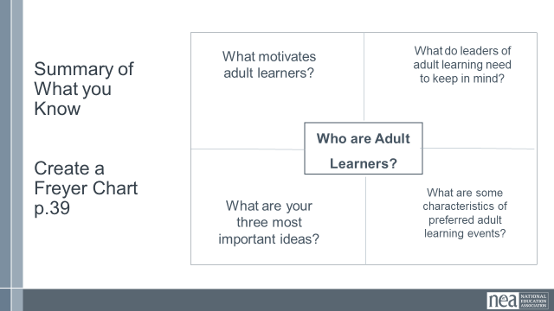  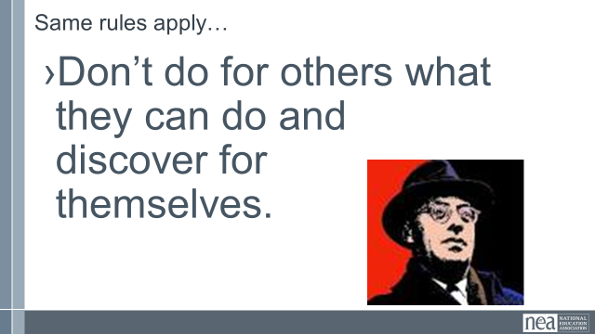  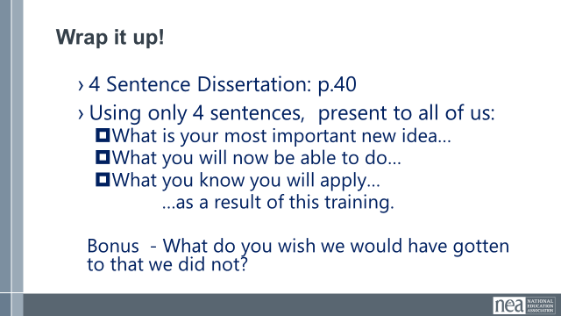 | p. 39 of handouts | Show the slide - Summary of what you know and SAY – we are going to create a Freyer Chart – Which is just a graphic organizer to capture big ideas. We are going to use this one to summarize all that we have learned today. For this final team charting – work in teams of 4 and you can self select – take about two minutes to get grouped and then I will give you then next directions.  Hang a piece of chart paper and create five blocks on it like the example on the slide. As a group – spend the next 10 minutes answering the questions and charting your answers to these questions. (wait 10 minutes)  Now, we are going to visit each of the other group’s charts. As you walk, notice what is similar and what is different, we are going to do this for 10 minutes.  (wait 10 minutes)  Show the slide – Same rules apply and SAY– as part of our wrap up l want to assure that the same rules for leading learners apply as for leading unions – Don’t do for others what they can do and discover for themselves.  Show the slide Wrap it up – SAY turn to PG 30 and we are going to bring some closure to your work. You are going to write a 4 sentence dissertation that answers these questions – In five minutes or less. (wait five minutes)  Turn in to your tables and share your dissertations - (Listen for it to grow quiet as tables finish)  Thank you so very much for your time and attention. You have been a great group of learners and I look forward to sitting in your learning event in the future. | Participants will use at least one method to summarize and share their learning.

