Audience: K-12 teachers
# Lessons:

Timeline for work:
 | Start date | Finish date
Outline
Ghost Writing
Copy editing
Building
Publishing

Writer Contact information
Writer | Email | Cell Phone # | Can we text?

Staff Contacts:
Brandy: 303-775-3186 bbixler@nea.org

Notes:
- Courses run for 6 weeks and participants should spend about 15 hours total for the entire course.
- We use the Learn-Design/plan- Do/implement-Reflect cycle
- Remember to put the writer(s) name and contact information in the footer of the document.
- Use the copy of the course that Brandy Bixler sends to you. Do not make copies for yourself. There should be only one copy and it should be owned by Brandy Bixler.
- Keep the templates in the same folder and do not move them.

Examples of Other Courses:
- LGBTQ+ Module 1: Taking a Stand Rise Course
- LGBTQ+ Module 1: Taking a StandFinished Template
- DECC Module 1: Unpacking Bias Rise Course
- DECC Module 1: Unpacking Bias finished Template
- Trauma Module 1: Creating a Healing Centered Classroom Rise Course
- Trauma Module 1: Creating a Healing Centered Classroom Finished Template

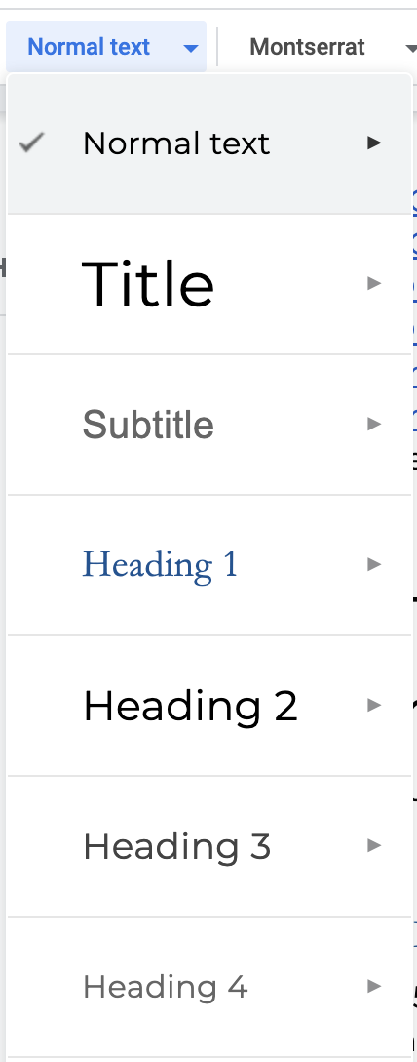
Part 1: Course Outline
(15 hours of work for content experts)
Please use the preformatted heading structure as you work through the outline. So that the sidebar reflects the outline and is easy to navigate.

Course Introduction:
Write 1-5 bullet points to introduce the course description. This should be a summary of all lessons.

Objectives
In this course you will learn ---- (This should cover all lessons)

Pre-assessment
Write 10 pre-assessment statements to be rated on a 1-3 scale shown
below.
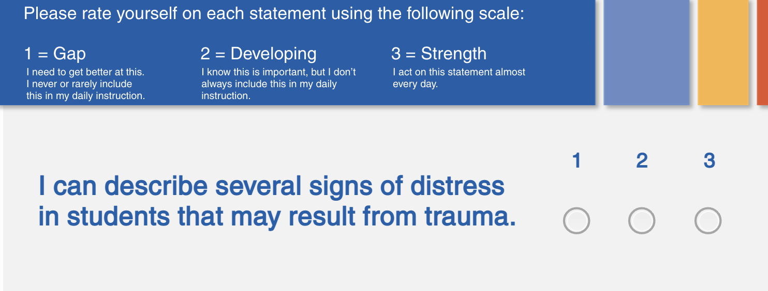
1.
2.
3.
4.
5.
6.
7.
8.
9.
10.

Learn
This part should be approximately 5 hours of work over a 2-week period, for participants

Lesson 1: [Title]

Objectives:
(1-3 objectives)
In this lesson, you will learn:

Topic:
Content

Topic:
Content

Topic:
Content

Topic:
Content

Check for Understanding Quiz
Multiple Choice, True False, matching, Card Sort activity (3-5 question)
Highlight the correct answers in yellow

Lesson 2: [Title]

Objectives:
(1-3 objectives)
In this lesson, you will learn:

Topic:
Content

Topic:
Content

Topic:
Content

Topic:
Content

Check for Understanding Quiz
Multiple Choice, True False, matching, Card Sort activity (3-5 question)
Highlight the correct answers in yellow

Lesson 3: [Title]

Objectives:
(1-3 objectives)
In this lesson, you will learn:

Topic:
Content

Topic:
Content

Topic:
Content

Topic:
Content

Check for Understanding Quiz
Multiple Choice, True False, matching, Card Sort activity (3-5 question)
Highlight the correct answers in yellow

Lesson 4: [Title]

Objectives:
(1-3 objectives)
In this lesson, you will learn:

Topic:
Content

Topic:
Content

Topic:
Content

Topic:
Content

Check for Understanding Quiz
Multiple Choice, True False, matching, Card Sort activity (3-5 question)
Highlight the correct answers in yellow

Lesson 5: [Title]

Objectives:
(1-3 objectives)
In this lesson, you will learn:

Topic:
Content

Topic:
Content

Topic:
Content

Topic:
Content

Check for Understanding Quiz
Multiple Choice, True False, matching, Card Sort activity (3-5 question)
Highlight the correct answers in yellow

Stop here for Independent Study

Forum Discussion
1-2 Questions should be about synthesizing and applying the learning to the individual's professional context.

60 min. Workshop 1 (Learn)
The purpose of workshop 1 is to synthesize learning, discuss applications of the learning, introduce the directions for the project, and answer questions.

Introduction Activity
Describe an introduction/ ice breaker activity that the facilitator can use to start the meeting with

Content Review
Describe an activity or question that can be used to review the content from the Learning portion of this course.

Breakout Room
Describe an activity or question (s) that can be used for the participants to engage in a small group discussion about how the learning applies to their professional context.

Next steps
Describe the Design and Do portions of this course (this in the next section that will be developed.

Design/Plan
Describe and provide directions for an activity that participants can do to apply their learning to their own personal contexts. This project should take about 4 hours to complete over a 2 week period.

Description of Activity

Step-by-step directions for the Activity

Forum discussion
Participants should be encouraged to share their plan, reflect on the process and ask/receive peer feedback.
Questions
Please share your design/plan in the group forum and ---------

Implement your design/plan (Do)
This part should take about 4 hours to complete over a 2-week period.

Directions for implementation

60 min. Workshop (Reflect)
The purpose of this meeting is for participants to share their work and reflect on the next steps.

Sharing
Describe how participants will share their work. They should have 2-3 minutes each

Reflection
Describe how participants will be asked to reflect on the process and next steps

Next Steps

Step 1-Ghostwriting
(10 hours of work for the ghostwriter. The writer should shoot for about 20-30 pages of writing)
- Ghostwriters will make a copy of the outline and rename it Template for Blended Learning Course: [Add Title]
- Keep the Copy in the same folder as the original document is in.
- Change ownership of copy to brandy.bixler646@gmail.com
- Put writer(s) name and email in the footer of the template

Step 2-Focus groups and revisions
- The ghostwriter will lead a 60 min focus group of educators for the purpose of getting feedback on the course as written.
- NEA Staff will recruit the focus group, set up the zoom link, and provide the structure of the meeting.
- The ghostwriter will make the requested revisions and send the updated course template to the focus group for final approval/thoughts.
- Staff will review the content and send to the copy editor.

Step 3-Copy editing
At this point the writers will be taken off the document and the copy editor will clean up the document.

Step 4-Sent to developer
Once the course has been copyedited and vetted by NEA staff it will be sent to the designer/developer to build out and design.

Step 5- Final Feedback
A review link will be sent to the writers and the focus group for one final round of feedback.

Step 6- Implementation
The final product will be added to the Teacher Quality Course Offering and be available for state/locals to offer to educators.

The courses are free for members but nonmembers will need to pay the following fees:
- Facilitated Blended Learning Course $100
- Independent Study Course $40
- Webinar with certificate $15

