Facilitator Breakout: Debriefing, Coaching, Difficult Conversations
General Materials Needed: |  | Room Set-up:
1 Set of Scenario Handouts per Pair  Name Tags or Name Tents | Chart Paper  Markers  Sticky Notes  Pens and Pencils | Round Tables  Projector, Screen and Speakers  Carousel stations and reporting stations around the perimeter  50 people
Key Outcomes for the Day
- Participants will learn to effectively debrief a facilitation module
- Participants will learn and discuss best practice strategies for coaching through conflict and/or obtusity
- Participants will learn and discuss strategies for not allowing discomfort with difficult situations hijack a learning opportunity
10 min Opening Activity
20 min Debriefing
30 mins Coaching & Scenarios
30 mins Difficult Situations Intro & Discussion
30 min Difficult Situations Group Work & Wrap Up

Slides and Facilitator | Resources | Instructions, Activity and Debrief | Outcomes and Essential Questions
 | Charts, handouts, articles, materials, slide | What are you saying, what are they doing, what questions will you use to guide learning and make clear the important points  Include an estimate for how long each section of the learning will take | As a result of this section of learning, what will participants know or be able to do? What key questions will they be able to answer
0:00-0:10  Opening Activity  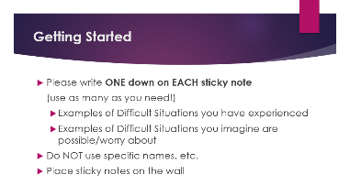 | Sticky Notes | 10 minutes - Linda and Jessica  Show the slide for getting started and say – If you are here today, chances are it is because you demonstrated competence in some situation that made other facilitators take notice of your grace. But that doesn’t mean that those situations were easy or that you handled it and moved on, never to think of it again. To this end, we are asking you to… [Bullet point the slide that they all can read].  We will come back to these later
0:10-0:30  20 minutes  DEBRIEFING  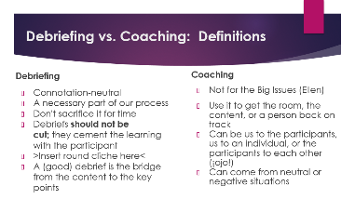  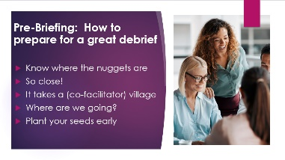  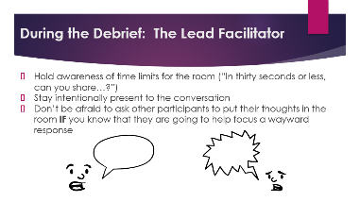  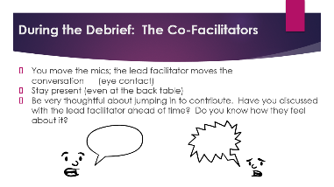  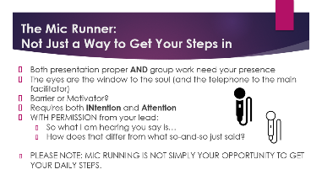 |  | 3 minutes - Linda  Debriefing​  - Debriefing is neither bad nor good; it's a connotation-neutral tool​  - A necessary part of our teaching/learning process; if we skip it we short-change the participants​  - Can be a spot that gets cut because of time–feels natural because at end.​  - SHOULD NOT be cut because it cements the learning with the participant​  - Brings us full circle, closes the loop, and all the rest of the round cliches.​  - A Debrief is NOT just what everyone said–it’s the bridge from the content to the key points​  Coaching​  - Tool for the small/medium issues–NOT the big issues that go to Ellen. ​  - Also an essential tool: use when things go awry or somebody is close but not quite there.​  - Can be person-generated, group-generated. If participants start to check or coach each other in the room, be sure not to let it devolve into attacks. Follow up.​  - Can come from neutral or negative situations​  13 minutes – Jessica  DURING JESSICA’S SECTION, LINDA STARTS TO GROUP/CATEGORIZE THE DIFFICULT SITUATIONS ONTO STICKY NOTE CHART PAPERS  Even though a debrief comes at the end of a section of content, there are some ideas to consider and prepare so that the debrief is efficient but enlightening. You want to get where you’re going, but not via the scenic route.  Pre-Briefing: How to prepare for a great debrief​  - Know what is being said at the tables; who gets called on should be intentional (know where the nuggets are)​  - Who has been saying things during the activity that you know are going to have to be massaged?​  - This is not a one-human job; co-facilitators should be supporting and suggesting participants who might have sprouts of good responses or even ready-to-go ideas​  - Know what the key points are from the beginning of the activity. Then you know who has the nuggets, and where you’re moving almost-there answers towards.​  - If you have been getting crickets during previous activities or parts of this activity, have your ringers (“What you said about X was really insightful, can I have you share this with the larger group?”)  During the debrief​  - Be aware of your time: specify to the participant (“in thirty seconds or less, can you share…”)​  - Stay present. In order to get an answer to where it needs to go, you need to be aware of what is being said, what has already been said, etc. This goes for the ​  - Don’t be afraid to ask other participants to put their thoughts in the room IF you know that they are going to help focus a wayward response.​  During the debrief​ pt 2  - If you are a mic runner, know that the lead facilitator probably has a plan as to who they want to speak in the debrief. Be sure to be acknowledged before you hand the mic to a participant. When you're walking around during discussion, listen for great insights and surface them to the lead facilitator.​  - We all have a lot going on back home; we also need to support our colleagues in the moment and stay present. If I'm presenting and you're at the back table, I think that you are ready to support. If you have to split your attention, consider stepping out.​  - Some of us are spontaneous peeps, but not everyone welcomes not-planned-for contributions from co-facs. Be sure to discuss this in your planning and know who is good with that and who might consider it an ouchie.​  4 minutes-Linda  The Mic Runner: ​Not Just a Way to Get Your Steps in!​  - Actively pay attention and stay engaged, even at the back table, in the conversation in the room–both presentation proper AND group work​  - You need to be practiced in eye conversations with the lead facilitator​  - You can serve as both the barrier or the motivator for whose voice is in the room​  - Requires both intention and attention​  - Can engage between lead facilitator and participant to probe–but make sure lead facilitator is ok with this.​  - So what I am hearing you say is…​  - How does that differ from what so-and-so just said?​
0:30-1:00 COACHING  30 Minutes  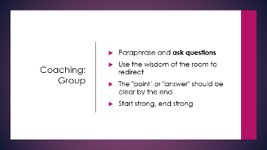  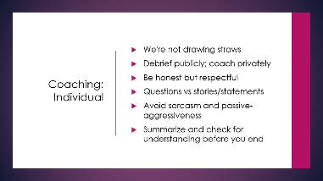  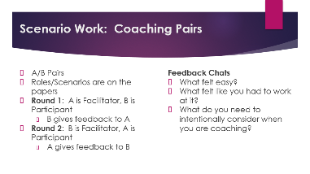  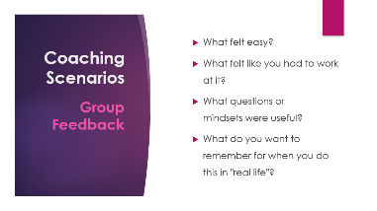  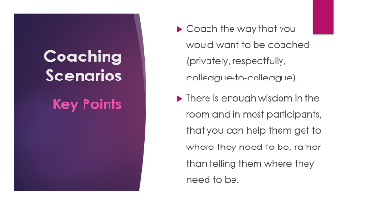 | Scenario Set for Pairs (each pair gets one yellow sheet and one blue) | Jessica-5 min  Coaching to the Group:​  - ​Repeat back and ask questions​  - Try to pull from other responses that are in the room–use those voices to redirect​  - Always make sure the “answer” or “point” is clear at the end​  - People remember what happens at the beginning and the end–make sure those parts are strong.​  Linda-5 min  Coaching: Individual​  - Talk with facilitator team to make sure that you are the right person to handle the conversation​  - Remove the person that requires coaching from the larger group so that the conversation can happen in private.​  - Be honest but respectful​  - Asking the coachee questions will get them to reflect on their behavior/the need for coaching. We often think our own war stories or "sage wisdom" is going to be helpful but usually it doesn't land as intended.​  - Avoid sarcasm and living in the land of Passive-Aggressive​  - Make sure that your coachee understands the feedback before you close out  Jessica-20 min Scenario Work  2 minutes- Explain  We’re going to take some time to role-play two coaching scenarios. Try to pair up with someone, maybe, that you didn’t know before you came to Austin. One of you will be Partner A and one will be Partner B. Your role in each scenario “round” is on the paper: A’s will be a Facilitator in the first round, as the Coach, and then in round two, they’ll be the Participant, and the Coachee. Partner B will be the reverse. Some thoughts to consider as you move through the activity:  - What feels easy-breezy? Some parts of these conversations might feel natural and that's great!  - What feels like you have to work at it? Where might you struggle to stay in a coaching track? Notice that.  - And then after you finish: What might you need to intentionally consider when you approach a participant to coach them?  You’ll have three to four minutes for each round; I’ll check in as we go.  9 minutes: 2 4-minute rounds with 1 minute to transition  7 minutes for group feedback and key points
1:00-2:00  60 minutes  DIFFICULT SITUATIONS  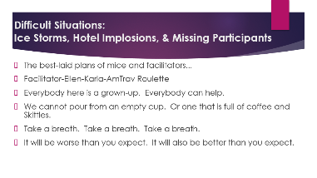  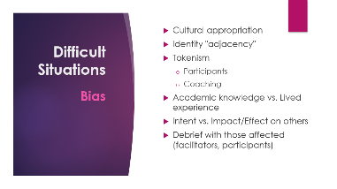  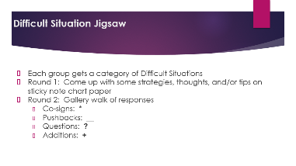 | **Chart paper and sticky notes that were prepped in opening segment, placed around the room (one sheet of paper with the sticky notes, one blank sheet)  **One marker per group  **Everyone needs something to write with (to respond) | The Jessica and Linda Show-10 minutes  Difficult Situations: Ice Storms, Hotel Implosions, & Missing Participants​  (Yes, these all happened. In the same week!)​  ​  - Things happen, that you won't be able to plan for. Every training has its own difficult situation.​  - It's important to know who is the right entity to address the DS. We are a team, and knowing everyone's skill set is essential.​  - This is not taking a group of students on a field trip. All participants are adults, and adults make choices. It's not our job to save someone from consequences. Generally, our participants are incredibly generous, and know when something is going on. Be honest, but don't infodump. If we need to make changes or adjust, they are more often than not very willing to flex.​  - Take care of yourself and take care of each other. If you're not sure, ask.​  - Take a breath. Take a breath. Take a breath.​  - Sometimes you just need to laugh at what's happening; hopefully, whatever it is will be a story that facilitators and participants tell with a smile.​  - Avoid talking TOO MUCH about how much TIME it is taking away  Linda—As a Circle with open opportunity to discuss situations openly-20 minutes  Difficult Situations that have to do with bias​  - Cultural appropriation​  - Identity "adjacency"​  - Tokenism​  - Participants​  - Coaching​  - Academic knowledge vs. Lived experience​  - Intent vs. Impact/Effect on others​  - Debrief with those affected (facilitators, participants)​  Jessica—25 minutes  2 minutes to explain  At the beginning of today’s session, we put on the wall many of the difficult situations we’ve encountered as facilitators and observed as participants, and situations that we could picture happening. While you were working, we grouped some similar types of situations together.  We’re going to number you off by __s, and each group will go over to one chart. Read through the situation examples together, and make some notes on the blank page of thoughts to consider, tips, ideas, etc. We’ll take eight minutes to read through the situations and make the notes.  8 minutes to make the charts  2 minutes to explain:  As a visual debrief, we’re going to take some time to walk around, look at the other groups’ charts, and respond to their thoughts. We can use some markings to indicate our reactions: a star if you cosign something; if there’s an idea you’d like to push back on, please underline it; when you read something you’d like to ask a question about, please put a question mark near it; and if you have something you’d like to add onto a thought, please find a space to make a plus sign and then briefly add your thoughts.  7 minutes to gallery walk + 1 minute to come back to seats  Key Points—Jessica—5 minutes  We’re so glad you took the opportunity to join us in this session; we hope that the wisdom generated by the room has added to your inner facilitator toolbox. Two points we wanted to be sure to highlight:  - We are all part of a team of facilitators, colleagues, and supports. Please don’t be an island; it’s not on you alone to solve any one situation.  - We are all responsible for finding our own balance of being generous with our colleagues and all that we know might be going on in the background, and the accountability that we all have to each other as colleagues and as community.  El fin.

