https://www.discprofiles.com/disc-personalities-under-stress/

DISC Personalities Under Stress byKristeen Bullwinkle

Every personality has areas of struggle. When we’re stressed by work demands, lack of sleep, or even hunger, we often display behaviors we aren’t proud of. When we feel threatened, we may call upon behaviors that are reactionary and don’t typically help the situation. We’re going to look at those. Without understanding these behaviors, we can’t ask for support in changing them or learn how to recognize them before we’re fully committed to their action.
Review of the Four Types
- D is Dominance (Direct). A person primarily in this DiSC quadrant places emphasis on accomplishing results and “seeing the big picture.” They are confident, sometimes blunt, outspoken, and demanding.
- I is Influence (Spirited) . A person in this DiSC quadrant places emphasis on influencing or persuading others. They tend to be enthusiastic, optimistic, open, trusting, and energetic.
- S is Steadiness (Considerate). A person in this DiSC quadrant places emphasis on cooperation, sincerity, loyalty, and dependability. They tend to have calm, deliberate dispositions, and don’t like to be rushed.
- C is Conscientiousness (Systematic). A person in this DiSC quadrant places emphasis on quality and accuracy, expertise and competency. They enjoy their independence, demand the details, and often fear being wrong
How we each struggle

The i-style personality (Spirited)
What struggles can such a fun personality have? Give them a few routine tasks and a deadline and find out. The i style can struggle with doing detailed analysis, performing repetitive tasks, or not being able to express themselves.
If you really want to drive i styles batty, put them alone in a windowless room and ask them to file historical documents related to something in which they have no interest. Increase the pressure by hosting a party just down the hall where they can hear everyone having fun.
When under a lot of pressure, the i style can become histrionic. If the person leans toward the D style, then they can also become narcissistic.
Core belief: I’m valuable if I can attract people.
How those of us with other styles can help
We can encourage the return of an i’s natural upbeat and positive attitude by allowing them to express themselves. Give them some positive attention. If you’re on a team, be sure they understand and share the team’s goals; then allow them to rally everyone. Show enthusiasm for whatever they’re working on. If they have to do all that filing, be sure they get lots of breaks, can decorate the room they’re working in, and can offer suggestions on how to make the task less dull. Even better, join them in the task and put on some good music. The i-type personality believes life should be pleasant, fun, and lively, so try to help them make it that way. (Hear

The C-style personality (Systematic)
Opposite the i style on the DiSC circle is the C. What upsets someone with an i style might be just what the C-type person longs for.
If you want to make the C styles stress out, put them in a room with lots of emotional and erratic people. Make them mingle without making introductions. Or give them a poorly defined goal to reach, few resources, and a short time frame. And tell them they’ll be graded. Or just ask them to learn a new skill in front of others.
A C under stress wants to display self-control, unlike the i who is about putting it all out there. Emotions can be hard because they are so hard to anticipate and manage. Being with lots of people is hard for C styles because it distracts their attention from their own thoughts and behaviors. They want to be socially appropriate, but might not know what the social rules are or consider them frivolous.
Under stress, the C style can be avoidant, disagreeable, and even hostile. They can get their backs up and become very resistant.
Core belief: I’m valuable if I’m competent.
How those of us with other styles can help
Be clear about expectations. Let them know how they will be judged. They’re always judging themselves and don’t want to be wrong or inappropriate. They really don’t want to be the cause of any emotional outbursts.
If someone with a C style has done something wrong and becomes defensive, allow them time to run a self-diagnostic of the situation. They need to know how and why they screwed up (and they need to be able to decide if they agree that it was a screw-up). Express confidence in their ability to learn from a mistake. Deflect their attention from the error, and move it toward how to make amends, fix it, or continue toward the goal. Assure them that you still see them as competent.
A C type will have a hard time asking for help. If you ask a C if they need help, it’s likely that they will take that as questioning their competence, or they’ll worry that you see them as weak. Ask anyway. As long as you do it with respect, C-style folks might really appreciate it in the long term. It’s very important to take the time to build trust with this style.
The S-style personality (Considerate)
The S style is so pleasant that it’s hard to think of them struggling with their behaviors while under stress, but they do. If you wonder what an S style looks like under stress, tell them that they have to confront someone else about their poor performance or disruptive attitude. Make them immediately change the operating procedure they’ve been following, providing no justification for the change and no time to practice. Next, have them convince someone they’ve never met that they support this new procedure.
The S seeks out harmony and is attentive to the needs of others. This means that you might not notice that they are feeling fear or not taking care of their own needs. S-style folks tend to get very quiet and passive when experiencing a high level of stress.
The S can be passive-aggressive. The S can also overcommit if they feel they have to take on responsibilities because no one else will. The S can inhibit innovation out of discomfort with change.
Core belief: I’m valuable if I’m accepted, if I can please.
How those of us with other styles can help
Encourage S-type personalities to speak up. The S might not promote themselves or call attention to their own success or abilities. Be sure that you are not mistaking their agreeable, low-key behaviors for a lack of passion, experience, or knowledge.
It can be tempting to try to take advantage of someone with this style. You can misread them and assume that they are aligned with your point of view or your actions. They might not be. Ask them. And if you really care about their answers, give them time to consider how they want to present their viewpoint and be sure that you’re showing that you care.
The D-style personality (Direct)
The D style often seems completely in control and confident, but this isn’t always true. They have a great need to be in control and a hard time when they aren’t.
You can drive a D-type personality nuts by being emotional, needy, or challenging, or by asking them to follow strict rules with no allowance for individual accomplishment. They will also feel stressed if you put them in a vulnerable position. They may have a hard time with being bedridden, for example.
When challenged or put under stress, someone with a D style can lack empathy (it’s inefficient, in their mind) and can be hurtful. They can ignore doubts that could alert them to risks. They can also have a hard time letting someone else take center stage.
Core belief: I’m valuable if I’m producing or on top.
How those of us with other styles can help
D-style people are looking for rewards in their environment, so you can help them structure that environment to promote their own successes and increase their autonomy. Be sure they can assume this autonomy safely and responsibly. Help them assess risk. Help them understand the possible outcomes of shortcuts they might want to take.
They can use help identifying when they are starting to railroad a decision or monopolize a conversation. Be direct. Remember that they need to know that when you point out something, it’s not to challenge their authority, but rather it’s to help them achieve a goal. Make sure they see the bigger picture and bottom line.

A note about where you are.
You’ll notice that people on the left side of the circle (or leadership styles chart) expect resistance and try to prepare for it. People on the right side tend to avoid resistance and skirt around it. Everyone has the ability to move into adaptive behaviors to match their situation or environment. Everyone also has the ability to move into maladaptive behaviors most commonly identified with another section of the circle. We’re all susceptible to using the behaviors we’ve found most rewarded in the past, and these can be positive or negative behaviors. In other words, our culture also contributes to our behaviors.
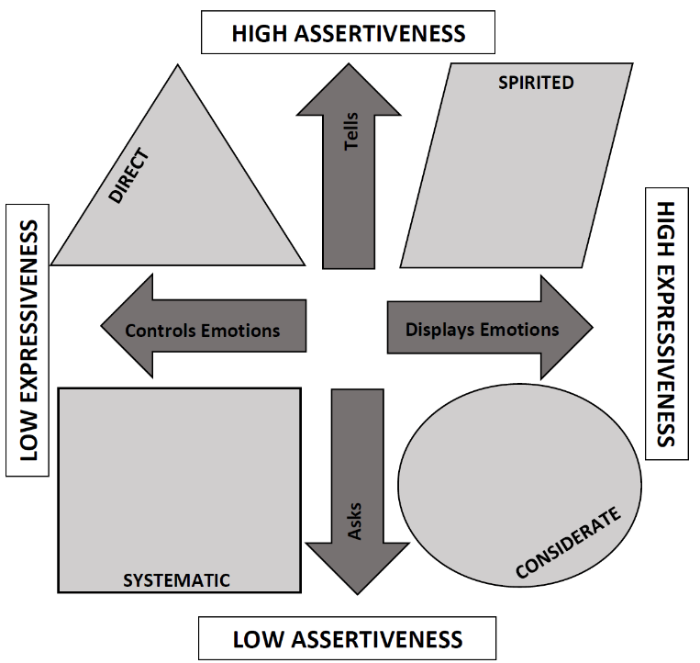
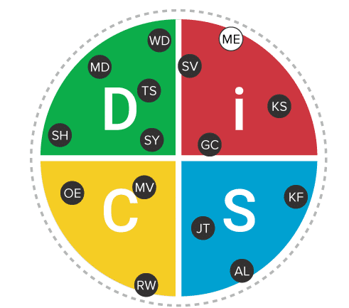

Crucial Conversation Patterns Under Stress
Direct and Systematic (D and C) | Spirited and Considerate (I and S)
Violence Patterns – Violence patterns consist of any verbal strategy that attempts to convince, control, or compel others to your point of view. It violates safety by trying to force meaning into the pool.  Methods range from name-calling and monologuing to making threats.  The three most common forms are controlling, labeling, and attacking. | Silence Patterns – Silence patterns consist of any act to purposefully withhold information from the pool of meaning. It’s almost always done as a means of avoiding potential problems, and it always restricts the flow of meaning.  Methods range from playing verbal games to avoiding a person entirely.  The three most common forms of silence are masking, avoiding, and withdrawing.

