UNDERSTANDING RACISM AS SYSTEMIC AND ABOUT POWER
MARCH 31, 2017 PLTHOMASEDD LEAVE A COMMENT\
https://radicalscholarship.com/2017/03/31/understanding-racism-as-systemic-and-about-power/?fbclid=IwZXh0bgNhZW0CMTAAAR11fWPDX0EBMwRWC32xCJWfKkrcPcpEB3duZZQmOfXthBsv4d408h9Rb-g_aem_ATrwYjJwTnYNW_kVaLKsNjGd-dzf4exFhBdFfs0OrqwBTovqKogW2mtUkIoolOIg67gcsG_P8p1IZLKJtnFU6ApE

You are an hourly worker in a non-union (euphemistically called “right-work-work”) state. Your immediate boss is abusive and unfair often, but in ways that are nearly impossible to prove.
This is your first real job, and you develop a deep resentment for that boss—eventually coming to despise all bosses and people in authority.
That manager uses tactics that workers believe are abusive and unfair because the manager has decided all workers are lazy and unwilling to work without threats and constant authoritarian oversight.
The worker attitude about bosses and the boss attitude about workers are, however, not the same because of the imbalance of power.
In the beginning, I mention “non-union” because unionization grew out of a recognition that an imbalance of power (owners/bosses/managers versus individual workers) was often conducive to abusive working conditions (think Upton Sinclair’s The Jungle).
Now let’s transfer this workplace dynamic to how people (usually white people) misread racism.
Too often individuals with race or class privilege respond to charges of racism at the individual level: “What about black people who hate white people?” or “What about this white cop shot by a black man? Nobody’s making a fuss about this incident!” or “I am not a racist!”
Decades after his death—and much like the warped legacy of Martin Luther King Jr.—Malcolm X lingers in the white psyche as proof of black racism toward whites because of his “white devil” refrain.
And just as my hypothetical workplace scenario above shows, there exists, in fact, whites who reject all blacks simply for being black and blacks who reject whites for being white.
But, as with bosses and workers, several aspects of these facts expose how they are not the same.
The worker above develops antagonism for all bosses based on actually being mistreated by a boss; now this is possibly an unfair overgeneralization, but it is grounded in real evidence.
Black distrust, black anger—these are expressed in the context of real historical and current inequities that give whites privilege and negatively impact the lives of most if not all blacks.
Advertisements
REPORT THIS AD
Both white privilege (advantages not earned) and white animosity to all blacks simply for being black (what most people view as “racism”) are primarily grounded in inequitable systems and stereotypes (not credible evidence).
To make understanding racism even harder, we must try to untangle the recognition that race is not a biological fact (and thus, racial tags cannot be used as valid claims that whites are smarter or blacks are faster, etc.), but a social construct.
And here is where, despite that complexity, racism can be better understood.
Racism cannot be proven or disproven by an individual example. One white person refusing to hire one black person does not prove racism (even when it is clearly a racist act); one black man shooting a white police officer does not prove “reverse racism” or disprove racism.
This individual-gaze has made examining racism and admitting racism a persistent social problem in the U.S. Barack Obama being elected president was never proof of a post-racial society because one event cannot prove (or disprove) a systemic reality.
We are left then with some important elements to understanding—and thus, for many whites, resisting and denying—racism.
Racism is systemic, and while race is not a biological fact, it is a social construction that can be relatively easily managed (we can usually see race, or most people believe they can).
That “believe” is important because racism remains a reality because it, like privilege, works mostly in invisible ways.
Yes, some people remain overt in their oafish racism—the KKK, etc.—but most racism occurs along with privilege without people making conscious decisions to be racist (since virtually everyone is aware that “racism” is a negative behavior) or consciously benefitting from their privilege (a person inherits money or parents secure him a nice profession, after which that person genuinely works hard and is very successful; for that person, the initial privilege is invisible).
So let’s think of another parallel: While men certainly can be raped and physically abused just as women can, virtually all women walk around with a pervasive sense of threat to them physically and sexually because men tend to be physically bigger and stronger but also disproportionately have more power and wealth—while men rarely consider the threats of rape or violent attack.
And this is where understanding racism raises the central element of power.
Systemic racism in the U.S. is exclusively white power over black and brown people—just as sexism is exclusively men’s power over women. When black or brown people hate or demonize whites, this is racial, but not racism because black and brown people lack the systemic power to create the large scale consequences that whites can and do for black and brown people.
Despite being well educated, black women in the U.S. on average earn less than white males because of systemic and inequitable forces, racism and sexism.
Just as we can prove and should be able to see sexism in domestic violence data, rape culture, and inequitable workplace pay and promotion, we can prove and should be able to see racism in access to all sorts of opportunities in the U.S. (education, work), inequitable incarceration rates for blacks and shootings by police, and disproportionate underrepresentation in positions of authority.
Denying racism—as with proving racism—cannot be accomplished at the individual level and and cannot be treated as if race is the singular element in racism.
Racism is systemic and about imbalanced power dynamics that can be correlated with socially constructed racial categories.
Privilege and power are inequitably pooled among white straight men, and thus, a key to eradicating all types of inequity—racism, sexism, homophobia, etc.—is for anyone with privilege to resist denying inequity, especially by focusing on individual examples and by ignoring the central role of power in all types of inequity such as racism.
When confronted with claims of racism, then, “I am not a racist” fails, turning all of the gaze onto the self and thus failing to see—leaving racism both invisible and corrosive.

Defining Racism Beyond its Dictionary Meaning: A System of Power, Privilege, and Oppression
ByNicki Lisa Cole
Parent Category: Stereotype, Bias, Racism
Category:Defining Racism
01 August 2019
Hits: 72543
Share

Article Index
- Defining Racism Beyond its Dictionary Meaning: A System of Power, Privilege, and Oppression
- Representational Racism
- Ideological Racism
- Discursive Racism
- Interactional Racism
- Institutional Racism
- Structural Racism
- Systemic Racism
- Racism in Sum
- All Pages
Page 1 of 9
Become a Patron!

Abstract
Excerpted from: Nicki Lisa Cole, Defining Racism Beyond its Dictionary Meaning: A System of Power, Privilege, and Oppression (Updated July 14, 2019) https://www.thoughtco.com/racism-definition-3026511 (Last Visited: July 29, 2019)

Racism refers to a variety of practices, beliefs, social relations, and phenomena that work to reproduce a racial hierarchy and social structure that yield superiority, power, and privilege for some, and discrimination and oppression for others. It can take several forms, including representational, ideological, discursive, interactional, institutional, structural, and systemic.
Racism exists when ideas and assumptions about racial categories are used to justify and reproduce a racial hierarchy and racially structured society that unjustly limits access to resources, rights, and privileges on the basis of race. Racism also occurs when this kind of unjust social structure is produced by the failure to account for race and its historical and contemporary roles in society.
Contrary to a dictionary definition, racism, as defined based on social science research and theory, is about much more than race-based prejudice—it exists when an imbalance in power and social status is generated by how we understand and act upon race.

Racism takes seven main forms, according to social science. Rarely does any one exist on its own. Instead, racism typically operates as a combination of at least two forms working together, simultaneously. Independently and together, these seven forms of racism work to reproduce racist ideas, racist interactions and behavior, racist practices and policies, and an overall racist social structure.

- Next

Week 1: Race & Power
PUBLISHED MARCH 6, 2023
Interactive presentation
Tutorial activity: Conversations about race bingo
I updated my introductory lecture to The Racial State. I welcome you to share the slides and notes below and to watch the recording where, as you can see, I grossly underestimated the time I had (when will I ever learn!)

I am joining you from the unceded lands of the Dharug people of the Eora nation. I would like to pay my respects to their elders, past and present and extend that respect to all Aboriginal and Torres Strait Islander people here. I remind myself and all of us that – whatever country we are on – these always were and always will be Aboriginal lands.
Universities are built on sovereign Aboriginal lands. Western Sydney University operates on the lands of the Darug, Tharawal, Eora and Wiradjuri nations.
As students and educators, it is worth remembering that Universities have been and continue to be complicit with ongoing colonisation. So, when we discuss together, it is important to think about the role of each of us in upholding the status quo and think about what we can do to bring change. I try to incorporate a critical reflection on my own role as a migrant-settler on unceded Aboriginal lands, the benefits that accrue to me as a result, and how I can use spaces like this virtual classroom to question why things are the way they are.
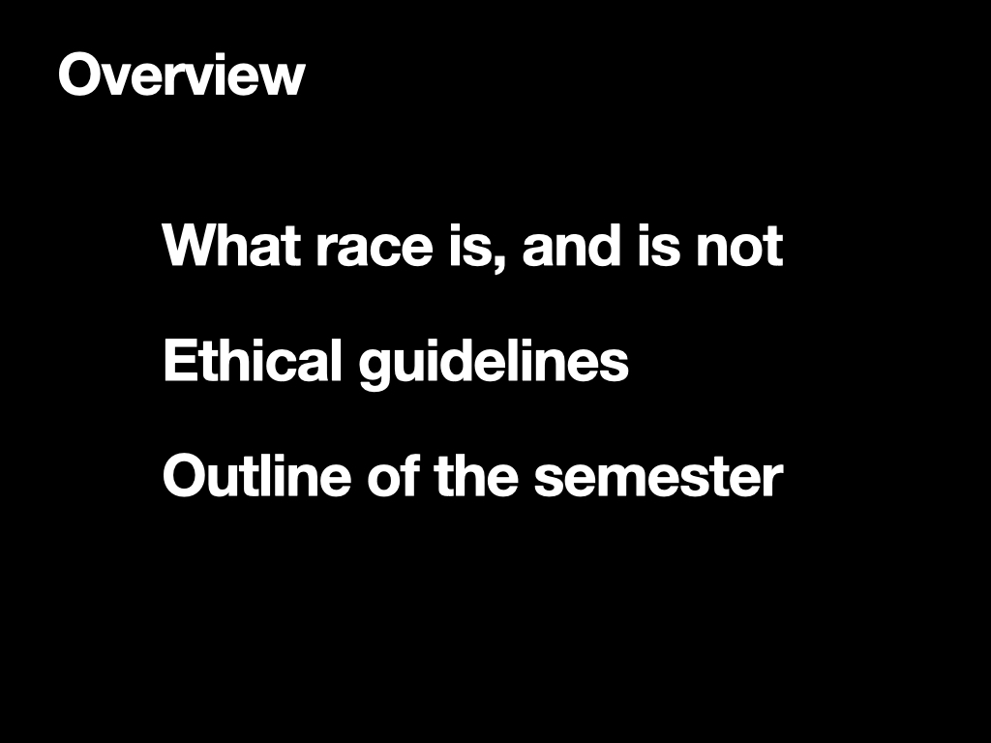
The purpose of the lecture: to lay the ground for the rest of the semester by setting up the interpretation of race and racism to be used in the Subject.
I will introduce some working definitions of race to frame our learning, and discuss two common ideas:
- that race is socially constructed
- That racism is a problem of individuals that can be overcome through getting rid of ignorance and bridging cultural divides or by rooting out extremists
We shall also discuss the ethics guiding teaching and learning on this Subject and what to expect as the semester goes on.
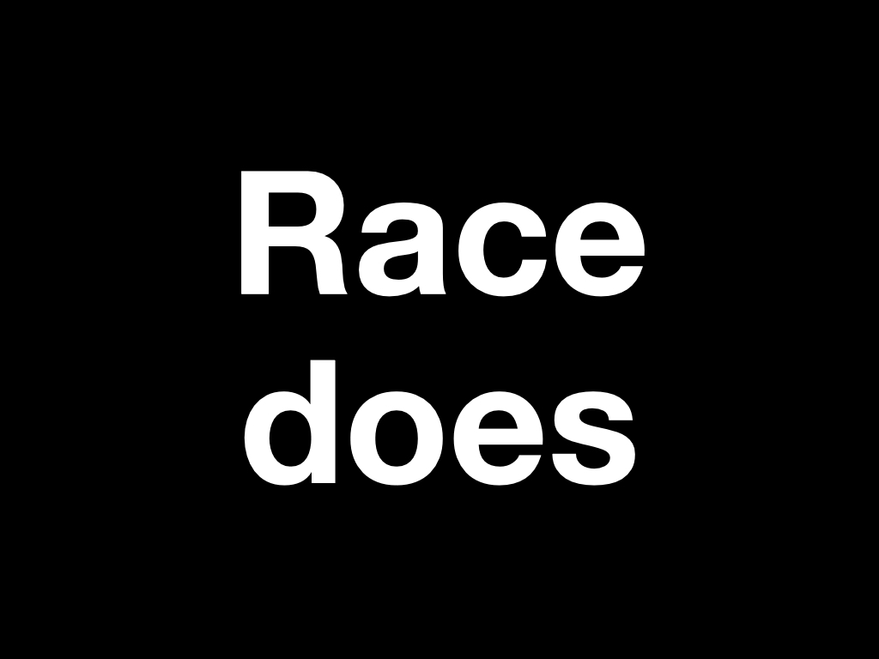
Race is something that does something. Race becomes attached to the body and is associated with individuals’ identity, but it is not equal to identity.
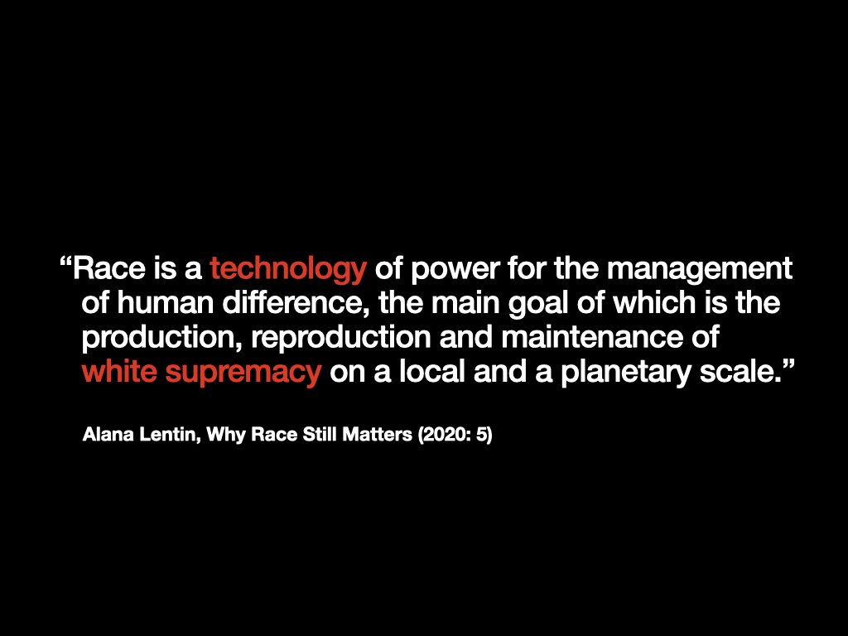
The idea of race as a technology is important. A technology does not exist in and of itself. It is a tool, or range of tools for doing something. So, my definition (building on Wendy Chun and Falguni Sheth), helps to further understand why race does something rather than is something. Race is a tool that works in conjunction with other tools, such as the law, policy, policing, surveillance, borders, and state and non-state institutions of various kinds, to enact practices that separate between people in order to dominate and exploit them.
This shows that race is always open to transformation because it is not a thing in itself. Race – the idea of intrinsic differences between people has no basis in science. Rather to understand it, we must see it as a range of – adaptable – technologies/tools for effecting domination and exploitation.
As we shall see next week when we examine the process of racialisation, this can lead to people/whole groups identifying with the racial category with which they have been assigned. So, race may become identity, but it is not equal to identity/does not begin with identity.
I argue that race is a tool for ensuring white dominance/supremacy. This is its purpose and that is why it needs to be maintained. A range of tools/technology are used.
References:
Lentin, A. (2020). Introduction. In Why Race Still Matters. Polity.
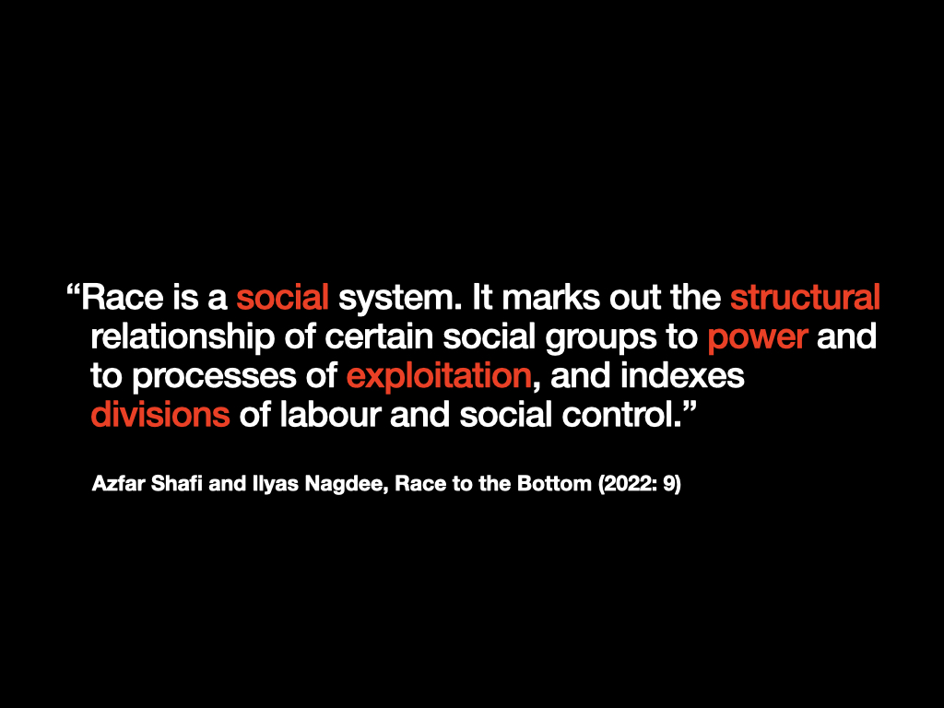
Here Shafi and Nagdee emphasise the social nature of race. So in addition to being a tool of political power, it creates an entire social system and works across institutions and the interpersonal level.
Both definitions emphasise race as a tool of power – to divide and exploit people on the grounds of made-up divisions that are said to make them different from each other in an essential way.
References:
Shafi, A., & Nagdee, I. (2022). Race, racism and racialisation. In Race to the Bottom (pp. 7–22). Pluto Press.
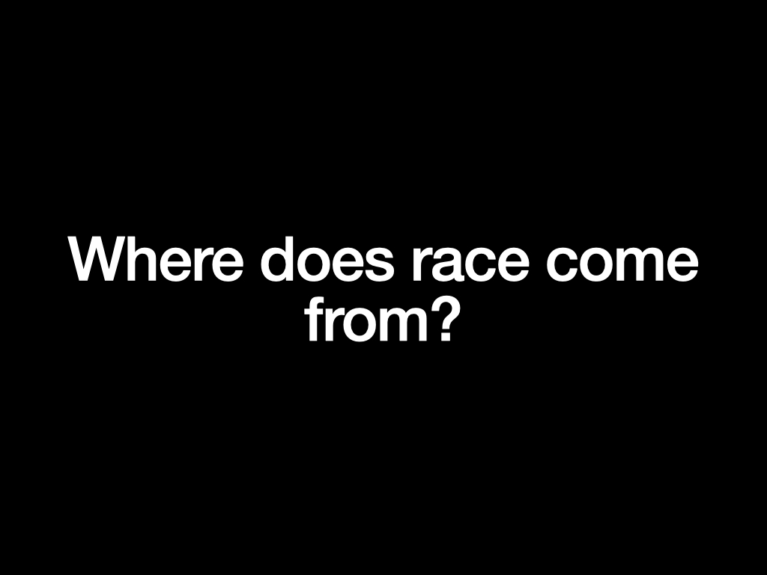
To recap, race is at its core an idea, an idea that is used to organise and manage groups of people at the level of populations with a view to exploiting them in various ways. So race does not stand alone from systems of power – the state, the colonial system and capitalism.
But there are debates about the origins of race.
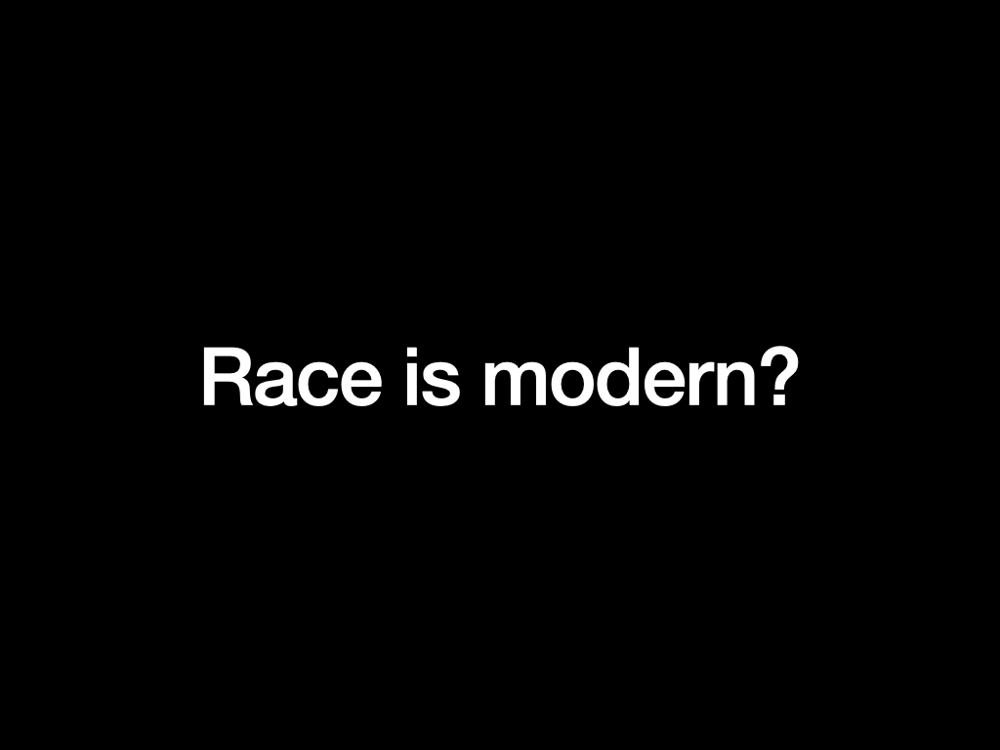
For many scholars of race, it is a modern phenomenon. They argue that, contrary to many people’s beliefs, race has not always been around, but it developed under specific conditions.
They argue that race emerges with the modern era: secularism (challenge to creationism), growth of science and ideas of rationality/irrationality, development of the nation state, colonial expansion.
This is an important idea because it challenges the belief that race is natural or is just a fact of life. If race can be shown to have emerged at a specific time, then we can also see a future in which it will no longer be so important.
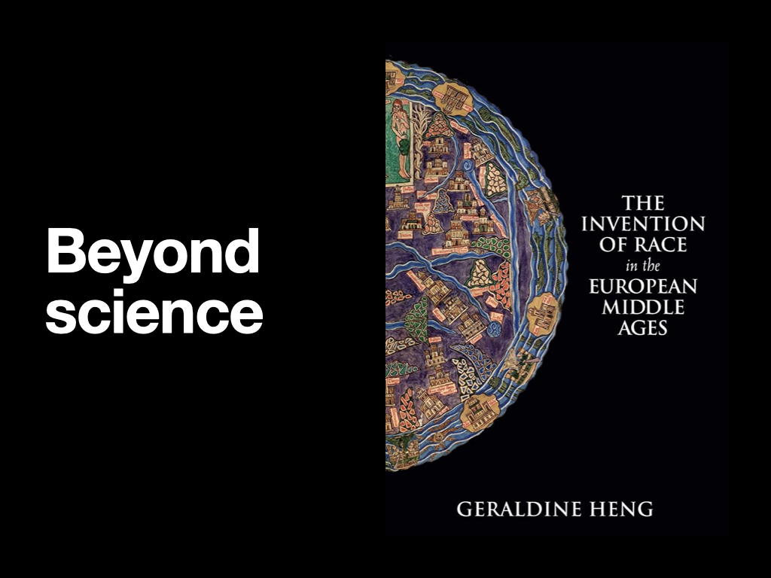
But a growing number of scholars challenge the notion that race is modern. For example, Geraldine Heng (The Invention of Race in the Middle Ages, 2018) says that we think of race as modern because we associate it too closely with science.
Race is associated with science, specifically biology and later genetics. Darwin’s evolutionism and the development of social darwinism (survival of the fittest) and eugenics (racial hygiene).
But, race is more than this. Heng looks at how the vilification and extermination of Jews in the Middle Ages in Europe shows how religion (Christianity) was used to ‘classify people in absolute and fundamental ways. We can also see the impact of religion on Islamophobic racism.
Stuart Hall also argued that science was the last stage in the development of race. First religion was the main mechanism used to distinguish between Christians and non-christians. This was fundamental to the establishment of Europe as Christendom, a continent for Christian peoples. This developed in opposition to the power held by Muslim rulers over large parts of European for centuries in the 14-15 centuries.
Race later became associated with geographic location; people from different parts of the world were said to have different origins. This idea was used in conjunction with ideas of religious incompatibility to justify the domination by Europeans of other lands, leading to the installation of colonial rule.
Only lastly was biology used to justify classifying whole groups of people as wholly different to each other and even killing them en masse. Racial classification, eugenics, and later biomedicine and other techniques such as intelligence testing were all tools used to create the idea that there was something intrinsic to different bodies that made people naturally different to each other. As we shall see, abhorrent practices of violence on people’s bodies were justified in the name of science, medicine in particular.
The important thing: race uses a range of ideas about intrinsic human difference – cultural, religious, ethnic, genetic/the body, national, etc. We can talk about a process being racial when differences between human beings are taken to be fundamental, absolute and insurmountable AND used to justify the domination of some by others. However, as we shall now see, this is not universal. The conditions for developing the idea of race were those of early modern Europe where various developments – in particular the development of capitalism and the birth of nation-states – were ripe for the emergence of racial ideas.
References:
Hall, S. (2017). Race—The Sliding Signifier. In The Fateful Triangle: Race, Ethnicity, Nation (pp. 31–79). Harvard University Press.
Heng, G. (2018). The Invention of Race in the European Middle Ages. In The Invention of Race in the European Middle Ages (pp. I-Ii). Cambridge: Cambridge University Press.
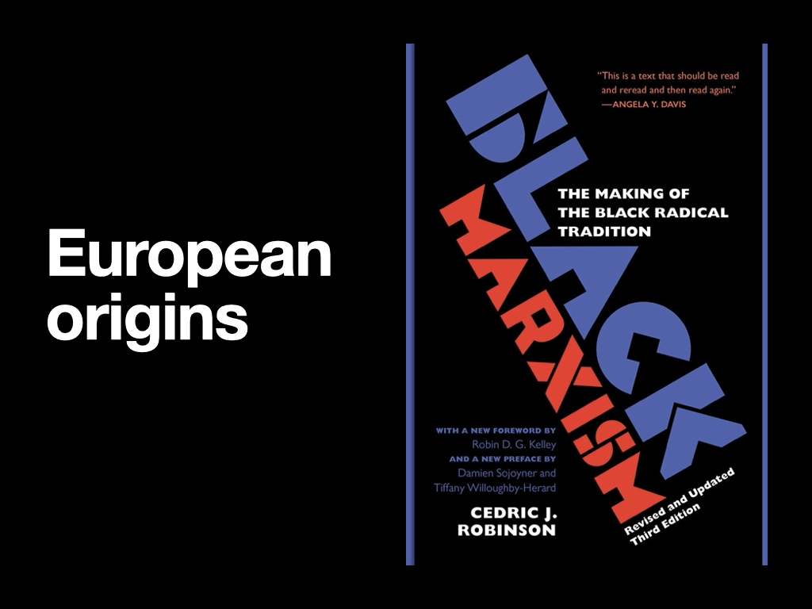
Similar to Heng, Cedric Robinson – perplexed by the idea that race ‘suddenly’ becomes such an important factor only after the birth of colonialism and, in particular, the Transatlantic slave trade.
He looks at the origins of race within Europe itself to show how race was already an idea and a practice that was available and could be adapted to new circumstances.
Robinson’s idea is challenging because he detached race from skin colour and Black African people in particular. He shows that, through colonialism and the slave trade race comes to be predominantly used as a tool to dominate and exploit Black and Indigenous peoples. But, in the Europe of the Middle Ages it developed initially along with the early days of capitalism as a way of dividing among different groups of people according to different forms of work.
Over times, different people were enslaved and people who were forced to migrate around Europe for reasons such as famine or labor scarcity, were used as slaves. Later, these practices were rolled out, first to Indigenous peoples in the Americas (the Caribbean) and later, to African people who were captured and exported all over the Americas.
He calls this system – which first emerged in Europe – racial capitalism.
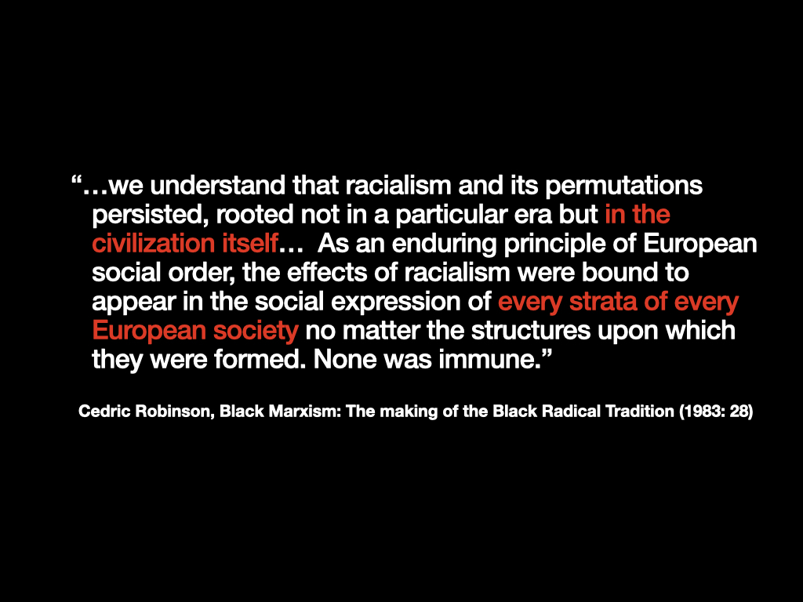
In this quote, Cedric Robinson wants us to understand that what he calls racialism (the organisation of society on the basis of the idea that there are different races) can only be understood by understanding the way European civilisation developed at a specific time: following the middle ages and the birth of capitalism.
His argument is that we need to understand this because capitalism spread across the globe through the colonial domination of the rest of the world by Europeans. Europeans brought with them this way of organising society on the basis of racial differences which is first and foremost a tool of power.
Understanding this is key to understanding why race continues to be such a force.
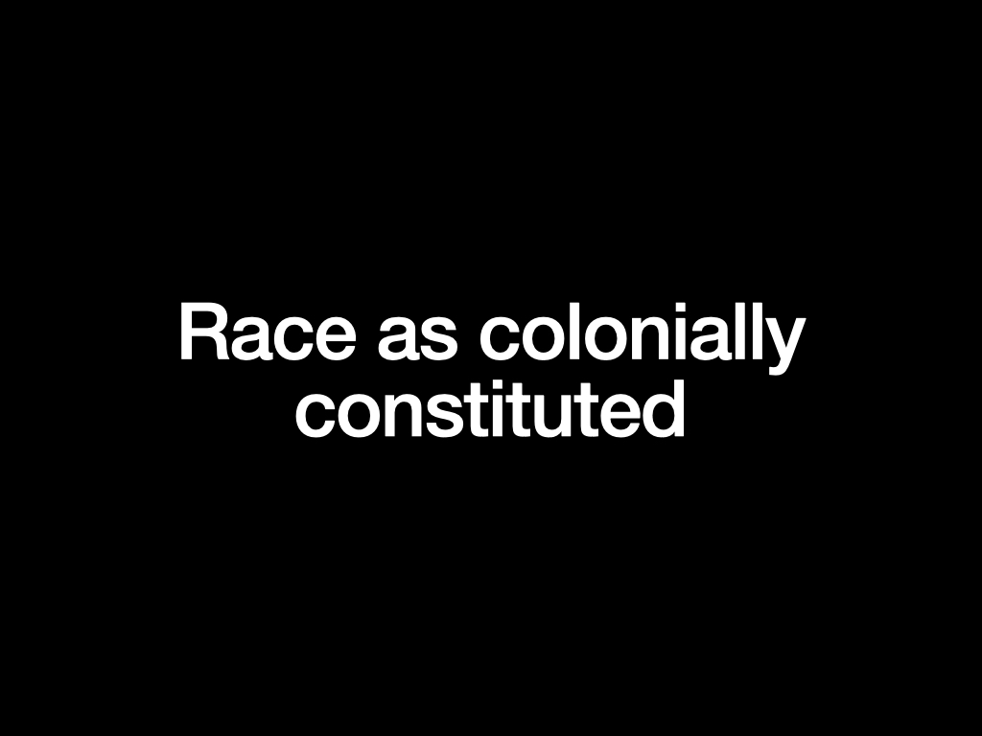
Key date: 1492 – invasion of the Americas by the Spanish crown.
At the same time, the Spanish were holding inquisitions based on the notion of purity of blood and forcing Jews and Muslims to either convert to Christianity or to go into exile.
Indigenous people whose lands were invaded by the Spanish and Portugese – as non-christians – were questioned as to whether or not there were truly human. Could a heathen be really human was a key question.

This was the question at the heart of a theological debate called by the Spanish King on the rights and treatment of Indigenous people in 1550.
Sepulveda argued that Indigenous people Indians could be enslaved due to their inability to govern themselves, and could be subdued by war if necessary.
De Las Casas used religious arguments to claim that every individual was obliged to prevent the innocent from being treated unjustly. Las Casas’ was motivated to make Indigenous people into Christians, while Sepulveda argued that because they were not Christians they were less than human and so could be enslaved and/or killed.
In the end, both positions did not end the domination of Indigenous people and colonisation expanded apace.
Here we can see that different arguments can be out forward to the same end – to justify the domination by European over non-Europeans, either by theft of land and genocide OR by forced conversion into European ways and the loss of Indigenous culture and lifestyle.
We shall see how this worked in practice in later weeks.
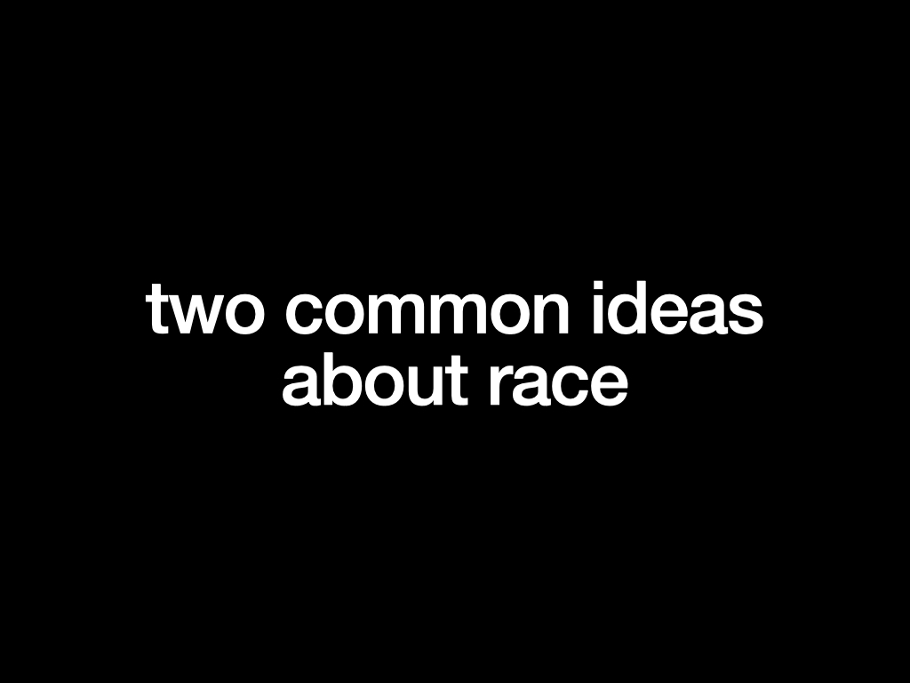
Go deeper to interrogate two common ideas about race:
- Race is a social construct
- Racism can be overcome with better education and more cultural diversity
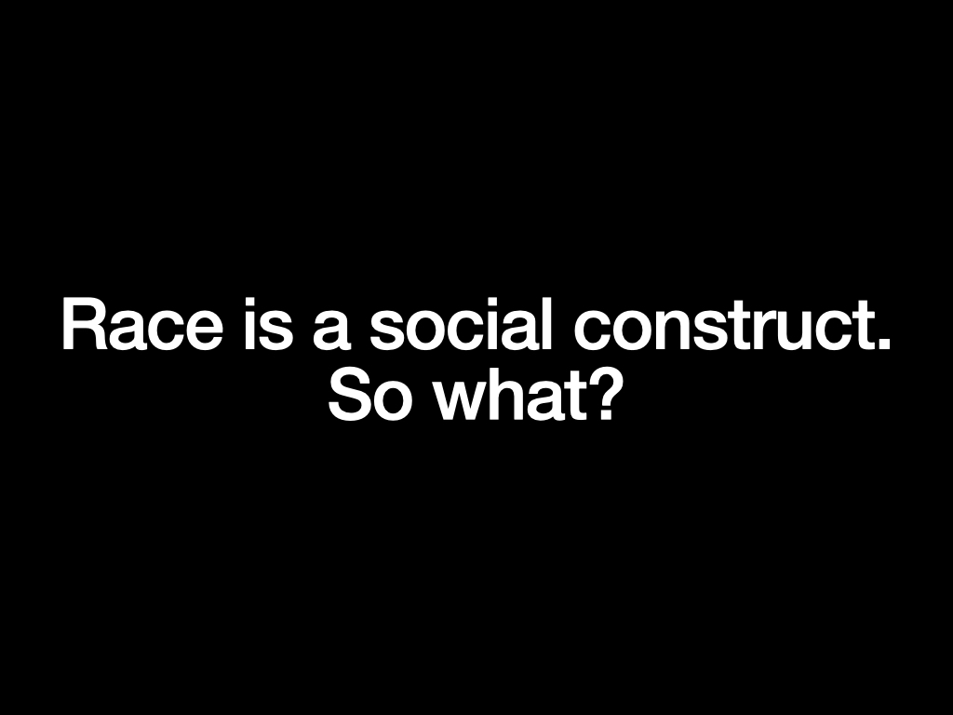
Race is commonly referred to as a social construct but what do we mean by this?
Race is socially constructed is an argument against accepting the terms set out by scientific racism: that there are essential biological differences between groups of human beings.
Indeed, scientists have proven – especially since the discovery of DNA – that there is more human variation between individuals (each of us has our own unique DNA) than there is between whole groups who might look different to each other physically. Essentially, the old antiracist idea that we are all one human race is correct.
According to Barnor Hesse, when we say race is a social construct of the biological idea of race, we do not actually dismantle the idea of biological race. It is a circular argument.
But we need to ask, what use is this when racism still exists?
Sometimes people wilfully misunderstand the idea of social construction to argue that because there are no real biological differences between so-called ‘races’ then there is no such thing as racism: racism a myth. But that isn’t true, so we must ask is the idea of race as a social construction useful?
Race is both fact and fiction. Or in other words, social facts are built upon the fiction of race and there are real and devastating outcomes for people.
I argue that it is better to focus on the real impacts of race rather than arguing about whether it is real or not. This is especially the case because, as we have already seen, race is NOT just about biology and genetics; it uses religion, culture, ethnicity etc. to construct itself. These differences are all real. The question is why have they been used to make the case for the domination and exploitation of billions of people both historically and today?
Asking this question pushes us to be more specific about just how race comes to be constructed.
References:
NU Political Union Debate – Barnor Hesse vs. Charles Mills https://www.youtube.com/watch?v=1j0WYoLFUCg
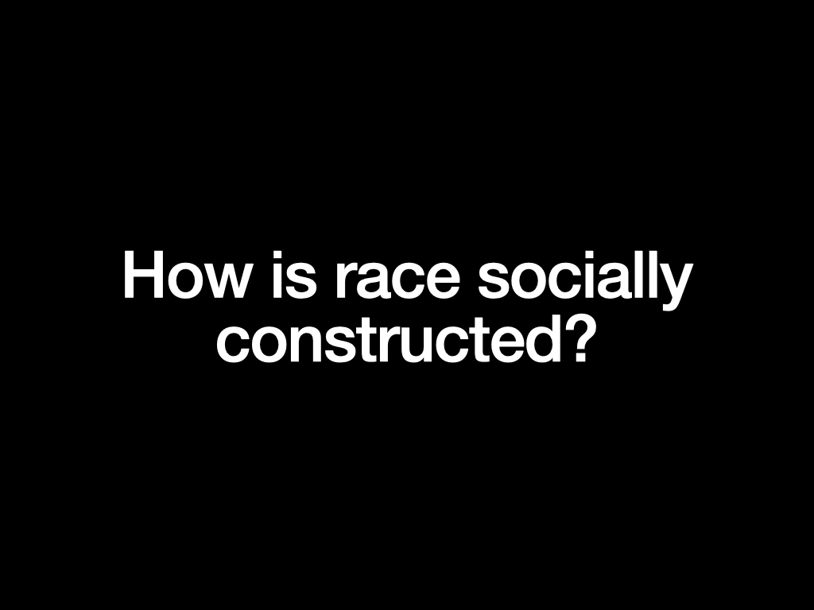
This is our aim as students of race. We need to look at how, why and when race is constructed, not just historically but today, as a continual process.
Cedric Robinson uses the idea of the racial regime to show how race takes different forms in different times depending on the demands of that time. Each era/regime builds on the past, adding to old forms of race making and transforming them for new times.
And many thing stay the same but are more difficult to uncover. For example, as we shall see in Week 10, while the Stolen Generations (referring to the theft of Indigenous children from their families) officially ended in the 1970s, today Indigenous kids are being removed at higher rates than ever before despite the fact that there has been a national apology to the Stolen Generations. We might argue that in the current racial regime, it is more difficult to speak about this because, as a nation ‘Australia’ has officially moved on from its past when there was a much overt commitment to extinguishing Indigenous cultures. Today we acknowledge country and seek about past atrocities, but it is more difficult to speak about ongoing racist practices. Tracking this is one way of thinking about race as a project which is under continual construction.
References
Cedric Robinson (2007) Forgeries of Memory and Meaning
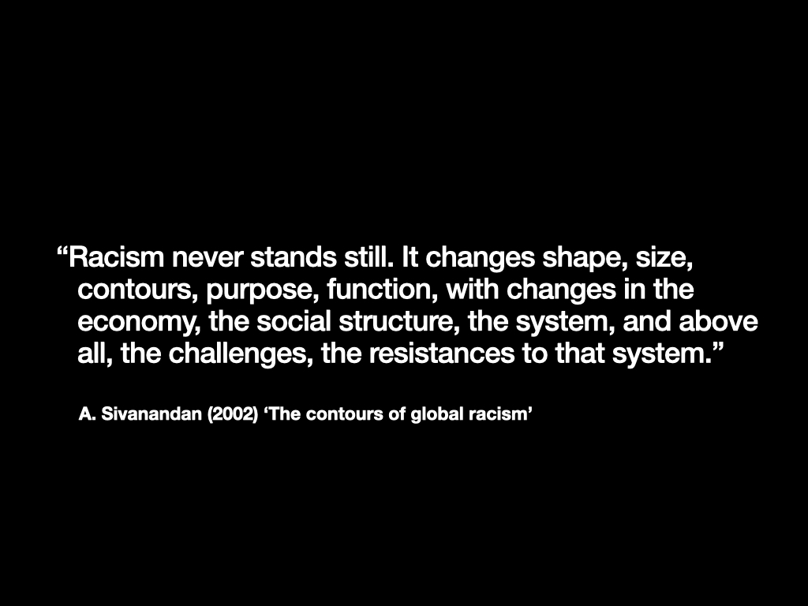
This is the point being made by A. Sivanandan in this famous quote.
References:
- Sivanandan (2002) ‘The contours of global racism’ https://irr.org.uk/article/the-contours-of-global-racism/
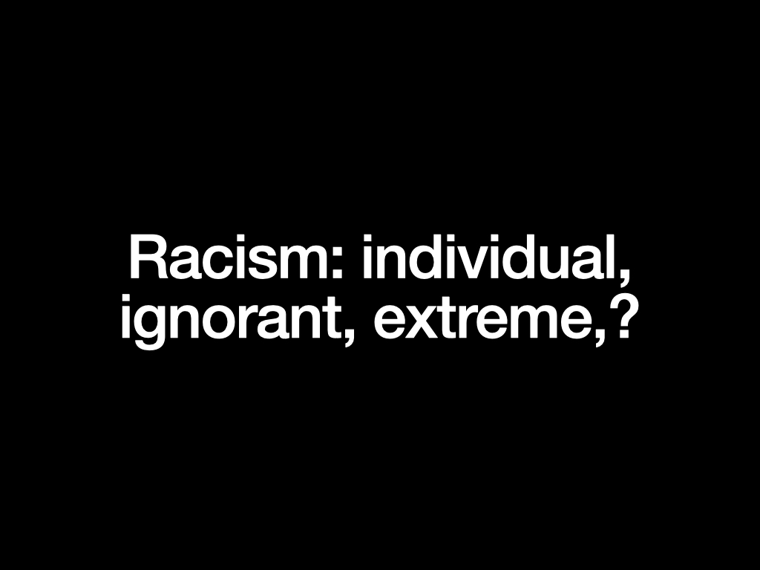
The second idea I want to take to was is the idea that racism is a problem of individuals that can be overcome through getting rid of ignorance and bridging cultural divides or by rooting out extremists
To think about this, we first need to think about the relationship between race and racism.
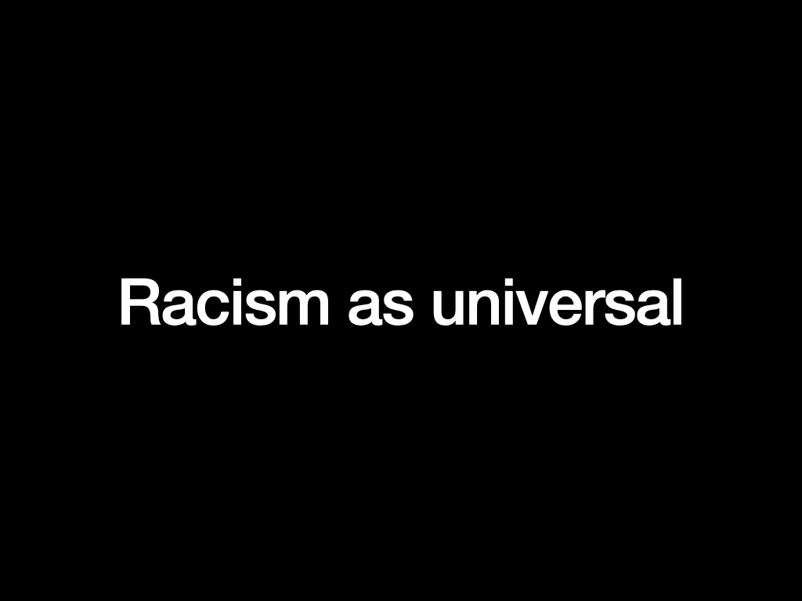
In common conceptions, racism is an ideology based on the idea that there are different racial groups who are organised according to a hierarchy. Again, this idea does not do much to explain where this comes from. Often, this view of racism sees it as an unfortunate but universal attitude: the idea being that everyone is prejudiced against others who are different to themselves. But whether or not this is true, being prejudiced is not the same as being racist. Prejudice does not lead to domination and exploitation; it does not imply the existence of races which are fixed and unchanging with no movement possible between them.
This view also does not contend with the European origins of race. While race has become globalised as a system of rule, it does us no favours to ignore its ‘history, severity and power’. As Miri Song argues, seeing race as free-floating from its history allows it to be used to describe any number of processes and being made equivalent to each other. This logic leads us to concepts such as ‘reverse’ or ‘anti-white racism’.
References:
Song, M. (2014). Challenging a Culture of Racial Equivalence. British Journal of Sociology, 65(1), 107–129.
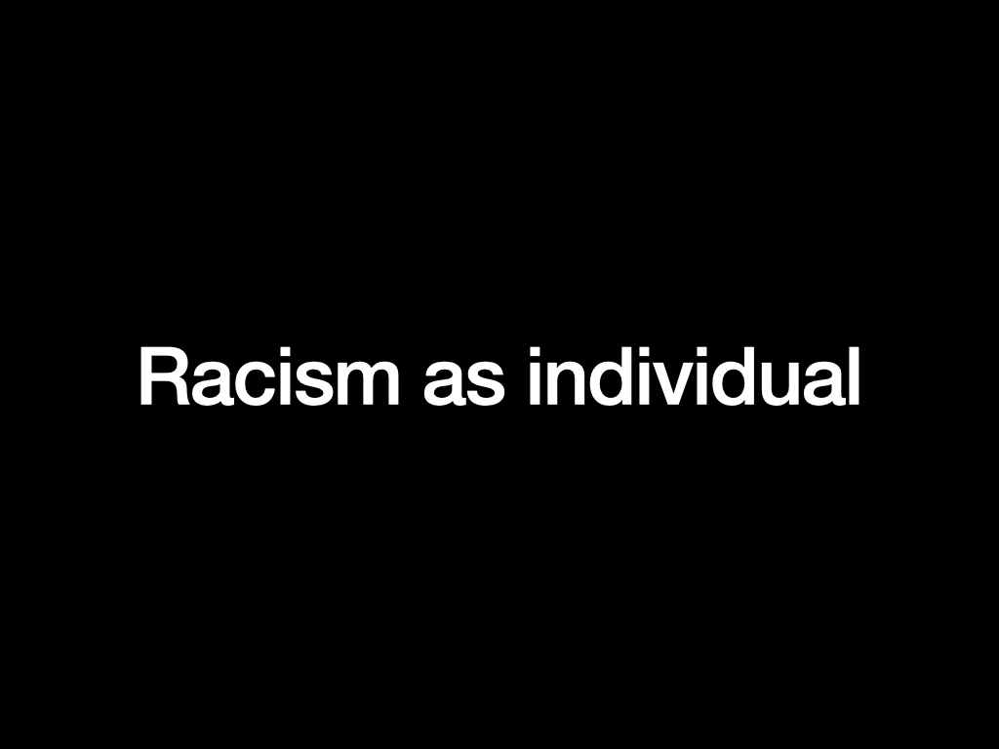
An additional problem that comes from treating racism as a form of ignorance is that this focuses too much on the individual and not enough on the systemic. We talk about people being racist or non-racist. Racist people are either those with extremist views or those who are ignorant and lacking education. Taking this perspective means we fail to ask how people become racist.
Can you be born a racist? (Y/N?)
Racism then gets reduced to individual bad attitudes. Because very few people wish to be seen as racists they deny being so.
That is why surveys about attitudes to race don’t reveal very much and further promote the notion that racism is an individual matter.
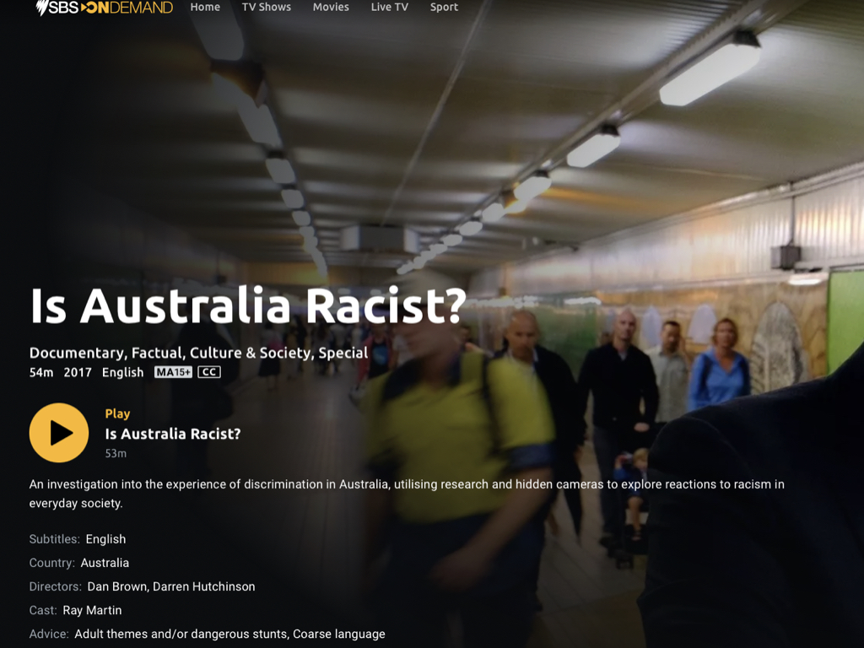
An example of this individualising approach to racism – the 2017 SBS documentary, Is Australia Racist?
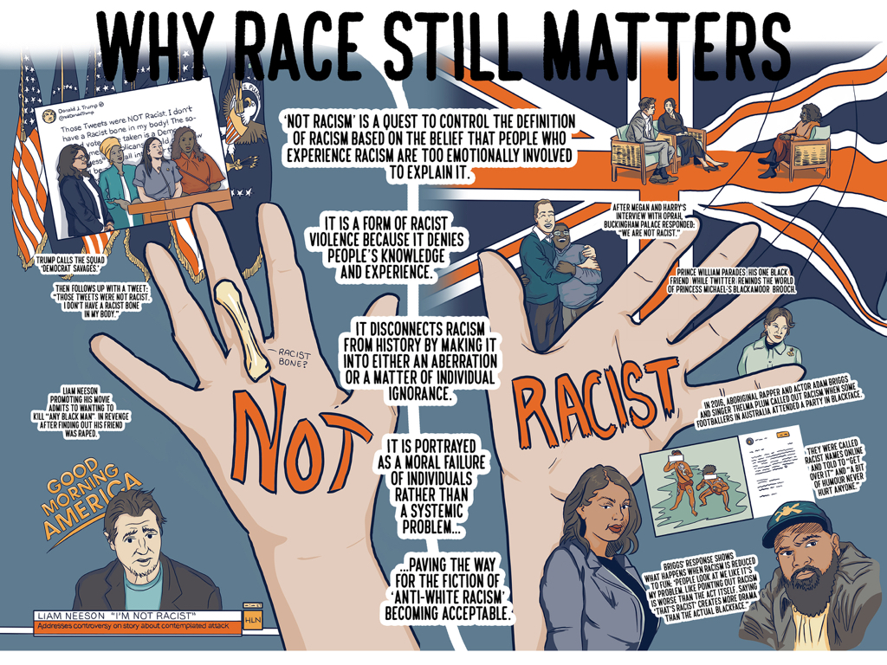
In fact, as the Yorta Yorta rapper Adam Briggs has pointed out, sometimes calling out the racism is seen as worse than the racist itself.
In my work, I formulated the idea of ‘not racism’. This is when, not only is racism denied, but it is reformulated from a white perspective that minimises the racism, or insists that a situation can only be racist if there was intention to harm. However, racist actions have racist effects, whether or not they were intended to cause harm.
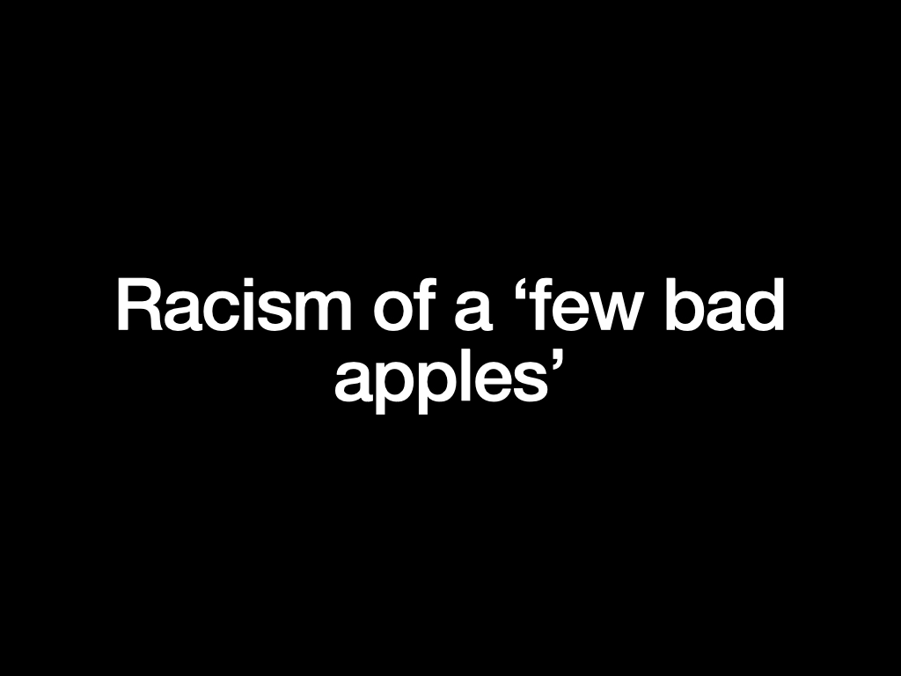
Racism is often seen as the preserve of extremists who commit abhorrent acts of violence. While these people certainly exist and the amount of racist violence is on the rise, trying to root the problem out at the level of the individual violent extremist does not – once again – contend with the question of what emboldens individuals such as Brenton Tarrant or Dylann Roof.
Perpetrators of racist atrocities are often treated as a bad apple or a lone wolf. But, the fact is that these perpetrators are motivated by mainstream views, particularly on immigration and Muslim people.

For example, Anders Breivik who murdered over 70 young people in Norway in 2011 because he was opposed to multiculturalism, wrote a manifesto – A European Declaration of Independence – that cited articles published in mainstream newspapers that raised ‘concerns’ about immigration and social cohesion. When we treat violent extremists as mentally ill lone wolves, we turn racism into a pathology rather than an expression of the whole culture.
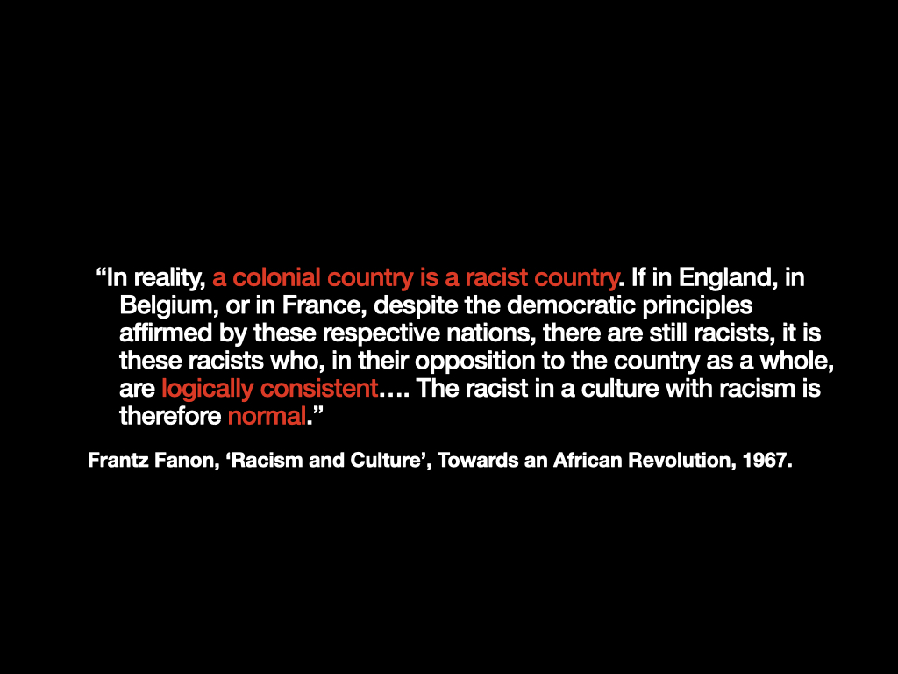
As the anti-colonial psychiatrist and freedom fighter, Frantz Fanon wrote in ‘Racism and Culture’, a colonial country or a country that has benefited from colonialism is racist. Therefore the individual racist is acting normally.
This is an argument against seeing racism as out of the ordinary or rare. As Fanon says, it is not useful to say things like, ‘”There are a few hopeless racists, but you must admit that on the whole, the population likes . .. With time all this will disappear.’
For more on this, check out my TikTok video, ‘Is racism a pandemic?’
I refer to Fanon’s claim in Racism and Culture: ’It is a common saying nowadays that racism is a plague of humanity. But we must not content ourselves with such a phrase. We must tirelessly look for the repercussions of racism at all levels of sociability.’
If we speak about racism as a pandemic we run the risk of seeing it as something natural and lose sight of its systemic grounds.
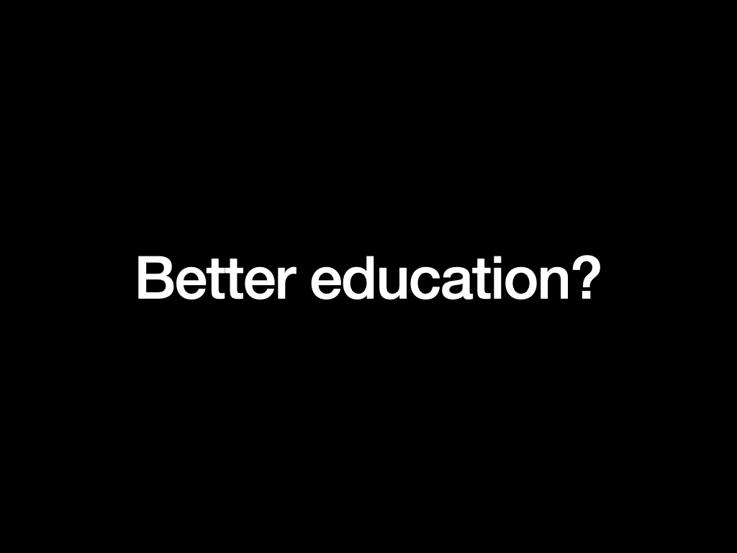
Yes, educating about race and racism is crucial. But there is a fallacy that this alone will end racism. People believe more education and – in particular – greater knowledge of non-dominant cultural groups will bring about a end to racism. But to say this discounts the fundamental role that race plays in underpinning the social, political and economic system that has been in development for over 500 years.
This system depends on race and other structures of dominance (class, gender…) and it also reproduces them in order to function. Ending racism demands a whole system – not an individual approach.

Much antiracist activity is grounded on promoting better cultural understanding between groups who are defined as distinct. There are several potential problems with this including the fact that it, again, individualises the problem. People knowing each other better is certainly valuable, however it does not bring about systemic change. It could lead to people using their ‘one Indigenous friend’, for an example, as a justification for the racist status quo.
People of colour who grow up in multiracial families often talk about the degree of racism they face within their own families, even from their own parents. To return to Fanon, a society founded on racism will produce racist individuals.
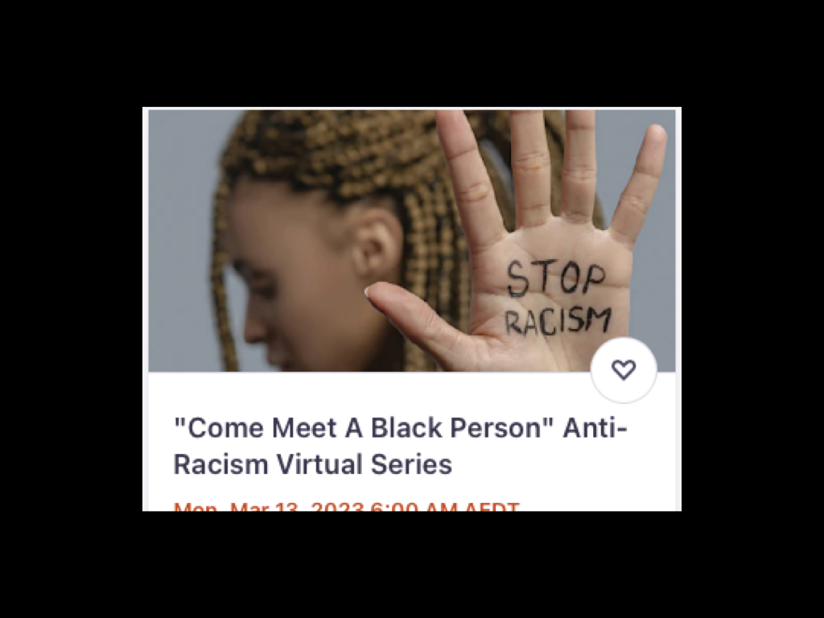
This workshop promoted on Eventbrite is an example of a well-meaning approach that stresses individual interaction. However, both historically and in the present white, Black and Indigenous people knew each other, often intimately (think enslavers who fathered the children of those they enslaved). This approach also places a lot of weight on the shoulders of racialised people to open themselves up to people who may be racist towards them.
To struggle against racism, people must feel that their struggle is a common one, and that ending racism benefits everyone, and is not a benevolent act on behalf of non-white people, a patronising attitude.
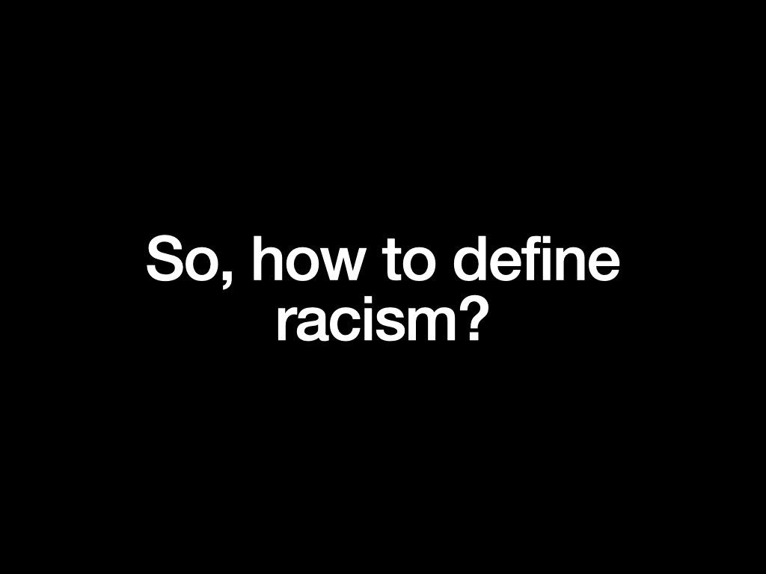
I have said a lot about what racism is not, so what is it? What is the relationship between race and racism? If race is a technology of rule for the management of human difference and a social system that positions people in relation to power and exploitation, racism is the practices that produce and reproduce race.
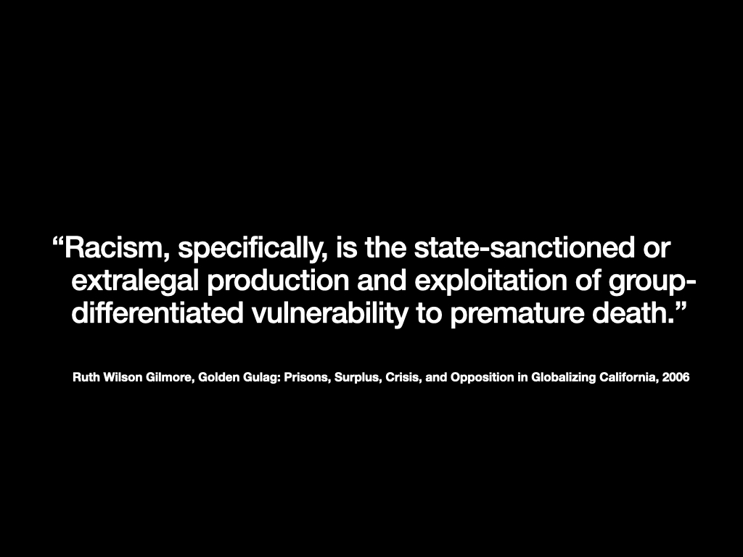
The best definition I have found is by the geographer and abolitionist activist, Ruth Wilson Gilmore from her book on the California prison system, The Golden Gulag.
Here we see that racism is not just a matter of bad attitudes towards people who are different to ourselves. Neither is it just the extremist actions of lone wolves. It is about creating the conditions in which whole groups of people are made more likely to die. Ruth Wilson Gilmore also talks about ‘organised abandonment’. If race constructs people as less-than-human, they are less deserving of care and more likely to be forced to exist in conditions which leads to impoverished lives which, in turn, can cause premature death. This is by design. We will look at how this works in far greater detail throughout the semester.
References:
Wilson Gilmore, R. (2006). Golden Gulag: Prisons, Surplus, Crisis, and Opposition in Globalizing California. University of California Press.
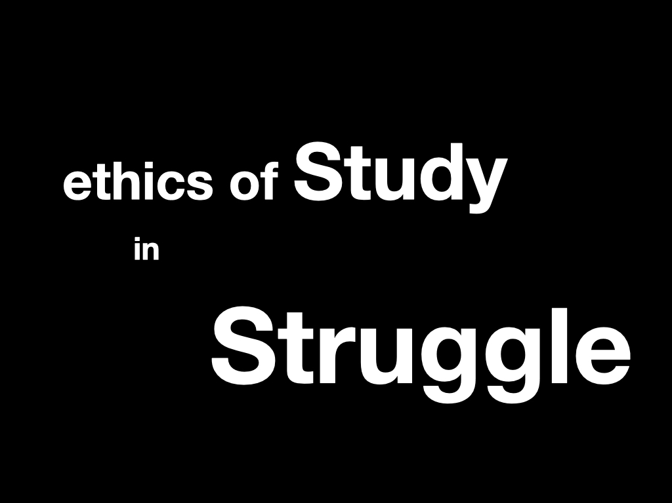
What are ethics guiding this subject?
I have adapted this from Robin DG Kelley’s ‘Black Study, Black Struggle’. Kelley argues that the university, as a colonial, capitalist and racist institution, cannot be the place from within which to dismantle unjust conditions. But is can be a place where we come together and gather as much knowledge as we can, and use this to struggle for a better world outside.
We need better racial literacy, not because education is a route to progress, but because knowledge is a weapon.
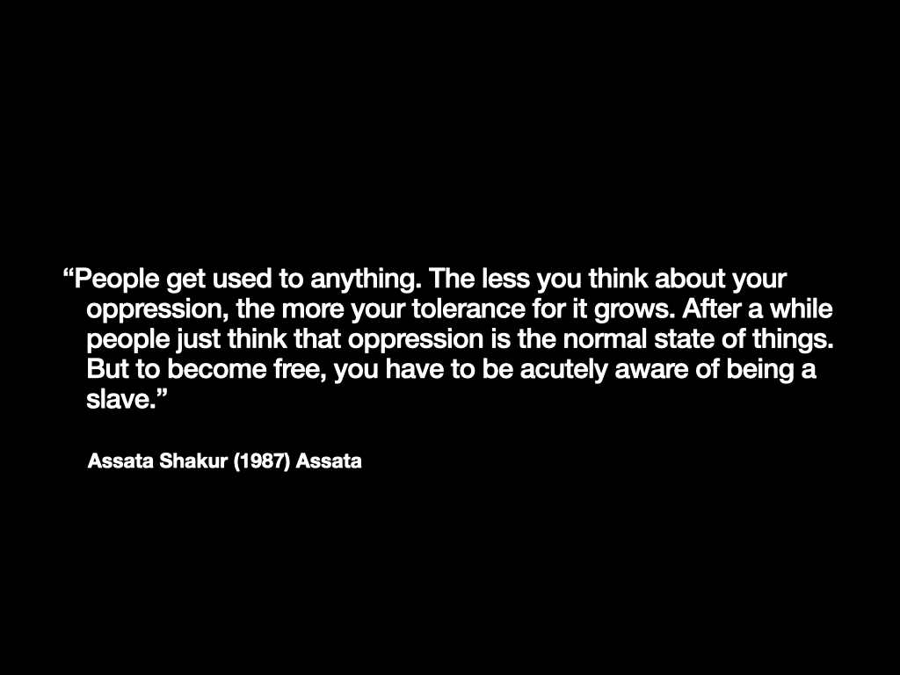
As the Black freedom fighter Assata Shakur said, ‘People get used to anything. The less you think about your oppression, the more your tolerance for it grows. After a while people just think that oppression is the normal state of things. But to become free, you have to be acutely aware of being a slave.”
References:
Assata Shakur (1987) Assata: 262
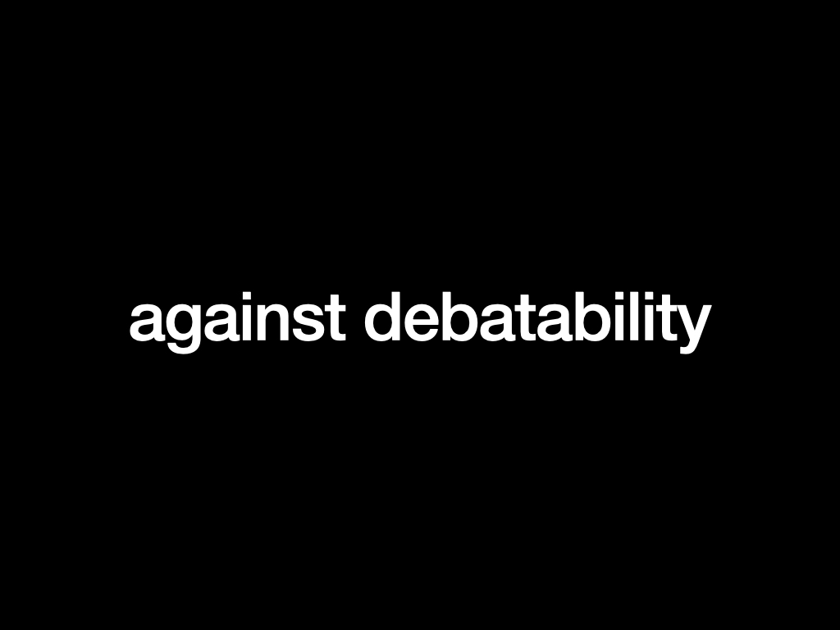
Debate is a common technique used to further knoweldge, a technique grounded in a western approach to knowledge which assumes that we can be objective about facts. So, when you are on a. Debating team you might be forced to argue for something you do not believe in.
Today, it is common for racism to be turned into a matter of debate. The media scholar, Gavan Titley, refers to the ‘debatability’ of racism. When we turn the question of racism into a debate with two even sides – for example, for and against the wearing of hijabs or whether or not there should be mandatory detention of asylum seekers – we treat questions about people’s lives as though they were just another subject.
This desensitises to the issue at hand. We can see how the approach taken by liberal media to racism has led to people with extreme racist and fascist views being given an equal airing in the media, serving to legitimise what should be commonly agreed upon as abhorrent views or being allowed to make statements that are not grounded in fact, such as it is illegal to seek asylum by boat (when in fact it is legal according to all international and Australian law).
So, in this class we will unpick the questions we look at thoroughly and use our critical thinking to the maximum, but we will not be debating the existence of racism. That will be a given. This will free us up to spend time to explore how race works with the aim of getting ride of it.
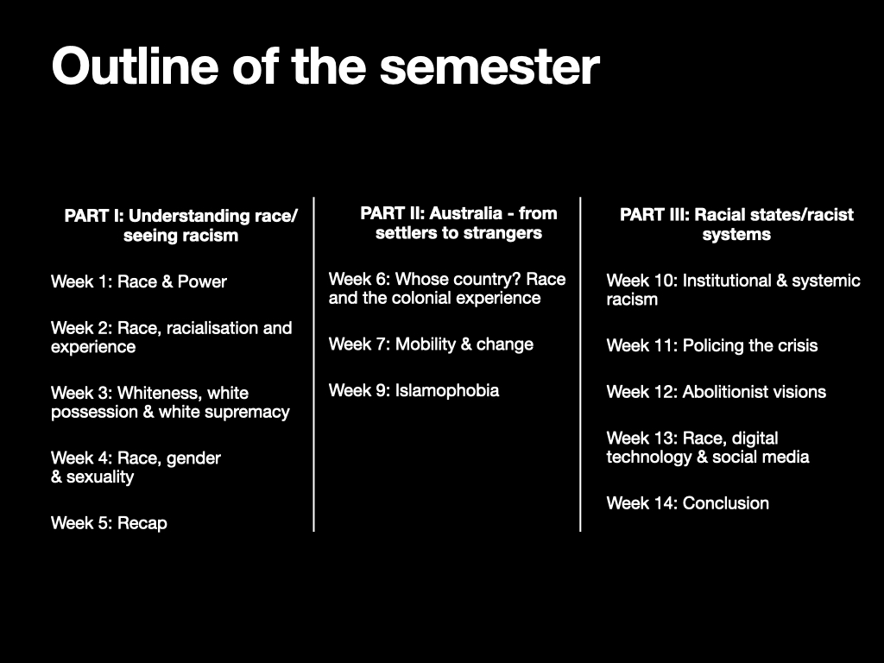
CATEGORIES:The Racial State

