Facilitator Agenda: Systems of Power and Oppression
Clock time, Facilitator Name | Resources | Intro to Power (30 Min) | Participant Outcomes and Essential Questions
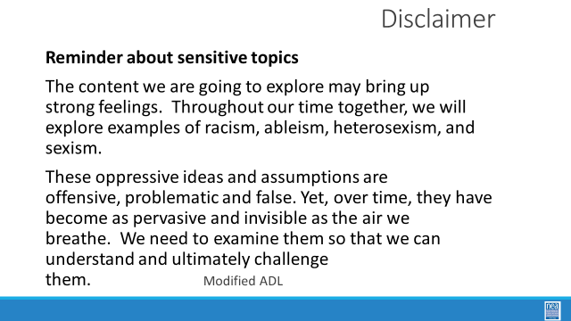  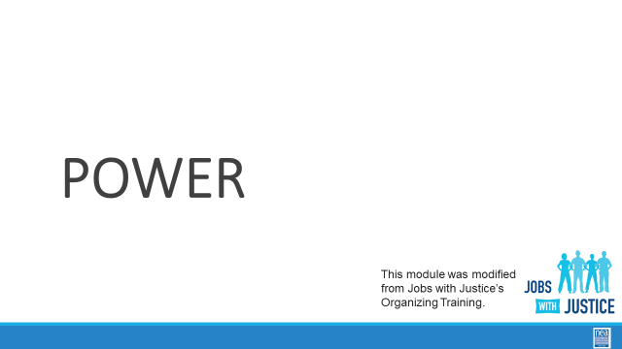  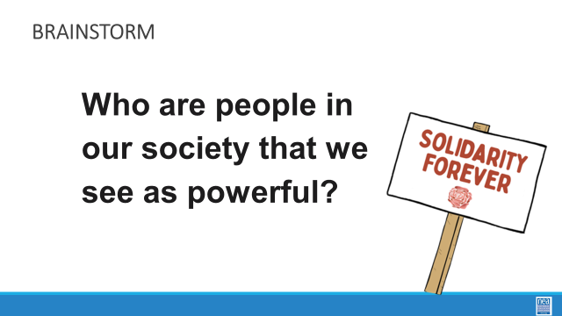  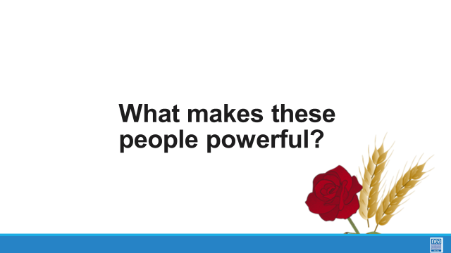  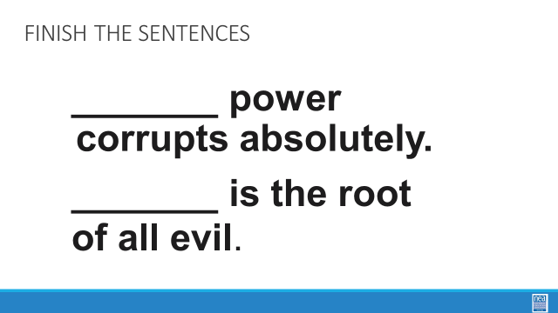  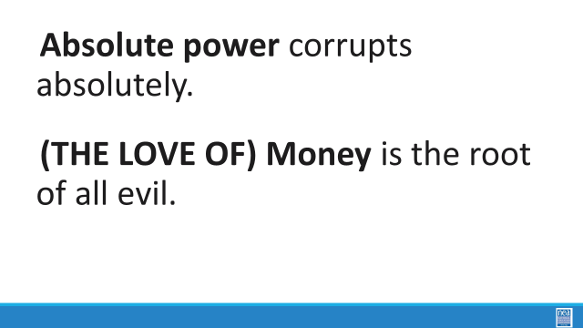  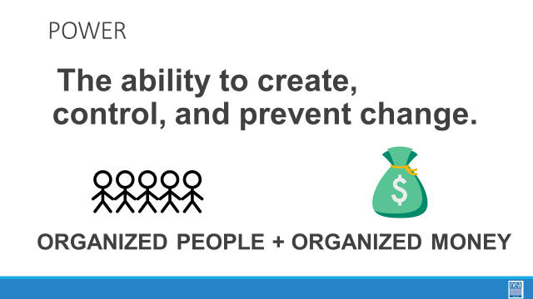  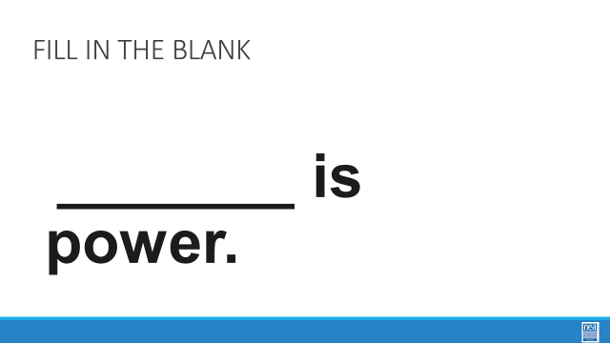  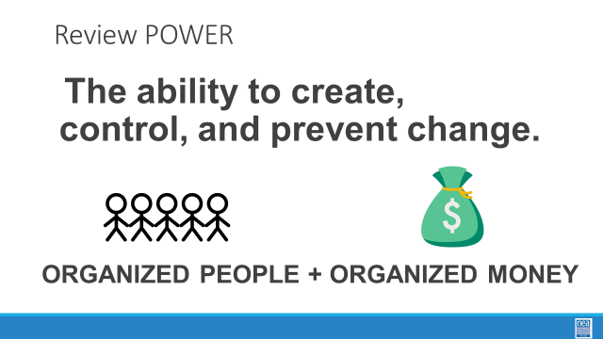  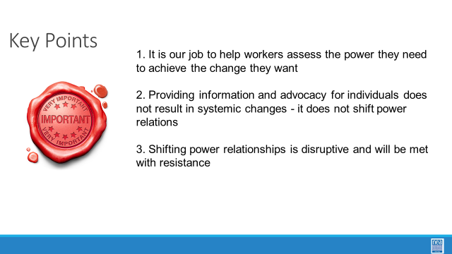 | Chart paper/marker at the front of room to chart responses. | 1 Min Reminder The content we are going to explore may bring up strong feelings. Throughout our time together, we will explore examples of racism, ableism, heterosexism, and sexism.  These oppressive ideas and assumptions are offensive, problematic and false. Yet, over time, they have become as pervasive and invisible as the air we breathe. We need to examine them so that we can understand and ultimately challenge them.  4 Min - Power  Transition - We’ve spent some time discussing systems of oppression. At the heart of those systems is power. Now we want to move to discussing the concept of “power” more broadly.  This module is modified from Jobs with Justice’s organizer training. We use their model because we are stronger if we are using shared language and shared understanding of concepts.  10 Min – Chart Activity  Each table should brainstorm a list.  Who are some people in our society who are powerful?  Report out each table.  Chart the answers:  No repeats.  We are going to come back to these in a minute.  Reveal sentences and ask group to fill in the blanks:  - Absolute ___________ corrupts absolutely.  Raise your hand if you believe this is true.  - _________ is the root of all evil.  Raise your hand if you believe this is true.  If the room agrees, challenge them, and tell them no. Power and money are neutral. These ideas were thought up and perpetuated by someone who doesn’t want you to have any power. Our values affect the way we use power and money. When our organizations have power, we use it aligned with our values.  - Where do these two phrases come from, how do we know them?  The power quote is from Lord Acton, an 19th century British scholar, who said it as part of an argument against papal infallibility and divine right of kings, but it’s often misquoted and quoted out of context.  The Bible actually says “Love of money” is the root of all evil, but most people do not know that version of the quote.  - Powerful people, who have lots of money and power, invoke these phrases as a way of making us uneasy about money and power.  5 Min - Define Power  “Power is the ability to create, control, and prevent change. Power is made up of organized people and organized money.”  So let’s go back to the list of people we identified who are powerful.  Refer to the list of people and walk at least one example through how they organize people and money, and what they can change.  Ask for a volunteer from the room:  Can someone else walk us through our definition of power as it relates to these powerful people? How are they organizing people and money and what change do they control?  10 Min - Table talk:  In our work, what are examples of how we organize money and people to build our power?  Ask who still feels nervous or scared about power and money. Being nervous and scared is fine! But we need to know where that comes from and be able to get through it to do our work.  Key Ideas:  - Power is neutral. How we build power and use power is based on our values  - We measure power by our ability to control change. For us that is the ability to win on issues that matter to our workers.  - We want power.  As you facilitate the interactive discussion above, look for opportunities to highlight the below points. If any of them don’t come up organically, raise them and hit these points before moving to the next section.  - Point out that we measure power by our ability to win on issues that matter to our workers.  - Power is neutral. How you build it and use it is about your values.  - We have to be constantly building power | What is power and why do we want it?  Participants will be able to define power and then practice ways to discuss it with members and make it a present part of UniServ work.
Clock time, Facilitator Name | Resources | Systems of Power – Race, Class, and Gender – 45 MInutes | Participant Outcomes and Essential Questions
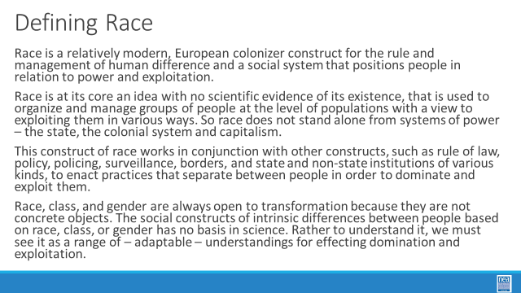  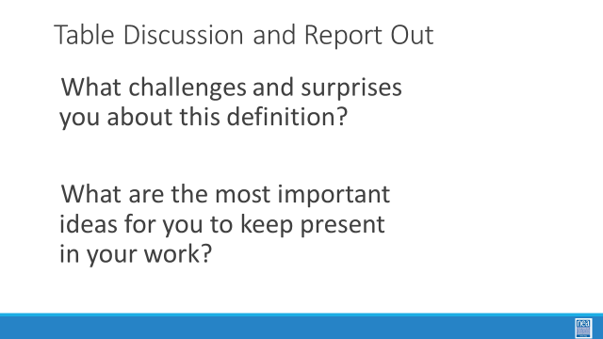  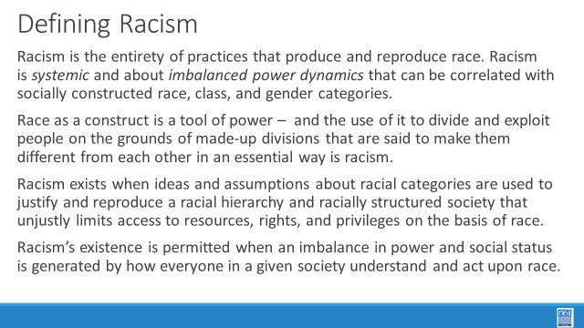  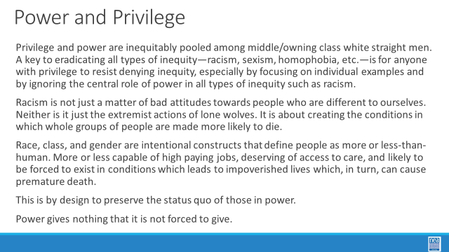  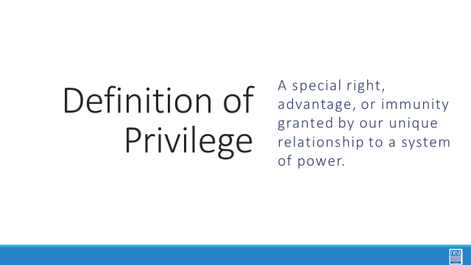  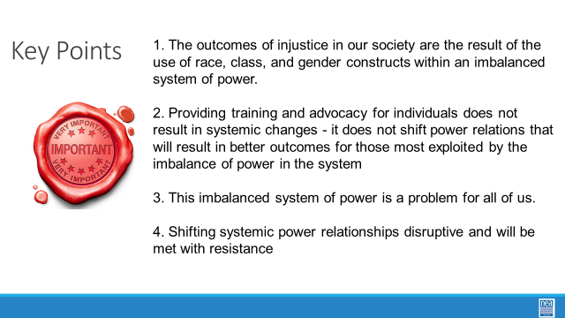 |  | (Facilitator Team this needs your magic. It is set up as a read a piece of content, then turn and discuss, then talk as a room. I feel like this section is 45 Minutes and we might not have the time to do it all in this way. I trust your thinking on this. It would update our thinking from one where we academically define race and racism as though it is its own thing not part of a power structure and move it into a stronger foundation of power. This takes the focus off who has privilege and individuals, and grounds it more firmly in systems of power. I think that this is a more productive way to include this and is a result of some of our debriefs this year. I would like to see this incorporated in some way into all of our training in part or in full. I have included the full run of content around power from Foundations and situated this piece where I thought it made sense.)  Defining Race 5 minutes - ask participants to read the following definition –  Race is a relatively modern, European colonizer construct for the rule and management of human difference and a social system that positions people in relation to power and exploitation.  Race is at its core an idea with no scientific evidence of its existence, that is used to organize and manage groups of people at the level of populations with a view to exploiting them in various ways. So race does not stand alone from systems of power – the state, the colonial system and capitalism.  This construct of race works in conjunction with other constructs, such as rule of law, policy, policing, surveillance, borders, and state and non-state institutions of various kinds, to enact practices that separate between people in order to dominate and exploit them.  Race, class, and gender are always open to transformation because they are not concrete objects. The social constructs of intrinsic differences between people based on race, class, or gender has no basis in science. Rather to understand it, we must see it as a range of – adaptable – understandings for effecting domination and exploitation.  5 minutes as pairs –  - What challenges and surprises you about this definition?  - What are the most important ideas for you to keep present in your work?  5 Minutes as whole room – what did you talk about?  Defining Racism –- ask participants to read the following definition –  Racism is the entirety of practices that produce and reproduce race. Racism is systemic and about imbalanced power dynamics that can be correlated with socially constructed race, class, and gender categories.  Race as a construct is a tool of power – and the use of it to divide and exploit people on the grounds of made-up divisions that are said to make them different from each other in an essential way is racism in action.  Racism exists when ideas and assumptions about racial categories are used to justify and reproduce a racial hierarchy and racially structured society that unjustly limits access to resources, rights, and privileges on the basis of race.  Racism’s existence is permitted when an imbalance in power and social status is generated by how everyone in a given society understand and act upon race  5 minutes as pairs –  - What challenges and surprises you about this definition?  - What are the most important ideas for you to keep present in your work?  5 Minutes as whole room – what did you talk about?  Power and Privilege 5 minutes - ask participants to read the following definition –  Privilege and power are inequitably pooled among middle/owning class white straight men. A key to eradicating all types of inequity—racism, sexism, homophobia, etc.—is for anyone with privilege to resist denying inequity, especially by focusing on individual examples and by ignoring the central role of power in all types of inequity such as racism.  Racism is not just a matter of bad attitudes towards people who are different to ourselves. Neither is it just the extremist actions of lone wolves. It is about those with power creating the conditions in which whole groups of people are made more likely to die.  Race, class, and gender are intentional constructs that define people as more or less-than-human. More or less capable of high paying jobs, deserving of access to care, and likely to be forced to exist in conditions which leads to impoverished lives which, in turn, can cause premature death.  This is by design to preserve the status quo of those in power.  Power gives nothing that it is not forced to give.  Privilege is a special right, advantage, or immunity granted by our unique relationship to a system of power.  5 minutes as pairs –  - What challenges and surprises you about this definition?  - What are the most important ideas for you to keep present in your work?  5 Minutes as whole room – what did you talk about?  Key Points – 2 Minutes  1. The outcomes of injustice in our society are the result of the use of race, class, and gender constructs within an imbalanced system of power.  2. Providing training and advocacy for individuals does not result in systemic changes ​- it does not shift power relations that will result in better outcomes for those most exploited by the imbalance of power in the system  3. This imbalanced system of power is a problem for all of us.  4. Shifting systemic power relationships is disruptive and will be met with resistance | How are race and racism defined?  How do systems use race, class, and gender to entitle some and exploit others?  Participants will explore race and racism through a structured conversation focused on rooting these within systems of power.
Clock time, Facilitator Name | Resources | Power Shield –How can you do an analysis of an individual or group’s power dynamic? (60 Min) | Participant Outcomes and Essential Questions
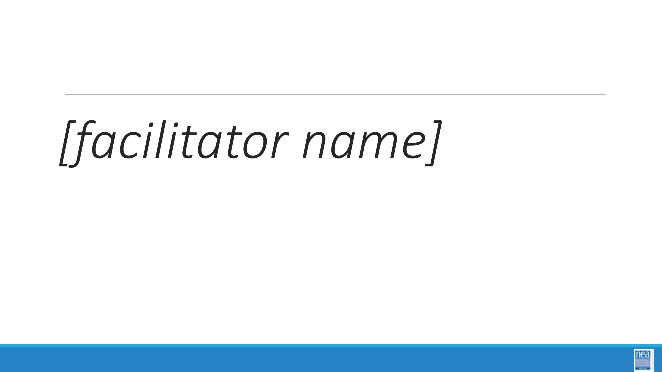  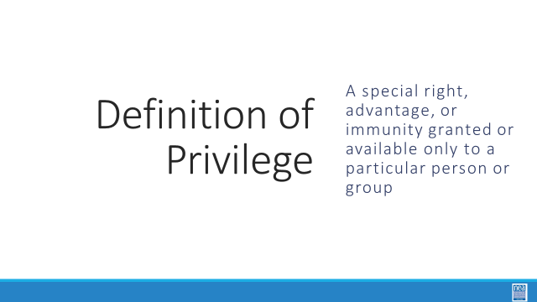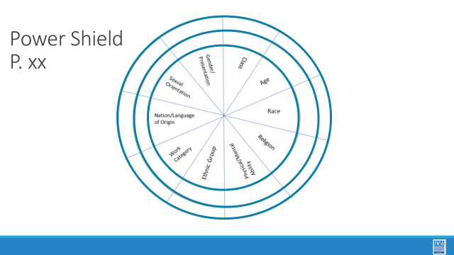  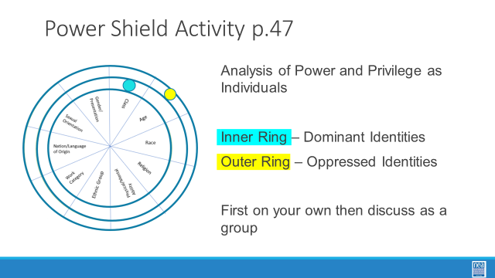  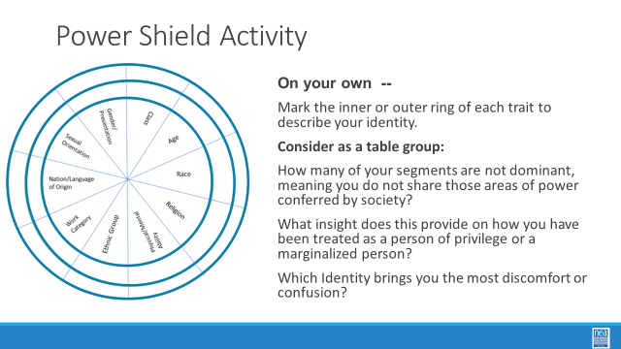  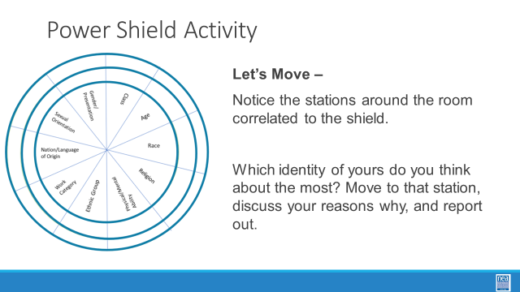  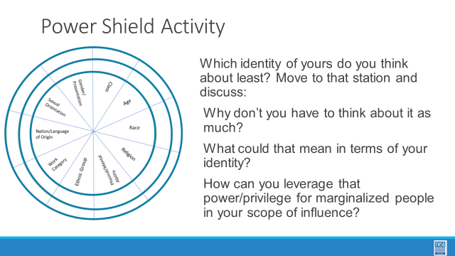  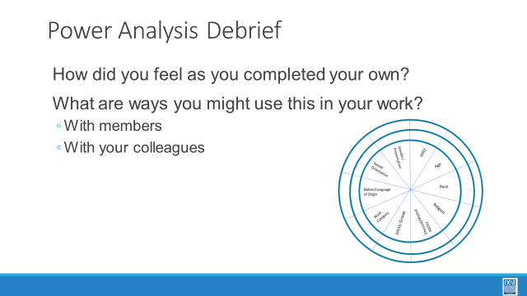  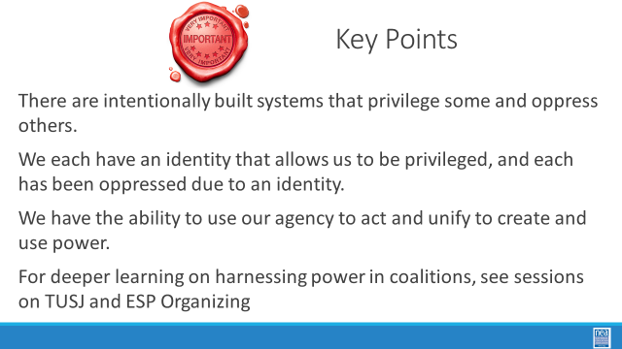  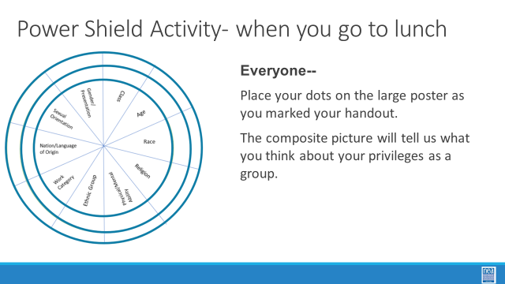 | Stations posted around room include:  - Race  - Gender/Presentation  - Age  - Class  - Sexual Orientation  - Nation or Language of Origin  - Work Category  - Ethnic group  - Religion  - Physical/Mental ability  Power Shield Handout (p.18)  Possible Reading on Building Power  (note for facilitators when using this article- This reading is good to intro BCG, an explicit link to expanding the petals of the flower ought to be emphasized. This article is not a DIRECT link with the activity, however, so it would have to be threaded.) | 2 Min – Identity Introduction (correction: In your book, change “gender” to “sex”)  We are going to take a minute to look intentionally at our identities.  [Facilitator] REMEMBER OUR Definition of the term: Privilege: A special right, advantage, or immunity granted by our unique relationship to a system of power.  Introduce activity by saying (p.18)  - This activity is based on “Power Flower,” a tool developed by social change educators when working with groups to “identify who we are (and who we aren’t) as individuals and as a group in relation to those who wield power in our society.” The object of the exercise is to discover how close, or how distant, each person is to the dominant identity of their current society.  - The center of a shield is divided into 10 segments, each representing one facet or category of our social identity.  - Facilitator note: Explain any confusing identities-  - Gender is referring to gender for this activity. ie Man, woman, non-binary with Man/Masculinity being the place of privilege, and femininity and woman being the place of oppression.  - Gender Identity: For this one, we are referring to whether you are cisgender (identify with the gender you were assigned at birth) and transgender (does not identify with the gender they were assigned at birth)  - Sexual Orientation: Who people have romantic and sexual attraction to. (Gender is who you are, sexual orientation is who you love)  - Ethnicity- : Some people identify with a part of their cultural heritage, or they may not know it, they lean into one part more than another. They celebrate traditions of a culture they embrace.  - Each identity is surrounded by an inner and outer ring segment. The inner ring segments represent the dominant or powerful identities within that category in society. The outer ring segments represent oppressed or marginalized identities within that category. You will select inner or outer segments to describe your social identity.  - Facilitator note: Participants decide for themselves which ring segment to choose in ambiguous situations such as: non-dominant religious beliefs with no external visual cues, passing or presenting features, or disabilities that may not be obvious to others.  - Some coaching questions may include,  - Can you choose whether to express this part of your identity?  - If so, how does that choice affect your access to privilege?  - How does that choice feel?  - The more inner segments an individual marks, the more social power that person possesses.  - 5 Min - Participants complete shield activity and individual reflection questions at their seat THEN each person comes to the large poster and places dots corresponding to their own shield. This makes up the composite, communal social identity of your group.  Questions for individual reflection at your seats:  - How many of your petals are different from the dominant petals, which means you do not share those areas of power conferred by society?  - What light does this throw on the way you have been treated as a person of privilege or as a marginalized person?  - Which identity of yours brings you the most discomfort or confusion?  8 Min - small group reflection and movement  - Notice the stations around the room correlated to the identities in the shield. Which identity of yours do you think about the most? Move to that station, discuss your reasons why, and report out on common themes. (Everyone chooses. It is a sign of privilege to sit out.)  - Which identity of yours do you think about the least? Move to that station, and discuss why you don’t have to think about it as much, and what that could mean in terms of your identity? How can you leverage that privilege/power for marginalized people in your scope of influence?  15 Min - large group reflection (select from debrief questions according to time and group needs)  - What does the composite picture tell you about who we are as a group?  - Who is missing or invisible?  - How might this affect, for example, the way you might go about your work as union staff?  - If one of your schools is in a neighborhood that has changed quite substantially in recent years, what kind of pattern might your “members” present, and how much would it differ from the parents and students in that school?  - What implications would this pose to that school’s ability to organize in that community?  - In what places are there gaps in your power, and what coalitions could you make to harness an ally’s power?  - How can you flex areas of privilege to empower marginalized allies in a coalition? Who can you empower in a coalition?  Key Points  - Race, Class, and Gender are intentionally constructed ideas built for the rule and management of human difference in a social system that positions people in relation to power and exploitation.  - Each of us has a unique relationship to this system of power and exploitation.  - We have the ability to use our collective agency to act to change these systems of power. | How do we think about the power and privilege in a group?  Participants will develop an understanding of power by also learning about oppression and privilege
Clock time, Facilitator Name | Resources | Systems of Oppression – 4 Quadrants (20 Min) | Participant Outcomes and Essential Questions
  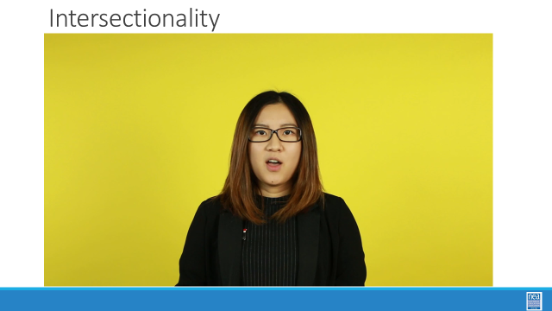  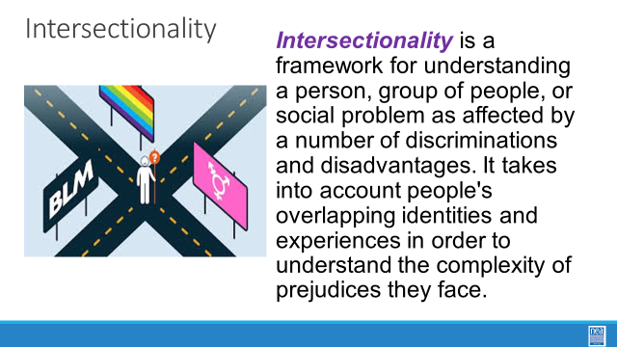  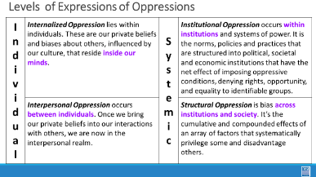  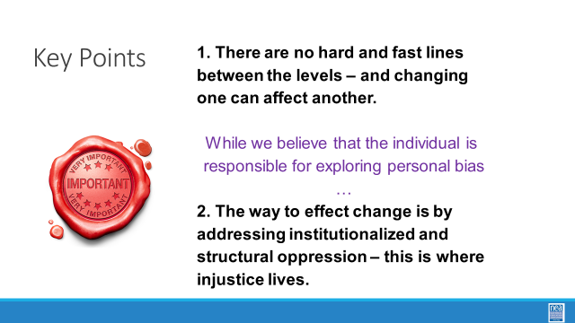 | Video on Intersectionality we could use  https://neahq-my.sharepoint.com/:v:/g/personal/eholmes_nea_org/EYAirmGnDFpPvXDQZRhUzJEB1jZxORMr-bcuK4L7mu_z_A?e=lWWeeU  Pg 19  Levels of Expression of Oppression Handout | 4 expressions of Oppression and Intersectionality  10 Min - Define  We are going to define two key terms in this next section, the first is Intersectionality and the second is Levels of Expression of Oppression– We will start with a video which discusses intersectionality.  5 Min – Video  Let’s watch the following video  - Video of intersectionality  5 Min  To review Intersectionality is a framework for understanding a person, group of people, or social problem as affected by a number of discriminations and disadvantages. It takes into account people's overlapping identities and experiences in order to understand the complexity of prejudices they face. This is important to keep in mind as we approach our work in supporting individuals experiencing oppression.  Now, let’s define The Levels of Expressions of Oppression. We use this framework because it allows us to think about the scope of the solution to a particular problem.  - Internalized oppression lies within individuals. These are our private beliefs and biases about others, influenced by our culture.  - Interpersonal Oppression occurs between individuals. Once we bring our private beliefs about differences into our interactions with others, we are now in the interpersonal realm.  - Institutional Oppression occurs within institutions and systems of power. It is the norms, policies and practices that are structured into political, societal and economic institutions that have the net effect of imposing oppressive conditions and denying rights, opportunity, and equality to identifiable groups based upon differences.  - Structural Racism is bias across institutions and society. It’s the cumulative and compounded effects of an array of factors that systematically privilege white people and disadvantage people of color.  Key Points  - There are not hard and fast lines between the levels and changing one can affect another.  - While we believe that the individual is responsible for exploring personal bias –the way to effect change is by addressing institutionalized and structural racism –this is where injustice lives. | How do various parts of a person’s identity inform and effect other parts?  Participants will learn about a framework of understanding oppression so that they can better identify actions to take in seeking justice.
Clock time, Facilitator Name | Resources | Defining Expressions of Racism Activity (40 Min) | Participant Outcomes and Essential Questions
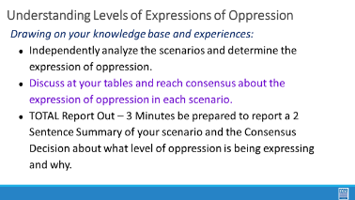  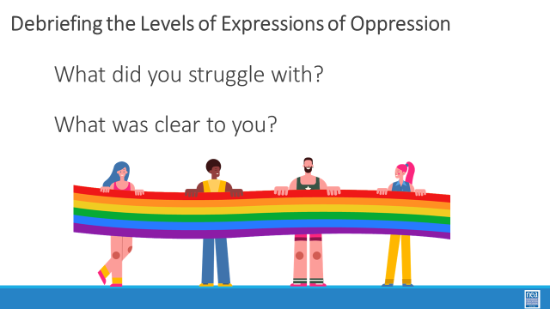  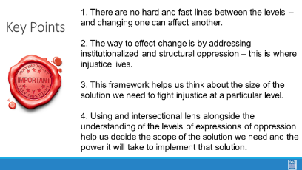 | Pg. 20-24 of Participant Handouts | 5 Min - Scenarios  - Use the Handout Levels of Oppression Scenarios Page 20-24 ***Facilitator will split the participants into 9 Groups ***  - Each group is given a scenario to look at. They are to determine the level of oppression that is described in the scenario.  15 Min – Group work time  Each team is to review the scenario and come up with what level of oppression their scenario is and why. Prepare a summary of your scenario to share with the whole group. Each group will have a total of 2 minutes to share a short summary, provide which level of oppression the scenario exemplifies, and tell why.  15 Min - Debrief  Share a summary of your scenario with the whole group. Each group will have a total of 2 minutes to share a short summary, provide which level of oppression the scenario exemplifies, and tell why. And what level did your group determine your scenario was at and why?  Overall debrief questions if there is time:  - What did you struggle with? What was clear to you?  5 Min – Revisit Key Points  - There are not hard and fast lines between the levels – and changing one can affect another.  - While we believe that the individual is responsible for exploring personal bias – the way to effect change is by addressing institutionalized and structural racism – this is where injustice lives.  - This framework helps us think about the size of the solution we need to fight injustice at a particular level.  - Intersectional lens alongside the understanding of levels of oppression can really help us decide the scope of the solution we need and the power it will take to implement that solution. | How do we address oppression?  Participants will work with scenarios to identify levels of expressions of oppression.

