Facilitator Agenda: Building an Issue Campaign
General Materials Needed: |  |  |  |  | Room Set-up:
1 Set of Handouts per Person  Name Tags or Name Tents  Sign-in Sheet  UBL Form Folder  Agendas on the table (1 per)  Room signs, sign in signs |  |  | Chart Paper  Markers  Post its  Index Cards  Highlighters – 3 colors  Chart Markers – non-permanent  Pens and Pencils |  | Round Tables  Projector, Screen and Speakers  Carousel stations and reporting stations around the perimeter  50 people
Key Outcomes for the Day
Participants will be able to build a campaign of escalating of tactics designed to target an issue within a scenario
Participants will understand that collective action is the way to address systemic issues of injustice
Time | Essential Questions | Resources |  | Instructions, Activity and Debrief (Facilitators) |  | Outcomes
 | What question(s) should this learning section answer? | Charts, handouts, articles, materials, slide |  | What are you saying, what are they doing, what questions will you use to guide learning and make clear the important points  Include an estimate for how long each section of the learning will take |  | As a result of this section of learning, what will participants know or be able to do?
ENTER TIME  (5 minutes)  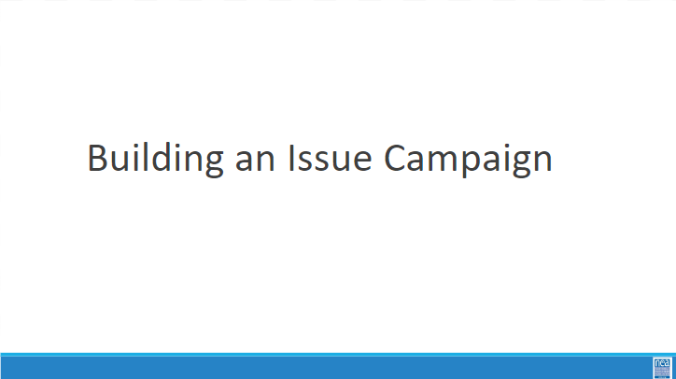  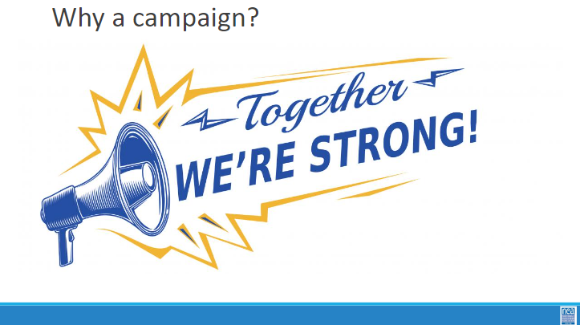  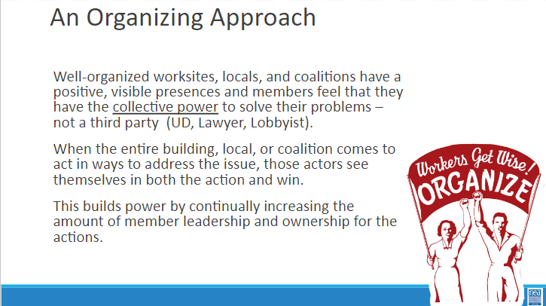 |  |  |  | Why an issue Campaign/An Organizing Approach  Why a campaign? What is the first thing that comes to mind when you hear campaign?  Political campaign? What make a campaign a campaign? What do campaigns need to win?  *Get folks to talk about People, A demand/change.  campaigning: people think of phone calls and door knocking. The main purpose of that is talking to and mobilizing folks.
ENTER TIME  (5 minutes)  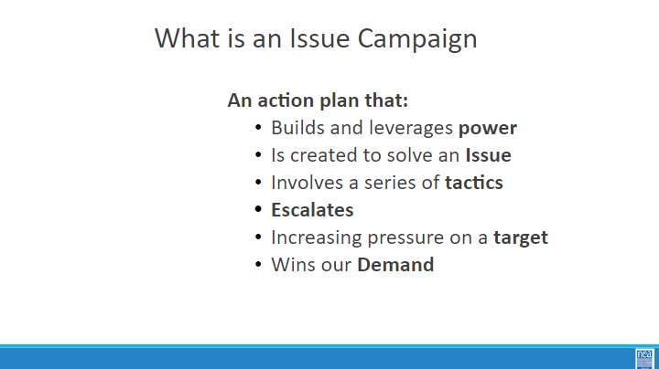  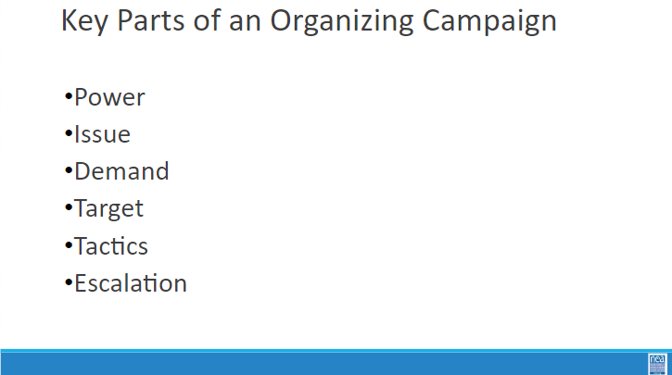 |  |  |  | What is an issue campaign  5 mins – INTRODUCTION TO CAMPAIGN PLANS  - Once in their scenario groups ask- Why do you think that it is important that we address concerns around LGBTQ+ equity through an organizing model (as opposed to relying on lawsuits and grievances?  - So why do we need campaigns? A campaign is an action plan with a beginning, middle, and end, working towards a specific demand that we want to win.  - A campaign has a target, someone who can give us what we want. It usually involves a series of escalating actions (or tactics), which means that we progressively turn up the heat.  - A good campaign creates increasing pressure on decision-makers over time by escalating the intensity and visibility of the tactics and increasing the numbers of people involved.  - Campaigns are a way to identify in advance the ingredients we need to win and put them together in a way that maximizes our chances of success.  - One isolated action may not be enough to solve the problem.  - Campaigns help us to shift the balance of power in our workplaces and build members’ confidence.  - Many issues that members care about can’t be solved with grievances.  - Besides, grievances are invisible to most members, because they don’t usually involve collective action.  - We need our actions to be participatory and public.  There are six main parts to a campaign. We are going to go through each-  - Power  - Issue  - Demand  - Target  - Tactic  - Escalation  We are going to go through each of the key components of an organizing campaign and apply each to our scenario. Then, at the end, we will compile and present our final campaign plans for our scenarios.  Campaigns involve lots of people are member led and increase power and visibility of the union
ENTER TIME  5 minutes  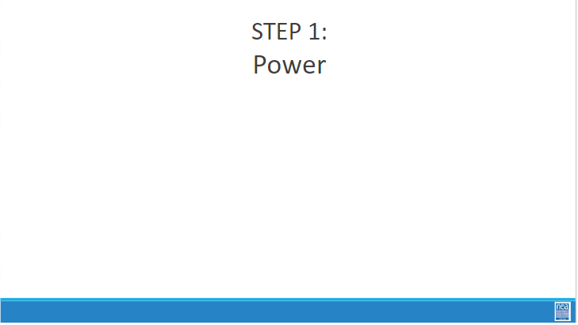  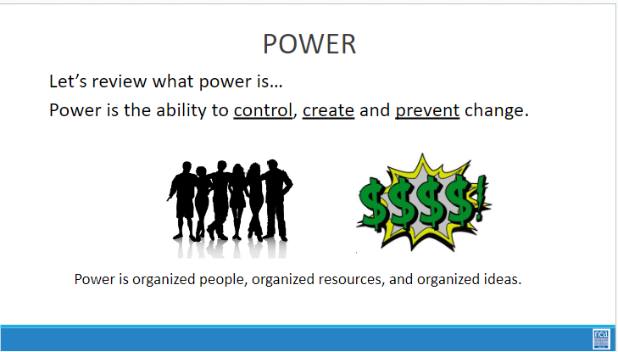  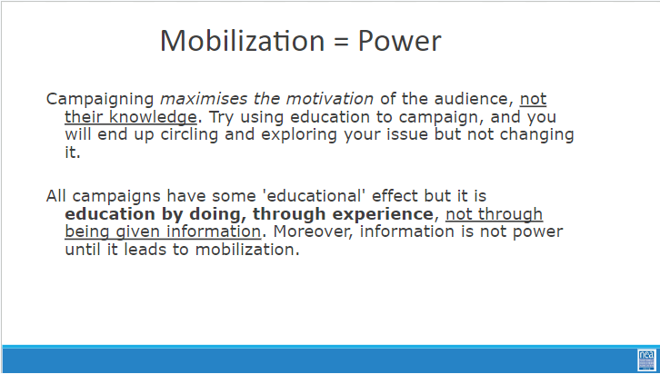 |  |  |  | Power  (5 minutes)  We talked about what power was already. Power is at the heart of our organizing campaigns. Our campaigns are all about leveraging our power to get what we want.  A reminder- Power is the ability to control, create, or prevent change. In our work it most often takes the form of organized people and organized money.
ENTER TIME  30 minutes  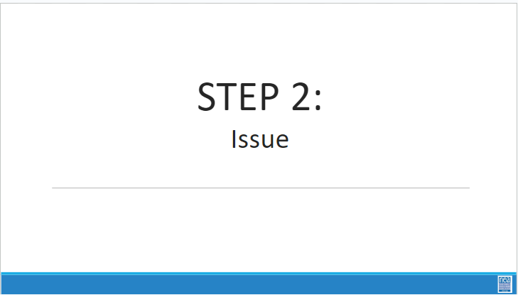  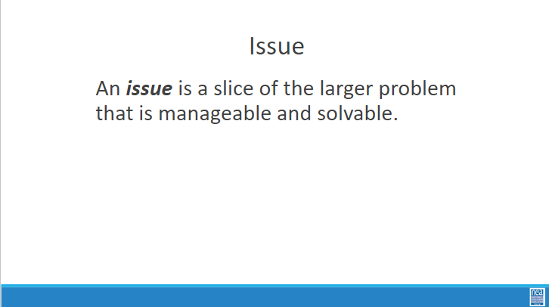  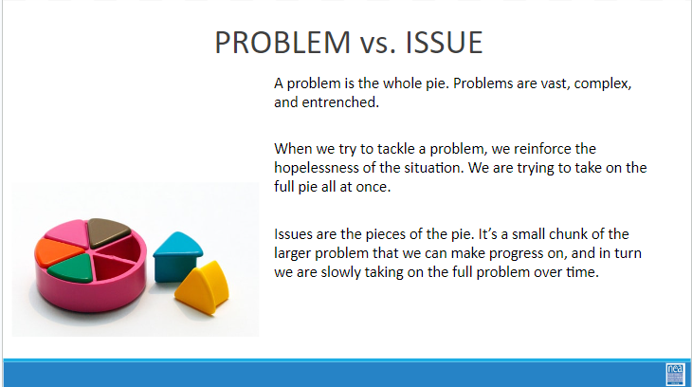  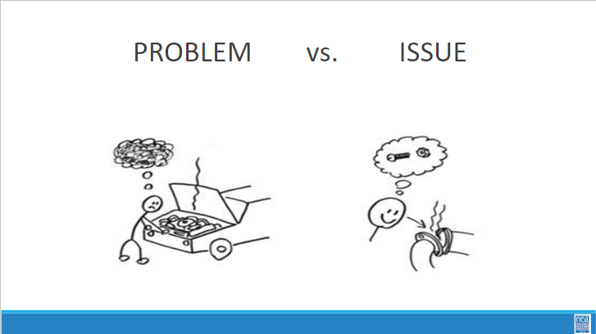  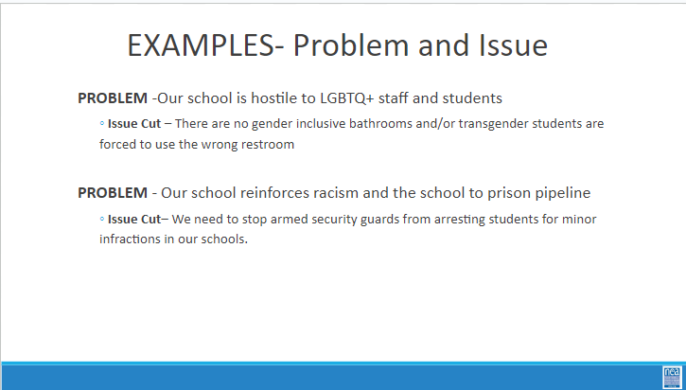  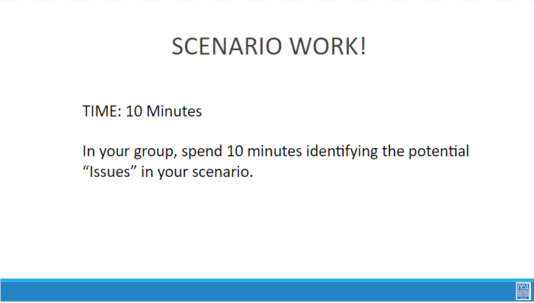  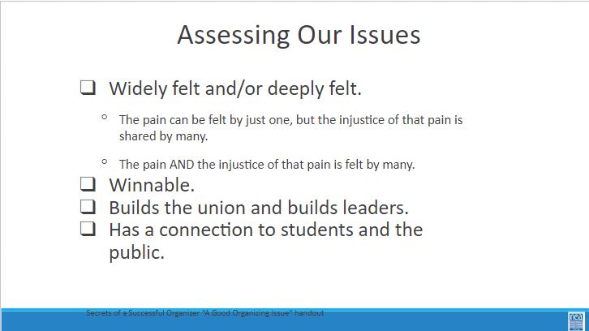  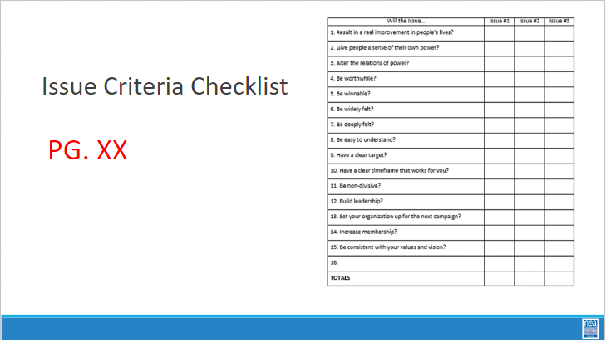  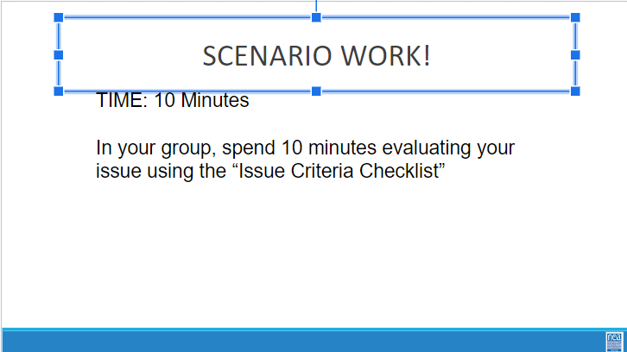 |  |  |  | Issue/ Assessing an Issue  PROBLEM vs. ISSUE  - Campaigns start with issues members care about.  - An issue is a slice of a workplace problem.  - Often, a problem can have different issues depending on the perspective of the people we are working with.  - It is key to get enough input on what the issues are that make up the problem so that YOU don’t drive the solution.  - A staff-driven solution may not meet the needs and commitment of the people you are working with.  Note: for your scenarios, there may be a “service” model solution and an organizing issue. Think of the direct service as a way of solving the immediate crisis, and the organizing as a way of addressing a bigger systemic issue so it doesn’t happen again.  10 Mins – GROUP WORK  In your groups, return to your scenario and decide the:  The potential issues in your scenario  BRAINSTORM- ON CHART PAPER- ANYTHING GOES- ALL IDEAS ON CHART PAPER  Assessing an issue  How to select an issue  - Since there may be many issues confronting workers on the job, we have to also think about what makes a good issue to organize around.  - CRITERIA:  - It is widely felt.  - It is deeply felt.  - It is winnable.  - It builds the union and builds leaders.  - It has a connection to students and the public.  A NOTE HERE: Often, issues of equity are deeply felt by a marginalized few, and NOT by the privileged majority. If an issue is very deeply felt, it does not have to be widely felt.  5 Mins – GROUP WORK 15 minutes  In your groups, return to your selected issues. Use the chart in the handout PAGE 112 to determine whether the issue you identified is a good issue.
ENTER TIME  5 minutes  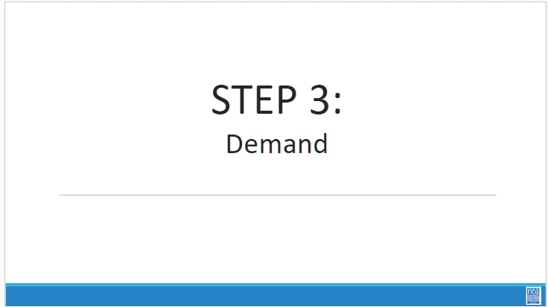  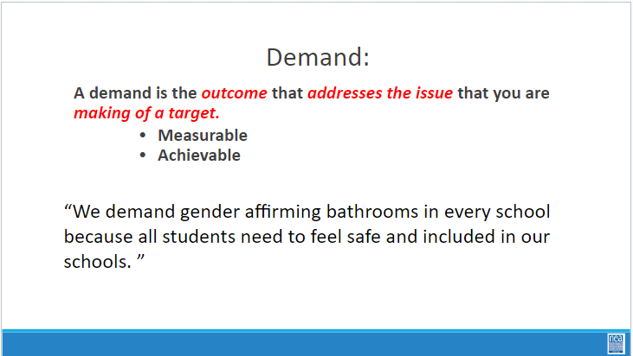 |  |  |  | Demand  5 minutes  DEMAND  - A demand is what the group wants– the win –  - A demand is the outcome that addresses the issue you are making of the target  - If the issue is what is wrong, the target is what we want that will fix the issue.
ENTER TIME  25 minutes  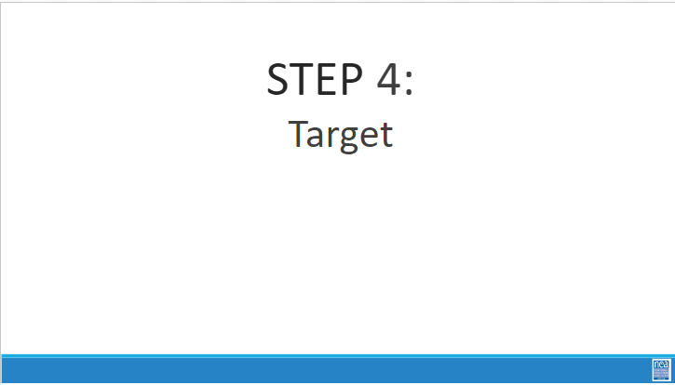  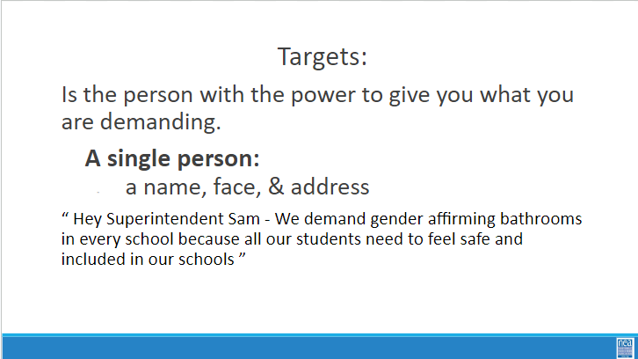  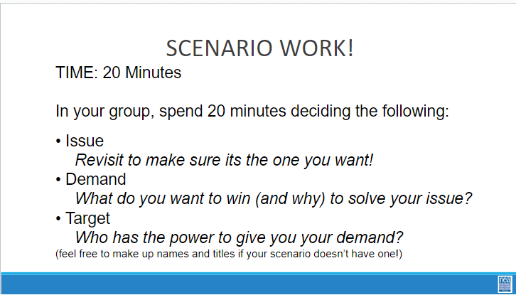  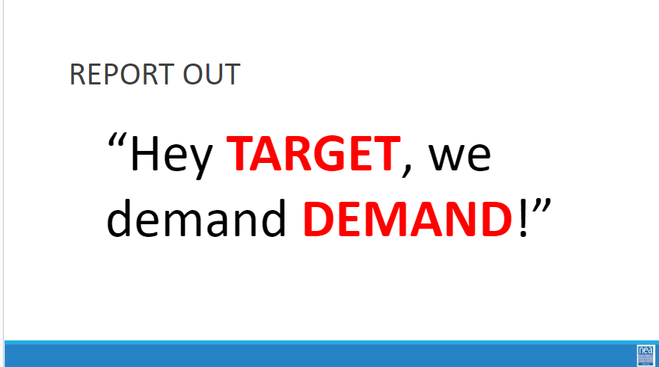  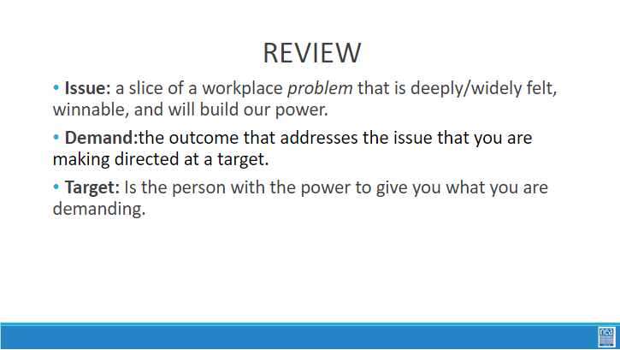 |  |  |  | Target  TARGET  - TARGET: A target is a single person with a name and an address. The target is the person with the power to give the workers the change they are asking for. A target has a name, a face and an address.  15 Minutes Scenario Work  - You now have 15 minutes to return to your scenario. In that time make sure you 1) review your issue and make sure it is good to go then 2) decide your demand then 3) decide on your target  5 Minutes Report Out  Have them quickly go around the room and report their target and demand following the structure on the powerpoint.  Note- Even though we are explicit, someone will inevitably pick a group of people as the target.  These answers are wrong and need to be corrected.  - School Board (Make them pick a member. Possibly the president or the swing vote. They can make up information if they need to)  - Members or the public (Often this is because they have an incorrect issue and have concluded that educating their members is the solution. Members are our base, they are never the target. And an education campaign will not make meaningful change in workers lives)
ENTER TIME  48 minutes  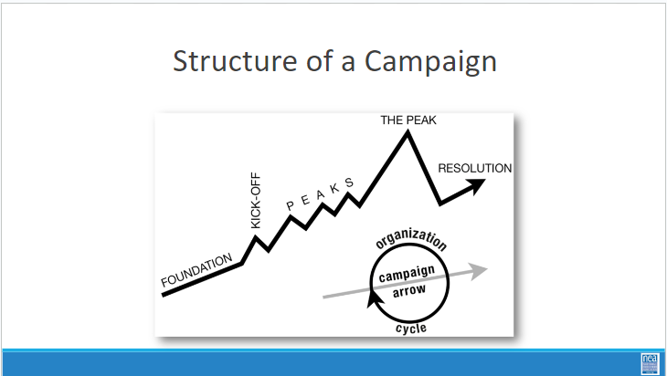  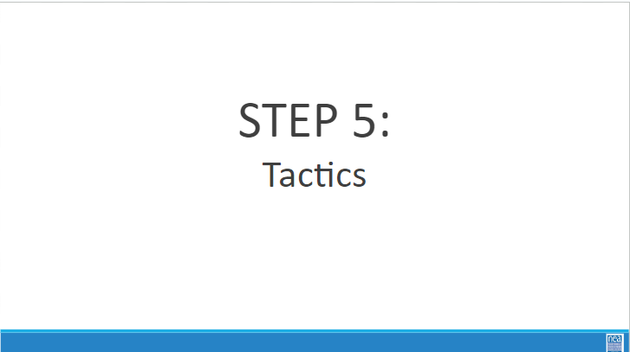  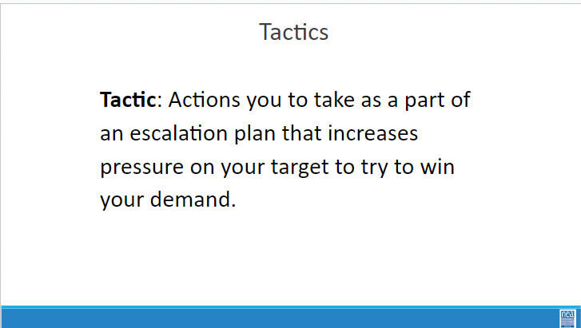  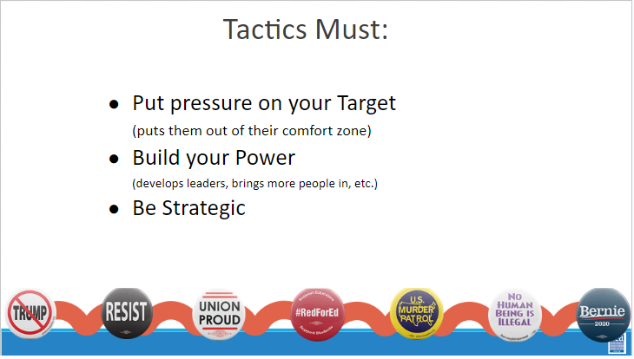  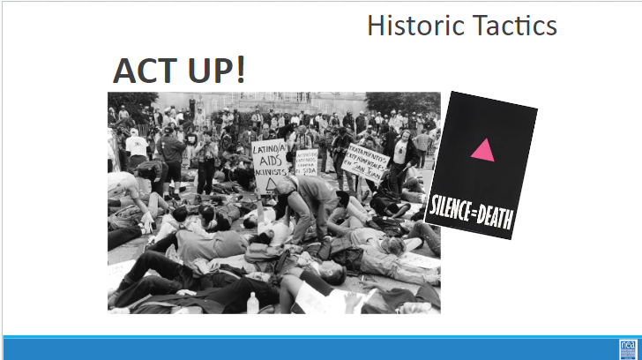  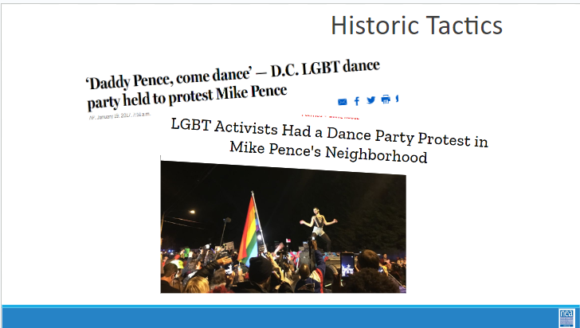  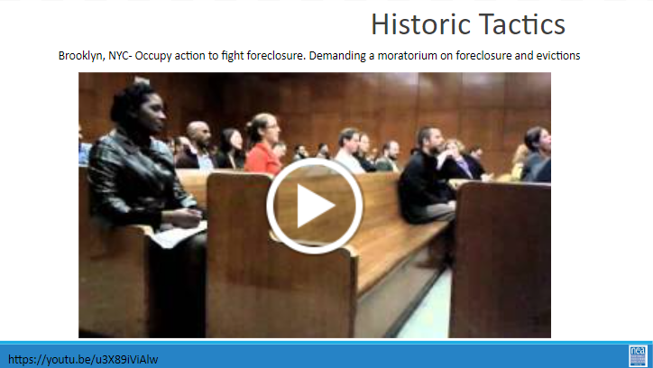  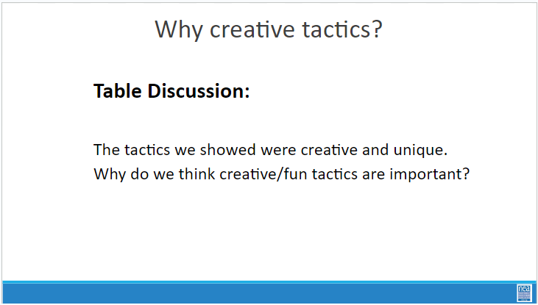  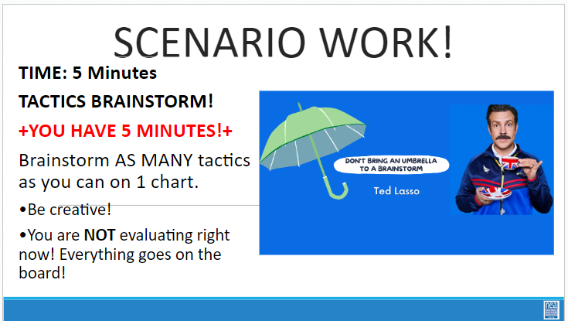  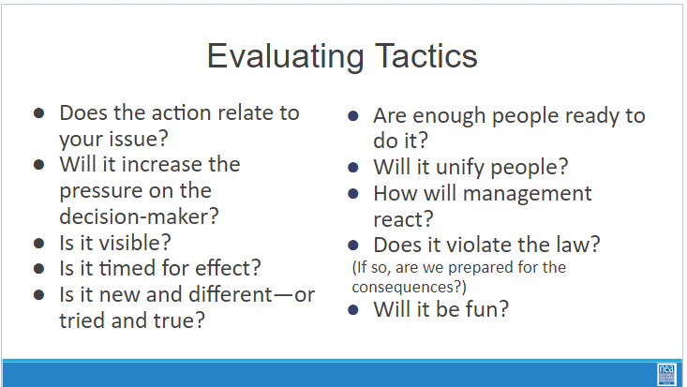  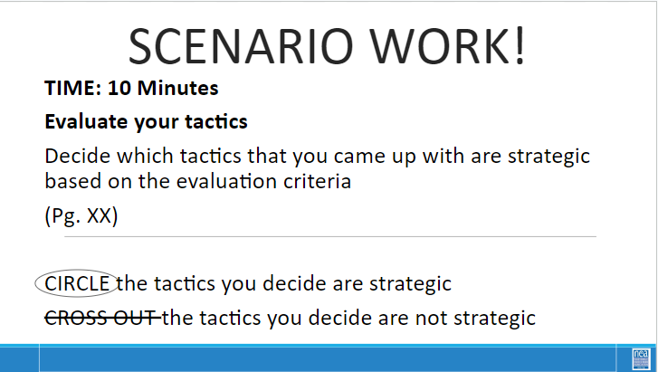 |  |  |  | Tactics/Tactics Evaluation  2 Mins- INTRODUCE Campaign Mountain  - Foundation – gather info, id issues, id leadership team  - Kick-off –public event that indicates what the issue, demand, and targets are  - Escalating peaks of activity that should escalate in  - Risk  - Capacity (people, resources, engagement)  - Increase leadership and ownership  - Campaign Compression Points  - THE PEAK – The most public, risky, momentum, engagement, and resources  - The Win- We achieve our demand  - Debrief, regroup, and continue to climb  25 Mins- INTRODUCE Tactics  Next we are going to talk about Tactics.  Tactics are Actions we take as a part of an escalation plan that increases pressure on your target to try to win your demand.  Every tactic must  Puts pressure on your Target  (puts them out of their comfort zone)  Builds your Power  (develops leaders, brings more people in, etc.)  Is Strategic  What are some examples of tactics? (Have a few people share out some tactics)  look at some historical tactics - creative, engaging, maybe fun, and very public  Video- Anti-foclosure action (intro to video explains the context)  Use this video to check for understanding.  From this video,  - Who is the target?  - What is the problem?  - What is the Issue?  - What is the demand?  - What is the tactic?  We are going to model a tactics brainstorm that you can use when working with members.  5 Minutes Scenario Work  Brainstorm AS MANY tactics as you can on 1 chart.  - Be creative!  - You are NOT evaluating right now! Everything goes on the board!  We are going to have 5 minutes to list as many tactics as you can. Extra points for super creative ideas. WE ARE NOT. NOT. NOT. Evaluating tactic at this time. If someone says something (example- We are going to wear the same clothes without washing them until we get what we want) you right it down and move on. All ideas get on the board. Again, this is a brainstorm. NO EVALUATING.  YOU HAVE EXACTLY 5 MINUTES. After 5 minutes put your pens down.  Open your phone and actively start a timer. “ON YOUR MARKS. GET SET. GO”  Excellent! We now have a whole list of tactics. Next. We are going to assess our tactics. For this, I encourage you to use a list of questions like this-  6 minutes- How to evaluate a tactic  - Does the action relate to your issue?  - Will it increase the pressure on the decision-maker?  NOTE! This means that we have to engage in actions that make our target uncomfortable. SOOOOO the same old tactics WON’T WORK! They are used to them!  - Is it visible?  - Is it timed for effect?  - Is it new and different—or tried and true?  Note! SEE above. If a tactic is the same as always, your target has likely become comfortable with it AND it won’t develop new skills in your members and therefore build your power.  - Are enough people ready to do it?  - Will it unify people?  - How will management react?  - Does it violate the law? (If so, are we prepared for the consequences?)  NOTE! This doesn’t mean that it is off limits. Historically, breaking laws has been a big part of social justice movements. ESPECIALLY THE LABOR MOVEMENT! However, we have to consider if an unlawful tactic is the right tactic and whether you have the power to mitigate/absorb the consequences.  - Will it be fun?  Folks want to engage in things that fill them up! Who had a tactic that they would be excited to participate in?  10 minutes- Evaluating your tactics  You have 10 minutes. Look at your list of tactics.  - Circle the ones that you think are strategic, when looking at these questions.  - Cross out the ones that are NOT strategic.
ENTER TIME  40 minutes  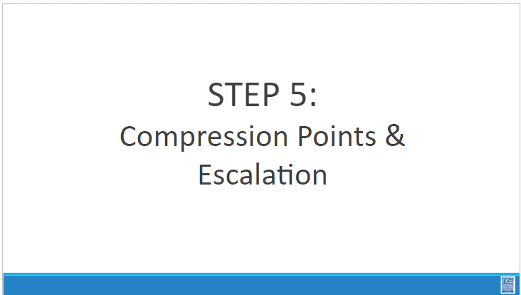  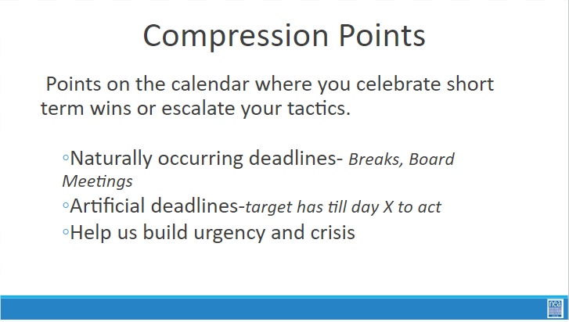  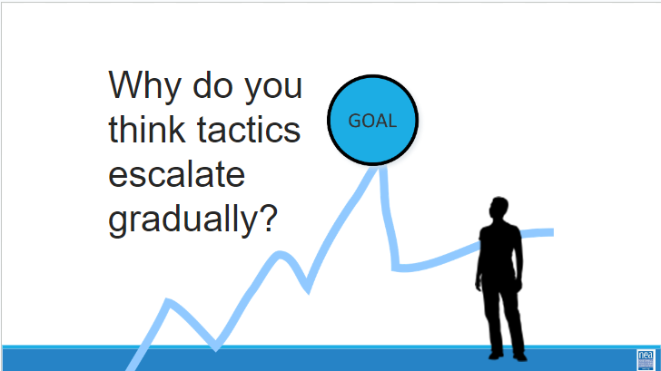  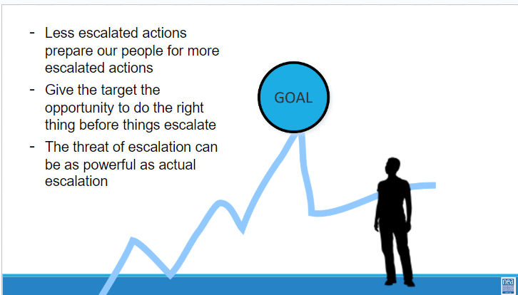  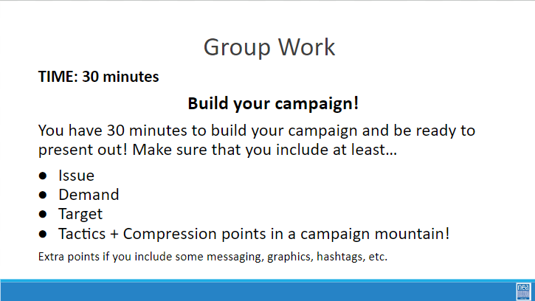  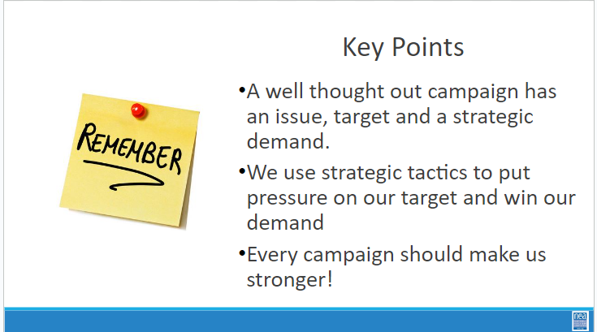 |  |  |  | Escalation (40 Mins)  2 Minutes – Compression Point Definition  - Points on the calendar where you celebrate short term wins or escalate your tactics based on how you have assessed your readiness to escalate.  - Naturally occurring deadlines  - Artificial deadlines  - Help us build urgency and crisis  2 Minutes – Turn and Talk  We keep saying that tactics should escalate gradually why do you think that is?  2 Minutes – Debrief  Each escalation is more public, more visible, and has more risk. WE transform members to activists, activists to leaders by asking them to take bigger risks  Some points to make if they are not said by the group  - Less escalated actions prepare our people for more escalated actions  - Give the target to do the right thing before things escalatee the threat of escalation |  | Participants will create a campaign composed of escalating tactics.
 |  |  |  | Team Time (30 Minutes)  - Work on scenario- in teams  - Scenario description in day two- can be placed here for reference or here in enough time is not available in day two |  | Participants will create a campaign composed of escalating tactics.
ENTER TIME |  |  |  | Present Scenario work |  | Participants will create a campaign composed of escalating tactics.

