Advancing LGBTQ+ Justice Facilitator Agenda: Day # 2
General Materials Needed: |  |  |  |  | Room Set-up:
1 Set of Handouts per Person  Name Tags or Name Tents  Sign-in Sheet  Highlighters – 3 colors  Chart Markers – non-permanent  Pens and Pencils |  |  | Chart Paper  Markers  Post its  Index Cards |  | Round Tables  Projector, Screen and Speakers  Carousel stations and reporting stations around the perimeter  50 people
Key Outcomes for the Day
Participants will expand their ability to use correct terminology
Participants will become familiar with a framework of oppression for the purpose of understanding the size and target of solutions that seek justice
Participants will practice applying advocacy strategies to a scenario and understand strategies to implement in a workplace for improving inclusivity
Participants will understand key laws and policies for the purpose of understanding the limits of legal advocacy
Time | Essential Questions | Resources |  | Instructions, Activity and Debrief (Facilitators) |  | Outcomes
 | What question(s) should this learning section answer? | Charts, handouts, articles, materials, slide |  | What are you saying, what are they doing, what questions will you use to guide learning and make clear the important points  Include an estimate for how long each section of the learning will take |  | As a result of this section of learning, what will participants know or be able to do?
Entry Activity  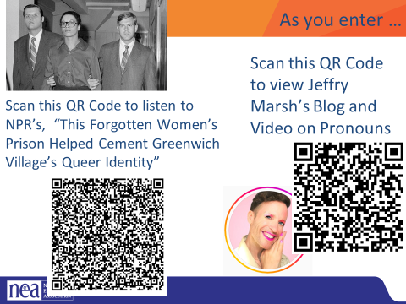 |  |  |  | View Videos Jeffrey Marsh | Nonbinary LGBTQ Activist, Speaker & Author  View Webpage This forgotten women's prison helped cement Greenwich Village's queer identity | NPR & Houston Public Media This is a Fresh Air episode
8:30-8:50  Ellen  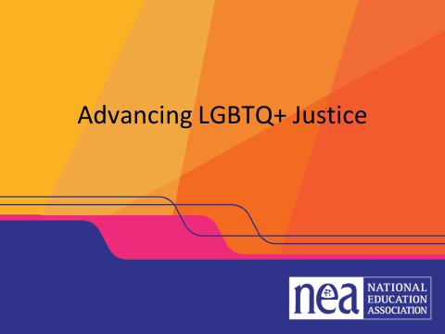    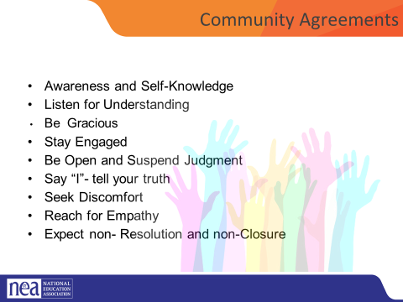  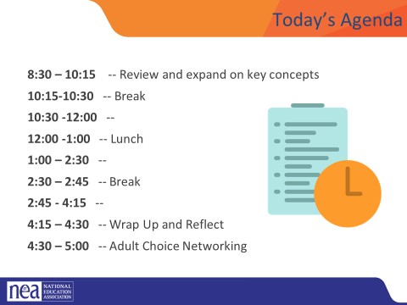 | What do we need to know today? |  |  | Getting Started (20 Minutes)  Intro to the day  revisit group agreements,  Review Feedback,  Review Agenda  Questions/Needs/Etc. |  | Participants will understand how day 2 will work.
8:50-9:10  Barb | Who am I and Who are we? |  |  | Shared Identity Activity - Higher risk, content groups (20 minutes)  Post the following identities around the room:  Medium risk (day 2) – parent, only child, has siblings, struggles with technology, tech is easy, life-long learner  Participants will get up and gather around an identity of their choosing (2 min instructions), then they will answer the following discussion questions (8 min):  - Why did you select this piece of your identity?  - What are some challenges you face with this identity?  Share out/debrief (10 min)  - What was something you learned about someone else?  - What was easy/hard about this activity?  - How safe did you feel sharing in this activity?  Key Ideas  Discreet identities bind us  We all have pre-conceptions that might not match an actual identity of another  We don't get to assign a person's identity for them |  | Participants will continue to expand their connections to each other and build a learning community.
9:10-9:30  Jeny    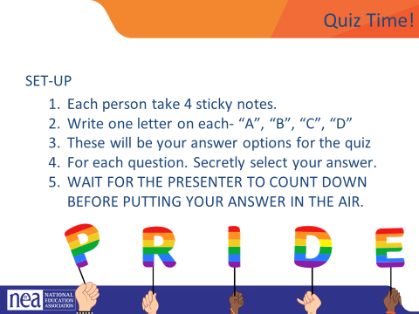  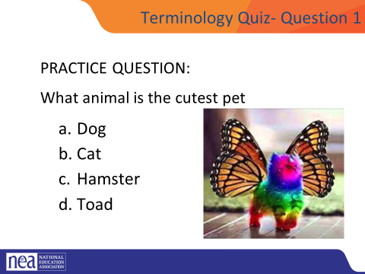  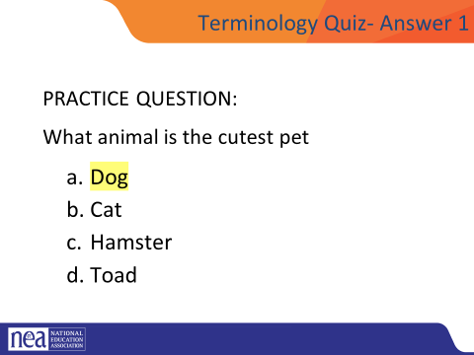  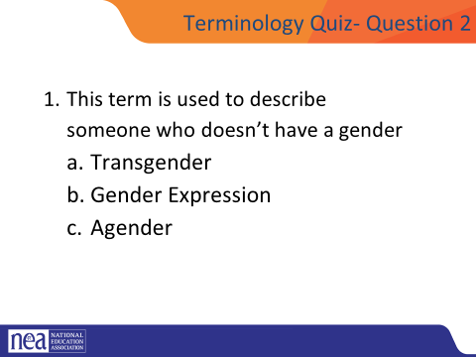  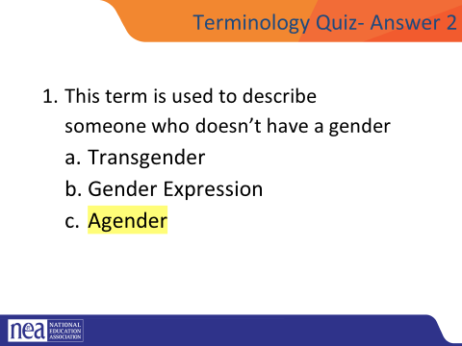  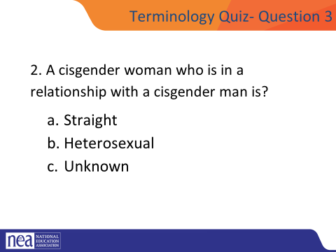  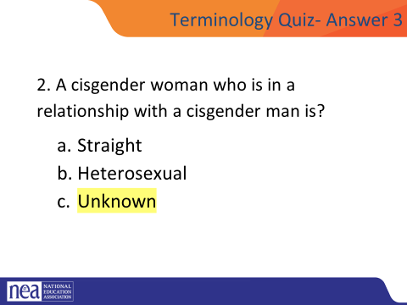  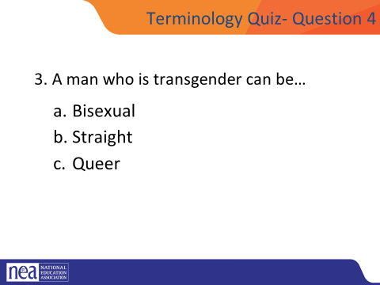  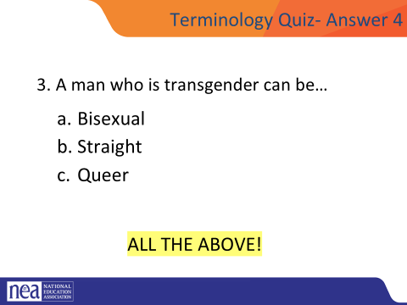  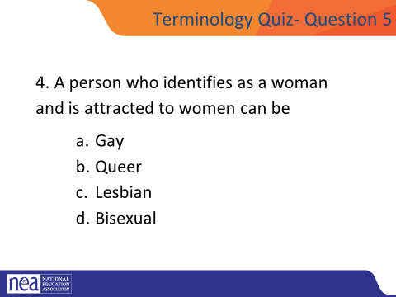  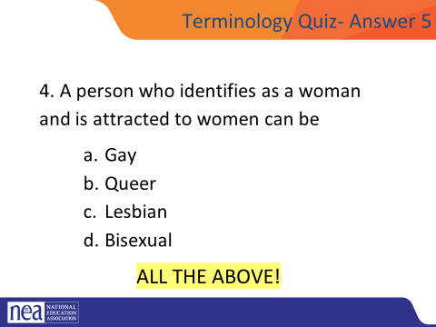 | What word am I supposed to use? |  |  | Terminology quiz (20 minutes) took 10 minutes- added “died by suicide, death by suicide, lost life by suicide, died or survived suicide, do not use wasn’t successful. add the article to pre-reading? Should we bring this up when we do the WHY on the first day in terms of terminology or keep it here?  SET-UP (on slides as well)  - Each person takes 4 sticky notes.  - Write one letter on each- “A”, “B”, “C”, “D”  - These will be your answer options for the quiz  - For each question. Secretly select your answer.  - WAIT FOR THE PRESENTER TO COUNT DOWN BEFORE PUTTING YOUR ANSWER IN THE AIR.  Go through the quiz in the slides. Tell everyone to put 4 sticky notes in front of them  Yesterday we learned terminology, now we reviewed them in context  Identity is separate from relationships  Gender identity and sexual presentation are different. |  | Participants will practice their use of terminology.
9:30-10:15  Sara    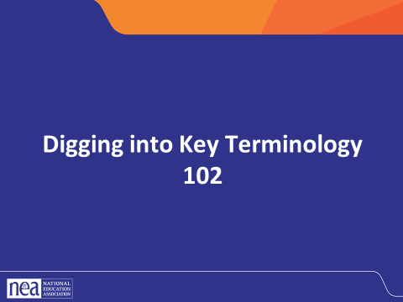  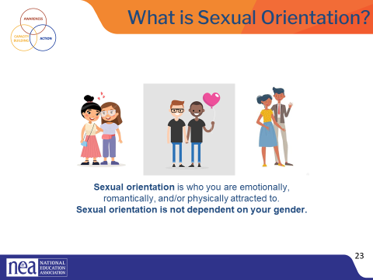  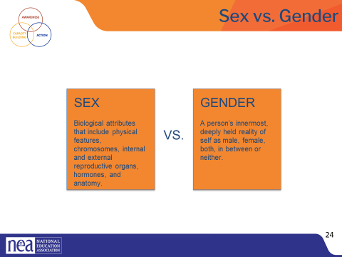  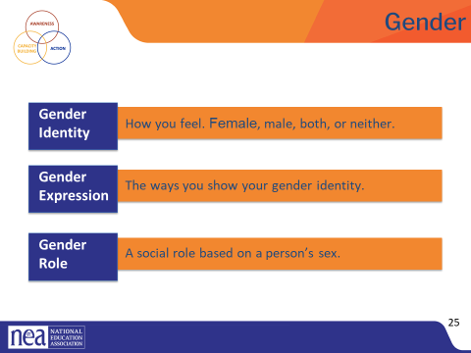  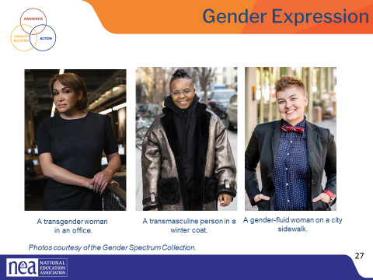  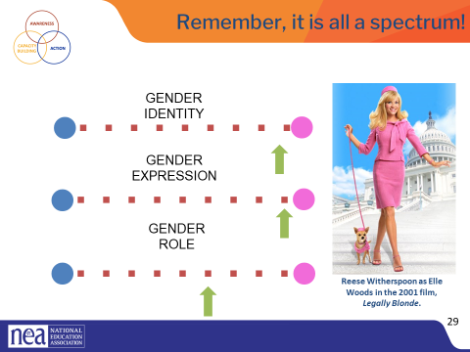  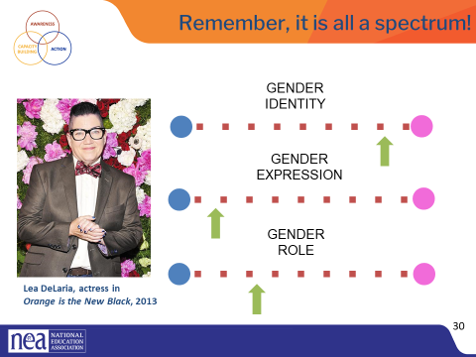  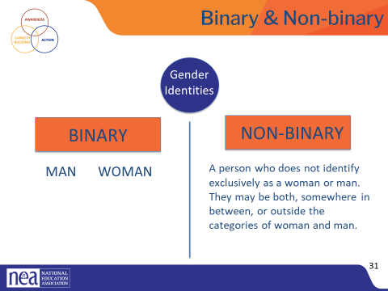  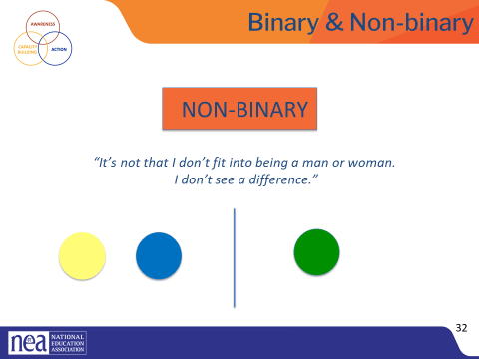  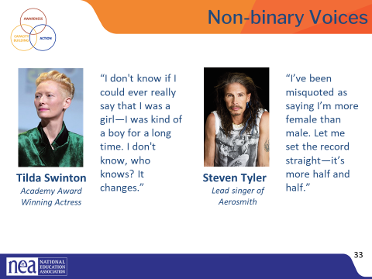  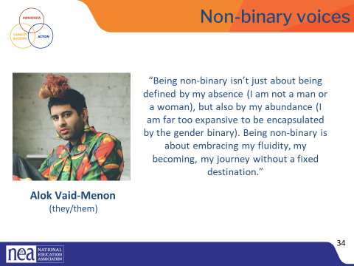  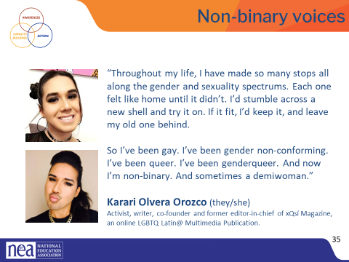  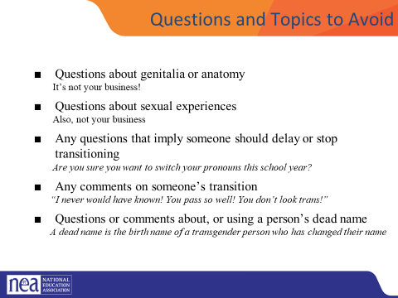  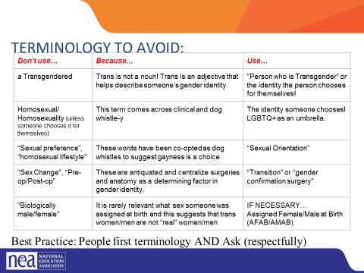 | Why do my words matter? | Video: https://youtu.be/i83VQIaDlQw |  | Digging in to key terminology 102 (45 minutes)added 15 minutes here- we were over by 18 minutes  Sexual Orientation vs Gender identity  Sexual orientation is an important part of a person’s identity. It is not a decision that one makes, rather it is an awakening.  There are a variety of sexual orientations:  Heterosexual  Bisexual  Homosexual  Pansexual  Asexual  Even though sexual orientation is a private identity, it can be a source of public scorn and a basis for exclusionary practices and discrimination.  Sex and Gender do NOT mean the same thing.  Our sex is determined by biological attributes such as chromosomes, hormones, reproductive organs, and other parts of our anatomy.  Gender is a person’s innermost, deeply held reality of self. It’s almost like being right-handed or left-handed. We don’t know why each person favors one hand over the other, but we all know that one just feels more correct for us. And, some people feel comfortable using either hand.  A person can have an inner reality of being male, female, both, neither, or somewhere in between.  Gender, or gender identity, is that internal sense of self we just mentioned—the feeling of being male, female, both, neither, or somewhere in between.  Gender expression includes all the ways you show your gender to the world. For example, your hair and clothes, how you cross your legs, how you walk, and even your voice inflections. Some of these are innate, and some are learned from our cultural norms.  Gender roles are social constructs based on one’s sex or biological attributes. They can be very different from one culture to another. These roles can become so internalized that they create stereotypes or an implicit bias within us (e.g., assuming nurses are women, or mechanics are men).  Gender non-conforming simply means the person is breaking cultural or social rules about gender roles and/or expression.  There is a huge difference between not conforming to certain societal norms and expectations for one’s gender and having an internal identity that is not in alignment with one’s biological sex.  A Note About Phobias:  A phobia is a persistent, irrational and exaggerated fear of an object, person, activity, animal or situation. Homophobia is a fear of people who are gay and lesbian. Transphobia is a fear of people who are transgender. When someone’s identity challenges a person’s expectations or preconceived notions of male and female, they may go into a panic. The incongruence of what someone sees, and what they think creates fear and misunderstanding.  We say “i-dentity” because it’s about the individual and how they personally identify, not “you-dentity” because of how you want to determine someone else’s existence.  Video: (3 minute)  - This video offers a simple way of looking at various gender identities (~3 mins).  - Debrief the video with these three questions:Added a quick table talk here of 3 minutes  - What is the gender binary? How many of you grew up thinking the only gender options were male or female?  - What does it mean to be non-binary?  - What is the difference between transgender and non-binary?  Transgender, non-binary, and gender non-conforming individuals show their gender to the world in many ways. Just as cisgender people have different hairstyles, clothing choices, mannerisms, and more, the same is true for trans, non-binary, and gender-non-conforming people. There is no “one way” to look to be any gender.  These images are from the Gender Spectrum Collection – a group that works with trans and non-binary models. In the first image we see a transgender woman in an office. The second is a transmasculine person in a winter coat. Transmasculine is a term generally used for people who were born female at birth, but who identify with masculinity. As we can see in both of these two photos, they present within the gender binary of male and female.  In the last image, we see a gender-fluid woman. Gender fluid refers to a person who does not feel they have a fixed gender.  Gender identity, gender expression, and gender roles all exist on a spectrum. Using our handy stereotypes of blue to represent masculinity and pink to represent femininity, let’s think about how people might rate themselves.  The character Elle Woods in the film Legally Blonde, likely (we don’t know, because we didn’t ask) had a gender identity that was strongly female. Her gender expression was also strongly female – she often wore high heels, the color pink, and was often getting her nails done. Her gender role, however, was slightly more toward the middle. Elle was a law student – a field that has historically been dominated by men.  The construct of gender has changed over time. In the 17th century, European aristocrats wore long, flowing clothes, make up and high heels. It’s not the same today. Gender is about the values society ascribes to males and females, and it changes over time.  Let’s consider the actress Lea DeLaria. She identifies pretty strongly with being female, but has a very masculine gender expression. Her short hair, little if any makeup, more boxy clothes, and swagger when she walks give her a more masculine gender expression. Lea considers herself a butch lesbian. (For reference, the descriptor “butch” has generally referred to a woman whose gender expression and traits present as traditionally masculine.)  Envision another person who falls at the same places on this scale. Instead of being an actress, she could be a married woman and mother who prefers a masculine presentation and works as a mechanic in an auto body shop. In that case, the person could also be gender non-conforming. Remember, gender is a spectrum.  Gender non-conforming refers to people who do not follow dominant social norms or stereotypes about how they should look or act based on their biological sex at birth.  Check in - Where are you on the spectrum? Note that some people will feel this does not apply to them.  Added convo about TERF trans exclusive radical feminist, somehow damaging women’s rights  Binary and non-binary are two types of gender identities.  Gender is a social construct. What it means to be male and what it means to be female are concepts created by humans, and over time, those definitions and views became generally accepted by society at large. Most of us align with these long-standing definitions of male and female and feel comfortable saying so.  A non-binary person is someone who does not adhere to these gender expectations or stereotypes. The binary—being male or female—will feel very foreign to them.  A lot of Sara reading slides- need to ask participants to read slides- or another adult learning strategy to capture participation  For a non-binary person, their gender identity does not fit within the binary of male and female.  While we might see two separate colors, yellow and blue, a non-binary person may only see green. Someone who is agender (or who has no gender identity) might only see gray.  This is why non-binary is a gender identity and not a gender expression. Non-binary people are not attached to gender.  For a lot of cisgender people, those whose sex and gender align really well, the concept of non-binary identities is really hard to understand. But we have some famous people who have described it really well.  Tilda Swinton and Steven Tyler have never indicated that they identify as transgender, but they describe a blending or fluidity of gender. For a lot of non-binary folks, that’s the only label they apply to themselves. Others can refine things a bit more.  - (Read the slide.)  Here we see the words of Alok Vaid-Menon who uses the gender pronouns they/them. They are an internationally acclaimed gender non-conforming writer, performer, and public speaker. As a mixed-media artist, Alok’s work explores themes of trauma, belonging, and the human condition.  - (Read the slide.)  As we’ve said, gender can be fluid. Here, writer and activist Karari Olvera Orozco shares a bit of their story. (Read the slide.)  A demiwoman is someone who was assigned female at birth but does not fully identify with being a woman, socially or mentally.  If someone has two types of pronouns, like we see here with Karari, they may feel more comfortable with one over the other. So be sure to ask which one they are most comfortable with.  Key Ideas:  Gender identities are constructed as binary, however, people’s identities are much more fluid.  People who identify as non-binary express their gender identity in many ways.  People’s gender identity and sexual orientation can shift at different times.  Intersex conditions comprise more than 30 natural genetic variations. Historically, these variations have not been socially acceptable.  Proposed laws focused on the rights of transgender people regarding restroom usage, participation in sports, and even access to specific health care coverage, and have centered on genitals or proposed chromosome tests. These laws also affect the intersex community, who are often entirely ignored or left out of those conversations.  More people are intersex than we realize. In the past, this was often discovered in testing for the Olympic games, because some women were subjected to gender testing if they were thought to have a perceived physical advantage.  Scientists say there is no clear definition of male & female – that one’s sex includes more than just physical anatomy. It also includes hormone levels, chromosomes, and more.  The LGBTQ+ movement is now often referred to as LGBTQIA+ to include intersex people because of the similar issues facing each group around body autonomy and identity. (The “I” is for Intersex and the “A” for Asexual, which is a lack of sexual attraction.)  Please note that “transgender” or “trans” are adjectives. They are terms that describe. A person is transgender, not “a transgender.”  A trans woman (or trans girl) is assigned a male sex at birth but knows themself to be a woman. Alternately, a trans man is assigned a female sex at birth but knows themself to be a man.  Someone who is transmasculine, identifies on the masculine side of the gender spectrum, but may not identify as a man. The same is true for transfeminine people. They may identify as more female, but not see themselves as a woman.  Gender fluid is exactly what it sounds like. Gender flows in a more masculine way at times and in a more feminine way at others, with no internal struggle between the two. That fluidity could happen over many years, or it may fluctuate during a week.  Genderqueer people are fluid in their gender and often their sexuality. People who consider themselves genderqueer will often say that no rules apply. They like what they like, who they like, and feel the best living outside of any boxes.  WHAT IS QUEER? This discussion was rich and needs 10-15 minutes on its own for discussion  Older generations often regard the word “queer” as a derogatory term. It causes LGBTQ+ people of a certain age to feel pain and relive some tough times when they hear it. But younger generations have reclaimed the word and are using “queer” for themselves. They don’t want to be narrowly defined as gay, lesbian, bi, or trans. Because there is respect for the spectrums of gender and sexuality, “queer” feels more all encompassing for who they are.  Agender is the last term on this slide, and it describes someone who does not have a gender. Agender people can feel no connection to the concept of gender at all. They may feel genderless or gender neutral.  Added some from here- https://freedomforallamericans.org/messaging-terms-avoid/ (Sara) |  | Participants will apply their understanding of the key terminology around gender.
10:15 -10:30  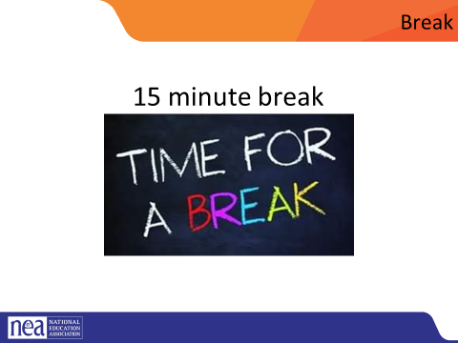 | BREAK
10:30-11:15  Ben/ Ellen  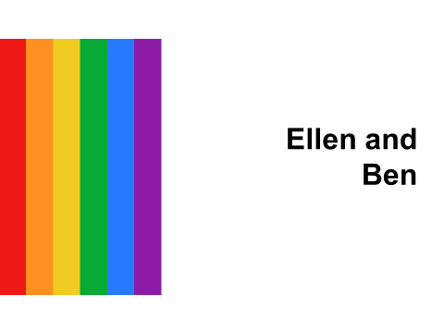  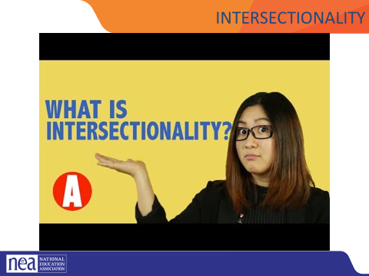  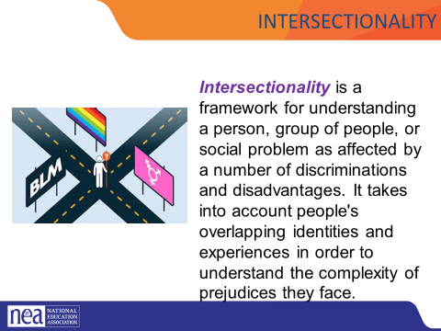  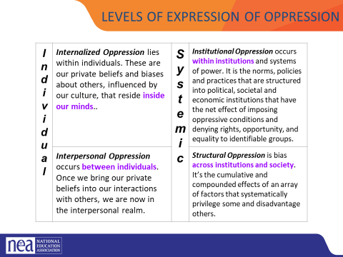  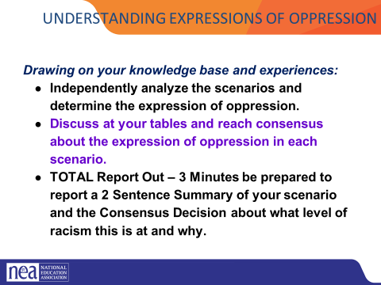  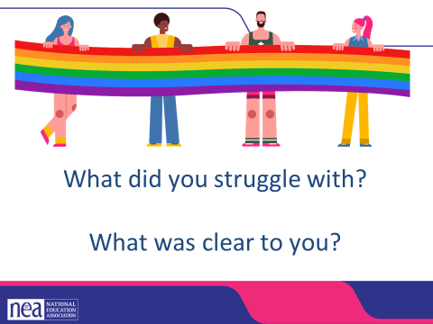  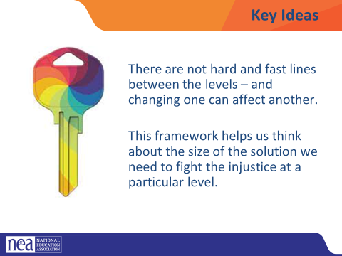 | What are the right size solutions for the level of oppression? | Pg 24  Video on Intersectionality we could use  https://neahq-my.sharepoint.com/:v:/g/personal/eholmes_nea_org/EYAirmGnDFpPvXDQZRhUzJEB1jZxORMr-bcuK4L7mu_z_A?e=lWWeeU  Pg 27  Levels of Expression Of Oppression Handout |  | 4 expressions of Oppression and Intersectionality – (45 minutes)  10 Mins We are going to define two key terms in this next section, the first is Intersectionality –  Let’s watch the following video  3-5 minutes Video  - Video of intersectionality –  To review Intersectionality is a framework for understanding a person, group of people, or social problem as affected by a number of discriminations and disadvantages. It takes into account people's overlapping identities and experiences in order to understand the complexity of prejudices they face. This is important to keep in mind as we approach our work in supporting individuals experiencing oppression.  Now, let’s define The Levels of Expressions of Oppression. We use this framework because it allows us to think about the scope of the solution to a particular problem.  Internalized oppression lies within individuals. These are our private beliefs and biases about others, influenced by our culture.  Interpersonal Oppression occurs between individuals. Once we bring our private beliefs about differences into our interactions with others, we are now in the interpersonal realm.  Institutional Oppression occurs within institutions and systems of power. It is the norms, policies and practices that are structured into political, societal and economic institutions that have the net effect of imposing oppressive conditions and denying rights, opportunity, and equality to identifiable groups based upon differences.  Structural Racism is bias across institutions and society. It’s the cumulative and compounded effects of an array of factors that systematically privilege white people and disadvantage people of color.  Key point – there are not hard and fast lines between the levels – and changing one can affect another. While we believe that the individual is responsible for exploring personal bias – the way to effect change is by addressing institutionalized and structural racism – this is where injustice lives.  30 Min Defining Expressions of Racism Activity - PAGE 28 Use the Handout Levels of Oppression Scenarios had to shorted to 15 minutes  3 minutes form 8 groups. Each group is given a scenario to look at. They are to determine which level of oppression this scenario is about  5 minutes for teams to review scenarios and come up with what level of oppression their scenario is and why. Prepare a summary of your scenario to share with the whole group. Each group will have a total of 3 minutes to share a short summary, provide which level of oppression the scenario exemplifies, and tell why.  20 Mins: Debrief – GIVE a summary of your scenario to share with the whole group. Each group will have a total of 3 minutes to share a short summary, provide which level of oppression the scenario exemplifies, and tell why. what level did your group determine your scenario was at and why?  Overall debrief questions if there is time:  - What did you struggle with? What was Clear to You?  Let’s revisit our key point - there are not hard and fast lines between the levels – and changing one can affect another. While we believe that the individual is responsible for exploring personal bias – the way to effect change is by addressing institutionalized and structural racism – this is where injustice lives.  Also, let’s revisit how using an intersectional lens alongside the understanding of levels of oppression can really help us decide the scope of the solution we need and the power it will take to implement that solution.  Key Points  There are not hard and fast lines between the levels – and changing one can affect another.  This framework helps us think about the size of the solution we need to fight the injustice at a particular level.  Discussion on cycle of oppression went over by 5-7 minutes |  | Participants will learn about a framework of understanding oppression so that they can better identify actions to take in seeking justice.
11:15-11:45  Grat (with mic stand)    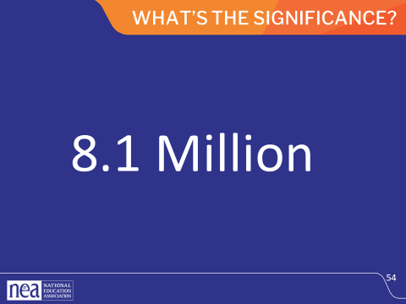  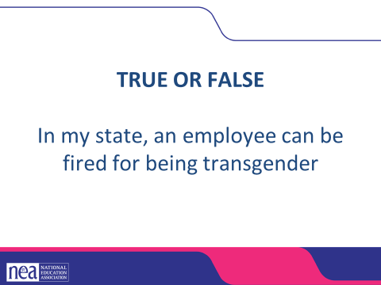  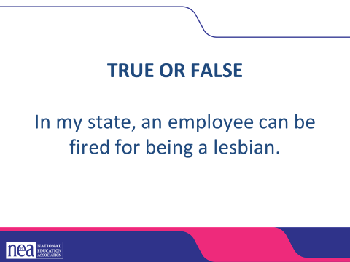  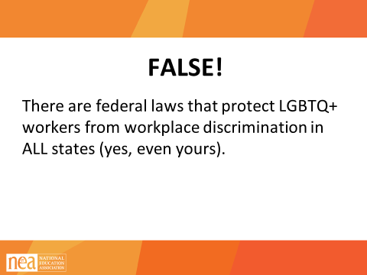    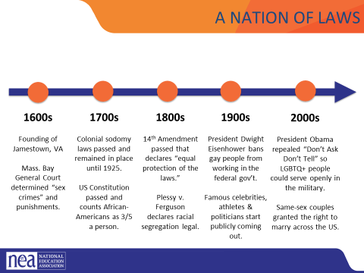  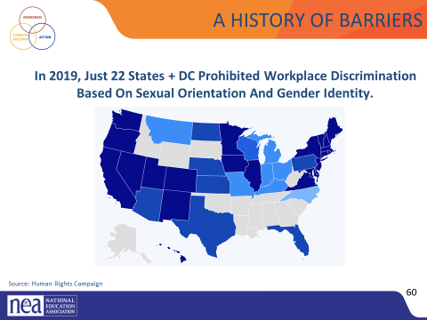  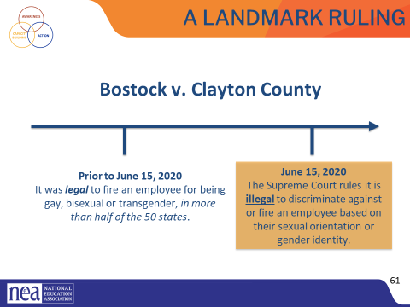  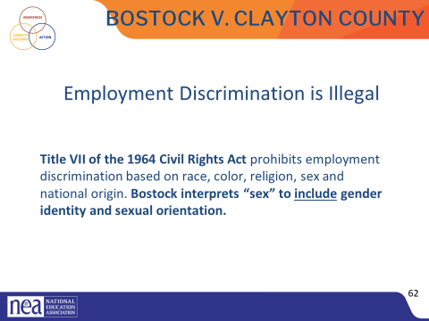  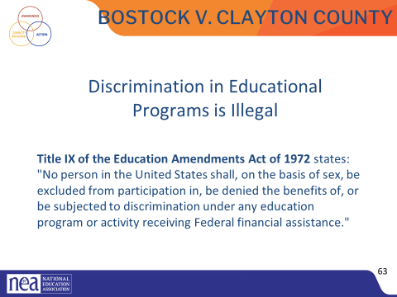  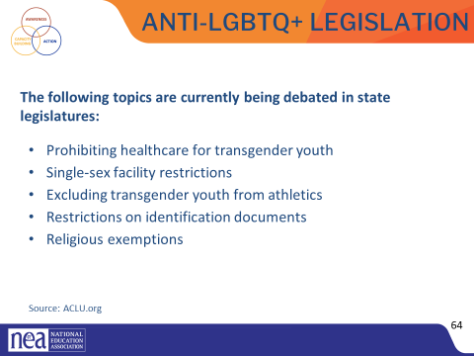  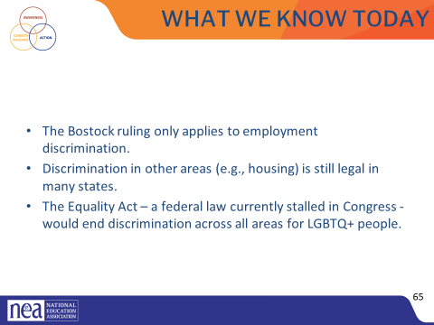  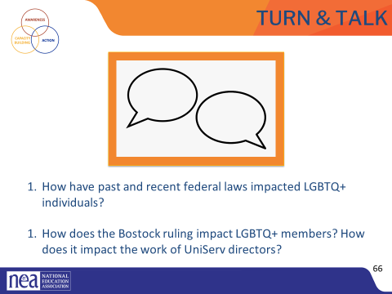  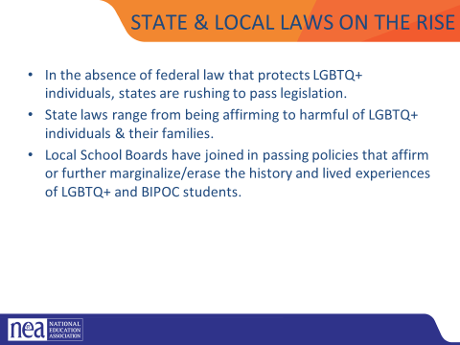  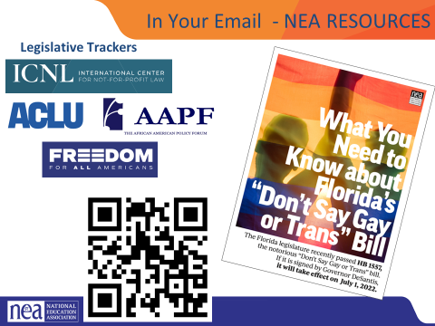  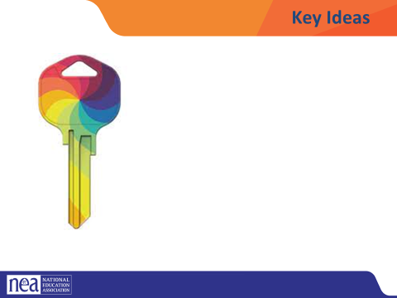 |  | SEND NEA RESOURCE PAGES TO PARTICIPANT EMAIL |  | Legal Overview (30 Minutes) needs 1 hour  In 2019, there were 157 million employees in the US. What do you think this number represents?  According to Catalyst.org, there are an estimated 8.1 million LGBTQ+ employees in the United States who are age 16 or older. 50% of these employees are not out at work because of fears of discrimination or ostracization. And 1 in 5 LGBTQ+ employees have experienced discrimination.  Reference: https://www.catalyst.org/research/lesbian-gay-bisexual-and-transgender-workplace-issu  The US has called itself a “Nation of Laws,” but what are the laws for? And, who do they help or harm? This timeline shows only a glimpse of how discrimination, exclusion, and beliefs in white supremacy have been a part of US laws since the earliest of colonial times. For a more comprehensive list of laws that impact LGBTQ+ people throughout US history, please see your handout.  Highlights for further discussion:  1607 – Founding of Jamestown, VA, the first permanent English settlement in the “New World.”  1607 – Massachusetts Bay Colony was established believing they made a “covenant with God to build an ideal Christian community.”  1619 – The first enslaved Africans arrive to Jamestown, VA  1631 – The Massachusetts Bay General Court, in accordance with Puritan religious and moral beliefs, declared that the following were considered sex crimes and punishable by whipping, banishment or execution: fornication, adultery, rape and sodomy.  1705 – The Colony of Virginia adopted the first Blood Quantum Law. A person’s blood quantum is defined as the fraction of their ancestors, out of their total ancestors, who are documented as full-blood Native Americans. These laws were applied across the thirteen colonies and later the entire United States. They limited the civil rights of Native Americans and regulated who could be classified as Native American.  1714 – Sodomy laws were passed in the early colonies and in the colonial militia. They stayed in place until challenged in 1925.  1775 – Population of enslaved people in the colonies is nearly 500,000.  1776 – Declaration of Independence signed.  1778 – Lieutenant Gotthold Frederick Enslin of the Continental Army becomes the first documented service member to be dismissed from the U.S. military for homosexuality. Read more at U.S. History Naval Institute Blog / Timeline of Military Gay History.  1779 – Thomas Jefferson proposes Virginia law to make sodomy punishable by mutilation rather than death. It was rejected by the Virginia legislature.  1788 – U.S. Constitution adopted. Includes a three-fifths clause that counted each enslaved person as three-fifths of a person for the purposes of congressional representation and tax apportionment.  1852 – Scottish writer J.D. Bothwick reports his attendance at a “miner’s ball” – a men’s only dance held in Angels’ Camp in California.  1857-1861 – James Buchanan elected president. A lifelong bachelor, Buchanan had a long-term relationship with William Rufus King, who served as vice president under Franklin Pierce. The two men lived together from 1840-1853 until King’s death. Some historians suggest Buchanan, by today’s terms, was gay.  1868 – Fourteenth Amendment Ratified. This is the most cited amendment in Supreme Court civil rights cases and has been the basis for landmark civil rights cases such as Brown v. Board of Education, Roe v. Wade and Obergefell v. Hodges. Gay rights advocates cite this amendment in support of equality for future court cases.  “All persons born or naturalized in the United States and subject to the jurisdiction thereof, are citizens of the United States and of the State wherein they reside. No State shall make or enforce any law, which shall abridge the privileges or immunities of citizens of the United States; nor shall any State deprive any person of life, liberty, or property, without due process of law; nor deny to any person within its jurisdiction the equal protection of the laws.”  1868 – Two-Spirit, We’wha, a Zuni Native American, meets with President Grover Cleveland.  Source: https://www.lgbtqhistory.org/lgbt-rights-timeline-in-american-history/  Source: https://en.wikipedia.org/wiki/Blood_quantum_laws  US history is full of barriers for BIPOC and LGBTQ+ people. Discrimination because of one’s race and LGBTQ+ identity means lost wages, jobs, promotions, unfair treatment and even harassment at work. This discrimination compels many to hide their LGBTQ+ status for fear of retribution, losing one’s livelihood, support system, and more.  Before 2019, only a handful of states (in dark blue above) provided LGBTQ+ people some protection against employment discrimination, as well as in housing and public accommodations. This meant that in all the other states (those in tan and lighter shades of blue), LGBTQ+ people could be denied jobs, health care, housing, hotels, and more. This discrimination – across the majority of the US, and nearly all of the South— was perfectly legal.  The Civil Rights Act of 1964 prohibits discrimination based on race, color, religion, sex, or national origin. The courts and the federal government have long refused to recognize LGBTQ+ discrimination as a form of sex discrimination. Over the past 20 years, however, federal courts and the government have at times recognized LGBTQ+ discrimination as sex discrimination.  It was not until June 15, 2020 that the Supreme Court finally recognized that LGBTQ+ employment discrimination is prohibited sex discrimination under Title VII of the Civil Rights Act of 1964.  This ruling recognized that it is illegal to discriminate against or fire an employee based on their sexual orientation or gender identity. Now lower federal courts and the Biden Administration are applying that ruling to education, health care, housing, credit discrimination, and more.  The Bostock ruling specifically states that employment discrimination on the basis of gender identity and sexual orientation is illegal.  Title VII of the Civil Rights Act covers the full spectrum of employment decisions, including recruitment, selections, terminations, and other actions concerning terms and conditions of employment. This is significant for the LGBTQ+ community because, as we saw, in many states it was legal to be denied an interview or a promotion, and even to be fired because of one’s gender identity or sexual orientation.  On March 26, 2021, the Department of Justice concluded that, as a result of the Bostock ruling, Title IX of the Education Amendments Act of 1972 also prohibits sexual-orientation and gender-identity discrimination in educational institutions that receive federal funding. This means all public schools. This means that students cannot be discriminated against in schools based on their LGBTQ+ identity.  There have been some significant wins recently for LGBTQ+ rights in the US But while progress is being made, attacks on LGBTQ+ rights in certain states have accelerated.  Reference: Department of Justice, “Application of Bostock v. Clayton County to Title IX of the Education Amendments of 1972,” March 26, 2021, https://www.justice.gov/crt/page/file/1383026/download  While some schools and districts are implementing gender-affirming policies and practices, like recognizing proper names and pronouns for children, in the background, states are trying to license LGBTQ+ discrimination under the guise of religious freedom. The proposed legislation in these areas, if passed, would serve to limit, further marginalize, and in some cases criminalize efforts to support LGBTQ+ youth and adults.  These attacks on LGBTQ+ people, especially young people, are being challenged in court and should be struck down under the reasoning of Bostock. But those lawsuits are just getting started.  Got here before lunch  Key Notes  Bostock only applies to employers with more than 15 employees. Employers with fewer than 15 total employees are not covered by Title VII.  Bostock applies nationwide and protects employees from sexual orientation or gender identity discrimination regardless of state or local laws.  An employer covered by Title VII is not allowed to fire, refuse to hire, or take assignments away from someone (or discriminate in any other way) because customers or clients would prefer to work with people who have a different sexual orientation or gender identity. (For example, keeping LGBTQ+ employees out of public-facing positions.)  Although accidental misuse of a transgender employee’s preferred name and pronouns does not violate Title VII, intentionally and repeatedly using the wrong name and pronouns to refer to a transgender employee could contribute to an unlawful hostile work environment.  Get in groups of 4- with folks you haven’t worked or spoken to before. 2 minutes after lunch quick chat  Turn & Talk: Suggested Discussion Questions  - How have past and recent federal laws impacted LGBTQ+ individuals?  - How does the Bostock ruling support LGBTQ+ members? How does it impact the work of UniServ directors?  Well funded political groups have launched a coordinated and strategic approach to overwhelm and see what legislation sticks regarding harmful legislation.  Local School boards & the public education system have become a focus for advancing anti-LGBTQ+ policies  While children of color make up the majority of U.S. public school students, policies that affirm their histories and lived experiences are not centered in local and state legislation.  The coordinated attacks on LGBTQ+ individuals include providing people scripts that denounce teaching topics such as transgender rights, banning books from well known authors, and labeling inclusive and culturally responsive instruction as “critical race theory.” Unfortunately, these efforts have been effective.  As we see in this Twitter thread, a post from an out trans person, who six months ago shared their experience of teaching in middle school, is now accused of “grooming” students by sharing their pronouns.  FIGHTING BACK- PATCHES OF HOPE: While many states and lawmakers are working to advance anti-LGBTQ+ and other laws that discourage teaching an honest history of the US, not every effort is successful. While many of these efforts are specific to students, it worth noting that not all attempts have been successful.  - In March 2022, a “CRT” bill in Indiana failed despite having a GOP supermajority.  - Parents are mobilizing to counter the loud voices that dominate local school board meetings:  - Red Wine & Blue is a national network of more than 300,000 like-minded, mostly Democratic suburban women who believe the only way to fight back is to present a calm face to counter the angry groups that have dominated and disrupted board meetings and in some cases threatened officials. The group recently broadened its focus to fight the rising number of book bans across the country, and is running training sessions to help women testify and manage highly charged government meetings.  - One WillCo is a community organization in Williamson County Tennessee that was organized by two mothers to address racial disparities in the community in 2021.  - Invite discussion: Ask participants if they have heard of anti-LGBTQ+ or anti “CRT” laws that have failed to pass. Why do they think this is?  Sources:  https://www.wfyi.org/news/articles/indiana-anti-crt-bill-failed-republican-supermajority  https://onewillco.org/  ACTIVITY: Look at Your State’s Equality Profile. Had 18 minutes for this  How might this impact members who are transitioning or transgender?  Instructions:  Go to www.lgbtqmap.org  Click Equality Maps  Select “Choose a State” in the drop down menu.  Select a state and review the data. How might this data impact members who are transitioning or transgender in your selected state?  The NEA has several resources and recommendations for legislative trackers. (See handout for full list and website links.)  https://www.icnl.org/usprotestlawtracker/  https://www.aclu.org/legislation-affecting-lgbtq-rights-across-country  NEED KEY IDEAS – What does all this mean? |  | Participants will gain an understanding of the legal landscape.
11:45-12:00  Jeny  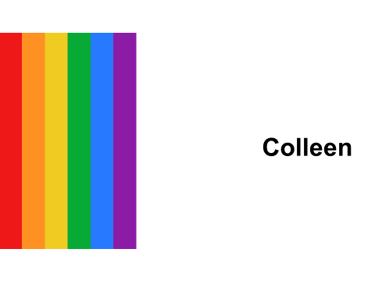  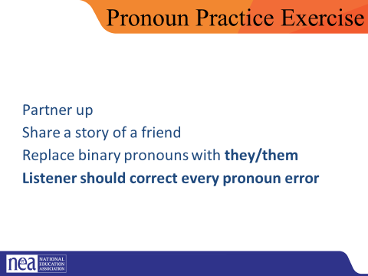 |  | Pg 33  NEA handouts  GLSEN Handout on Pronouns as an overview resource – not as an activity |  | Pronoun Practice Exercise (15 minutes)- took 5 minutes to get into pairs and give directions  Everyone thinks of a story about your best friend. Something silly, funny, endearing. Find a partner. Tell the story of your friend. USE They/them pronouns. The listener’s job is to correct any time a binary pronoun is used.  Key Ideas:  - Using someone’s correct pronouns is an important way to show respect.  - It is on us to get good at this.  - Using someone’s name or neutral pronouns is the most respectful approach if you don’t know. |  | Participants will practice the use of gender neutral pronouns.
12:00 to 1:00  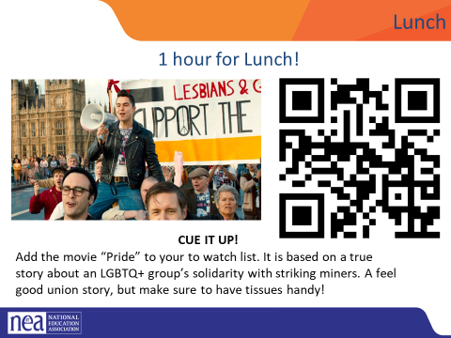 | LUNCH
1:00-1:20  Michelle  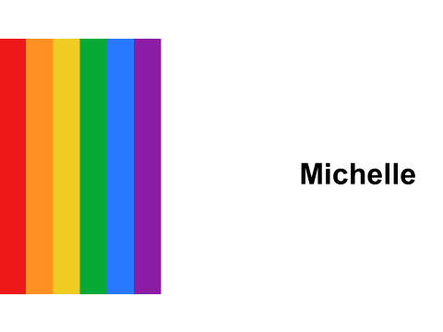  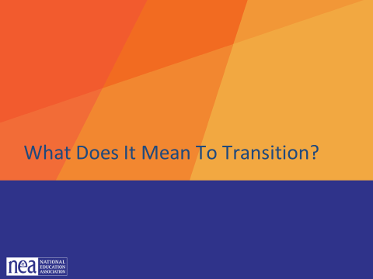  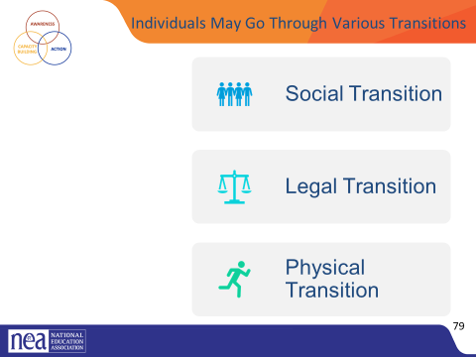  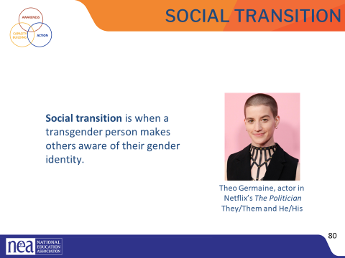  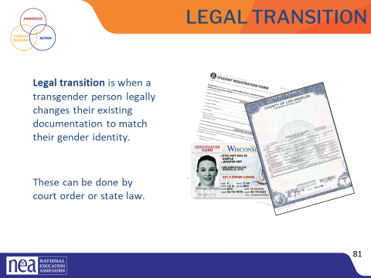  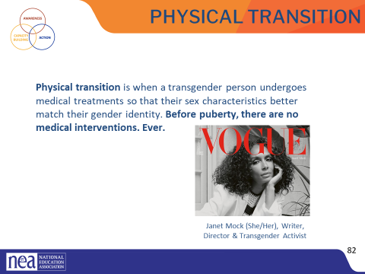  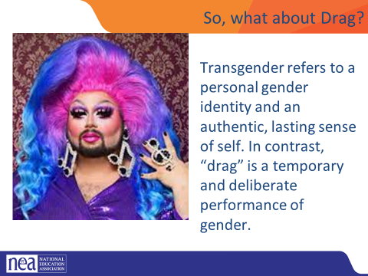  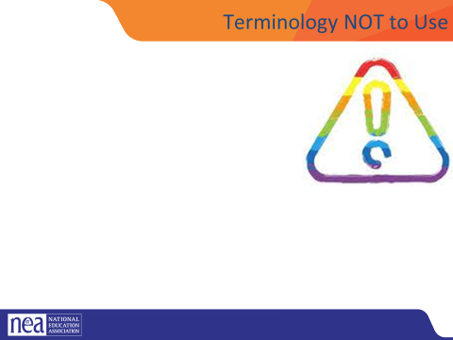  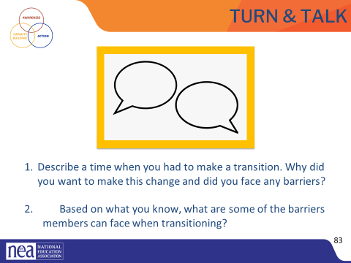 |  | Refer to Supporting an Employee During Transition handout |  | Types of transitions and barriers to transitioning (20 Minutes)  Given all that a transgender person may be experiencing, one option is to transition. This means they align their inner identity with their external one. We’re going to talk about this process and how it affects trans adults.  Transitioning is not a simple, one-time event, and there is no “one-size-fits-all” process, checklist, or approach. Transitioning is a complex issue, and it involves a wide variety of options for an individual.  Many factors influence a person’s decision to transition, and because of these factors, their transition may not be linear. Transitioning is a personal decision specific to the individual, so how a person goes about transitioning can change over time and vary from person to person.  There are 3 main types of transitions someone could go through: social, legal, and physical  Social transition is just what it sounds like—changing how you present yourself and how others see you socially. A social transition can happen at any age. A person may start their transition, pause it, move back, and move forward again. It often includes changing clothing or hairstyles. Usually, it entails changing a name and switching pronouns—sometimes more than once.  A person may try on names for a while and switch from one gendered pronoun to another, only to decide that a non-binary pronoun fits better. Again, no rules.  A legal transition means updating documents through the legal process.  Some parts of the legal transition can include changing gender markers on birth certificates, changing names on social security cards, driver’s licenses, or passports. Legal transitions can also have other identification components, such as school documents. Passports are the easiest documents to change.  People cannot always experience a legal transition because of several barriers. Those barriers do not make their gender identity or their distress at being misgendered any less real.  Transgender health is a specialized area of medicine. There is no one way to have a physical transition.  Given the specialized nature of transgender health care, we can see how problematic it is for a trans person to be told they can only access gender-segregated spaces once they have “had a surgery.” It puts a burden on them that is impossible to overcome, denies their full identity, and creates equal-access issues. Additionally, not all trans people want to have surgery. It’s wrong to demand that another person undergo serious, invasive medical procedures to make other people comfortable.  Keep in mind that just like you would not want to be asked about your medical procedures, we don’t ask others about theirs.  What about drag?  Transgender refers to a personal gender identity and an authentic, lasting sense of self. In contrast, “drag” is a temporary and deliberate performance of gender.  Drag is most commonly associated with gay men dressing up and embodying a “larger-than-life” female persona. Drag queens are flamboyant and this form of drag often involves sequins and feathers but it can also be sleek and edgy.  For drag queens, their drag persona can be an important part of their own identity as a gay man (this does not mean they are transgender). Similarly, women also perform drag as drag kings. Drag kings dress as men and take on male personas, often wearing facial hair, adopting masculine mannerisms and a deep voice.  Groups of 4- 5 minutes  Turn & Talk: Suggested Discussion Questions:  - Describe a time when you had to transition (e.g. moving to a new city, starting a new job, getting married, having or adopting a child, becoming a pet parent, etc.). Why did you want to make this change and did you have support?  - Based on what you know, what are some of the barriers members can face when transitioning?  Table talk Debrief - have participants share out- show slide- is there anything we missed?  - Not all trans people can transition as they would like to because of any number of factors, including:  - Financial cost  - Legislative rules/roadblocks  - Lack of access to competent healthcare  - Health problems  - Unhappy with options available  - Unsupportive family/family instability  - Homelessness/domestic violence  - Other personal reasons  Here are a few examples of barriers a transgender educator might face:  Legislative rules/roadblocks — In most states, a person’s gender marker can only be changed on their birth certificate after permanent medical procedures have occurred. This is often stipulated as surgery.  Lack of access to competent healthcare — Trans health is still not taught in most medical schools. Often there is one class (class period…not entire course) devoted to it, if at all. Many providers are afraid to treat trans patients, and some patients travel to other states just to get competent care.  Health problems — Underlying health conditions can complicate a physical transition just as they would complicate any number of other medical treatments or procedures.  Unhappy with options available — This could be surgical options, but could also affect a non-binary person who does not want to proceed with hormones that would make them look too feminine or too masculine.  And, other personal reasons. |  | Participants will analyze what they need in their understanding to properly advocate for employees who are transitioning.
1:20-1:40  Michelle  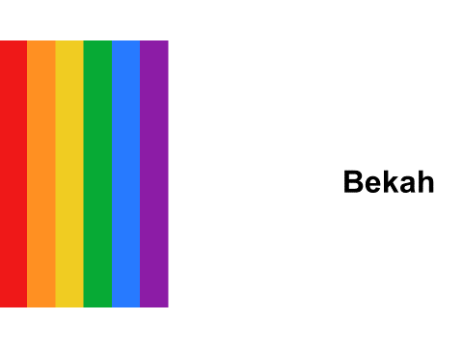  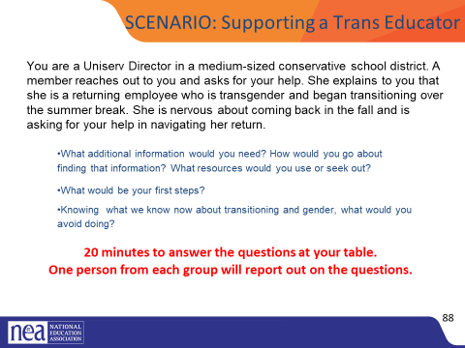  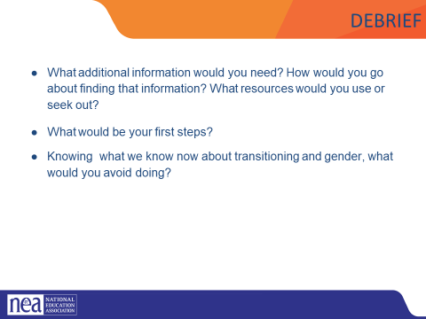  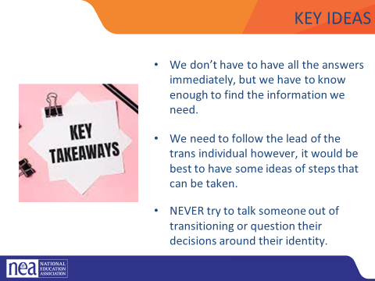 |  | Pg 37  Supporting Transitioning Employees |  | Supporting a transitioning employee scenario (20 Minutes)- ON SLIDE  Intro-  We are now going to apply the information we have learned over the last day and a half to a scenario about supporting a transitioning educator in our roles as Uniserv directors. You have 15 minutes to discuss the scenario with the people at your table and answer the questions. Please make sure one person is prepared to report out.  Transition in different ways in different places.  A reminder- EVERY EDUCATOR HAS THE LEGAL RIGHT TO TRANSITION AT WORK UNDER BOSTOCK. Your job is to make a plan to help this educator exercise their legal right!  Group Work- 15 minutes 10 minutes  Scenario is on the slides with questions  Debrief- 5 minutes- page 37- some questions you could use.  - Have each group report on the three questions.  - Things to push back on  - Incorrect or inappropriate language  - Inappropriate lines of questions to the member  - Any suggestion that the UD would challenge or discourage the member from transitioning  Finish with key ideas on the final slide-  - We don’t have to have all the answers immediately, but we have to know enough to find the information we need.  - We need to follow the lead of the trans individual however, it would be best to have some ideas of steps that can be taken.  - NEVER try to talk someone out of transitioning or question their decisions around their identity. |  | Participants will analyze what they need in their understanding to properly advocate for employees who are transitioning.  Participants will apply their new understanding to a scenario.t
1:50-2:30  Linda    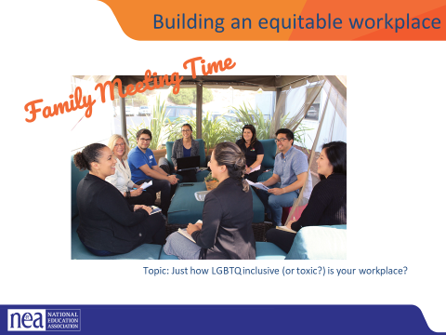  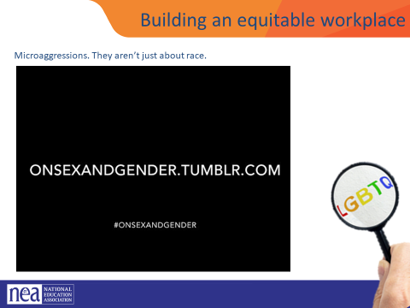  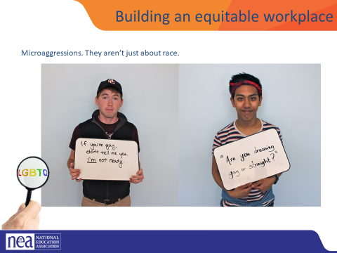  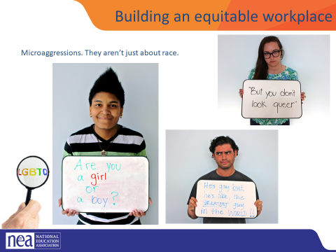  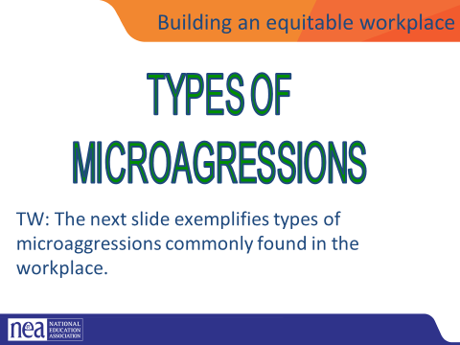  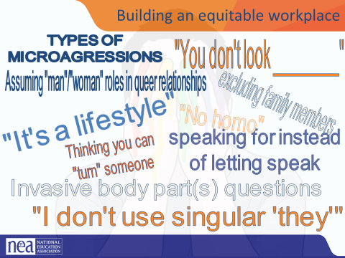  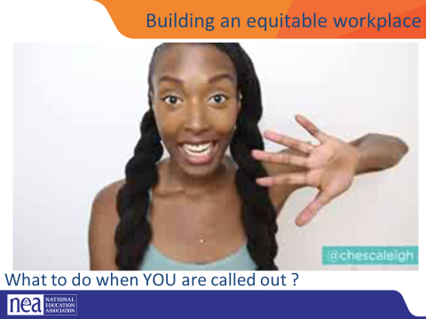  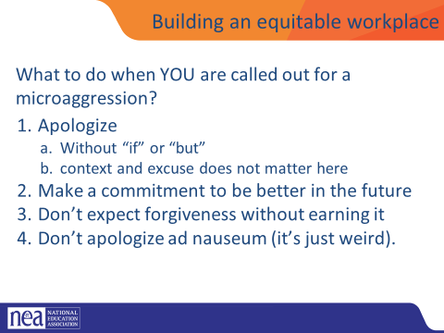  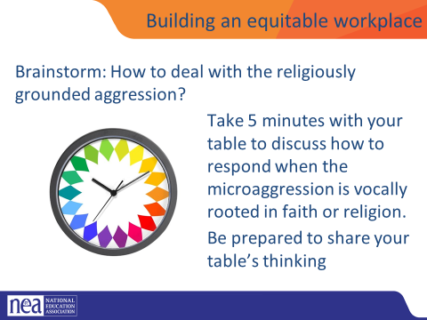  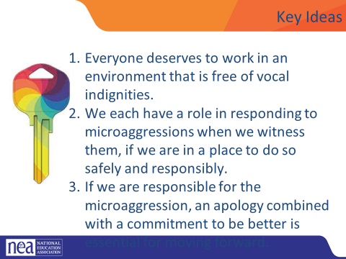 | 3:00-3:40 | Pg 48  Statistics about Workers Handout  What does it mean to be an ally handout  Welcoming spaces Handout  Supportive colleague or peer handout  Being and Ally Handout |  | Building an equitable workplace for ourselves and LGBTQ+ colleagues (40 Minutes)  Content/Trigger Warning  It’s time for a family meeting. Before we do that, I want to review one of our community agreements.  Remember: We speak our truth here. But in order to do that about our place of work we need to know that what is shared here, authentically, is shared in order to build supports to deal with stuff back home. So what does that mean? It means when someone shares a story about something that has happened at their affiliate, it doesn’t get shared at your affiliate. Remember: we share the lessons, not the stories.  We need to talk about our workplaces. Not the members we support but the folks we are fortunate enough to work with. Some of us may be fortunate enough to work in incredibly gender inclusive and supportive environment. Others deal with the side comments and whispered judgments on a regular basis.  For anyone who has done work in Racial Justice, you should recognize this.  MICROAGGRESSIONS—they aren’t just about race.  At your table: React to the video and the highlighted pictures. --3 minutes. How do these manifest in your workplace?  Warning: The next slide has common microaggressions that members of the LGBTQIA+ community may deal with on a regular basis.  So that is the bad. How do we come out of this? Let’s look at some of our interrupting microaggression strategies, reframed for the LGBTQ+ world.  Review the 6 steps of interrupting microaggressions-  WHAT to do when you witness a microaggression:  1. Assess the situation: are you able to respond  a. Environment  b. Physical/Employment Safety  c. Your own mental/emotional status  2. PAUSE. Breathe.  a. Ask the person to repeat what was said  b. “I don’t understand the joke. Can you please repeat it so I can get what was funny?  c. “Did you just say______?”  3. WHAT to do when you witness a microaggression:  4. Take control of the situation.  a. “I don’t find that funny.”  b. “That type of language/question makes me uncomfortable, particularly in the workplace.”  5. Offer a way to learn/grow (if you are in a place to do so with generosity, not passive aggressively). Was at 15 minutes here  6. Reflect: What information did you need to help educate the person OR to better understand the microaggression yourself?  Be aware of:  Context  Environment  Assessing whether or not the person directly affected wants the help or not.  Review what to do as a person of privilege witnessing microaggressions  BEING AN ALLY  Allyship is the use of personal PRIVILEGE and  proximity-to -power to advocate for change  Allyship is a verb not a self-proclaimed identity  Allyship is continuous  Allyship means checking in not saving the day  How do you incorporate allyship into your collegial and professional relationships?  SAVIOR TO ALLY TO ACCOMPLICE- graphic on slide  TURN AND TALK: How are you dealing with these things at work? skipped  How did you respond?  Do you wish you could have handled it differently?  What roadblocks exist to your most complete response?  There is, of course, another way you might interact with microaggressions in the work place: this is when YOU are the person who creates the microaggression, however inadvertently. It can happen. One of the best strategies is to simply apologize,  VIDEO skipped  What to do when YOU are called out for a microaggression?  Apologize  Without “if” or “but”  context and excuse does not matter here  Make a commitment to be better in the future  Don’t expect forgiveness without earning it  Don’t apologize ad nauseum (it’s just weird).  Don’t expect them to let you out of it. (Barb quote)  Brainstorm: How to deal with the religiously grounded aggression?  Take 5 minutes with your table to discuss how to respond when the microaggression is vocally rooted in faith or religion.  Be prepared to share your table’s thinking  There is one way where LGBTQIA+ microaggressions can differ from those grounded in race. This is where religion or faith can come into play. Let’s be clear: people spouting hateful ideas grounded and defended by religion or faith are not participating in microaggressions. It is often purposeful and directed. It is an aggression. But we also have two rights in tension: the right to freedom of religion versus the right to ... exist. There is no easy answer here except to share amongst ourselves what has worked and what has fell flat. So. Five minutes at your table to do this. |  | Participants will explore what it takes to provide an inclusive workplace.
2:30 - 2:45  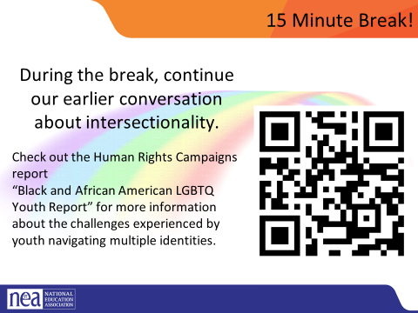 | BREAK
2:45-3:00  Barb      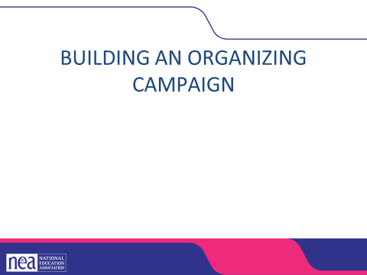  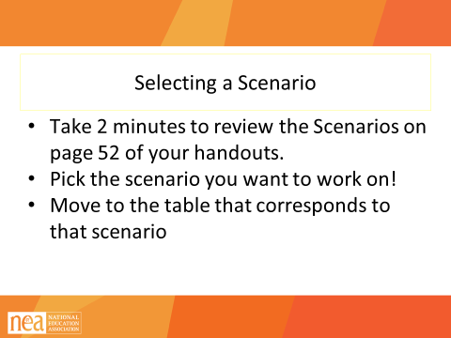  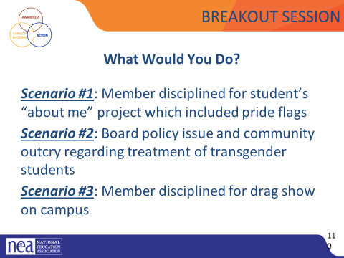  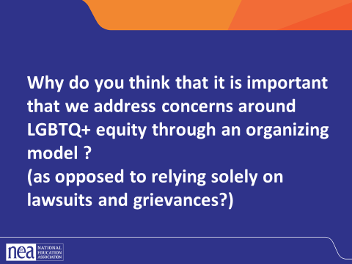  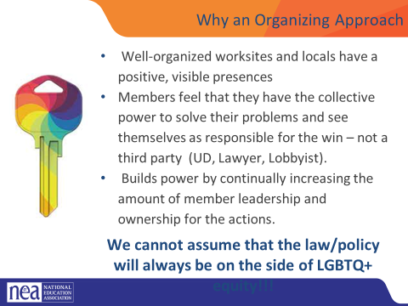  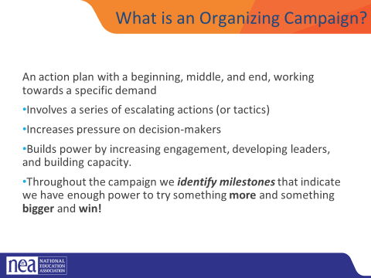  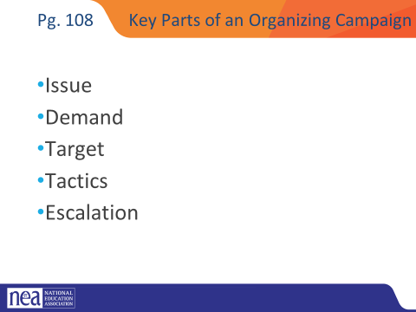 | 3:40-4:00 | Scenario Package Handouts Pg 51  Campaign Plan Handouts  Pg 108 |  | Building a Campaign around the Scenarios (15 Minutes)  Getting into Scenario Groups (2 minutes)  Take 2 minutes to review the scenarios found on Page 52 and sent in your pre-attendance package. For much of our remaining time, we are going to work on building an organizing plan to address these issues. Go to the table that corresponds with the scenario you would like to work on.  In small groups, invite participants to discuss what they would do in one of the following scenarios:  For the following scenarios, imagine you’re in a state that has recently banned conversation about LGBTQ+ topics. What would you do?-WE need a slide on this in the powerpoint, edit the debrief slide in PP  Scenario #1: Member disciplined for student’s “about me” project which included pride flags  Scenario #2: Board policy issue and community outcry regarding treatment of transgender students  Scenario #3: Member disciplined for drag show on campus  DEBRIEF: For thought ---Why do you think that it is important that we address concerns around LGBTQ+ equity through an organizing model? (as opposed to relying solely on lawsuits and grievances?)  Well-organized worksites and locals have a positive, visible presences  Members feel that they have the collective power to solve their problems and see themselves as responsible for the win – not a third party (UD, Lawyer, Lobbyist).  Builds power by continually increasing the amount of member leadership and ownership for the actions.  We cannot assume that the law/policy will always be on the side of LGBTQ+ equity!!!  5 mins – INTRODUCTION TO CAMPAIGN PLANS  - Once in their scenario groups ask- Why do you think that it is important that we address concerns around LGBTQ+ equity through an organizing model (as opposed to relying on lawsuits and grievances?  - So why do we need campaigns? A campaign is an action plan with a beginning, middle, and end, working towards a specific demand that we want to win.  - A campaign has a target, someone who can give us what we want. It usually involves a series of escalating actions (or tactics), which means that we progressively turn up the heat.  - A good campaign creates increasing pressure on decision-makers over time by escalating the intensity and visibility of the tactics and increasing the numbers of people involved.  - Campaigns are a way to identify in advance the ingredients we need to win and put them together in a way that maximizes our chances of success.  - One isolated action may not be enough to solve the problem.  - Campaigns help us to shift the balance of power in our workplaces and build members’ confidence.  - Many issues that members care about can’t be solved with grievances.  - Besides, grievances are invisible to most members, because they don’t usually involve collective action.  - We need our actions to be participatory and public.  There are five main parts to a campaign. We are going to go through each-  - Issue  - Demand  - Target  - Tactic  - Escalation  We are going to go through each of the key components of an organizing campaign and apply each to our scenario. Then, at the end, we will compile and present our final campaign plans for our scenarios.  1 MIN- WRAP UP/KEY POINTS  Grievances are typically singular and don’t build people power  - Campaigns involve lots of people are member led and increase power and visibility of the union  BEGINNING OF DAY THREE CONTENT |  | Participants will apply their new learnings to complex teams based scenarios.  Participants will apply a campaign framework to their plan to seek justice for the individual(s) in the scenario.
3:00-3:45  Barb  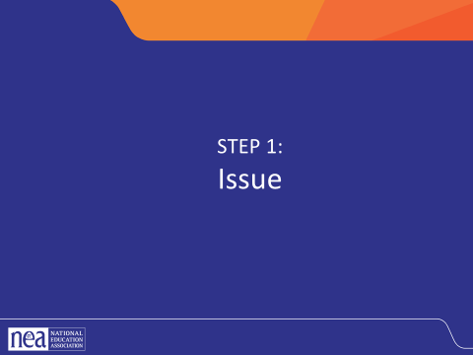  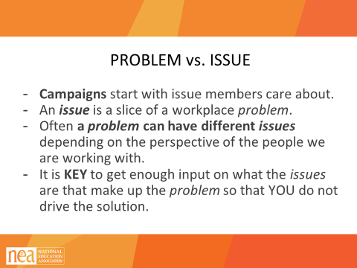  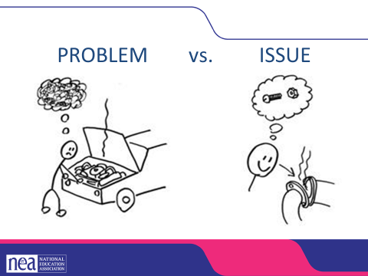  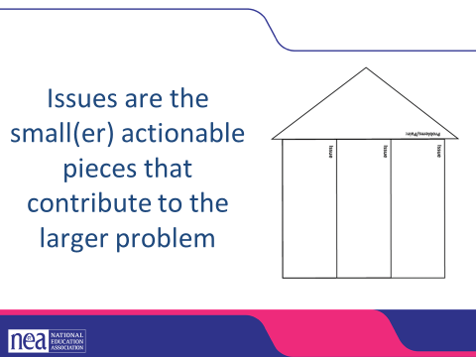  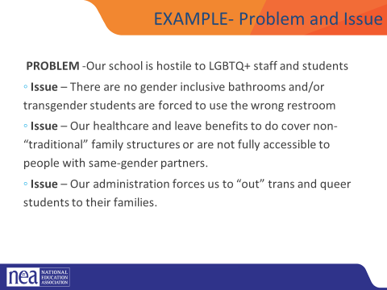  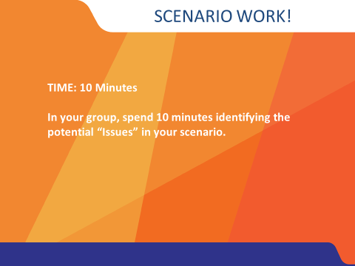  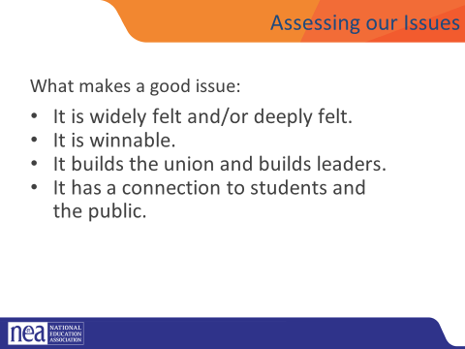  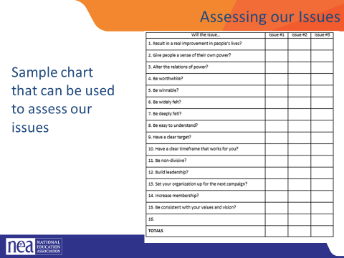  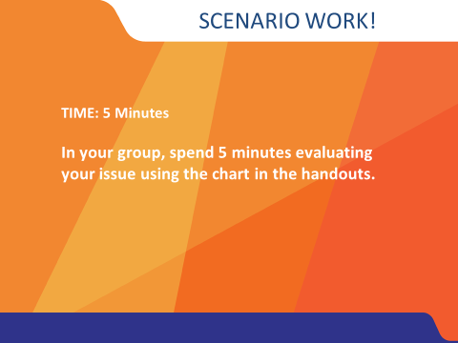 |  |  |  | 45 Minutes Problem vs. Issue  PROBLEM vs. ISSUE  - Campaigns start with issues members care about.  - An issue is a slice of a workplace problem.  - Often, a problem can have different issues depending on the perspective of the people we are working with.  - It is key to get enough input on what the issues are that make up the problem so that YOU don’t drive the solution.  - A staff-driven solution may not meet the needs and commitment of the people you are working with.  Note: for your scenarios, there may be a “service” model solution and an organizing issue. Thing of the direct service as a way of solving the immediate crisis, and the organizing as a way of addressing a bigger systemic issue so it doesn’t happen again.  10 Mins – GROUP WORK  In your groups, return to your scenario and decide the:  The potential issues in your scenario  BRAINSTORM- ON CHART PAPER- ANYTHING GOES- ALL IDEAS ON CHART PAPER  Assessing an issue  How to select an issue  - Since there may be many issues confronting workers on the job, we have to also think about what makes a good issue to organize around.  - CRITERIA:  - It is widely felt.  - It is deeply felt.  - It is winnable.  - It builds the union and builds leaders.  - It has a connection to students and the public.  A NOTE HERE: Often, issues of equity are deeply felt by a marginalized few, and NOT by the privileged majority. If an issue is very deeply felt, it does not have to be widely felt.  5 Mins – GROUP WORK 15 minutes  In your groups, return to your selected issues. Use the chart in the handout PAGE 112 to determine whether the issue you identified is a good issue. |  | Participants will apply their new learnings to complex teams based scenarios.  Participants will apply a campaign framework to their plan to seek justice for the individual(s) in the scenario.
3:45-4:15  May move to Day 3  Sara  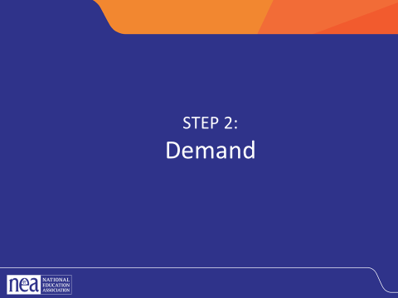  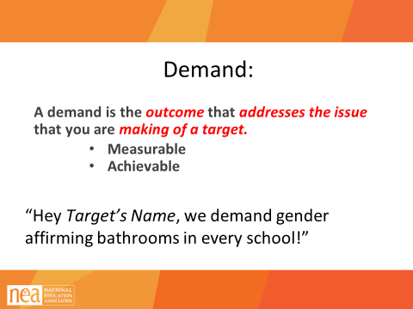  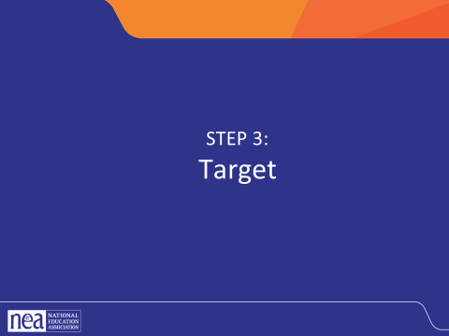  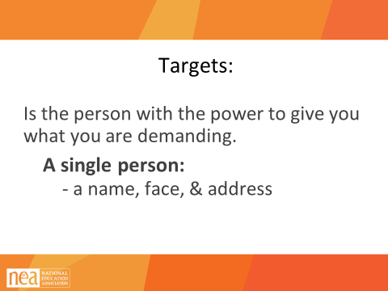  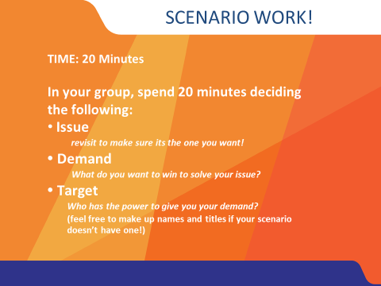 |  |  |  | DEMAND  - A demand is what the group wants– the win –  - A demand is the outcome that addresses the issue you are making of the target  - If the issue is what is wrong, the target is what we want that will fix the issue.  Value ends up being the messaging  TARGET  - The last idea that we want to cover is Targets.  - TARGET: A target is a single person with a name and an address. The target is the person with the power to give the workers the change they are asking for. A target has a name, a face and an address. Takes 5 minutes to introduce  20 Mins – GROUP WORK  In your groups, return to your scenario and decide the:  Issue- Finalize the issue!  Demand What do you want to win to solve your issue?  Target Who has the power to give you your demand? |  | Participants will apply their new learnings to complex teams based scenarios.  Participants will apply a campaign framework to their plan to seek justice for the individual(s) in the scenario.
3:45-4:20  Ellen/Grat  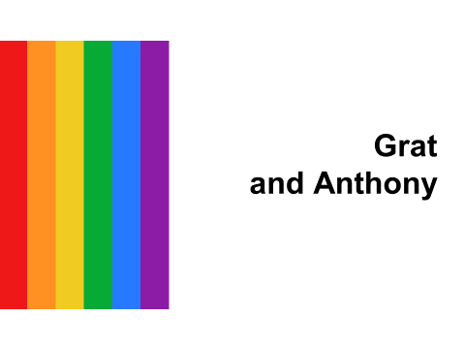  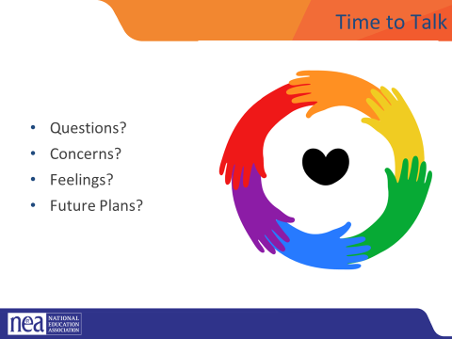 |  |  |  | Have participants move into a circle.  - Address outstanding questions from the chart.  - General questions |  | Participants will take time to discuss what they are feeling about doing this work when they return home.
4:20- 4:30  Ellen |  |  |  | Wrap Up and reflect
4:30-5:00 |  |  |  | Choice Networking
 | ADJOURN

