



LEADERSHIP POLICY & POLITICS TEACHING & LEARNING TECHNOLOGY OPINION JOBS MARKET BRIEF

OPINION
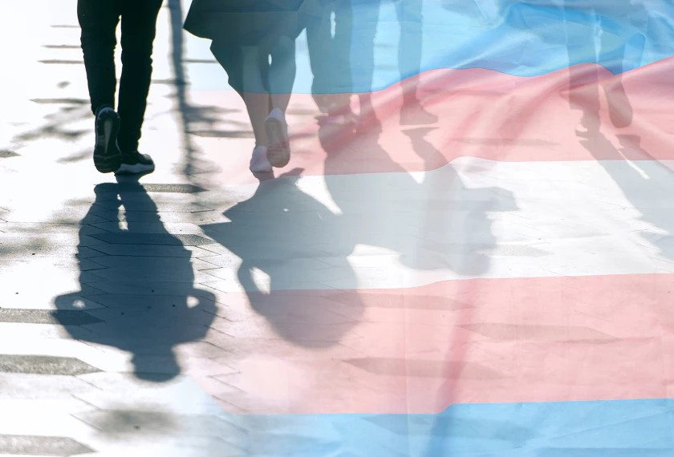

EQUITY & DIVERSITY OPINION

I’m a Transgender Teacher. Here’s Why I Came Out at My School
By Sam Long — March 28, 2019  5 min read

Sam Long

Sam Long (he/him) teaches biology at an urban high school in Denver. You can learn more about Sam’s work at sam- long.weebly.com.

My ﬁrst year teaching high school was in 2015, months after the Supreme Court ruled on Obergefell v. Hodges, which guaranteed same-sex couples the right to marry in the United States. Like many members of the LGBTQ community, I celebrated the landmark decision. But as a transgender man, I worried that not everyone at my school would be ready to embrace the ‘T’.

Schools are some of the most binary-gendered spaces in our society. Every adult uses the honoriﬁc “Mr.” or “Ms.” Dress codes and uniforms often diﬀer for boys and girls. The building has a boys’ bathroom and a girls’ bathroom—single-stall, gender-neutral facilities are seldom an option.
A decade earlier, when I was attending high school and beginning my transition from female to male, these binaries were direct challenges for me. But when I began my career nearly four years ago as a binary, male-passing teacher, to talk about my trans identity was a choice. Could I work openly as a trans teacher? Or would I be better oﬀ not telling anybody?

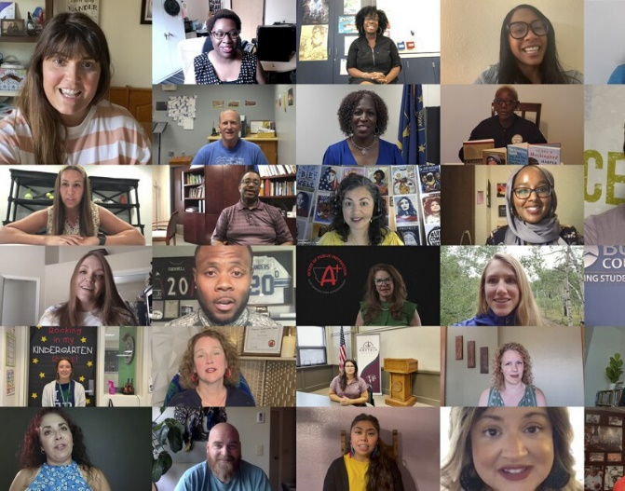
Our training that summer had a strong focus on forging relationships among staﬀ. We played team-building games and read teaching articles together, jigsaw-style. On a three-day retreat in the mountains, we shared our stories, hopes, and fears. We were given prompts like, “What is the hardest thing you’ve ever done in your life?” and “What is an experience you had as a student that informed your philosophy of education?”

For me, all the answers were tied to my trans identity. To omit this would be to omit the best and most valuable things about myself. And so I chose to stand up and share the story of my transition with my 50 new coworkers. First the room was silent apart from my trembling voice, then the air was ﬁlled with claps and snaps. My coworkers applauded my act of courage and authenticity. I slept soundly that night in my bunk with the other male staﬀ.

By the time students had been in the building for a few weeks, I knew I wanted to tell them, too.

Supporting Transgender Staﬀ

I told my principal, Dan, that I wanted to come out to the students at one of our all-school morning meetings. We sat down together to plan out what that would look like. I wanted to broadly message to students that identity can be tricky to ﬁgure out, and it can only be self- determined. Thinking of our queer, trans, and questioning students, as well as our students of color and multiracial students, I wanted to pass on a message of aﬃrmation: Believe that people are who they say they are, and celebrate it. Our school emphasized civic engagement, so I planned to highlight my experience as a student petitioning my high school for a trans-inclusive bathroom policy.

Dan liked all of these messages, and he scheduled my coming out for a Monday morning in November. Recognizing the sensitive topic, he planned to send a letter home to parents, allowing them to opt their child out of attending the morning meeting. Before I could object, Dan spoke with an equity consultant who talked him out of it.

The consultant asked him to reﬂect, “What if it were a presentation about homosexuality or Black

history? Would you allow parents to opt out of that?” She suggested instead that Dan invite families and community members to this event, as a nod to the signiﬁcance of my coming out.

When the day came, I stood in front of 500 students and I spoke my truth. I told the students that I was transgender, what it meant, and the challenges that I went through as a young person navigating school, work, family, and social life. As the carefully practiced story ﬁnally left my mouth, it entered 500 diﬀerent minds, each to process it in a unique way. The students in the Gay-Straight Alliance club loved that this was happening, and in our after-school GSA meeting they gushed over its impact. I was stopped in the hall by a Harvard-bound senior that I did not teach, and she thanked me for sharing my story. An email landed in my inbox from a parent expressing gratitude for my decision to come out.

If any parents were upset, they didn’t contact me—they must have talked to Dan, who dealt with their concerns without my involvement. If anybody asked to switch out of my class, Dan didn’t allow it.

His support as a principal was a major factor in my decision to be out with the students. It is in the hands of school leaders to ensure that transgender staﬀ are never made to feel like a burden for being themselves. School districts need precise guidelines on how to support transgender staﬀ as they transition, come out, and continually navigate the workplace.

My Impact

Four years later, I have shared my story with every new class that I’ve taught, totaling about 1,000 students in Denver-area schools. For many, I am the first openly transgender person that they have known. The signiﬁcance of this is clear to every single child—if I’m coming out to a class of 30, I will have no fewer than 30 pairs of eyes staring at me intently while I speak.

Students ﬁnd my story fascinating and easier to relate to than they might have expected. Not everyone has felt gender dysphoria, but almost everyone can relate when I say that when I looked in the mirror, it didn’t match how I felt inside, or when I say that my parents didn’t see me for who I really was.

Students process my story by talking about it with their friends or with other adults in their lives. I’ve seldom been asked a question that was intentionally rude, but when I decline to share, for example, my birth name, students easily understand that it is no longer a part of my identity.

It can be challenging for students to process ideas about gender-diversity, and some students express their frustration outwardly. One boy, who had a history of anti-gay remarks, came around my classroom during lunch and peeled my school picture oﬀ of the door. He stuck my photograph onto the sign of the gender-neutral bathroom nearby. Another boy in my class decided to write my name, incorrectly, as “Mrs. Long” on the cover of his ﬁnal exam. I have noticed that it tends to be adolescent boys, processing many messages about masculinity, who externalize more discomfort about my trans identity.

Queer, trans, and questioning students react profoundly to my story and ongoing presence. For some, the reaction is all internal, and they don’t say a word or ask any questions on the day I come out. Others smile and nod, approach me afterwards, and want a hug. Every day I go to work, I get to be living proof that trans people can be happy and successful—proof that didn’t exist when I was a student. The result is that closeted LGBTQ students begin to consider coming out. In every year that I’ve shared my story, it’s been followed by at least one student coming out to the school community.

In some cases, I get to advocate for LGBTQ students when they are struggling. It breaks my heart when I learn that LGBTQ students are being bullied, almost as if I feel obliged to be a human shield for them. But the reality is that transphobia will persist in schools until confronted by all staﬀ and all role models. The trans teacher can’t do it alone.

