Levels of Expressions of Oppression
Individual | Internalized Oppression lies within individuals. These are our private beliefs and biases about others, influenced by our culture. | Systemic | Institutional Oppression occurs within institutions and systems of power. It is the norms, policies and practices that are structured into political, societal and economic institutions that have the net effect of imposing oppressive conditions and denying rights, opportunity, and equality to identifiable groups.
Individual | Interpersonal Oppression occurs between individuals. Once we bring our private beliefs into our interactions with others, we are now in the interpersonal realm. | Systemic | Structural Oppression is bias across institutions and society. It’s the cumulative and compounded effects of an array of factors that systematically privilege some and disadvantage others.

Key Points to Remember
Key Point 1 - There are not hard and fast lines between the levels - and changing one can affect another.

Key Point 2 - The way to effect change is by addressing institutional and structural oppression- this is where injustice lives.

Expressions of Oppression Exercise
INSTRUCTIONS: Please review the cases below and as a group, have a discussion on each case and decide which level of oppression each case belongs to. Please ensure there is consensus in your group in your answers.

Scenario #1: Oppression in Medicine
Expression of Oppression:
https://www.thetaskforce.org/new-report-reveals-rampant-discrimination-against-transgender-people-by-health-providers-high-hiv-rates-and-widespread-lack-of-access-to-necessary-care-2/

Transgender and gender non-conforming people face rampant discrimination in health care settings, are regularly denied needed care, and experience a range of health risks because they are transgender or gender non-conforming, according to a report of more than 6,450 transgender and gender non-conforming people. The National Transgender Discrimination Survey: Report on Health and Health Care was released nationally today by the National Gay and Lesbian Task Force and the National Center for Transgender Equality.
Key findings include:

*Nearly 1 in 5 (19 percent) reported being refused care outright because they were transgender or gender non-conforming.

*Survey participants reported very high levels of postponing medical care when sick or injured due to discrimination and disrespect (28 percent).

*Harassment: 28 percent of respondents were subjected to harassment in medical settings.

Reflections:

Scenario #2: Financial Services
Expression of Oppression:
https://www.cnbc.com/2022/06/28/30percent-of-lgbtq-adults-experienced-discrimination-in-financial-services.html
Members of the LGBTQIA+ community are still struggling, in some instances, to access financial services that would help them manage their money.

Some 30% of LGBTQIA+ adults have experienced bias, discrimination or exclusion in the financial services sector, either from individuals or organizations, a survey from the National Endowment for Financial Education found. The online survey of more than 1,000 adults in the LGBTQ+ community took place from May 6 to May 17.

Of those who experienced such barriers to accessing financial services, many noted that age and orientation were the top reasons they felt led to the experience. In addition, transgender respondents face the most discrimination, the survey found.

Reflections:

Scenario #3: Department of Education
Expression of Oppression:
https://www.washingtonpost.com/education/2022/03/30/transgender-discrimination-title-ix-rule-students/
Discrimination against transgender students would be a violation of federal civil rights law under proposed regulations the Education Department is expected to finalize in the coming weeks.

Title IX bars discrimination on the basis of sex in education, and the new rules would make clear this includes discrimination based on sexual orientation and gender identity, among other things, according to two people familiar with a draft of the proposed regulation who spoke on the condition of anonymity because they were not authorized to publicly comment on the subject.

Regulations carry the power of law. The rules, if finalized, would set up a clash with state laws that bar transgender women from competing in women’s sports. Those statutes are already being challenged in the courts.

Reflections:

Scenario #4: Swimming Ban
Expression of Oppression:
https://www.nydailynews.com/sports/more-sports/ny-fina-world-swimming-bans-transgender-athletes-elite-women-lia-thomas-20220619-hxjhhrmwaffapibcp3lnogy2hm-story.html

Transgender women have been effectively banned from competing in women’s events, swimming’s international governing body ruled Sunday.

In voting to restrict the participation of transgender athletes, FINA members announced a new “gender inclusion policy” that permits only swimmers who transitioned before age 12 to compete in women’s events.

Transgender rights have been a hotly debated issue in swimming after University of Pennsylvania swimmer Lia Thomas became the first transgender NCAA champion in Division I history. She won the women’s 500-yard freestyle in March, leading to some parents and competitors to complain that she had an unfair advantage.

Thomas competed on the men’s team at Penn before transitioning. She competed as a woman for the first time in 2021-22 after meeting NCAA standards for competition after undergoing testosterone suppression therapy for more than two years.

Reflections:

Scenario #5: Biracial Boy Pushed Off Table
Expression of Oppression:
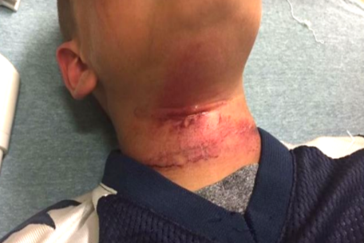
Associated Press September 12, 2017
CLAREMONT, N.H. — Teenagers in New Hampshire taunted an 8-year-old biracial boy with racial slurs and then pushed him off of a picnic table with a rope around his neck, injuring him, the boy’s family said.
The child was treated at a hospital for cuts to his neck following the near-hanging Aug. 28 in Claremont, the boy’s grandmother, Lorrie Slattery, told the Valley News of West Lebanon, N.H. He has since been released and has returned to school in Claremont.

Slattery said the children were in a backyard when some of the teens got on the table and grabbed a rope that held a tire swing. It’s not clear how the rope got around the child’s neck, but Slattery said the teens pushed him off the table. No adults are believed to have witnessed the incident.
An expert on abuse who spoke to the boy at the hospital said he swung from his neck three times before being able to remove the rope, Slattery said. None of the teens came to his aid, she said.

Reflections:

Scenario #6: The School-To-Prison Pipeline
Expression of Racism:

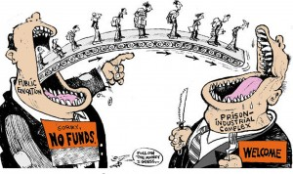
A significant number of Chicago students are pushed into the path of juvenile and adult prisons as a result of harsh disciplinary policies and high stakes testing. By harsh disciplinary policies, we mean excessive security procedures and police involvement as well as the overuse of suspensions and expulsion for minor infractions. These policies feed the “School to Prison Pipeline”, sometimes also called the “Schoolhouse to Jailhouse Track”. Research suggests that students of color, in particular African American students, are disproportionately impacted by these punitive policies.

As Matt Kelley has written: “Whether or not they realize it, the punishments school officials hand out can literally determine — and derail — the path of a student’s life. Which makes it even more critical that when schools make these decisions, they hand out discipline that’s fair.”
The “School to Prison Pipeline” describes a reality in which many young people are being pushed OUT of schools through zero tolerance policies, suspension, expulsion, discouragement and high stakes testing requirements; and INTO the juvenile and adult legal system. These zero tolerance policies involve the police in minor incidents and often lead to arrests, juvenile detention referrals, and even criminal charges and incarceration.

Reflections:

Scenario #7: Woke Girls
Expression of Racism:

Excerpts from an article written by educator Mickey Maki, creator of Woke Girls.

Before school started every morning a 1st-grader student in my class, with very dark skin would visit me so I could apply cocoa butter lotion to his skin. I assumed it was just about the lotion, but when I tried to give him a bottle he could keep in his classroom, he cried and told me I was the only one who thought his skin was beautiful.

Just down the hall in the 3rd-grade ESL class, two Mexican American girls got into a fight. The cause? One girl called the other a “little Mexican girl.”
It made me sad to see that little had changed since I was a child myself, when I was policed for not being black enough, while simultaneously taught that being black meant fewer options and bad hair.
Besides modeling self-love and loving my students, I made an effort to fill my classroom library with books that would support my students to be who they already were. That was quite the challenge.

Reflections:

Scenario #8: Doorway To A Better Life?
Expression of Racism:
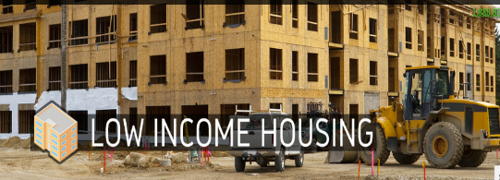
A state government agency decides that low-income housing must be built, which will house low-income Blacks and Latinos. The agency fails to look for locations near jobs and important infrastructures, like schools, decent public transportation, and other services. In fact, it is built in a poor, mostly Black and Latino part of town.

Often times the government locates the housing where it will have the least opposition. White neighborhoods tend to oppose public and affordable housing. Resources, whether public or private, often follow whites who flee urban problems for white suburbs
When the housing is built, the school district, already under-funded, has new residents too poor to contribute to its tax base. The local government spends its limited resources on transportation to connect largely white, well-to-do suburban commuters to their downtown jobs.

The public housing residents are left isolated, in under-funded schools, with no transportation to job centers. Whole communities of people of color lose opportunities for a good education, quality housing, living wage jobs, services and support-systems.

In this town, no one individual stands in front of the doorway to a better life and says, “No Blacks/Latinos/ Native Americans/Asians allowed.” Race, however, is the unspoken motivator behind a series of actions which lead to decisions about where to place the walls.

Reflections:

