Scenario:
You are the UniServ director for a rapidly changing county. The northern portion of the county is quickly becoming a bedroom community for Washington DC while the southern portion of the county is fighting hard to remain true to its rural southern roots. This has led to many clashes regarding local policy, both at the school board and board of supervisors level. Four years ago, you and your teachers sat through a series of increasingly contentious school board meetings regarding the bathroom policy for a young transgender girl in the fourth grade—the only openly transgender student in the county. During that spring, parents became increasingly hostile and threatening to the board, and indicated that they would personally go after the jobs of any employee who allowed this young girl to use the girl’s bathroom. That summer, the school board passed a policy that required the student to use only single stall bathrooms and barred her from using both the boys’ and girls’ bathrooms or locker rooms.
One day in the first month of a new school year, you receive a call from a PE teacher at one of your schools. She tells you that earlier that week, the school held one of the state-required lockdown drills during a PE class where that girl, now a 14-year-old 8th grader, was a student. The 3 PE teachers quickly conferred after realizing that their lockdown procedures did not take this student into account. The lockdown procedures call for boys to shelter in place in the boys’ locker room and girls to shelter in place in the girls’ locker room. This student, however, uses the single stall accessible restroom in the gym when she needs to change or use the restroom during PE class. Without clear guidance—and with the wrath of the parents still echoing in their minds— the teachers had decided to have the one male PE teacher take the boys into the boys’ locker room, while one female PE teacher took the rest of the girls into the girls’ locker room and the second female PE teacher remained in the gym with the transgender student.
The PE teacher proceeds to tell you that the mother of the child runs a group called Equality Stafford and has posted on Facebook about the incident. That post has quickly gone viral and has already been shared a couple hundred times:
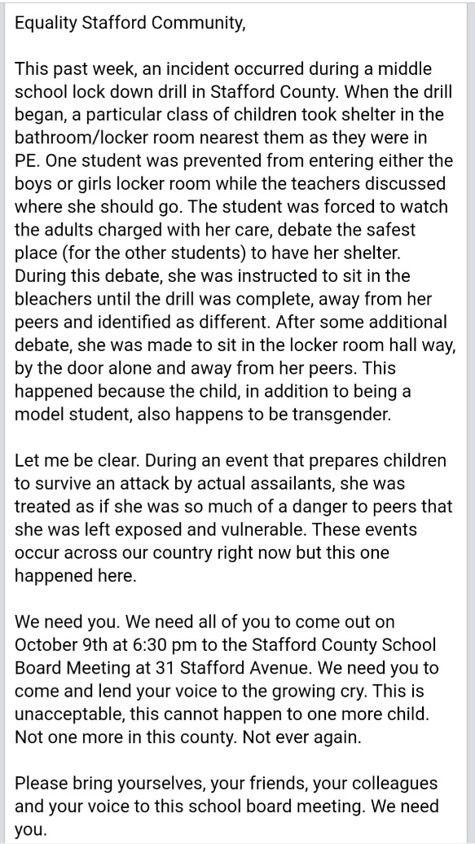
What do you do next?

