Pre Attendance Email
Hello all!
This is a long email with a lot of details about your upcoming LGBTQ+ and Trans Advocacy Focus Academy. Please read it carefully. I have included the previously sent registration email at the end of this message so that you have everything you need to get ready for our event.

A personal point of privilege before you jump into the details - this event has been a labor of love and commitment by a dedicated team of your colleagues from around the country. This is a pilot partnership between the Center for Social and Racial Justice and the Center for Organizing and Affiliate Support. Like any first-time event, I would ask you to expect and accept some degree of imperfection. As with all our programs I will be seeking your feedback so come prepped to help us make this as fabulous as possible for you and for our future attendees.

Where and When
We are looking forward to working with you in just a few weeks in Philadelphia from September 27-29, at the Hyatt Centric City Center, 1620 Chancellor St., Philadelphia, PA. Our meeting will convene at 8:30 am on the 27th and conclude at 2 pm on the 29th following lunch. Breakfast will be served from 7:30 to 8:30 am each day, lunch from noon to 1:00 pm on days 1 and 2, with a boxed lunch on day 3.

Getting There
Please make your travel arrangements ASA and register. You can arrive anytime on the 26th, and you may not book flights for departure prior to 4:00 pm on the 29th. I recognize that this registration was sent later than we usually do, and I appreciate your patience. We are still working to get fully restarted and restaffed post-COVID shutdown. Please remember to adhere to all NEA COVID requirements for in-person participation that were outlined in your registration. This includes the use of the Return Safe App and KN 95 masks. We will have masks and COIVD tests available for those who need them.

Pre-Attendance Package
Attached, you will find a pre-attendance package chock-full of goodies for your busy brain to work on. Page 2 of the package will suggest the best way to prioritize what is essential to do prior to arriving, what is nice to do prior to arriving, and what is there as a resource should you need it.

Communications
You should expect an evening email on the Monday prior to the start of our session. This email will have additional information about the meeting location, any new COVID directions, and locations for breakfast and lunch. We also provide a PDF of the slides we will use for the day to assist anyone with vision issues. You will receive an evening email each night with a feedback form and files we will use the next day. Any questions you have about the content should be sent to eholmes@nea.org and any questions about the hotel, flights, food, and vouchers should be sent to jeatmon@nea.org.

What to Pack
Please dress comfortably and show all your colors. You already have the job, so business attire is not necessary. I know that several of us on the facilitator team will be sporting our pride and allyship clothing and we encourage you to do the same. Conference rooms are notorious for being too hot or too cold - so please bring layers so that you can adjust to your own comfort needs.

Evenings
You will be on your own for supper and entertainment - but the facilitator team is working on a list of queer-owned establishments and is on the lookout for any events in the area that are aligned with our content and interests in case there are some folks looking for a group experience. If you are aware of events or places of business that this group would like to know about in advance feel free to use the reply all and let your fellow participants know. I am going to get us started with the following link that is a great overview of LGBTQ+ Philadelphia https://www.visitphilly.com/articles/philadelphia/essential-lgbt-sites-things-to-do-philadelphia/
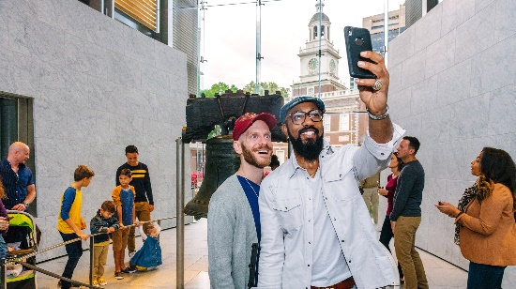 | An Essential Guide to LGBTQ Philadelphia  Historic sites, restaurants and more — in the Gayborhood and beyond...  www.visitphilly.com

One of the events listed is a walking tour of LGBTQ+ or Trans history in the city. IF there is at least a group of 10 who would be willing to pay $39 per person, they would do one especially for us. If you are firmly committed to doing this and maybe a group eat afterwards use the following link to let Ellen know before September 9 : https://forms.office.com/r/X4f5MkNpxr
 | Fill | LGBTQ+ Walking Tour in Philly  Please respond by September 9th if you plan to attend. Please include your name, work email, and cell number if you would like to do this event.  forms.office.com


